|  |
| --- |
| **STANDARD OPERATING PROCEDURE**  **SAMPLING OF FINISHED GOODS** |

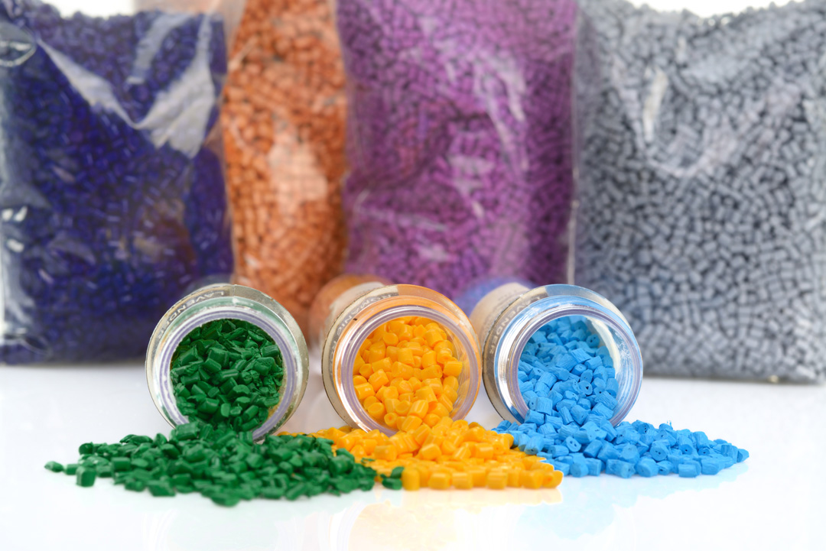

|  |  |  |
| --- | --- | --- |
| **Author** | | |
| Name : | Mr. Arif Kamal | **Signature** |
| Designation: | Asst. QCM |
| Date: | 28 July ,2021 |
| **Review** | | |
| Name: | Mr.Ghulam Murtaza | **Signature** |
| Designation: | LAB Head |
| Date: | 28 July ,2021 |
| **Approval** | | |
| Name: | Mr. Ahsan Abid | **Signature** |
| Designation: | General Manager Operations |
| Date: | 28 July ,2021 |

## Purpose

To lay down the procedure of sampling of finished goods in order to get a representative sample of the whole batch of lot for analysis.

## Scope

This procedure shall apply to only all the finished goods batches produced of a lot of any master batch grade. The grade may be Prime Color, Cheap Color, Filler, Additive, White and other Master Batch Grades including Black and R & D Trials on larger lines.

## Responsibilities

* 1. Trained Quality Control Lab Operator shall collect the sample from the production/ packing line and inform the respective shift in-charge or shift engineer.

## Procedure

* 1. Production operator shall inform the start of extrusion operation of the batch to the respective Quality Control Lab Operator.
  2. Quality Control Lab Operator shall collect the sample from the production line and or packing line in a zipper bag.
  3. Collect the sample in such a manner that it must cover middle and end of the batch to get the representative sample of the batch.
  4. The quantity of the sample shall be such as to enable complete analysis of the product at least twice.
  5. Affix Sample Retention Label and write down the details on the label properly.
  6. Place the sample in the Sample for Inspection tray and consult the respective shift in-charge/engineer for testing

## Frequency for Sampling

* 1. Sampling and testing frequency for each lot of the grades depends on the grade nature, requirement of the test in specific end application and quantity of the lot.

|  |  |  |  |  |
| --- | --- | --- | --- | --- |
| S# | Testing Detail | Sample Size  (g) | Frequency Per Lot | Collection Location |
| 1 | Color Testing | 5-10 | Every batch | Prod. Line |
| 2 | Melt Flow Rate | 10-20 | Each Lot twice | Prod. Line |
| 3 | Bulk Density | 50-60 | Each Lot Once | Pack. Line |
| 4 | Ash Content | 10-20 | Each Lot once | Pack. Line |
| 5 | Pellet Count | 1-2 | Each Lot once | Prod. Line |
| 6 | Moisture Content | 30-40 | Once in every Shift | Pack. Line |
| 7 | Blown Film | 50-100 | First Batch in the shift | Prod. Line |
| 8 | FPV Testing | 80-100 | First batch (CPP) | Prod. Line |

**AMENDMENT HISTORY**

|  |  |  |  |
| --- | --- | --- | --- |
| **REV. #** | **DCR #** | **SECTION** | **AMENDED TEXT** |
|  |  |  |  |
|  |  |  |  |
|  |  |  |  |
|  |  |  |  |
|  |  |  |  |