|  |
| --- |
| **STANDARD OPERATING PROCEDURE**  **PELLET COUNT** |

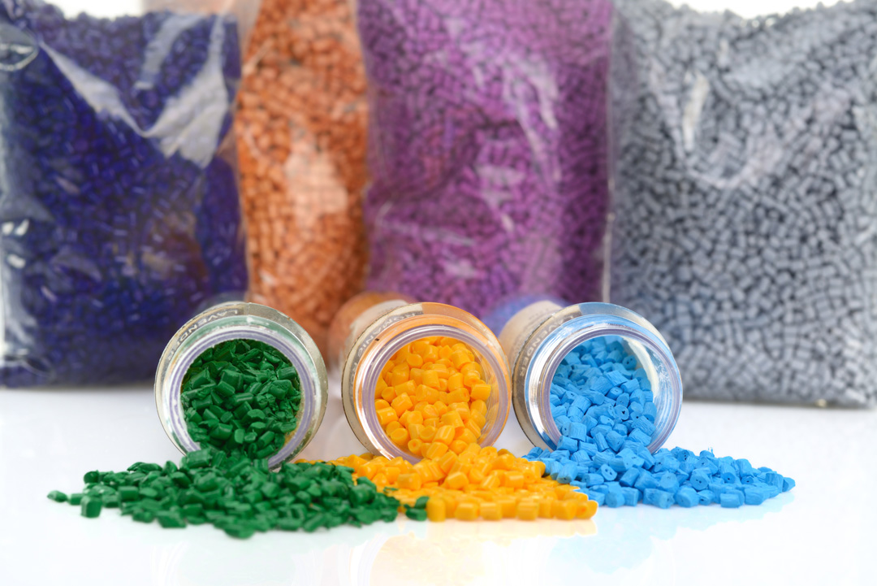

|  |  |  |
| --- | --- | --- |
| **Author** | | |
| Name : | Mr. Arif Kamal | **Signature** |
| Designation: | Asst. QCM |
| Date: | 28 July ,2021 |
| **Review** | | |
| Name: | Mr.Ghulam Murtaza | **Signature** |
| Designation: | LAB Head |
| Date: | 28 July ,2021 |
| **Approval** | | |
| Name: | Mr. Ahsan Abid | **Signature** |
| Designation: | General Manager Operations |
| Date: | 28 July ,2021 |

## Scope

* 1. These test methods describe the determination of the Pellet Count of Master Batch in one gram of Master Batch sample.
  2. The values stated in Pellets/gram are to be regarded as the standard.

1. **Terminology**
   1. *Definitions:*
      1. *Pellet count, n—*the number of pellets per gram of master batch or polymer resin in granular form.
      2. *Master Batch, n* *—* Master Batch is a concentrated mixture of pigments and/or additives encapsulated during a heat process into a carrier resin which is then cooled and cut into a granular shape.
2. **Significance and Use**
   1. The pellet count of master batch is a property that is conveniently measured to identify a master batch pellet size, degree of packing, to follow physical changes in a sample, to indicate degree of uniformity among different sampling units or specimens, or to indicate the average pellet count of a large lot of master batch.
   2. Changes in pellet count of a single lot of master batch are due to localized differences in material density, pellet size, composition (types or proportions of resin, plasticizer, pigment, or filler) or to other causes.
3. **Sampling**
   1. The sampling units used for the determination of Pellet Count shall be representative of the quantity of product for which the data are required

1. **Apparatus**
   1. Electronic Balance—A balance having the capability to weigh the sample to the nearest 0.01 g. The balance should be checked periodically to ensure accuracy.
   2. Sample Holder—Any Pan made from any nonreactive material such as aluminum pan.
2. **Test Specimen and Sample**
   1. Due to the small specimen size, exercise care to ensure that the specimen is representative of the sample.
3. **Test procedure**
   1. Place the sample holder on electronic balance.
   2. Tare the balance and weigh 1 gram of the sample master batch.
   3. Count the number of pellets in one gram of the sample.
   4. Results to be displayed in Pellet per gram of sample.

**AMENDMENT HISTORY**

|  |  |  |  |
| --- | --- | --- | --- |
| **REV. #** | **DCR #** | **SECTION** | **AMENDED TEXT** |
|  |  |  |  |
|  |  |  |  |
|  |  |  |  |
|  |  |  |  |
|  |  |  |  |