**Department:** Maintenance **Date:** 08-02-2018

`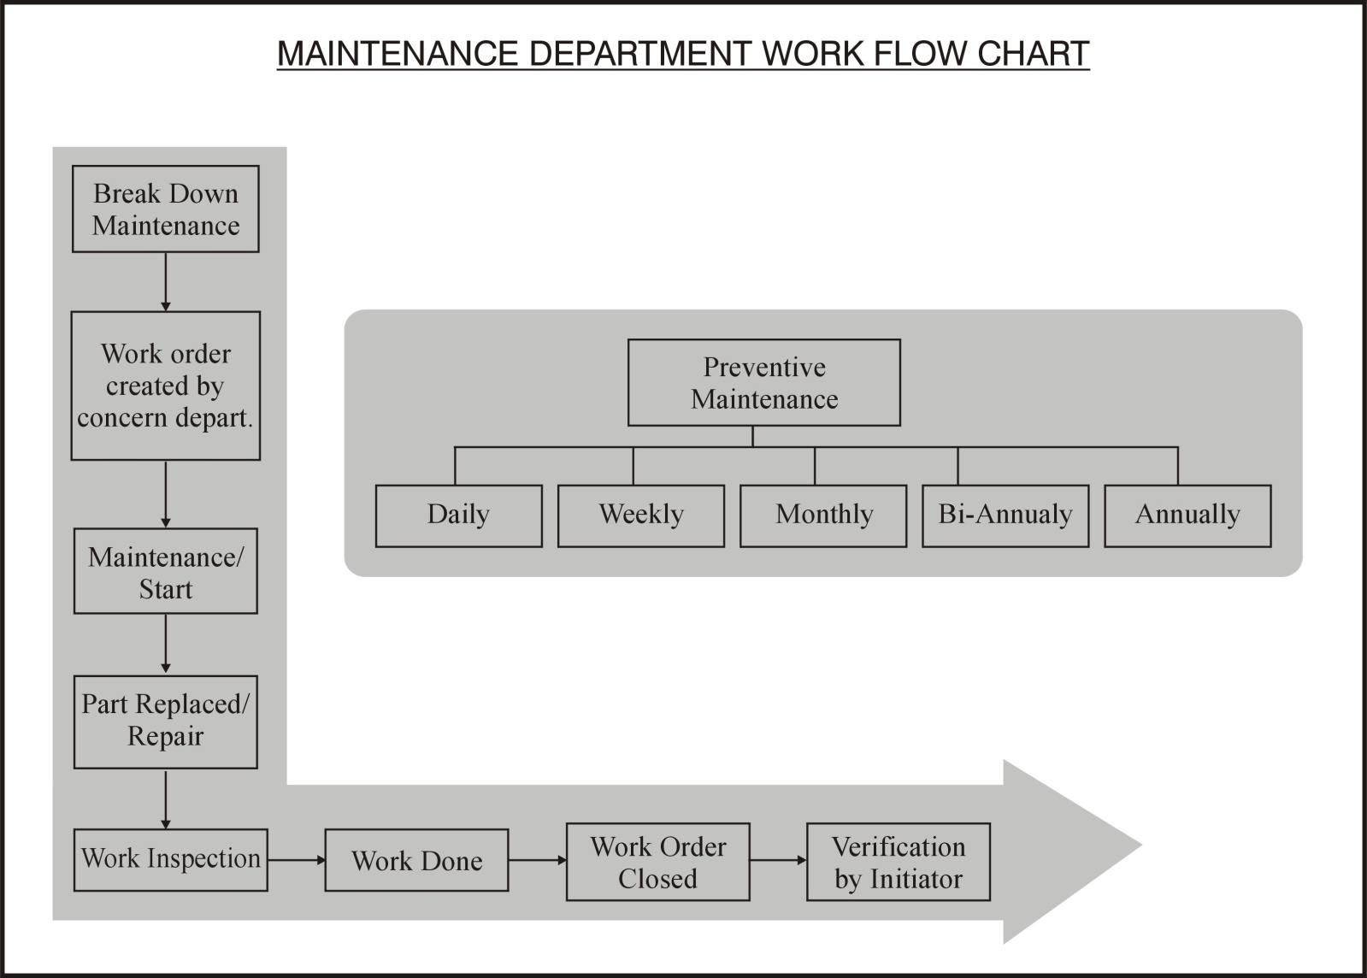

Checked By (HOD): ___________________ Approved by (QHSE TL): _____________________