## bead mill.gif

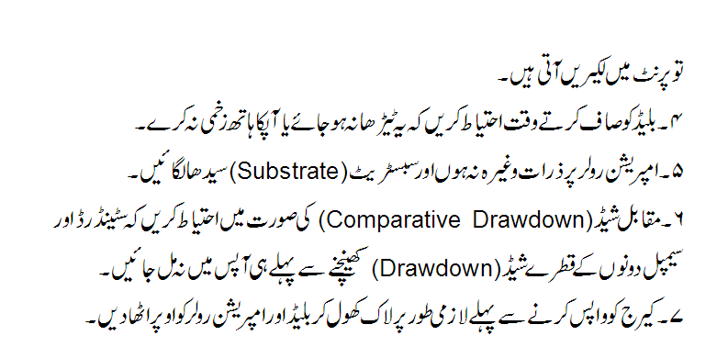

|  |  |
| --- | --- |
| **Author** | **Approved by** |
| Ahmad Raza (DM Lab) | Waseem Ahmed (GM Operations) |
|  |  |