TRAIANGLES

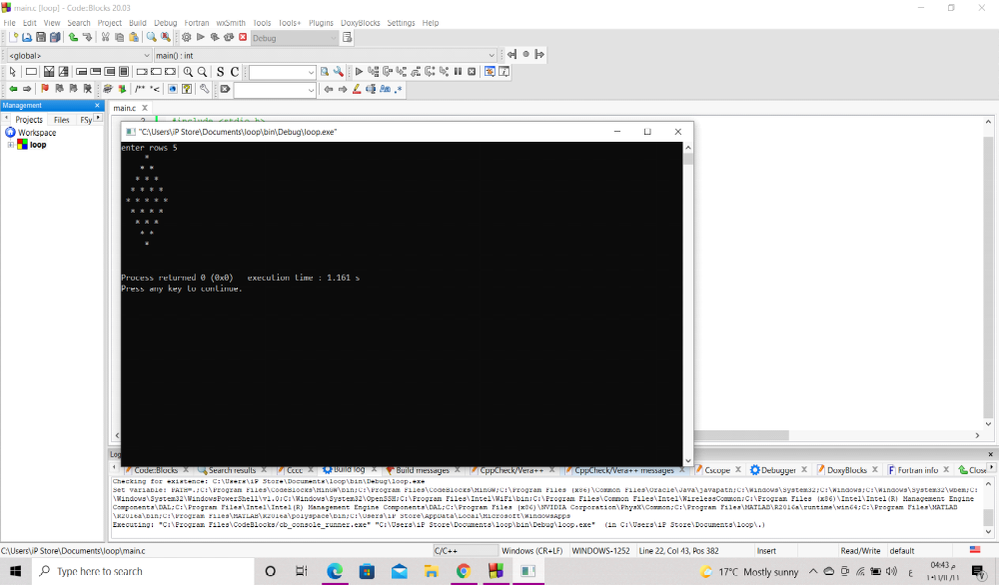طباعه مثلث متساوي الساقين
#include <stdio.h>

int main()
{int i, y,g,z;
int rows;do{
printf ("enter rows ");
scanf ("%d",&rows);
for (i=1;i<=rows;i++){
for(g=rows;g>=i ;g--){printf (" ");}
for(y=1;y<=i;y++){printf ("* ");}

puts ("");

}}while (1); //طباعه مثلث متساةي الساقين
return 0;
}
مقلوب بقا

#include <stdio.h>
int main ()
{ int b ,s,k;
int rows;
printf ("enter rows ");
scanf ("%d",&rows);
for (b=rows-1;b>=0;b--){
for (k=1;k<=4-b;k++){printf (" ");}

for (s=1;s<=b;s++){printf ("* ");}

puts ("");
}

return 0;

}

كله بقا

#include <stdio.h>
int main()
{int row;int i,j, g;do{
printf ("enter hight");
scanf("%d",&row);

for (i=0;i<=row;i++)
{
for(j=row;j>i;j--)
{
printf (" ");
} for( g=0;g<=i;g++)
{
printf (" *");
}
puts("");
}

for (i=0;i<=row;i++)
{for (j=0;j<=i;j++){printf(" ");}
for (g=row-1;g>=i;g--){printf(" *");}
puts("");}}while(1);

return 0;}
array
Search in array linear
#include <stdio.h>

int main()
{
int rates [10];
int i=0;
int x,n;
int key;
int pos;

for (i=0;i<5;i++){ printf ("values\n") ;
scanf ("%d",&rates[i]);}
printf("enter key");
scanf ("%d",&key);
pos=-10;
for (i=0;i<5;i++)

if (rates[i]==key){

pos =i;
break;}

if (pos == -10)printf ("key is not found ");
else {printf ("postion of %d=%d",key ,pos);}

return 0;
}
- Search binary
#include <stdio.h>

int main()
{
int rates [10];
int i=0;
int x,n;
int key;
int pos;
int low ;
int upper;
int mid ;
do{

for (i=0;i<5;i++){ printf ("values\n") ;
scanf ("%d",&rates[i]);}
printf("enter key");
scanf ("%d",&key);
low=0;upper =4;pos=-10;
do {
mid=(low+upper)/2;
if(key==rates[mid]){pos=mid;break;}
else if (key >rates [mid]) {low =mid +1;}
else {upper =mid-1;}

}while (low <=upper);

if (pos == -10)printf ("key is not found ");
else {printf ("postion of %d=%d",key ,pos);}}while (1);

return 0;
}
Sorting
In selection
#include<stdio.h>
int main()
{
int i,j;
int arr [5]={1,8,9,5,6};
for (i=0;i<5;i++){printf ("res is =%d\n",arr[i]);}
for (i=0;i<4;i++)
{for (j=i+1;j<5;j++)
{if (arr [i]>arr[j]){int temp =arr [i];arr[i]=arr[j];arr[j]=temp;}
}}
puts ("-----------------------------");
for (i=0;i<5;i++){printf ("res is =%d\n",arr[i]);}
return 0;
}
In bupple
عظمه بقا...............
#include<stdio.h>
int bupple (int x[],int y );
int print (int z[],int n );
int main (){

int rates[]={4,8,9,6};
int rates1 []={5,6,3,8,1,0,2,9,4};
int n1=sizeof(rates)/sizeof(rates[0]);
int n2=sizeof(rates1)/sizeof(rates1[0]);
print(rates,n1);
bupple(rates,n1);
puts ("--------------");
print(rates,n1);
puts ("--------------");
print(rates1,n2);
bupple(rates1,n2);
puts ("--------------");
print(rates1,n2);

return 0;}

int bupple (int x[],int y)
{ int i,temp ;int sort;
do {sort=1;
for (i=0;i<y-1;i++){

if(x[i]>x[i+1])
{ temp=x[i];x[i]=x[i+1];x[i+1]=temp;sort=0;}
}

}
while (sort==0);
}
int print (int z[],int n){
int i;
for (i=0;i<n;i++){printf ("res is %d=%d\n",i,z[i]);}

}
المصفةفه اكتر من صف
#include <stdio.h>

int main()
{ int a[2][3];
int r ,c;
for (r=0;r<2;r++)

for (c=0;c<3;c++)
{
printf ("enter value [%d,%d]",r,c);
scanf ("%d",&a[r][c]);

}

for (r=0;r<2;r++)
{
for (c=0;c<3;c++)
{
printf (" %3d",a[r][c]);}puts ("");}

/* char word [5];
printf ("enter your word ");
scanf ("%s",word);
printf ("your name is :%s",word );*/
return 0;
}

sort in words
#include <stdio.h>
#include<string.h>

int main()
{int j,i;
char word [10][25];
for (i=0;i<5;i++)
{
printf ("enter value [%d]",i);
gets (word[i]);
}
for (i=0;i<4;i++)
for (j=i+1;j<5;j++){

if (strcmp(word [i],word [j])>0)
{char temp [25];
strcpy(temp,word[i]);
strcpy(word [i],word[j]);
strcpy(word[j],temp);
}
}

for (i=0;i<5;i++){printf("\n",word [i]);}

return 0;
}

درجات طلاب
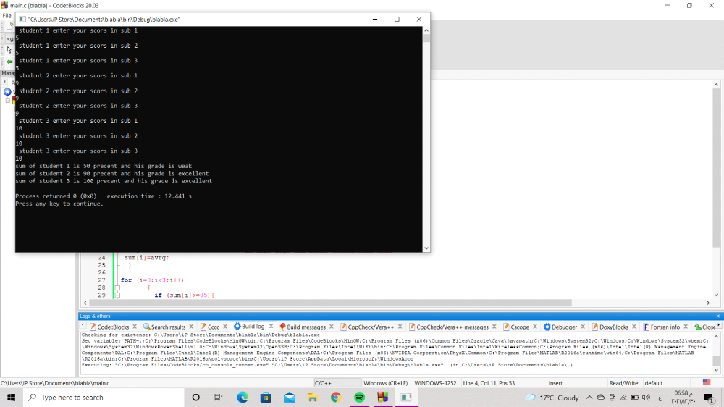

#include <stdio.h>
#include <stdlib.h>

int main()
{int i ;int j;

int sum [3]={0};
int scores [3][3]={0};
for (i=0;i<3;i++){
for (j=0;j<3;j++){

printf (" student %d enter your scors in sub %d\n",i+1,j+1);
scanf ("%d",&scores[i][j]);}
}

for (i=0;i<3;i++)
{int sim=0;int avrg;int tot=30;
for (j=0;j<3;j++)
{ sim=sim+scores [i][j];

}
avrg =sim*100/tot; //لو عاوز ازود عدد الطلاب براحتي فاهم يعرص
sum[i]=avrg;
}

for (i=0;i<3;i++)
{
if (sum[i]>=85){
printf ("sum of student %d is %d precent and his grade is excellent \n",i+1,sum[i]);}
else if (sum[i]>=75){ printf ("sum of student %d is %d precent and his grade is v good \n",i+1,sum[i]);}
else { printf ("sum of student %d is %d precent and his grade is weak \n",i+1,sum[i]);}

}
return 0;
}
reverse words
#include <stdio.h>
#include<string.h>
#include <stdlib.h>

int main()
{ char word [20];
printf ("please enter word to reverse");
scanf("%s",word);
int i=0;
int n = 0 ;
while (word[i]!='\0')
{ i++;n++;}
printf ("%d\n",n);

char temp;
for (i=0;i<n-1;i++)
{
temp =word[i];
word[i]=word[n-1];
word[n-1]=temp;
n--;
}
printf ("word is %s",word);
return 0;
}
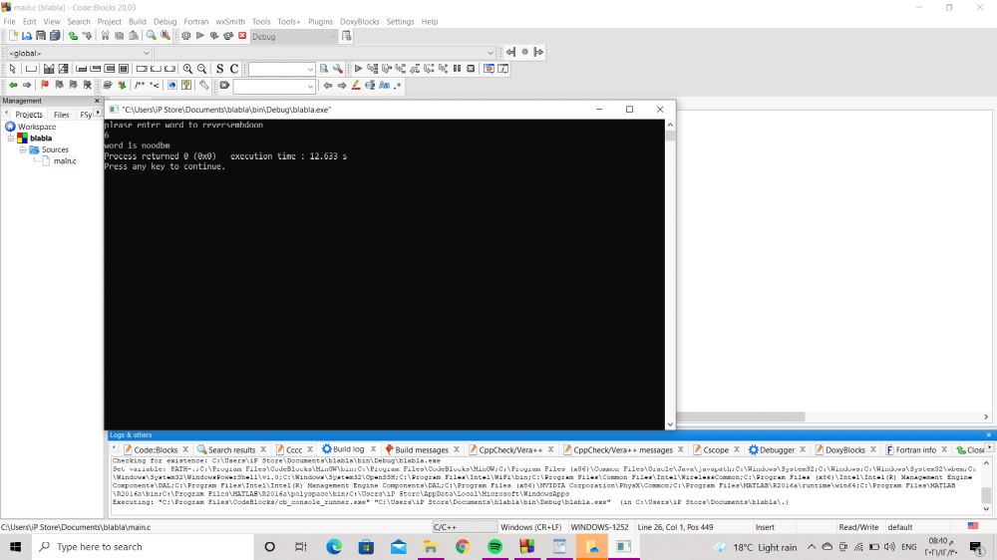
frequency]
#include <stdio.h>
#include<string.h>
#include <stdlib.h>

int main()
{ char word [20]={0};int i;
printf ("please enter word to check");
scanf("%s",word);
int freq [26]={0};
int x;
// printf ("%d",'c'-'a');
for (i=0;word[i]!=0;i++)
{
x=word[i]-'a';
freq[x]++;
}
for (i=0;i<26;i++)
{
if (freq [i]>1){printf ("the repeated car is %c and repeat for %d times\n",i+'a',freq[i]);}
}
return 0;
}

