1. Python supports several data types, including:

* **Integers** (e.g., 1, 42, -7)
* **Floating-point numbers** (e.g., 3.14, -0.5)
* **Strings** (e.g., "Hello", 'World')
* **Booleans** (e.g., True, False)
* **Lists** (e.g., [1, 2, 3], ["apple", "banana", "cherry"])
* **Tuples** (e.g., (1, 2, 3), ("red", "green", "blue"))
* **Dictionaries** (e.g., {"name": "Alice", "age": 25})
* **Sets** (e.g., {1, 2, 3}, {"apple", "banana", "cherry"})

1. The lists in python, it contains a couple of elements in it, they could be names of fruits, animals and places. There are a number of functions that we can use to add or remove elements from list.

* *Ro'yxatga yangi element qo'shishning oson usuli bu list-name****.append()*** *metodi yordamida ro'yxatning* ***oxiriga*** *qiymat qo'shish:*

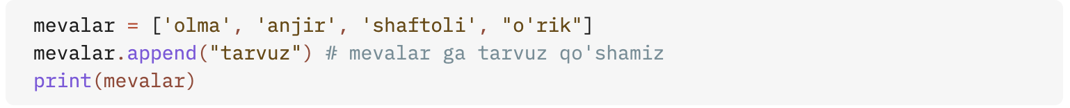

* *Ro'yxatning istalgan joyiga yangi element qo'shish uchun list-name****.insert()*** *metodidan foydalanamiz. .insert() metodi ichida yangi elementning indeksi va qiymati beriladi:*

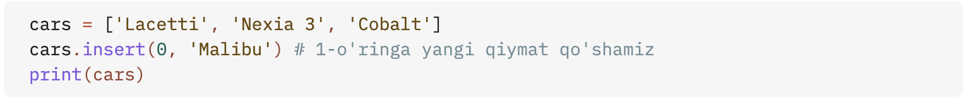

* *Element qiymati bo'yichi o'chirish uchun esa list-name****.remove(element-name)*** *metodidan foydalanamiz. Buning uchun qavs ichida o'chirib tashlash kerak bo'lgan qiymatni yozamiz*

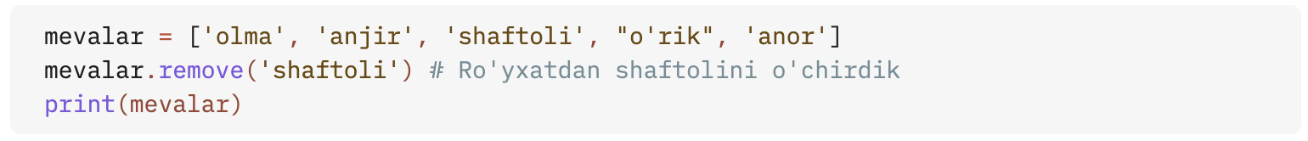

* *Ba'zida biror elementni butunlay o'chirib tashlash emas, balki uni ro'yxatdan sug'urib olish va undan foydalanish talab qilinishi mumkin. Buning uchun Pythonda list-name****.pop(indeks)*** *metodidan foydalanmiz.*

* *Inedks yordamida olib tashlash uchun* ***del*** *operatoridan foydalanamiz:*

1. There are two different ways to sort list elements out. The first one is before printing the list we need to use list-name.sort()

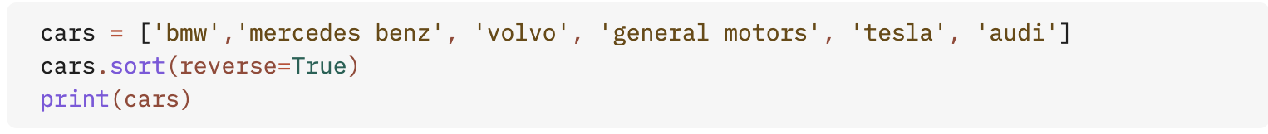

The next way of sorting is to use sorted(list-name) inside of print() function:

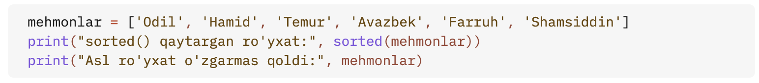

# Here is how to cut some elements from the list

