**SUMMER TRAINING REPORT**

Submitted For Partial Fulfilment of Award of degree of

**BACHELOR OF TECHNOLOGY**

**In**

**Computer Science and Engineering (2024)**

**Project Title**

STUDENT MANAGEMENT SYSTEM

**Training Organization**

SOFTPRO INDIA COMPUTER TECHNOLOGIES (P) LTD

**Duration**: 1st July 2024 to 1st September 2024

**Name of Supervisor:**

**SAIF ALI**

B. Tech - CSE (B), Fourth Year

**ROLL NO. 2100103507**

**SESSION:** 2024-25



**INTEGRAL UNIVERSITY, LUCKNOW (INDIA)**

ABOUT THE TRAINING CENTER

My summer training experience took place at **Softpro India Computer Technologies Pvt Limited;** Softpro India Computer Technologies (P) Ltd. is a leading IT firm and the software development division of Softpro Group of Companies with its headquarter located in the capital city of Uttar Pradesh, Lucknow. Softpro India was established in 2004 by technocrats from IIT-Kanpur and IET Lucknow. Softpro Group of Companies is a cluster of companies working in multiple domains like Software Development, IT Trainings, Research and Designing. The Founder and Managing Director of Softpro Group of Companies is Er. Ajay Chaudhary with over 25 years of experience. Softpro India is the fastest growing IT company with the largest learning centre of the region having experienced consultants of 15+ years and industry experts.

Softpro Group of Companies compromises of Softpro Learning Center (Training & Internship division – 2008), Softpro Innovations (R&D division – 2014) and Softpro Foods (Agro Production division – 2018). Softpro India has global presence with its Head Office and Training Center located in Lucknow, International Unit Office located in Malawi, Africa and Virtual Office located in Kuala Lumpur, Malaysia. Softpro India has successfully delivered Government Projects like the visionary project of Government of Uttar Pradesh – *URISE.*

Softpro India’s recent achievements include the MoU signing with Dr. A. P. J. Abdul Kalam Technical University, Uttar Pradesh. Technologies are transcending boundaries and their volatility is putting stringent demands on the time and mind-space of techno-professionals. At SPG, we update ourselves with technologies even before they become norms and master them long before they become redundant. That's why we are on the roster of clients from across the continents.

Softpro India offers training for all the ranches of engineering (Computer Science, Information Technology, Electronics, Electrical, Civil, Mechanical) for updated and trending technologies. Softpro India also has several online and offline trainings like Summer Training, Industrial Training, Vocational Training, Apprenticeship Program, Employment Training Program and Online Courses. The learning material and other resources are available on Softpro India’s Learning Management System (LMS) – “Polyprep – Knowledge @ Your Doorstep” and mobile application – “e-Study Zone”.

TABLE OF CONTENTS

**1- Introduction**

1.1- Background

1.2- Problem Statement

1.3- Purpose of the student management system

1.4- Scope of the Project

1.5- Data flow diagram

1.6- Database designing

**2- Feasibility Study**

2.1- Operational Feasibility

2.1- Technical Feasibility

2.1- Schedule Feasibility

2.1- Economic Feasibility

**3- PROJECT REQUIREMENTS**

3.1- Technology stack

3.2- Software Requirements

3.3- Hardware Requirements

**4- Project Development**

4.1- Software Development Model

4.2- Design (Ui/Ux and Backend)

4.3-Coding

4.4-Testing

4.5-Implementation

4.6-Maintainance

**5- Result Analysis**

5.1- Result Analysis

5.2- Screenshots, Charts and Grapahs

5.2.1- Future Scope

**7- Conclusion**

7.1 Summary of Work Done

7.2 Final Thought

1-INTRODUCTION

**Seth Anandram Jaipuria School, Sadhu Campus – Barabanki** is dedicated to the mission of 'Empower, Enthuse, and Excel,' ensuring that every child receives a holistic education that not only imparts knowledge but also instills values essential for navigating life. Our commitment at Seth Anandram Jaipuria School is to provide education that truly prepares students for LIFE!

Nestled in the serene environment of Barabanki, **Seth Anandram Jaipuria School, Sadhu Campus** spans 2.16 acres of lush green land. The campus is equipped with state-of-the-art facilities, designed to foster the all-round development of our students. Each classroom is outfitted with Digital Smart Boards, ensuring an interactive and engaging learning experience.

Our educational philosophy centers on a child-focused approach, where we identify and nurture the unique talents of every student. The school’s curriculum integrates contemporary pedagogical methods, including Design Thinking, and emphasizes Literacy and Numeracy Skills. We believe in cultivating not just intellectual abilities but also fostering values like compassion, empathy, kindness, solidarity, and tolerance, alongside encouraging critical thinking, analytical reasoning, and creativity.

* 1. **BACKGROUND**

Traditional school administration methods involve managing school operations manually, where administrators, teachers, and students rely heavily on paper-based processes. These methods typically include manual enrolment, where students fill out and submit physical admission forms, and teachers maintain paper-based records for attendance, grades, and communication. The process is often time-consuming and prone to delays, such as long waiting periods for processing admission applications or delivering important updates to parents and students. Additionally, communication between teachers, parents, and students is often limited to in-person meetings or delayed correspondence, leading to a lack of immediate feedback and responsiveness in addressing student needs or concerns. There is a pressing need for a modern, integrated platform that can transform these traditional school management practices. An advanced School Management System can streamline administrative tasks, enhance communication, and provide real-time access to critical information, ensuring a more efficient and effective school operation.

**1.2 PROBLEM STATEMENT**

The current school administration at Seth Anandram Jaipuria School, Sadhu Campus relies heavily on traditional paper-based processes for managing critical operations such as admissions, attendance, grade reporting, and communication between teachers, students, and parents. This manual approach is time-consuming, inefficient, and prone to errors. Key challenges include:

1. **Manual Admissions Process**: The student admission process involves filling out paper forms, which delays application processing and increases administrative burden. Lack of digital tracking makes it difficult to follow the progress of applications.
2. **Time-Consuming Attendance Management**: Teachers manually record attendance on physical registers, which not only consumes valuable instructional time but also poses challenges in maintaining accurate, up-to-date records.
3. **Inefficient Communication**: Communication between teachers, parents, and students is limited to physical meetings or delayed through offline correspondence. There is a lack of real-time updates and transparency regarding student progress, school activities, and announcements.
4. **Limited Access to Academic Information**: Students and parents often struggle to access real-time information regarding grades, attendance, and upcoming events. This lack of accessibility creates gaps in keeping stakeholders informed and involved in a student's academic journey.
5. **Delayed Reporting and Feedback**: Teachers face challenges in generating timely academic reports for students, and the feedback loop between teachers, parents, and students is hindered by the manual system, affecting the students' overall growth and timely interventions.

An integrated School Management System is required to digitize these operations, offering a seamless experience to manage administrative tasks, enhance parent-teacher-student communication, provide real-time access to academic data, and promote overall efficiency in school management.

* 1. **PURPOSE OF SMS (STUDENT MANAGEMENT SYSTEM)**

The School Management System (SMS) at Seth Anandram Jaipuria School, Sadhu Campus – Barabanki, is designed with the objective to streamline and enhance the entire school administration process. This secure and robust web application aims to provide a centralized platform for managing all aspects of school operations, from student information and attendance tracking to academic management and communication.

The SMS is user-friendly and easily accessible, ensuring that all stakeholders—students, teachers, and administrators—can efficiently perform their tasks. The system is built on a cloud-based architecture, allowing for scalability and flexibility as the school’s needs evolve. It ensures that resources are available whenever needed, providing 24x7 secure access to authorized users from any location.

The SMS addresses key administrative challenges, such as student enrollment, class management, attendance tracking, and communication, ensuring that all aspects of school management are handled effectively. By providing real-time access to data and resources, the system facilitates better decision-making and enhances the overall educational experience for students, teachers, and administrators alike.

**1.4 SCOPE OF PROJECT**

To address the challenges posed by traditional school administration methods, Seth Anandram Jaipuria School, Sadhu Campus – Barabanki, has introduced a comprehensive School Management System (SMS). This system is designed to digitize every aspect of school operations, from admissions to academic management, ensuring that all processes are streamlined and efficient.

The SMS features a **common zone** accessible to all visitors, providing a general overview and essential information about the school. Beyond this, the system offers three distinct login panels for **Students**, **Teachers**, and **Administrators**, each tailored to meet their specific needs:

* **Student Panel:** Students can log in to view their subjects, track their attendance, and manage their profiles. This allows them to stay informed and take responsibility for their academic progress.
* **Teacher Panel:** Teachers have the ability to mark attendance, view the subjects assigned to them, and manage their profiles. This ensures that teachers can efficiently manage their classes and stay organized.
* **Admin Panel:** Administrators have full control over the system. They can add, remove, edit, and delete student and teacher accounts, manage classes, add new subjects, and assign teachers to their respective subjects. This centralized control allows for smooth and effective school management.

Through this platform, communication and feedback between students, teachers, and administrators are streamlined, ensuring a seamless flow of information and prompt resolution of any issues. The system also enhances the digital experience by providing real-time access to educational materials, attendance records, examination results, and other essential resources.

This School Management System is set to revolutionize the way the school operates, making education more accessible, efficient, and effective for everyone involved.

* 1. **DATA FLOW DIAGRAM**

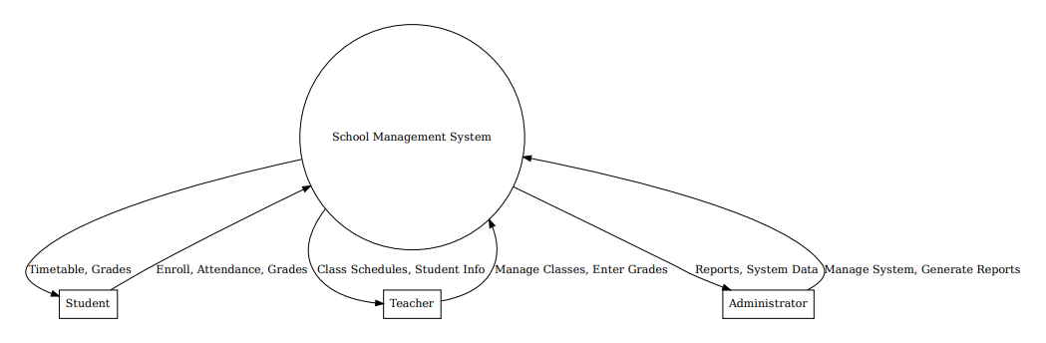

**Figure 1.1**

**1-LEVEL DFD**

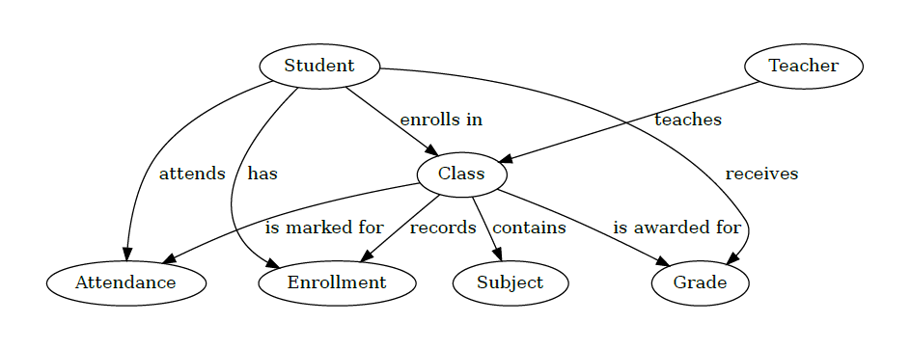

**Figure 1.2**

**1.6- Database Designing**

**Table 1.1 : tbl_student**

|  |  |
| --- | --- |
| Column Name | Data Type |
| Rollno | int primary key |
| Name | varchar(50) |
| Fname | varchar(50) |
| Mname | varchar(50) |
| Gender | varchar(6) |
| Address | varchar(255) |
| Class | varchar(50) |
| Sfee | varchar(50) |
| Restfee | varchar(50) |
| Contactno | varchar(10) |
| Emailaddress | varchar(50) |
| Pic | varchar(200) |
| Regdate | varchar(30) |

**Table 1.2 : tbl_teacher**

|  |  |
| --- | --- |
| Column Name | Data Type |
| Id | int primary key |
| Name | varchar(50) |
| Fname | varchar(50) |
| Email | varchar(50) |
| Gender | varchar(6) |
| Address | varchar(255) |
| Tclass | varchar(50) |
| Tsalary | varchar(50) |
| Contactno | varchar(50 |
| Emailaddress | varchar(10) |
| Pic | varchar(200) |
| Regdate | varchar(30) |

**Table 1.3 : tbl_login**

|  |  |
| --- | --- |
| Column Name | Data Type |
| Userid | varchar(50) primary key |
| Password | varchar(30) |
| Usertype | varchar(50) |
| Status | Varchar(10) |

**Table 1.4 : tbl_enquiry**

|  |  |
| --- | --- |
| Column Name | Data Type |
| Id | int primary key auto_increment |
| Name | varchar(50) |
| Gender | varchar(20) |
| Address | varchar(255) |
| Contactno | varchar(10) |
| Emailaddress | varchar(50) |
| Enquirytext | Varchar(255) |
| Enquirydate | Varchar(30) |

**Table 1.5 : tbl_class**

|  |  |
| --- | --- |
| Column Name | Data Type |
| Id | varchar(50) primary key |
| Name | varchar(30) |
| Roomno | varchar(10) |
| Seats | Varchar(10) |

**Table 1.6 : tbl_subjects**

|  |  |
| --- | --- |
| Column Name | Data Type |
| Id | varchar(50) primary key |
| Name | varchar(50) |
| Classid | varchar(50) |
| Teacherid | Varchar(50) |
| Book | Varchar(200) |

**Table 1.7 : tbl_attandance**

|  |  |
| --- | --- |
| Column Name | Data Type |
| Id | varchar(50) primary key |
| Name | varchar(50) |
| Classid | varchar(50) |
| Teacherid | Varchar(50) |
| Book | Varchar(200) |

**Table 1.8 : tbl_question**

|  |  |
| --- | --- |
| Column Name | Data Type |
| Qid | int primary key auto_increment |
| Question | varchar(255) |
| Postedby | varchar(50) |
| Posteddate | varchar(30) |

**Table 1.9 : tbl_answer**

|  |  |
| --- | --- |
| Column Name | Data Type |
| Aid | int primary key, auto_increment |
| Qid | Int |
| Answer | varchar(255) |
| Answeredby | varchar(50) |
| Posteddate | varchar(30) |

**Table 2.0 : tbl_feedback**

|  |  |
| --- | --- |
| Column Name | Data Type |
| Id | int primary key auto_increment |
| Rollno | Int |
| Name | varchar(50) |
| Class | varchar(50) |
| Contactno | varchar(10) |
| Emailaddress | varchar(50) |
| Subject | varchar(500) |
| Feedbacktext | Varchar(500) |
| Feedbackdate | varchar(30) |

**Table 2.1 : tbl_news**

|  |  |
| --- | --- |
| Column Name | Data Type |
| nid | int primary key auto_increment |
| Newstext | varchar(255) |
| newsdate | varchar(30) |

**Table 2.2 : tbl_material**

|  |  |
| --- | --- |
| Column Name | Data Type |
| Ids | int primary key, auto_increment |
| Program | varchar(50) |
| branch | Varchar(50) |
| Year | Varchar(50) |
| Subject | Varchar(100) |
| File_name | Varchar(255) |
| My_file | Varchar(255) |

2-FEASIBILITY STUDY

The project aims to develop a School Management System (SMS) to enhance and streamline the school's administrative processes. This feasibility study evaluates the practicality and benefits of implementing the system, ensuring it meets the technical, operational, and financial requirements of Seth Anandram Jaipuria School, Sadhu Campus. The study is an ongoing process throughout the system's life cycle.

**2.1- Operational Feasibility:**

The web-based SMS will provide easy access for administrators, teachers, parents, and students, meeting their specific needs efficiently. Key operational benefits include:

* Streamlined management of user information and records, reducing the manual workload.
* Efficient handling of large student databases, improving overall administrative functions.
* Minimized risk of data loss due to secure, automated data storage solutions.
* Enhanced communication and transparency between stakeholders, leading to higher satisfaction levels for all users.
* Improved operational efficiency, reducing delays in administrative processes and decision-making.

**2.2- Technical Feasibility:**

The SMS will be developed using proven technologies, ensuring a robust and scalable solution:

* Database Design: SQLite3 will be used as the database, providing an efficient and lightweight solution for storing and managing student and administrative data.
* User Interface: HTML, CSS, JavaScript, and Bootstrap will be used to create a responsive and user-friendly interface, ensuring accessibility across devices.
* Backend Development: Python, along with the Django framework, will be utilized for backend logic, offering scalability, security, and efficient development practices.

The chosen technology stack (Python with Django) is widely used in web application development, ensuring the technical feasibility of the project.

**2.3- Schedule Feasibility:**

The project schedule is realistic and aligns with the school's expectations. A detailed timeline has been prepared to deliver the system within the agreed timeframe. Key milestones, such as design, development, and testing, have been planned to ensure timely completion, making the project feasible from a scheduling perspective.

**2.4- Economic Feasibility:**

The estimated project cost fits within the allocated budget. Resources, including software tools, human capital, and development time, are well-planned and sufficient to ensure the successful development of the SMS. Therefore, the project is economically feasible.

3-PROJECT REQUIREMENT

**3.1-TECHNOLOGY STACK**

**1.HTML: -** HTML is stand for hypertext markup language, this markup language is used to design static web pages. HTML contain pre-defined tags, which are useful to design web pages. HTML describes the structure of a Web page. HTML consists of a series of elements. HTML elements tell the browser how to display the content. HTML elements label pieces of content such as "this is a heading", "this is a paragraph", "this is a link", etc.

**2.CSS: -** CSS stands for Cascading Style Sheets. CSS describes how HTML elements are to be displayed on screen, paper, or in other media.CSS is the language we use to style an HTML document. CSS describes how HTML elements should be displayed. CSS saves a lot of work. It can control the layout of multiple web pages all at once. External stylesheets are stored in CSS files.

**3.Javascript: -** JavaScript is a scripting or programming language that allows you to implement complex features on web pages — every time a web page does more than just sit there and display static information for you to look at — displaying timely content updates, interactive maps, animated 2D/3D graphics, scrolling video jukeboxes, etc. — you can bet that JavaScript is probably involved. It is the third layer of the layer cake of standard web technologies, two of which (HTML and CSS).

**4.Bootstrap: -** Bootstrap is the most popular HTML, CSS and JavaScript framework for developing a responsive and mobile friendly website. It is absolutely free to download and use.It is a front-end framework used for easier and faster web development. It includes HTML and CSS based design templates for typography, forms, buttons, tables, navigation, modals, image carousels and many others.It can also use JavaScript plug-ins. It facilitates you to create responsive designs.

**5.Database: -** A database is an organized collection of data, so that it can be easily accessed and managed. You can organize data into tables, rows, columns, and index it to make it easier to find relevant information. Database handlers create a database in such a way that only one set of software program provides access of data to all the users. The main purpose of the database is to operate a large amount of information by storing, retrieving, and managing data.There are many dynamic websites on the World Wide Web nowadays which are handled through databases. For example, a model that checks the availability of rooms in a hotel. It is an example of a dynamic website that uses a database. There are many databases available like MySQL, Sybase, Oracle, MongoDB, Informix, PostgreSQL, SQL Server, etc.

**6.Python: -** Python is an open source, object oriented, high level programming language. Python is a general-purpose programming language. By using python language, you can develop different kinds of applications like desktop applications, web applications, ERP, etc. In project development we use python as main programming language. In this internship program we develop a web-based application named “**School Management System**”, In this web application we used Python with django framework.

**7.Django Framework: -** Django is a web framework developed by using powerful python programming language. It follows MVT architecture.

**3.2- SOFTWARE REQUIREMENT**

|  |  |
| --- | --- |
| User Interface Requirement | HTML5, CSS3, Java Script, Bootstrap |
| Programming Language | Python with Django Framework |
| Database | SQLite3 |
| IDE | VS Code |

**3.3- Hardware Requirements**

The successful deployment and operation of the School Management System (SMS) at Seth Anandram Jaipuria School, Sadhu Campus – Barabanki, require a robust hardware infrastructure. This ensures that the system functions efficiently and can support the administrative, academic, and communication needs of the school.

**1. Server-Side Hardware Requirements:**

To handle multiple concurrent users (students, teachers, administrators) and ensure the smooth operation of the system, a reliable server is essential. The server will host the application, manage databases, and ensure secure communication.

* Processor: Intel Xeon or AMD EPYC with a minimum of 8 cores, running at 2.4 GHz or higher to handle multiple requests simultaneously.
* RAM: 16 GB DDR4 RAM or higher, ensuring smooth performance during peak usage hours (e.g., during admissions or exams).
* Storage: 1 TB SSD for fast access and read/write operations, with additional cloud-based or NAS storage for backups.
* Operating System: Linux (e.g., Ubuntu Server) or Windows Server, depending on the preference for system configuration.
* Network Interface Card (NIC): 1 Gbps or higher to ensure high-speed network communication between clients and the server.
* Backup Solution: Regular backups of data are essential to prevent data loss. An external RAID storage system or cloud backup service is recommended for disaster recovery.

**2. Client-Side Hardware Requirements:**

Users (students, teachers, administrators) will need access to devices that can interact with the system via a web browser. The following are the minimum requirements for client devices.

* Desktop or Laptop:
  + Processor: Intel Core i3 or AMD equivalent, running at 2.0 GHz or higher.
  + RAM: 4 GB or higher to smoothly run web browsers and other applications concurrently.
  + Storage: 500 GB HDD or SSD for offline data storage if needed.
  + Operating System: Windows 10, macOS, or Linux (Ubuntu, Fedora).
  + Display: 15" monitor with a minimum resolution of 1366x768.
* Mobile Devices (for future mobile app):
  + Processor: Quad-core processor or higher.
  + RAM: 2 GB minimum.
  + Storage: 16 GB internal storage.
  + Operating System: Android 8.0 or iOS 12.0 and above.
* Peripherals:
  + Printer/Scanner: For printing school reports, notices, or handling physical copies of data.
  + Barcode Reader: Optional for student ID or library management.

**3. Network Infrastructure:**

A strong, reliable network setup is crucial to ensure the seamless operation of the system across multiple devices within the school premises.

* LAN/WAN Connectivity: A 1 Gbps wired Ethernet network is recommended for internal administrative use. Wireless networks (Wi-Fi 6) should be made available for students and teachers.
* Wi-Fi Access Points: Sufficient Wi-Fi access points should be installed throughout the campus to provide full coverage, allowing students, teachers, and administrators to access the system wirelessly.
* Firewall: A hardware firewall is necessary to protect the system from external threats and ensure secure data transmission. Firewalls from brands like Cisco, Fortinet, or Sophos are recommended.

**4-PROJECT DEVELOPMENT**

This section provides an overview of the development process for the comprehensive School Management System (SMS) at Seth Anandram Jaipuria School, Sadhu Campus – Barabanki. The development process follows a systematic approach to ensure the software is built efficiently, meets user requirements, and performs well across all modules.

**4.1- SOFTWARE DEVELOPMENT MODEL**

The Agile Development Model will be used for this project. This model promotes iterative development, where the project is broken down into smaller parts (sprints), and each module is developed, tested, and improved based on continuous feedback from stakeholders. Agile ensures flexibility and accommodates changes during the development lifecycle, making it ideal for complex projects like SMS.

**4.2- Design (UI/UX and Backend):**

**UI/UX Design:**

* Student Panel: The design focuses on providing students with easy navigation to view subjects, attendance, and study materials. A clean and intuitive interface will be designed using HTML, CSS, and Bootstrap, ensuring responsiveness and accessibility.

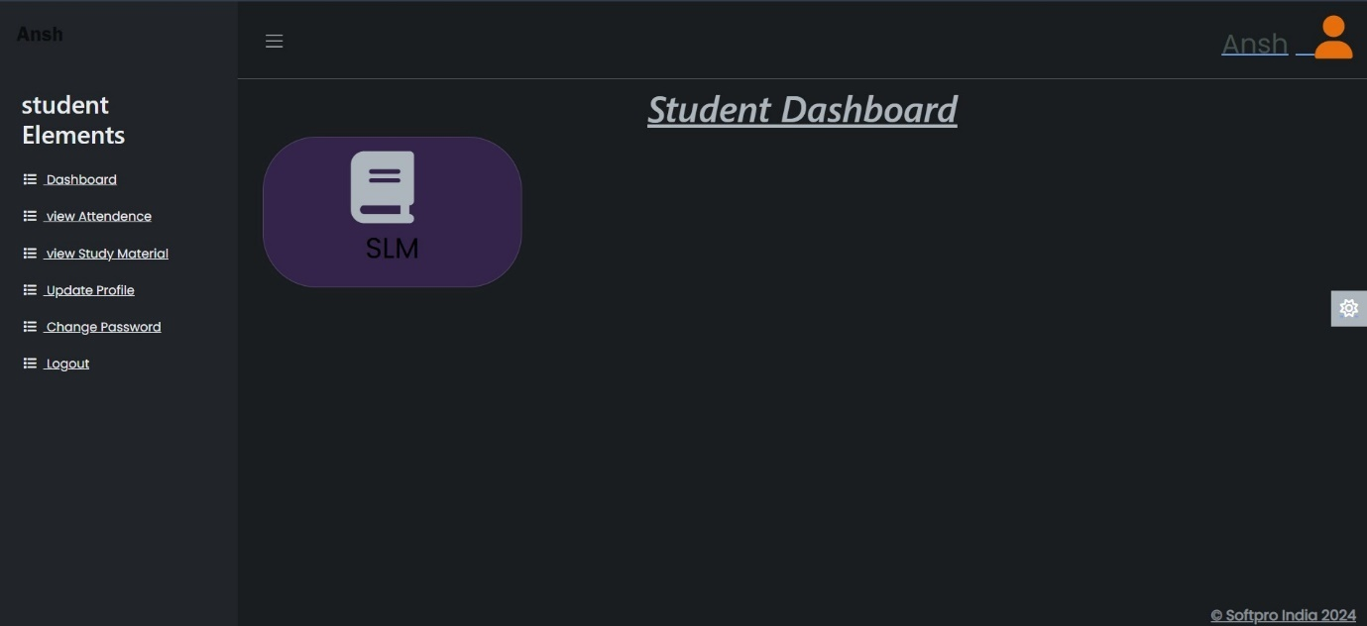

**Figure 1.3**

* Teacher Panel: Teachers will have access to tools for marking attendance, viewing class assignments, and posting study materials. The design will focus on simplifying their workload with quick navigation and clearly defined actions.

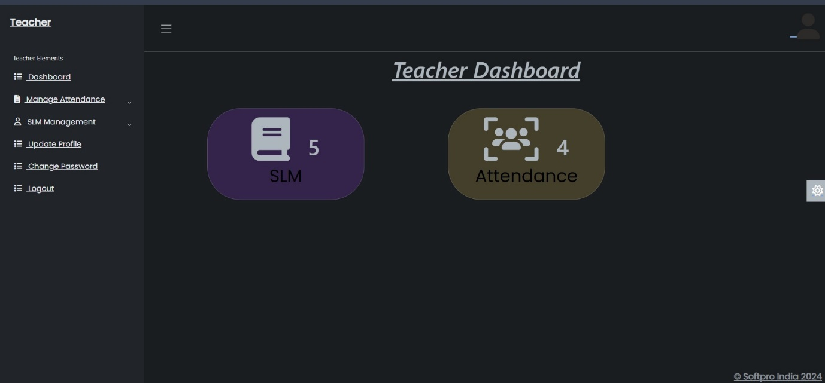

**Figure 1.4**

* Admin Panel: Administrators will manage all student and teacher data, subjects, and classes. The UI will focus on efficiency, providing easy access to all control functions in the system.

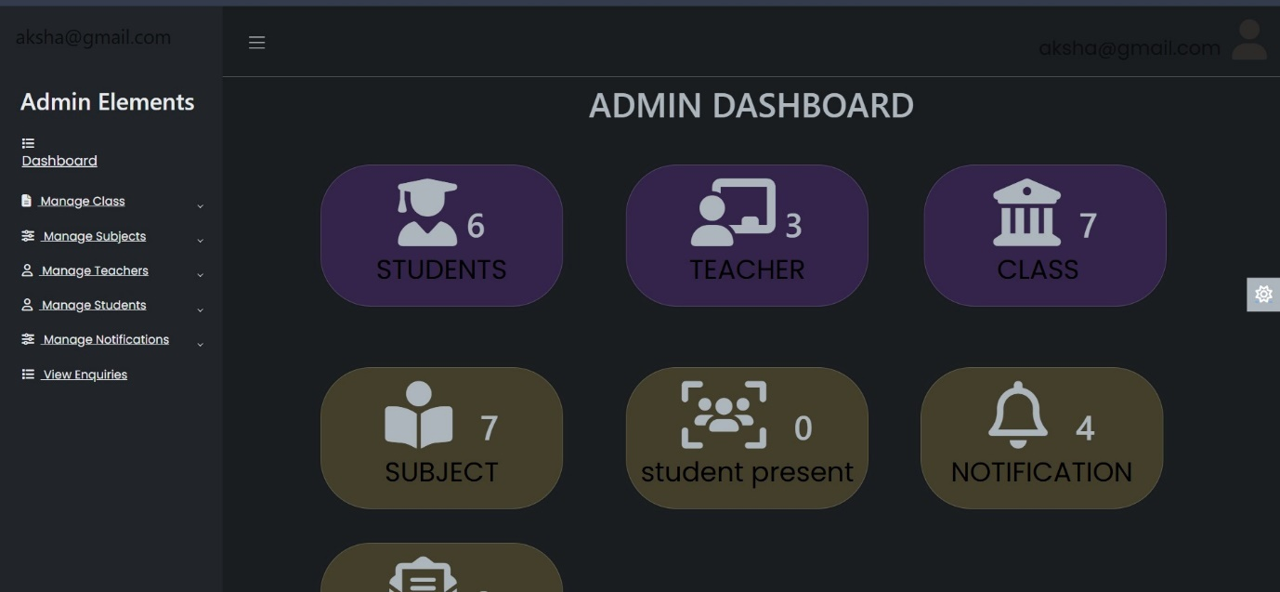

**Figure 1.5**

**Backend Design:**

* The backend will be built using Python and the Django Framework, ensuring scalability and security. The design will focus on efficient data handling and secure management of user roles (admin, teacher, and student).
* Database: SQLite3 will be used for storing student, teacher, and academic information. The database design will ensure that all modules (e.g., student information, feedback, complaints) are linked and can be accessed smoothly.

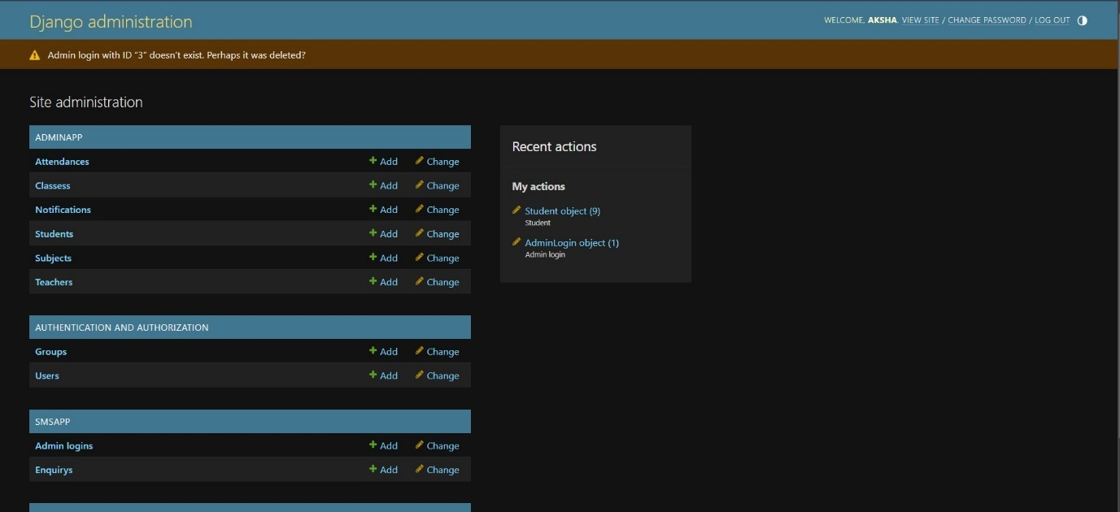

**Figure 1.6**

**4.3- Coding:**

The coding phase will involve building out each module:

* Student Information System: Code will be developed to store and retrieve student records, including details like roll number, name, program, branch, and year.
* Login Management System: This system will verify user credentials and manage access controls based on user roles (admin, teacher, or student). Secure login functionality will be implemented to ensure data protection.
* Discussion Forum Management: This will enable students to ask questions, discuss topics, and get clarifications. The coding will handle user interactions and data storage for the forum.
* Complaint and Feedback Management: These modules will allow students to raise complaints and provide feedback. Admins will be able to view, track, and resolve them through their panel.
* News and Enquiry Management: The news module will allow administrators to post updates, while the enquiry module will collect questions from external users. These will be displayed on the admin zone for follow-up.
* Study Material Management: Teachers can upload study materials, and students can access them based on their enrolled courses. Coding will ensure seamless uploads and downloads.
* Email and SMS Integration: Automated system-generated emails and SMS notifications will be sent upon registration, complaint resolution, and other key events. The integration will use APIs for these services.

**4.4- Testing:**

Each module will undergo rigorous testing to ensure the system is functional, secure, and meets quality standards.

* Unit Testing: Individual components, such as login systems and discussion forums, will be tested in isolation to ensure functionality.
* Integration Testing: Various modules will be tested together to ensure they work harmoniously without causing data inconsistencies or system errors.
* User Acceptance Testing (UAT): The system will be tested by actual users (students, teachers, admins) to ensure it meets their expectations and functions as required.

**4.5- Implementation:**

Once the testing is complete, the SMS will be deployed at Seth Anandram Jaipuria School, Sadhu Campus. The deployment will be gradual, with the system being rolled out first to administrators and teachers, followed by students, to ensure a smooth transition.

* Training: Training sessions will be held to familiarize staff and students with the system’s features.
* Data Migration: Existing student and academic records will be migrated into the new system to ensure continuity.

**4.6- Maintenance:**

Ongoing support will be provided post-implementation to resolve any issues that arise during the use of the system. Regular maintenance will include:

* Bug Fixes: Immediate addressing of bugs reported by users.
* Feature Updates: Periodic updates based on user feedback to enhance system performance or add new functionalities.
* Security Patches: Regular updates to ensure data protection and safeguard the system against potential vulnerabilities.

**Project Modules Overview**

1. **Student Information System:** Stores student records with fields like roll number, name, program, branch, and year.
2. **Login Management System:** Validates user credentials and tracks user roles (admin, teacher, student).
3. **Discussion Forum Management:** Provides a platform for student interaction and doubt resolution.
4. **Complaint Management System:** Allows students to submit complaints, which are handled by admins.
5. **Feedback Management System:** Collects feedback from students for administrative review.
6. **News Management:** Admin can post important news, displayed on the notice board.
7. **Enquiry Management:** Collects enquiries from external users for admin follow-up.
8. **Study Material Management:** Facilitates uploading and downloading of course-related materials.
9. **Email Integration:** Sends system-generated emails for actions like registration.
10. **SMS API Integration**: Sends system-generated SMS for user enquiries.

This project development structure ensures the SMS will be built efficiently, providing robust functionality and a user-friendly experience.

5-RESULT ANALYSIS AND FUTURE WORK

**5.1-Result Analysis:**

Upon completion of the School Management System (SMS) for Seth Anandram Jaipuria School, Sadhu Campus – Barabanki, the system was tested and evaluated for performance, user experience, and efficiency. The analysis results demonstrate that the system successfully addresses the core issues of traditional school management, with a marked improvement in overall operational efficiency.

**Key Results:**

* **Improved Administrative Efficiency**: Administrative tasks like student enrollment, attendance management, and grade handling have become faster and more organized. Data retrieval is instant, with significantly reduced manual work.
* **Enhanced Communication**: Communication between students, teachers, and administrators has improved through the introduction of discussion forums, feedback systems, and notification services (email/SMS). This has created a more connected and responsive school environment.
* **Reduced Data Loss and Errors**: The implementation of a centralized database and role-based access control has minimized the risk of data loss and unauthorized access, ensuring data integrity and security.
* **Real-Time Access**: Students and teachers now have real-time access to academic information, including attendance records, study materials, and notices. This has made tracking academic progress easier and more transparent.

**5.2-Screenshots, Charts, and Graphs:**

Screenshots, charts, and graphs would be included to visually showcase the system’s performance and user interaction. These graphical results would demonstrate improvements in the following areas:

1. **User Login**: Graph of login success rate across different user types (students, teachers, admin).
2. **Complaint Resolution**: A chart representing the time taken to resolve student complaints before and after system implementation.
3. **Student Engagement**: Graphical representation of student participation in discussion forums and feedback submissions.
4. **Data Management Efficiency**: A graph comparing the time required for administrative tasks (like attendance, grades) before and after the implementation of the SMS.

**Screenshots** of the system in use (e.g., Student Information System, Study Material Management, Complaint Resolution Dashboard) –

1-Login Management

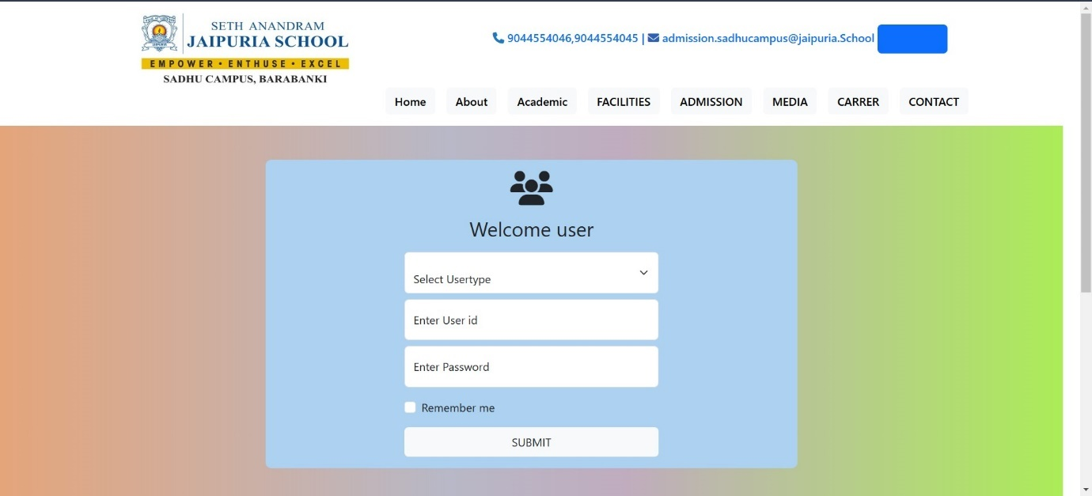

**Figure 1.7**

2-Study Material Management

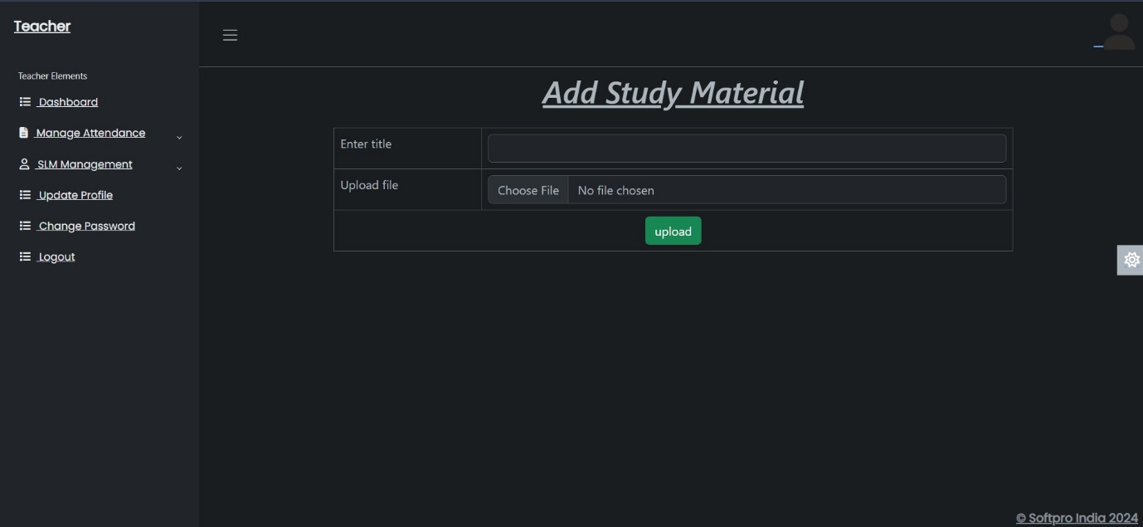

**Figure 1.8**

**5.3-Future Work:**

While the School Management System is robust and addresses many current issues, there are several areas for future development to enhance functionality:

6-CONCLUSION

**6.1 Summary of work done**

The development and deployment of the School Management System (SMS) at Seth Anandram Jaipuria School, Sadhu Campus, Barabanki, have yielded significant improvements in the school’s operational efficiency. The system's key modules—Student Information, Login Management, Discussion Forum, Complaint and Feedback Systems, News, Enquiry, Study Materials, Email, and SMS Integration—have successfully digitized the core administrative tasks, eliminating many of the inefficiencies and delays associated with traditional, paper-based methods.

The centralized, web-based platform has greatly enhanced communication between students, teachers, and administrators, improved data management, and ensured better transparency across the school’s activities. This project has not only reduced the administrative burden but also empowered students and teachers by providing real-time access to essential information.

**6.2 Final Thoughts**

* The SMS has successfully met its primary goal of streamlining school administration, improved communication, and providing a digital platform for managing academic and non-academic activities.
* With the addition of future enhancements like mobile accessibility and AI-based analytics, the system can be further optimized to meet the evolving needs of the school.

In conclusion, the SMS project marks a significant step toward modernizing school management, offering a scalable and adaptable solution that can serve as a model for similar institutions looking to transition to a more efficient digital system.

**1-Mobile Application**: Development of a mobile application for better accessibility on the go, allowing students, teachers, and administrators to interact with the system more conveniently.

**2-Integration with Learning Management Systems (LMS)**: Adding features to integrate with popular LMS platforms (e.g., Moodle) to provide seamless access to online learning tools and resources.

**3-AI-Powered Analytics**: Implementing AI and machine learning to analyze student performance and provide predictive insights. This could help in early identification of students needing additional academic support.

**4- Advanced Notification System**: Expanding the notification system to include push notifications, ensuring timely updates and reminders for students and staff.

**5-Multi-Language Support**: Adding support for multiple languages to cater to a broader audience, especially in schools with diverse linguistic backgrounds.

**List of Figures**

1. **Figure 1.1** – Data Flow Diagram of Student Management System
2. **Figure 1.2** -1-level DFD
3. **Figure 1.3** – Student Panel
4. **Figure 1.4** – Teacher Panel
5. **Figure 1.5** – Admin Panel
6. **Figure 1.6** – Database
7. **Figure 1.7** – Login Management
8. **Figure 1.8** - Study Material Upload and Access Dashboard

**List of Tables**

1. **Table 1.1** – student table
2. **Table 1.2** - teacher table
3. **Table 1.3** – login table
4. **Table 1.4** – enquiry table
5. **Table 1.5** – class table
6. **Table 1.6** – subjects table
7. **Table 1.7** – attendance table
8. **Table 1.8** – question table
9. **Table 1.9** – answer table
10. **Table 2.0** – feedback table
11. **Table 2**.1- news table
12. **Table 2**.2-material table

**Bibliography and References**

1. **Django Software Foundation.** *Django Documentation*. <https://www.djangoproject.com>, Accessed September 2023.
2. **Bootstrap-** Bootstrap documentation. [Get started with Bootstrap · Bootstrap v5.3 (getbootstrap.com)](https://getbootstrap.com/docs/5.3/getting-started/introduction/) used to make responsive designs.
3. **W3School-**[**W3Schools Online Web Tutorials**](https://www.w3schools.com/)
4. Seth Anandram Jaipuria School, Sadhu Campus – Barabanki. "Vision and Mission." <https://www.jaipuriaschoolbarabanki.com>.