# Connecting ADF to Tier 2 Environments

When connecting to Tier 2 environments , follow the steps bellow to connect

## Self-service deployments

The template that is included requires specific connection details for self-service deployment architectures.

To get the database connection details, you will first have to request JIT access from LCS for the environment you want to connect to

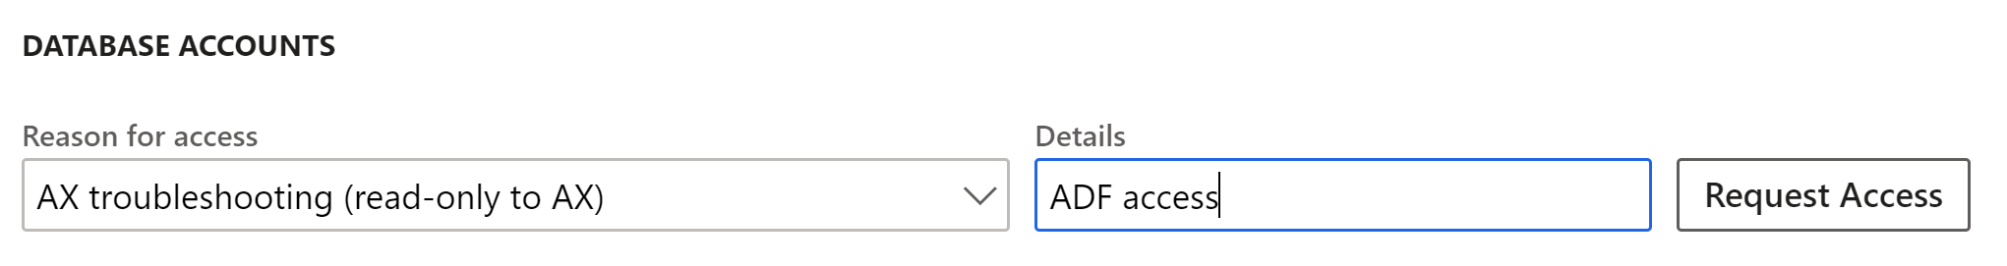

Once JIT access to received you will have access to the information required below.

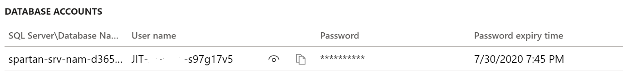

1. Populate the **New linked service (Azure SQL Database Managed Instance)** dialog with the connection details from LCS.

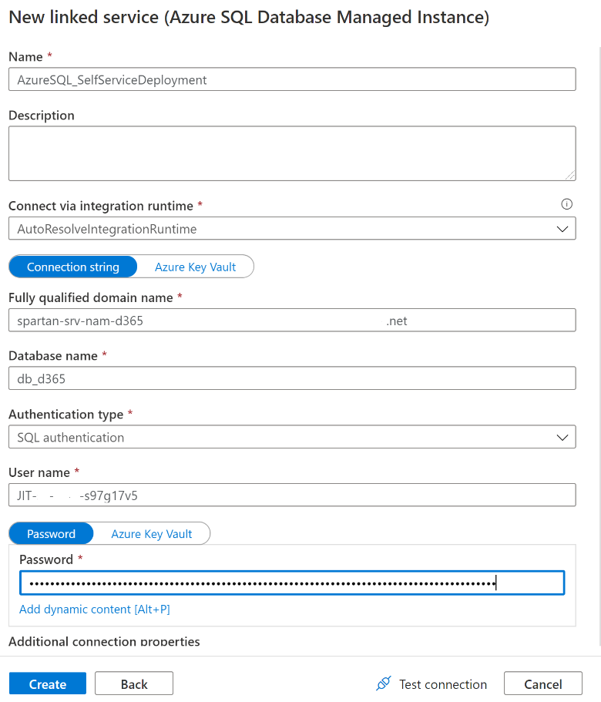

1. Click on the **Test connection** button. It is likely that the connection will fail, this is due to the firewall configuration. Click on the More link to see a message like the one below, from there make a note of the **IP address**.

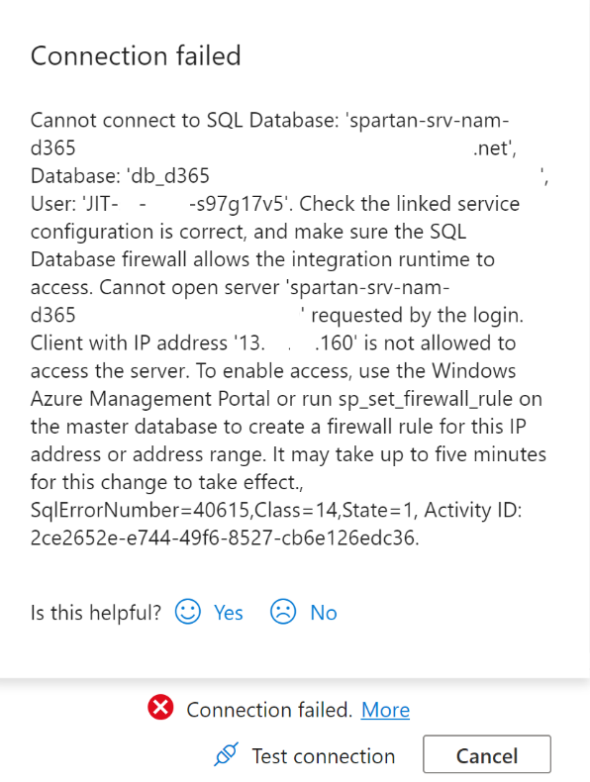

1. Within LCS and the environment page you are trying to connect to, click on Maintain > Enable access

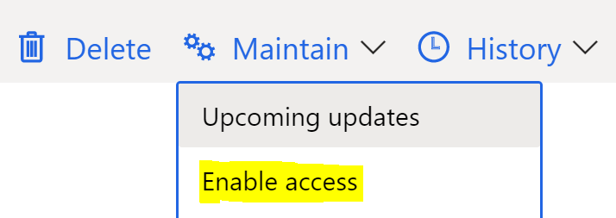

1. Using the IP address retrieved from the connection test, create a new inbound rule.

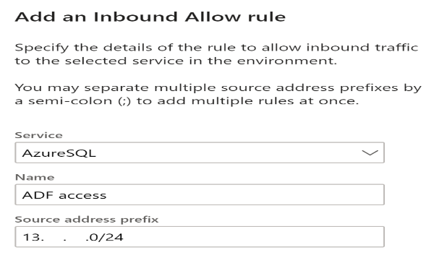

1. Once the inbound rule has been created, go back to ADF and click on the **Test connection** button again, you should see **Connection successful**. Then click on the **Create** button.

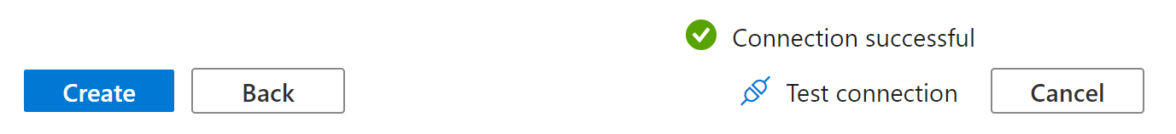

## IaaS Tier 2 environments

For tier 2 environment if you are on IaaS (VM based )  and don't have admin access on VM, you can connect to Tier 2 DB from ADF directly using AutoResolveIntegrationRuntime . Here are the steps

1. Identify IP address of ADF – Validate the connection with AutoResolveIntegrationRunTime  and check the error. Check error message for IP address

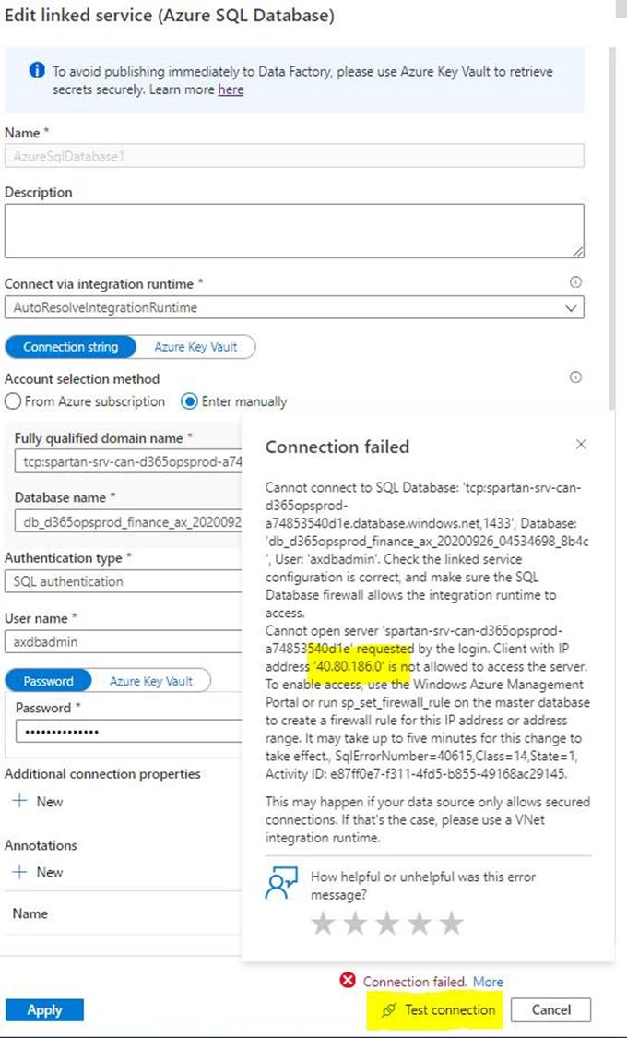

1. Login to the Tier 2 AOS VM and connect to Database and run bellow query to whitelist the IP address

EXECUTE sp_set_database_firewall_rule N'ADFIP', '40.80.186.0', '40.80.186.0';

1. Now ADF should be able to connect to your Tier 2 Azure SQL.
2. You may get errors with different IP when you run the pipeline - you can add those IP addresses too in the same way. After you get a successful execution you should be good to go.