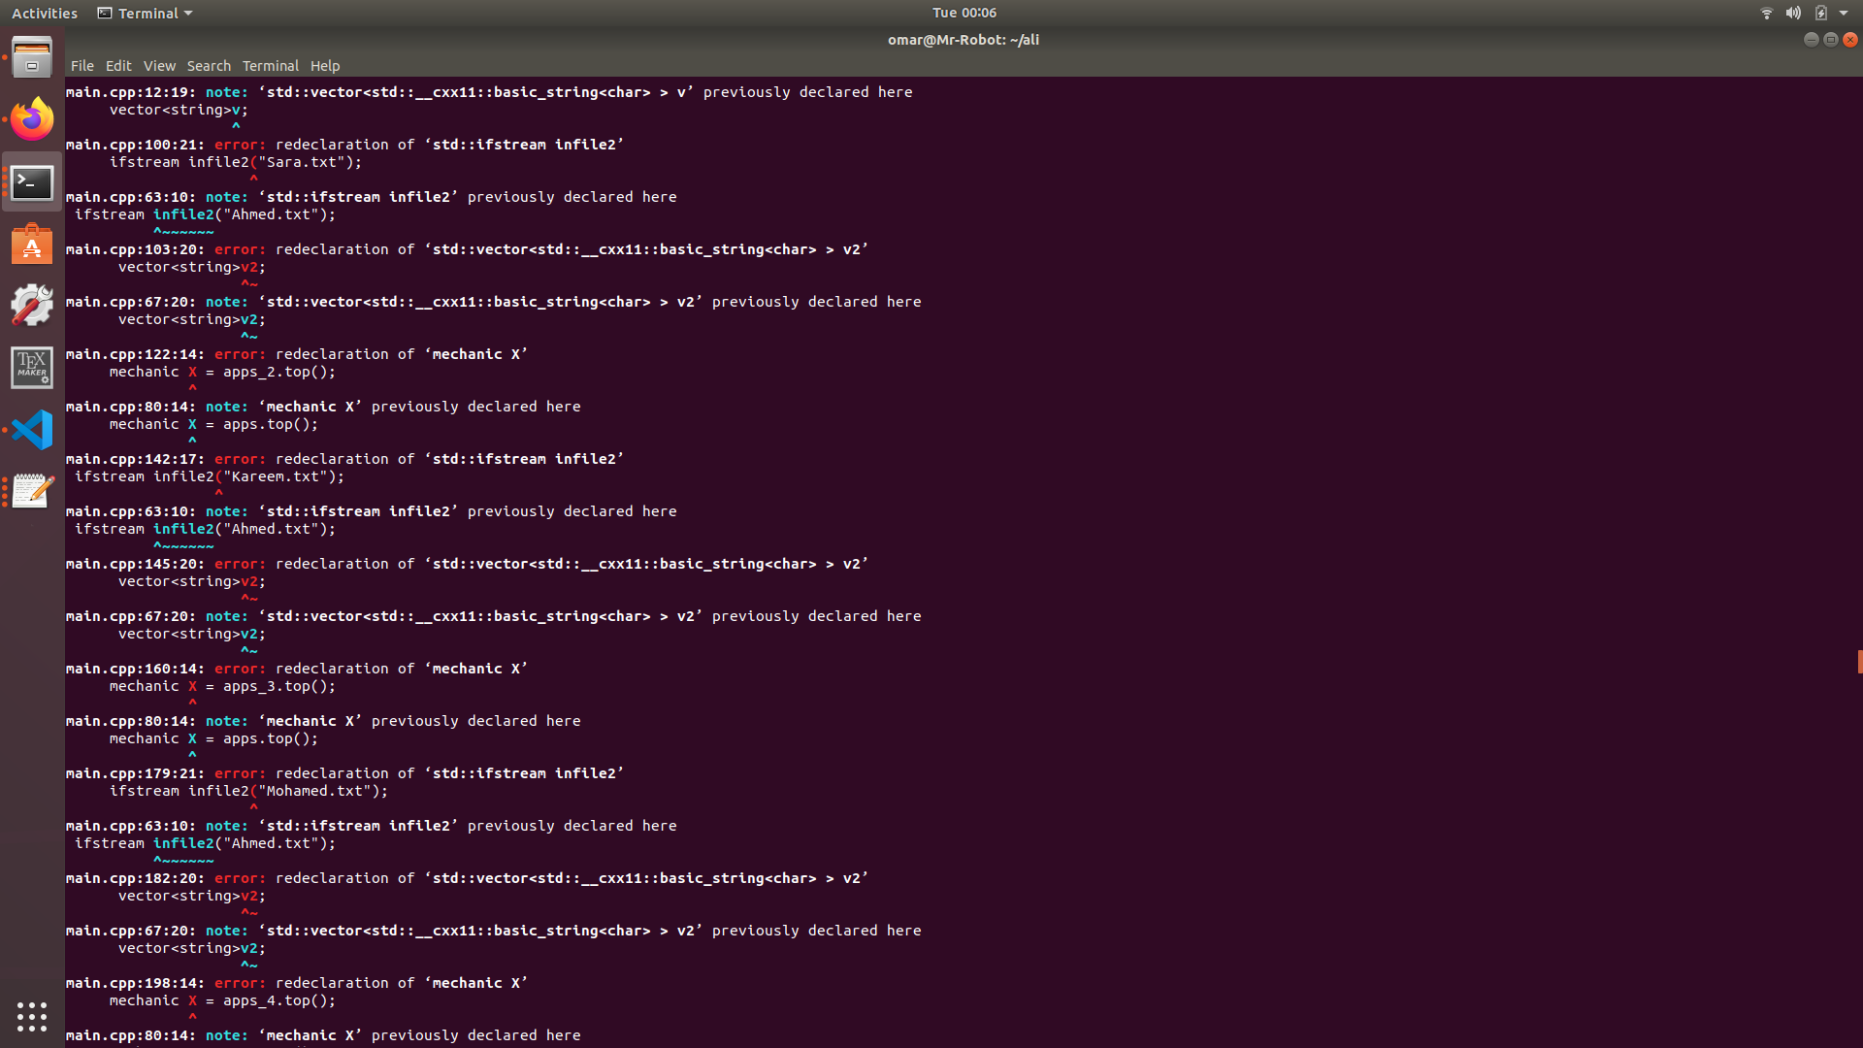

These are the errors that come when I try to run the code, ive tried almost everything to fix them. At first I thought it was the issue of the variable names so I changed all of them so they are all different although I didn’t think that was the issue, after doing so instead of the errors saying redeclared thy thn said they were undeclared. The files were inside of the folder and the correct input was inside of them, I tried to remove and re add the header files on the chance that one of them was called too many times that could cause this error but nothing fixed it.