** Namal University Mianwali**

9/27/2025

**Department Computer Science**

**Reg No. NUM-BSCS-2024-06**

**Name: Ali Abbas**

**Course: Assembly Language**

**Ali Abbas**

**Namal University Mianwali**

**LAB REPORT 1**

**Lab 1 Task 1:** **Write the assembly language program given in the Lab handout, assemble it and run it as per the instructions in the handout**.

In this task I copied the code as given in the task. I made no changes in the code. I assembled it linked it and cera its result is as:

**Output:**

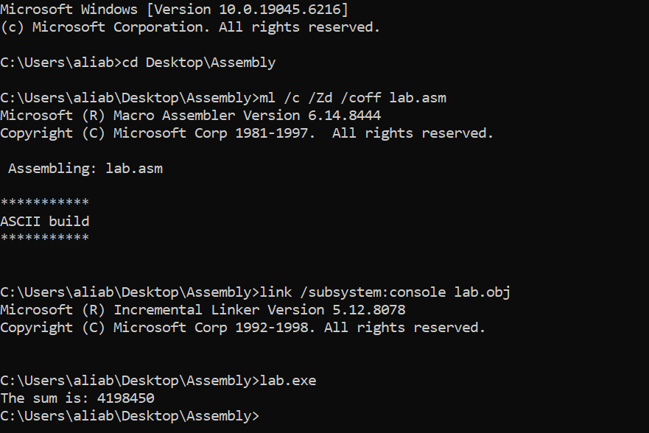

**Lab 1 Task 2**: **Note down the contents of registers EAX, EBX and ECX as displayed by the program.**

After running the program, the values observed in registered are as:

* **EAX = 30** (loaded by mov eax, 30)
* **EBX = 20** (loaded by mov ebx, 20)
* **ECX = Unexpected value** (because ECX was not initialized before performing additions).

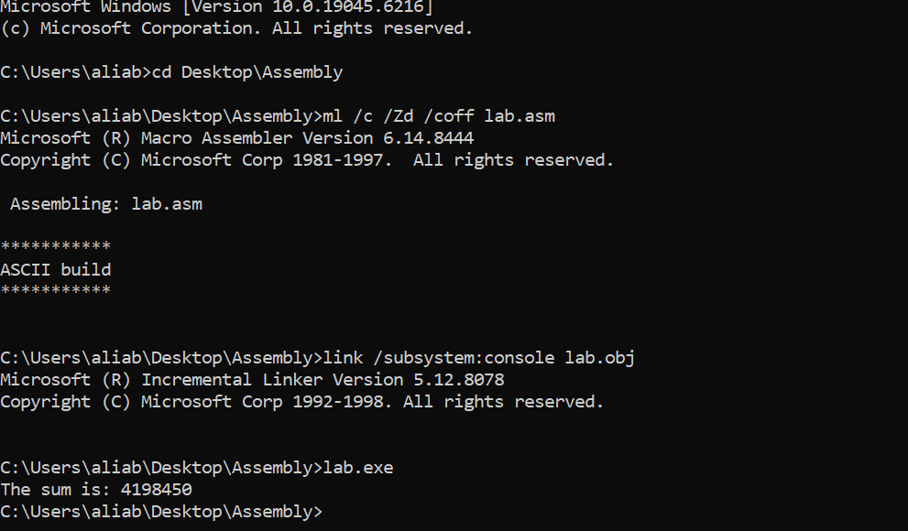

The output is not equal to 50

**Lab 1 Task 3: Do the contents of register ECX match the expected result? If not, what step needs to be taken?**

The expected result of adding EBX 30 and EAX 20 is 50.

The value of ECX is according to result is expected so, it does not match. This happened because ECX was not declared before use. It contains some garbage values.

**Step Taken:**

**Move ecx, 0**

This will have to start with a known number, and it will return correct results.

**Lab Task 4:** **Modify the source code to get the right result in the register ECX, re-assemble, and re-run the program.**

To ensure ECX should make correct result I initialized the ECX so it should make correct results.

mov ecx,0

mov eax, 30 ; Load 30 into register EAX

mov ebx, 20 ; Load 20 into register EBX

add ecx, eax ; Add the value in EAX (30) to ECX (ECX = 30)

add ecx, ebx ; Add the value in EBX (20) to ECX (ECX = 30 + 20 = 50)

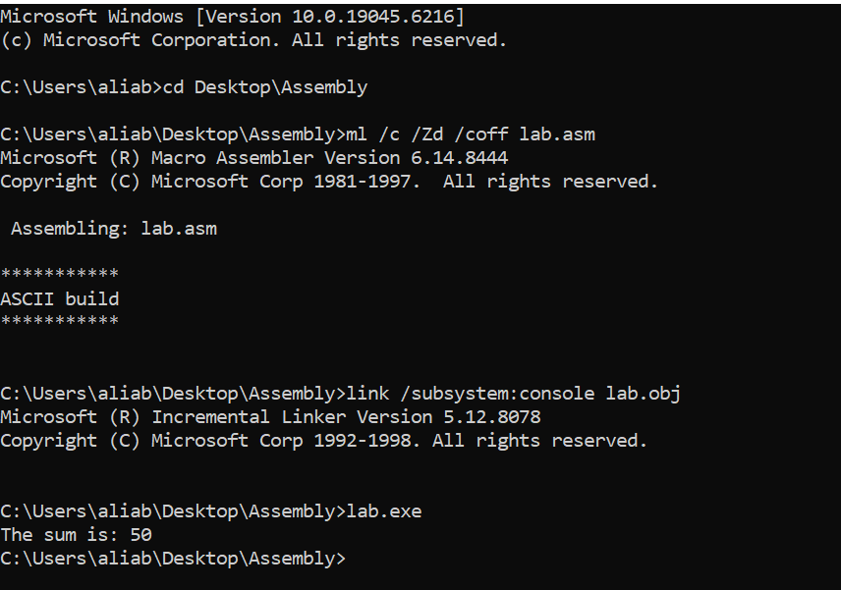

I saved the updated file as lab.asm, then re-assembled, linked, and executed it with the same commands.

**Lab Task 5:** **Verify that the contents of the ECX register are now correct**.

After modifying the program and initializing ECX to zero, I re-assembled and executed the program again.

The output on the console was:

**The sum is: 50**

Final register values:

* EAX = 30
* EBX = 20
* ECX = 50

------------------------------------------------------------

**------------------------------------------------------------**