I Drive



SUBMITTED BY:

1. NS Ali Abbas Chaudhary
2. NS Qamar Ali
3. NS Uzair Athar
4. NS Yasser Zubair
5. PC Aaima Mansoor
6. PC Rubba Rehman

34 – CE(A)

* Artificially intelligent, autonomous car

Contents

Components 2

Arduino Mega 2560 x1 2

Specifications: 3

Sonar Sensors 4

Specifications: 4

Accelerometer ADXL345 4

Light Sensor TCS3200 5

Features: 6

Voltage Regulators LM 7808, 7812 & LM 7805: 6

Project Theme 7

Progress 7

The Power Board 7

The H Bridge L298N 9

Features: 10

Specifications: 10

Challenges Faced 11

Working 11

Code 12

# Components

1. Arduino Mega 2560 x 1
2. Sonar Sensors x 4
3. Accelerometer Sensor x 1
4. Light Sensor x 1
5. LM 7812 Voltage Regulator
6. LM 7805 Voltage Regulator

## Arduino Mega 2560 x1

The Arduino Mega is a microcontroller board based on the ATmega1280 ([datasheet](http://www.atmel.com/dyn/resources/prod_documents/doc2549.pdf)). It has 54 digital input/output pins of which 14 can be used as PWM outputs, 16 analog inputs, 4 UARTs (hardware serial ports), a 16 MHz crystal oscillator, a USB connection, a power jack, an ICSP header, and a reset button. It contains everything needed to support the microcontroller; simply connect it to a computer with a USB cable or power it with an AC-to-DC adapter or battery to get started. Each of the 54 digital pins on the Mega can be used as an input or output. The Mega2560 has 16 analog inputs.

The power pins are as follows:

* VIN- The input voltage to the Arduino board when it's using an external power source.
* 5V- Regulated power supply used to power microcontroller and other components on board.
* 3V3- A 3.3 volt supply generated by the on-board regulator.
* GND- Ground pins.

Some other pins are:

* AREF- Reference voltage for the analog inputs.
* Reset- Bring this line LOW to reset the microcontroller.
* PWM- 0 to 13. Provide 8-bit PWM output with the analogWrite() function.
* External Interrupts: 2 (interrupt 0), 3 (interrupt 1), 18 (interrupt 5), 19 (interrupt 4), 20 (interrupt 3), and 21(interrupt 2). These pins can be configured to trigger an interrupt.

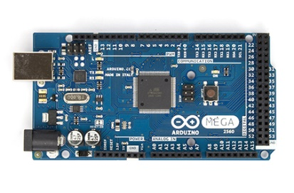

Arduino Mega 2560

### Specifications:

|  |  |
| --- | --- |
| Microcontroller | ATmega2560 |
| Operating Voltage | 5V |
| Input Voltage (recommended) | 7-12V |
| Input Voltage (limits) | 6-20V |
| Digital I/O Pins | 54 (of which 15 provide PWM output) |
| Analog Input Pins | 16 |
| DC Current per I/O Pin | 40 mA |
| DC Current for 3.3V Pin | 50 mA |
| Flash Memory | 256 KB of which 8 KB used by bootloader |
| SRAM | 8 KB |
| EEPROM | 4 KB |
| Clock Speed | 16 MHz |
| USB Host Chip | MAX3421E |

## Sonar Sensors

The [HC-SR04](http://cytron.com.my/p-sn-hc-sr04) ultrasonic sensor uses sonar to determine distance to an object like bats or dolphins do. It offers excellent non-contact range detection with high accuracy and stable readings in an easy-to-use package. From 2cm to 400 cm or 1” to 13 feet. Its operation is not affected by sunlight or black material like Sharp rangefinders are (although acoustically soft materials like cloth can be difficult to detect). It comes complete with ultrasonic transmitter and receiver module.

Basically it calculate distances from objects. It works by sending an ultrasound pulse at around 40 KHz. It then waits and listens for the pulse to echo back, calculating the time taken in microseconds (1 microsecond = 1.0 × 10-6 seconds). You can trigger a pulse as fast as 20 times a second and it can determine objects up to 3 meters away and as near as 3cm. It needs a 5V power supply to run. It has four pins, VCC which is connected to 5 Volts, Trig, Echo and Ground.

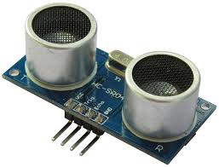

Sonar Sensor

### Specifications:

|  |  |
| --- | --- |
| Working Voltage | 5V(DC) |
| Working Current | max 15 ma |
| Working frequency | 40HZ |
| Output Signal | 0-5V (Output high when obstacle in range) |
| Sentry Angle | max 15 degree |
| Sentry Distance | 2cm - 500cm |
| High-accuracy | 0.3cm |
| Input trigger signal | 10us TTL impulse |
| Echo signal | output TTL PWL signal |

## Accelerometer ADXL345

An accelerometer is an electromechanical device that will measure acceleration forces. The ADXL345 is a low-power, 3-axis MEMS accelerometer modules with both I2C and SPI interfaces. The Adafruit Breakout boards for these modules feature on-board 3.3v voltage regulation and level shifting which makes them simple to interface with 5v microcontrollers such as the Arduino.

The ADXL345 features 4 sensitivity ranges from +/- 2G to +/- 16G. And it supports output data rates ranging from 10Hz to 3200Hz. The sensor consists of a micro-machined structure on a silicon wafer. The structure is suspended by polysilicon springs which allow it to deflect smoothly in any direction when subject to acceleration in the X, Y and/or Z axis. Deflection causes a change in capacitance between fixed plates and plates attached to the suspended structure. This change in capacitance on each axis is converted to an output voltage proportional to the acceleration on that axis.

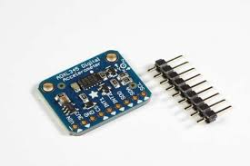

Accelerometer ADXL345

## Light Sensor TCS3200

Light-to-Frequency (LTF) Sensors convert light intensity to a digital form for direct interface to a microcontroller. The output of the device is square wave or pulse train whose frequency is linearly proportional to the light intensity. The TCS3200 is a programmable color light-to-frequency converter that combines configurable silicon photodiodes and a current-to-frequency converter on a single monolithic CMOS integrated circuit. The output is a square wave (50% duty cycle) with frequency directly proportional to light intensity (irradiance).

The full-scale output frequency can be scaled by one of three preset values via two control input pins. Digital inputs and digital output allow direct interface to a microcontroller or other logic circuitry. Output enable (OE) places the output in the high-impedance state for multiple-unit sharing of a microcontroller input line.

In the TCS3200, the light-to-frequency converter reads an 8 x 8 array of photodiodes. Sixteen photodiodes have blue filters, 16 photodiodes have green filters, 16 photodiodes have red filters, and 16 photodiodes are clear with no filters.

The four types (colors) of photodiodes are interdigitated to minimize the effect of non-uniformity of incident irradiance. All photodiodes of the same color are connected in parallel. Pins S2 and S3 are used to select which group of photodiodes (red, green, blue, clear) are active. Photodiodes are 110 μm x 110 μm in size and are on 134-μm centers.

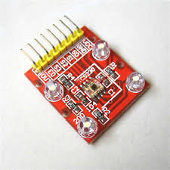

Light Sensor TCS3200

### Features:

|  |  |
| --- | --- |
| Supply voltage, VDD | 2.7 - 5.5 Volts |
| High-level input voltage, VIH | 2 - VDD Volts |
| Low-level input voltage,VIL | 0 - 0.8 Volts |
| Operating free-air temperature range,TA | −40 - 70 °C |

## Voltage Regulators LM 7808, 7812 & LM 7805:

A voltage regulator is designed to automatically maintain a constant voltage level. This series of fixed-voltage integrated-circuit voltage regulators is designed for a wide range of applications.

These applications include on-card regulation for elimination of noise and distribution problems associated with single-point regulation. Each of these regulators can deliver up to 1.5 A of output current. The internal current-limiting and thermal-shutdown features of these regulators essentially make them immune to overload.

In addition to use as fixed-voltage regulators, these devices can be used with external components to obtain adjustable output voltages and currents, and also can be used as the power-pass element in precision regulators.

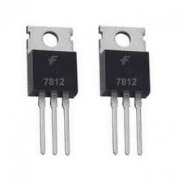 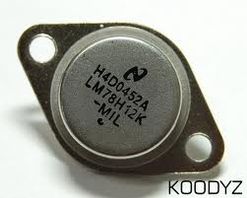

Features:

* Output Voltage: 5V
* Output Current: 1.5A
* Thermal Overload Protection
* Short Circuit Protection
* Output Transition SOA Protection

# Project Theme

i-Drive is an attempt to turn the concept of driverless futuristic cars into reality. The basic aim of this project is to produce an artificially intelligent, fully independent car which can make intelligent road decisions on its own minimizing the otherwise essential requirement of a driver. A car that not only makes travel easier for those who are fully capable but also for those who can’t afford the luxury due to some impairment.

# Progress

i-Drive was to be based on Arduino Due originally along with a power board, a sensor board and an h bridge. Accelerometer, Sonars and Light Dependent Resistors were to be used for detecting acceleration, distance from objects and changes in intensity of light respectively.

## The Power Board

The development of power board was the first step taken towards the implementation of the idea behind i-Drive. Firstly, the schematic was developed using proteus and then it was etched to the PCB board.

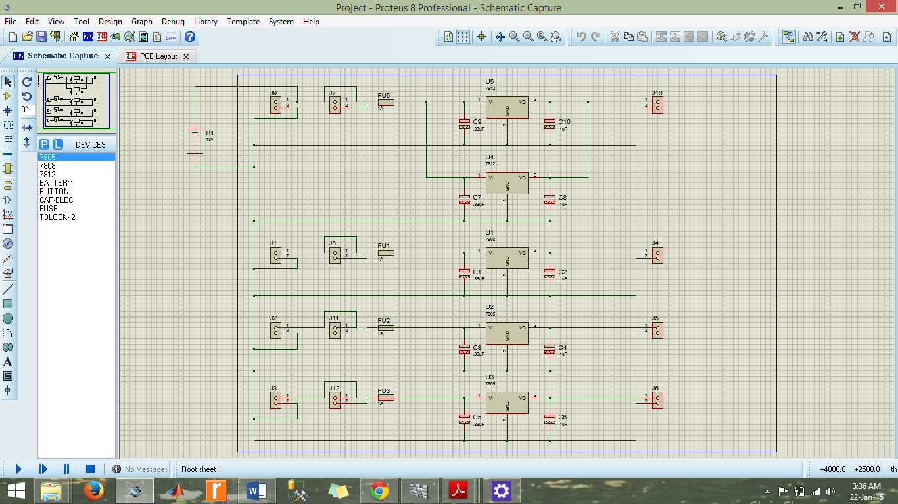

Then components were soldered onto it. The power board, in its final form consists of:

1. LM 7812
2. LM 7805
3. Switches
4. Fuses x4
5. Capacitors x5
6. Capacitors x5
7. Connectors x11

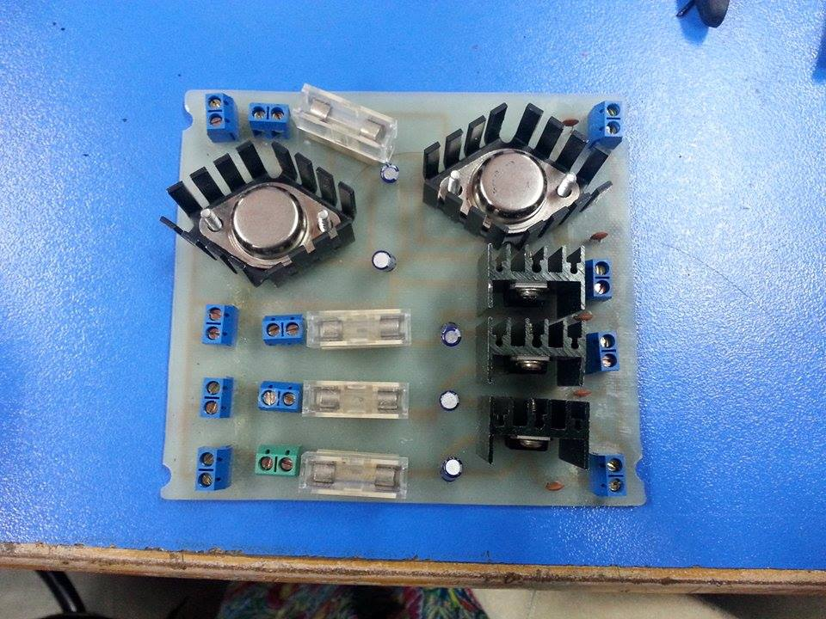

## The H Bridge L298N

To minimize the heating due to operation of ICs, an h bridge had to be developed consisting of wide copper patches acting as insulation to heat. The motors were to be fixed onto this board and placed at the center of the car’s structure.

This was however replaced later on by the module L298N.

Double H driver module uses ST L298N dual full-bridge driver. It is a high voltage, high current dual full-bridge driver designed to accept standard TTL logic levels and drive inductive loads such as relays, solenoids, DC and stepping motor.

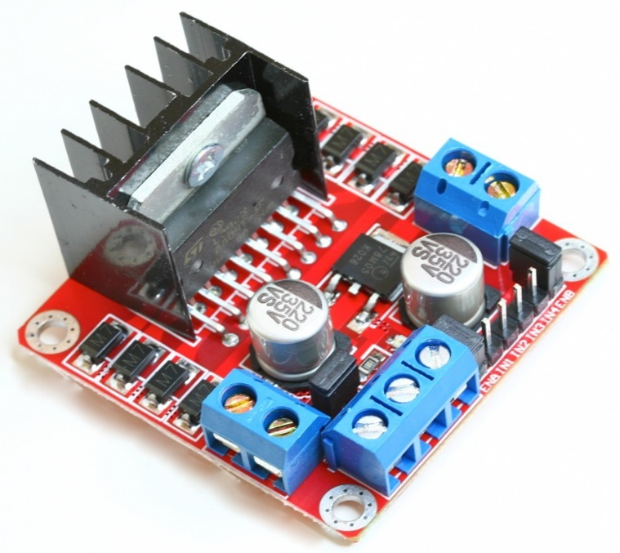

### Features:

|  |
| --- |
| Heavy load Heat sink |
| Power selection switch |
| 4 pull up resistor switch |
| 2 DC motor/ 4 coil dual phrase stepper motor output |

### Specifications:

|  |  |
| --- | --- |
| Driver power supply | +5V~+46V |
| Driver peak current | 2A |
| Logic power output Vss | +5~+7V (internal supply +5V) |
| Logic current | 0~36mA |
| Controlling level | 2.3V~Vss |

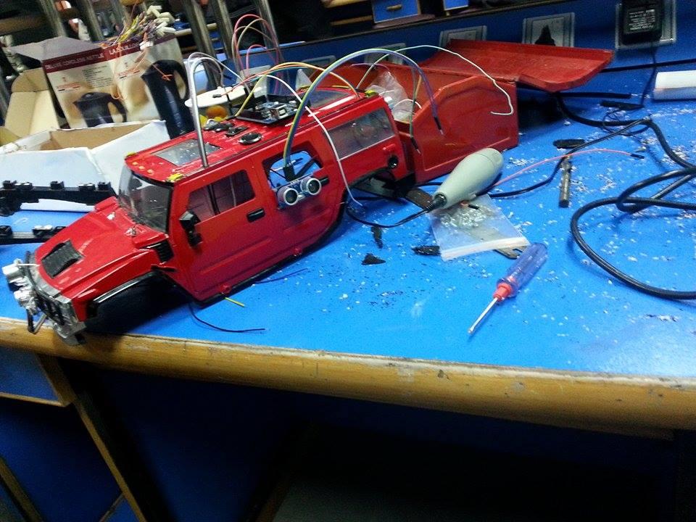 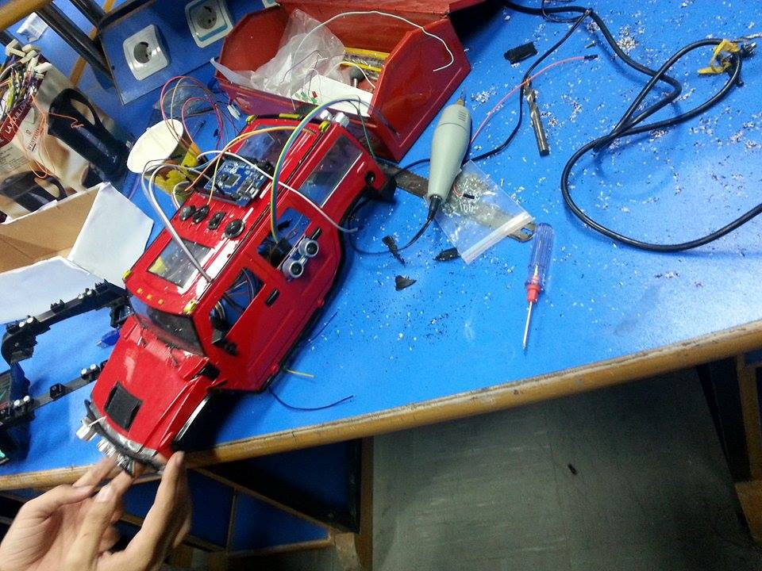

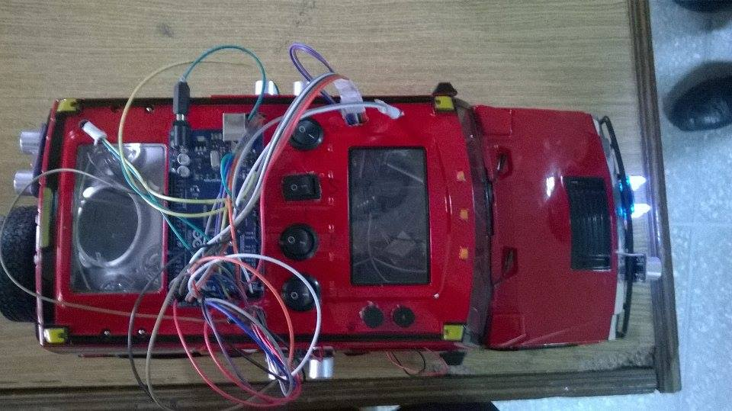 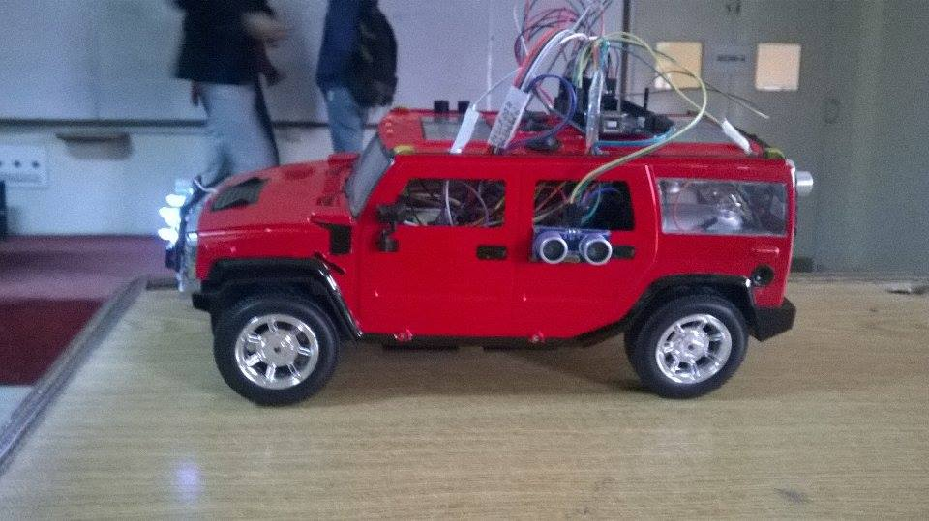

# Challenges Faced

Initially the project was started on Arduino Due. The operating voltage of Arduino Due is 3.3 Volts, whereas the sensors being used have an operating voltage of 5 Volts. Interfacing by means of Inverting and Non Inverting Amplifiers, Voltage Levelers was tried but it required 64 additional components. The unavailability of voltage leveler was also a major hindrance, therefore, the board was replaced with an Arduino Mega 2560 which operates on 5 Volts.

# Working

Basically, the battery provides 18 Volts, the connection to which is made to the four switches located at the top of the car. The switches are further connected to Power Board so that any one module can be turned on or off. When all the switches are on, the board (Arduino), the accelerometer, sonar and light sensor are connected to the battery.

When the front sonar is active and detects an object located at less than 40 inches in front of it, it generates an interrupt which in turn activates the concerned ISR. Next the right sonar detects whether there is some object on the right within the 10 inches range. If no object is detected on the right, the car turns right, changing its lane. If however, some object is detected, an interrupt is generated which in turn activates the concerned ISR and the car stops. Likewise, when the back sonar is active and detects an object which is coming towards it with distance less than 10 inches, it generates another interrupt making the car move if it was stationary or move faster if already moving.

Then the light frequency sensor, at the front of the car detects green, red and blue light. On detecting red light, the car stops and on detecting green light, the car moves if stationary.

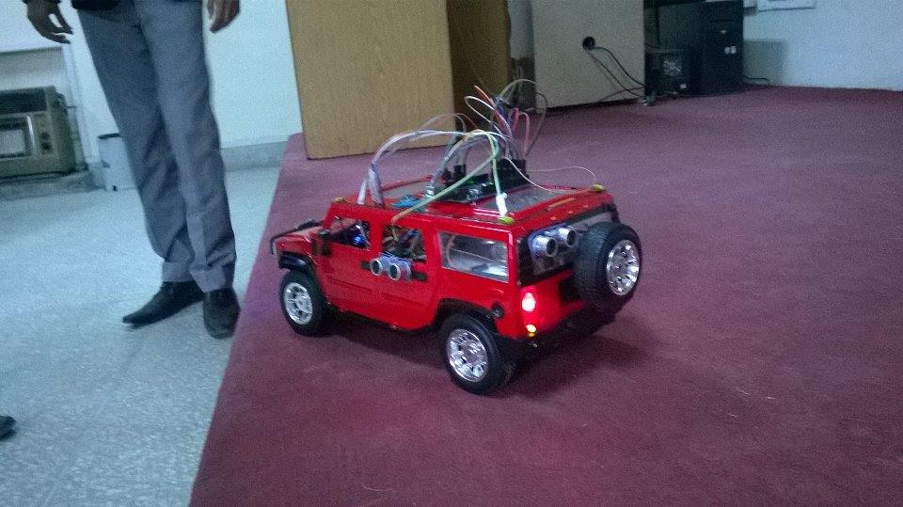

# Code

(Attached with the report).