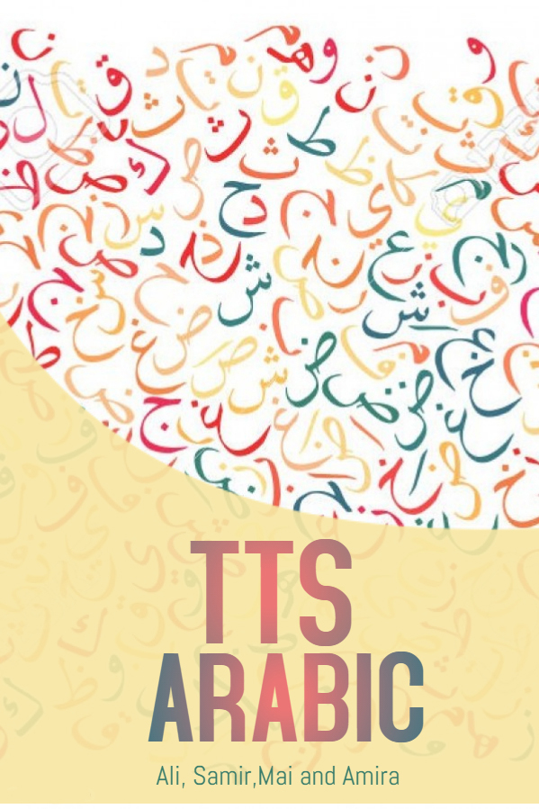

Faculty of Computer and Information
Cairo University

TTS Arabic

Team Names:
Samir Mohamed 20130133
Ali Abd Elrahman 20130163
Mai Ahmed 20130334
Amira AbdElNaby 20130082

Dr. Hanaa Bayomi
TA. Amr Magdy

TABLE OF CONTENTS

Chapter 1: INTRODUCTION
- Introduction to main area of the Project | 4
- Motivation | 5
- Problem definition  1.3.1 Text-to-Phonetic Conversion | 5
1.4 project objective (suggested solution) | 7
1.5 Gannet chart of Project Time Plan | 8
1.6 Project development methodology | 9
1.7 Used Tools | 11
1.8 Report organization | 11
Chapter 2: Related Works 13
Chapter 3: System Analysis
3.1 Project specification  3.1.1 Functional requirements  3.1.2 Non-Functional requirements | 17
3.2 Use Case diagrams  3.2.1 Modwanna  3.2.2 Frequency  3.2.3 Machine learning | 20
3.3 Sequence diagrams  3.3.1 Modwanna  3.3.2 Frequency | 23
3.4 System test cases | 27
Chapter 4: System Design
4.1 Project ERD  4.1.1 Conceptual model  4.1.2 Physical model | 30
4.2 Elementary design | 38
Chapter 5: Implementation and Testing 41
Summary
References
List of Figures
List of tables

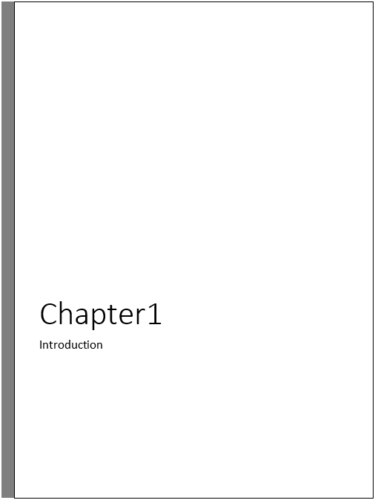1.1 Introduction

Language is among the mainly most important features that differentiate humans from
other living creatures and speech is the key medium of language .
With the advent of digital electronic technology, the goal of developing machines that
simulates human sounds has come closest to be achieved. It has to be said that no one
has really succeeded in synthesizing a voice that is identical to a human voice.
Meanwhile, speech synthesizers are now available which produce speech of a quality
adequate for many applications.

Text-To-Speech Synthesizer System (TTS) is simply defined as written
text transformed into speech; reading or dictating machines; the part of speech
technology, which is concerned with automatically generating speech from a computer.
Speech synthesizers used in TTS have been developed over the years as the memory resources become available and cheaper; as a result, large enhancements in the quality and the intelligibility of the synthesized speech have been achieved.

A TTS synthesizer System is a computer-based system that has the ability to read any text, whether it is directly introduced in the computer by an operator or scanned and submitted to an Optical Character Recognition (OCR) system. OCR is the process that allows the transformation of a string of phonetic/syllabic and symbols into an artificial signal, (i.e. the automatic production of speech, through a Grapheme-To-Phoneme transcription of the sentences to utter). Grapheme is the letters in a words’ dictionary, while, Phoneme is the smallest unit of speech that differentiates one word from another.
TTS system includes mainly two parts: natural language processing and digital signal processing. The general block diagram of TTS system is shown in )figure 1(

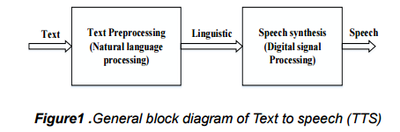
Figure 1.1
The TTS technology is becoming inevitable in some businesses that need to provide for
their customers with the latest and fundamental information in real time
Converting fundamental data stored in Web sites, databases and files into human voice using the traditional expensive and time-consuming human recordings is becoming a hard.

Arabic is a complex language and it is not like other languages, those languages written in Latin script have vowels, while the Arabic language has special characters called “diacritics” (التشكيل). These diacritics give the Arabic words the correct meaning within a sentence. For example, two Arabic words have different meaning can be written the same and only the diacritics can help the reader to distinguish them. Such as, the word “مدرسة” is for example, pronounced differently in "سَلِمْتُ عَلَى الْمُدَرِّسَةِ " meaning “I greeted my teacher” and in the other sentence
"ذَهَبْتِ الى الْمَدْرَسَةَ" meaning “I went to school”. This depends on diacritics.

1.2. Motivation
The motivation behind building and developing such a system is that the TTS interface
can improve the user’s experience on a desktop. It is more relaxing to listen instead of
reading large portions of text. It is good for the blind, slow readers, and less straining for
the eyes. Arabic TTS Synthesizer System brings benefits especially in the educational
field. It assists the research, data collecting and text analyzing. It is very useful for the
students, educators, and language researchers. It provides them with an effective way of
knowing how to pronounce the words. The following are benefits of the Arabic TTS
Synthesizer System:
- Easy to use – intuitive: Arabic TTS Synthesizer System interface will be designed
to be intuitive and easy to use.
- Efficient: Arabic TTS Synthesizer System reduces costs and increases efficiency.
- Arabic TTS Synthesizer System will help users to learn Arabic language
- Provides accessibility: Over the Web and over the phone.
- Offers adaptability and flexibility: Any time, anywhere.

  - Problem definition

Information and communication technology(ICT) is rapidly evolving as an effective tool for making information widespread and available online to several communities . The increased use of information technology is enabling people across the world to participate in the knowledge network; however, people in some developing countries are being deprived of the benefits of the use of ICT and the computer system. One of the main reasons for this is the lack of suitable human computer interface for disabled people and the software designed and developed to meet their needs. To design and develop a computer interface for a person who can not see what computer displays, is the most challenging task for many software developers.

TTS Synthesizer Systems converts the written input to spoken output by automatically
generating synthetic or computer generated speech. Typed text is converted into speech
using various algorithms such as formant synthesis, concatenative synthesis or Articulatory synthesis.

As the system being developed, it cannot avoid from having a problem. Primarily, there are problems that are actually faced by the people who develop the program as to make the program works efficiency and fulfills the users requirements. discusses the major problems that will be rose during the development of the system starting from the stage of designing the system until the stage where it is being implemented and tested.
The problem area in speech synthesis is very extensive. There are quite a few problems in text pre-processing, such as numerals, abbreviations, punctuation. Moreover, the pronunciation of written text is a major problem nowadays as well. For example, when concerning the Arabic words that cannot be translated the same into other languages.

Speech synthesis has been found also more difficult with female and child voices. Female voice has a pitch almost twice as high as with male voice and with children it may be even three times as high

1.3.1 Text-to-Phonetic Conversion
The first task faced by any TTS system is the conversion of input text into linguistic representation, usually called text-to-phonetic or grapheme-to-phoneme conversion. The difficulty of conversion is highly language includes many problems. In some languages, the conversion is quite simple because written text almost corresponds to its pronunciation. For Arabic and most of other languages the conversion is much complicated. A very large set of different rules and their exceptions is needed to produce correct pronunciation for synthesized speech
Natural language processing contains three steps. They are text analysis, phonetic analysis and prosodic analysis. The text analysis includes segmentation (the input sentence is segmented into token), text normalization, and part of speech (POS) tagger. Phonetic conversion is to assign phonetic transcription to each word and it is a Dictionary based approach. There are two approaches in phonetic conversion. They are rule based and dictionary based approaches. Rule based is applied for unknown words whereas dictionary based is used for known words. Prosodic analysis is to determine intonation, amplitude and duration modeling of speech. It describes speaker‘s emotion.
Text preprocessing is usually a very complex task and includes several language dependent problems. Digits and numerals must be expanded into full words. For example in Arabic, numeral 243 would be expanded as meaning two-hundreds and forty three. Fractions and dates are also problematic. 2/3 would be expanded as meaning (ثلثان) or (الثانى من مارس) in case if it is a date . Abbreviations may be expanded into full words, pronounced as written or pronounced letter-by-letter. There are also some contextual problems. For example, can be pronounced either as, كجم meaning kilogram(كيلوجرام) or as meaning kilograms depending on preceding number; yet another example .د as, Dr.(دكتور) meaning Doctor and as, الخ meaning etcetera(الى اخره).
Special characters and symbols, such as #, %, &, *, (, ), -, /, <, >, [, ] ) are generally spoken as at symbol, cause also special kind of problems. In some situations, the word order must be changed. For example, $71.55 must be expanded as meaning "واحد وسبعون دولاراً جنيه وخمسون سنتاً"
The second task faced by any text-to-speech synthesizer system is to find correct
pronunciation for different contexts in the text.
Some words, called homographs, cause maybe the most difficult problems
in TTS systems. Homographs are spelled the same way but they differ in meaning and
usually in pronunciation .The word " "ذهبis for example pronounced
differently in sentences “ذَهَّبَ الطَّالِبُ الى الْمَدْرَسَةَ. ” meaning “the boy went to the school” and
“اِشْتَرَتْ اُمى ذَهْبٌ.” meaning “my mother bought gold”.

The pronunciation of a certain word may also be different due to contextual effects.
Some sounds may also be either
voiced or unvoiced in different context. For example, phoneme /س/ in word “الصراط in " اهْدِنَا الصِّرَاطَ الْمُسْتَقِيمَ "
meaning “path” the character “ص” is voiced as “س”, but unvoiced in word “ المستقيم”
meaning “straight”.

  - Suggested solution
Study the diacritization system(نظام التشكيل) in Arabic text and hence build a system that would be able to diacritize Arabic text automatically. Such a system can be integrated into other systems such as text-to-speech and speech-to-text systems.

  - Gannet chart for the project time plan

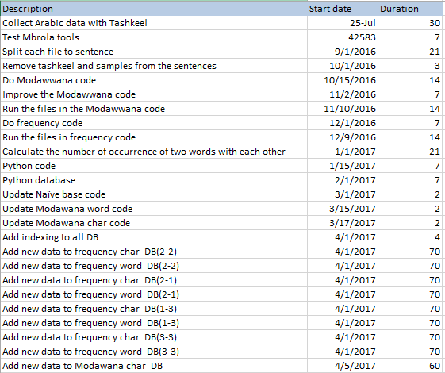
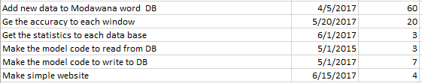
table 1.5(a) Gannet chart table for project time plan

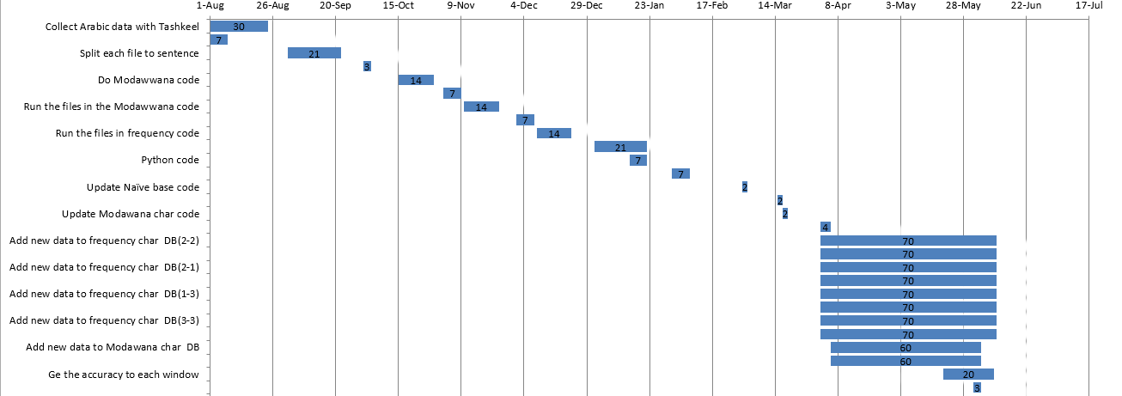
Figure 1.5(b) Gannet chart for project time plan

1.6 Project development methodology
Supervised Machine Learning
The majority of practical machine learning uses supervised learning. And we use it too in
our project. Supervised learning is where you have input variables (x) and an output
variable (Y) and you use an algorithm to learn the mapping function from the input to the
output.
Y = f(X)

The goal is to approximate the mapping function so well that when you have new input
data (x) that you can predict the output variables (Y) for that data.

It is called supervised learning because the process of an algorithm learning from the
training dataset can be thought of as a teacher supervising the learning process. We
know the correct answers, the algorithm iteratively makes predictions on the training
data and is corrected by the teacher. Learning stops when the algorithm achieves an
acceptable level of performance.

Supervised learning problems can be further grouped into regression and classification
Problems.

- Classification: A classification problem is when the output variable is a category, such as “red” or “blue” or “disease” and “no disease”.
- Regression: A regression problem is when the output variable is a real value, such as “dollars” or “weight”.

Some common types of problems built on top of classification and regression include
recommendation and time series prediction respectively.

Some popular examples of supervised machine learning algorithms are:

- Linear regression for regression problems.
- Random forest for classification and regression problems.
- Support vector machines for classification problems.

NBC
Naive Bayes is a simple technique for constructing classifiers: models that assign class labels to problem instances, represented as vectors of feature values, where the class labels are drawn from some finite set. It is not a single algorithm for training such classifiers, but a family of algorithms based on a common principle: all naive Bayes classifiers assume that the value of a particular feature is independent of the value of any other feature, given the class variable.
For example, a fruit may be considered to be an apple if it is red, round, and about 10 cm in diameter. A naive Bayes classifier considers each of these features to contribute independently to the probability that this fruit is an apple, regardless of any possible correlations between the color, roundness, and diameter features
  - Used tools
Software:
- المكتبة الشاملة website(for collecting data)
- MS word (for splitting large files to small files)
- Eclipse
- MySQL workbench
- PHPMyadmin
- Languages
- Java
- Python
- MySQL
- cherrpy framwork
- Html/css

Hardware:
- laptops

1.8 Report organization
Chapter 2 :
Chapter 2 will discuss the related work of our project, which includes
(“ARABTALK” , “Cimos French Company” ,”Aramedia company” ,”Sakhr TTS”, ”MBROLA”, ”ACAPELA”)
In addition, will give a brief introduction about each of them.

Chapter 3:
Chapter 3 will discuss
- Functional and nonfunctional requirements of each program we made.
- Will show some UML diagrams
  - Use Case Diagram
  - Sequence Diagram
- Will show some test cases for our project in the form of input ⇒ PROGRAM ⇒ output

Chapter 4 :
Chapter 4 will discuss 2 major things .
- ERD for each program .
- Will be snapshots of the GUI used in the system that show how you will use it and some functionality.

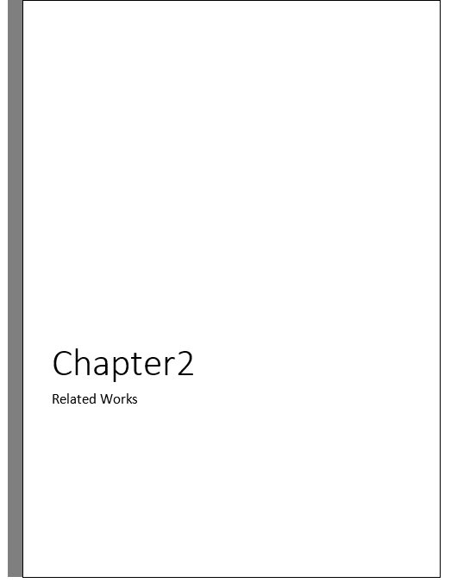

There is some of the commercial TTS Synthesis Systems available today.
More than 28 TTS Synthesizer Systems currently existing in the market.

ARABTALK

The ARABTALK TTS Synthesis System was developed at Research ad Development
International (RDI), for Arabic language. ARABTALK is a state-of-the-art corpus based
concatenative TTS System. The system uses Artificial Neural Networks (ANN)
statistical prosody based models.
In addition, it has a real time synthesis by selection algorithm to explore large speech
corpus. ARABTALK has a Hidden Markov models (HMMs) based procedure to automatically time-align new voices transcriptions to their acoustic phoneme boundaries.
The RDI Product is based on morphological analysis (التحليل الصرفى)
The speed of automatic diacritics for arabic text reaches to 100 words/sec and memory of 64 MB and runs on Microsoft's Windows system.
The Automated diacritics accuracy is more than 95% measured at the level of words.
http://www.rdi-eg.com/

Cimos French Company
This company produced system for automated formation of the Arabic text, have been buying this program and testing them. The correct formation ratio is equal to almost 70% at the level of the word and protect it, as it does not allow using it in more than one device.
This program add the diacritics to Arabic text, and it is on three copies
First one works on computer device, second one cooperate with another systems through API and third one connected to the server to work on a world network.
http://www.cimos.com/

Aramedia company (Diacritizer)
It has developed the formation of a system where it seems the fastest and most accurate (according to the producing company) since the formation at high speed and accuracy up to 98% and gives the option of forming end of words (اعراب نهاية الكلام او عدمه) or not. This system is part of the office software tools "صخر" Office Tools http://www.sakhr.com

https://www.aramedia.com/diacritizer.htm

Sakhr TTS
Sakhr TTS engine converts any Arabic/English text into a human voice. Sakhr has been
focusing in the last 5 years on creating an Arabic TTS engine that can match in its quality
the human voice.
Sakhr developed the Diacritizer engine. This engine can put the diacritics needed in Arabic texts automatically. The Diacritizer is the main component in Arabic TTS. Without the Diacritizer, the output quality of the TTS engine would be inaccurate and not clear. Since Arabic native speakers write Arabic text without diacritics, the TTS engine should handle the non-diacritized text. The Diacritizer will convert the non-diacritized text into a diacritized text and then the TTS engine will convert it to a clear and human Arabic voice. Moreover, Text-To-Speech technology Software Development Kit (SDK) converts any computer readable text into a human sounding synthetic speech. Arabic is at least one order of magnitude difficult than other common languages due to the lack of diacritics.

MBROLA – PROJECT

MBROLA-project is one of the main systems that have an Arabic voice.
The main goal of the project is to have a speech synthesis for as many
languages as possible. MBROLA is used for non-commercial purposes. Another purpose
with it is to increase the academic research, especially in prosody generation(علوم نحوية).
The MBROLA speech synthesizer is based on diphone concatenation.
The diphone databases are currently available for English, Arabic Brazilian Portuguese, Dutch, French, German, Romanian, Spanish, Greek, Turkish,.etc.
Some of these languages exist with male and female voice (MBROLA).

ACAPELA – GROUP

Acapela group constitutes all speech technologies that have been developed over the last
20 years. Speech synthesis and speech recognition have been created and improved by
Acapela. Acapela Group evolves from the strategic combination of three major European
companies in vocal technologies: "Babel Technologies" created in Mons, Belgium,
"Infovox" created in Stockholm, Sweden and "Elan Speech" created in Toulouse, France.
Acapela owns currently three technologies, TTS by diphone, TTS by Unit Selection and
Automatic Speech Recognition. Acapela is currently available for US English, UK
English, Arabic, Belgian Dutch, Dutch, French, German, Italian, Polish, Spanish and
Swedish.

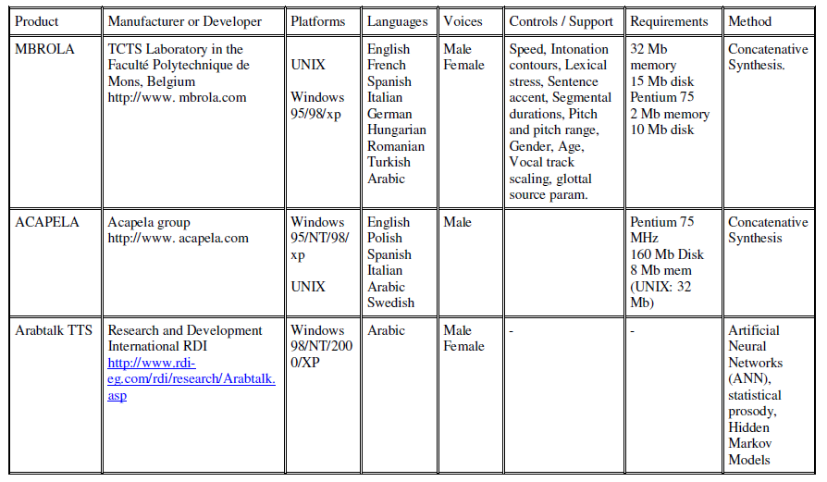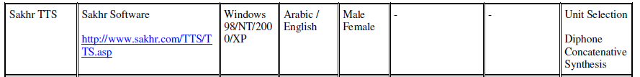
Table 2.1 Summary of Text-To-Speech Existing Products

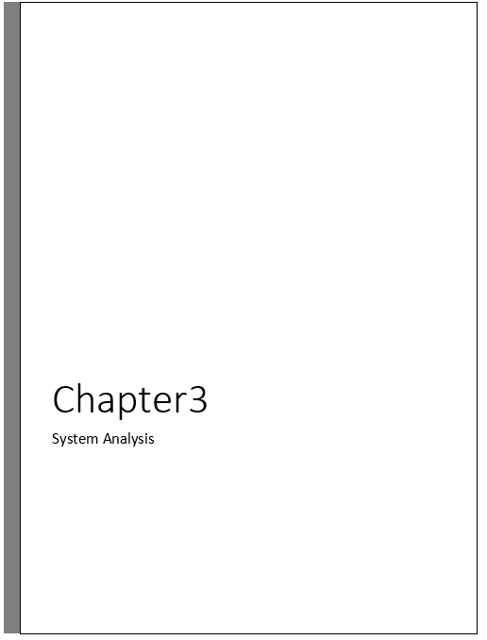
3.1 Project specification
3.1.1 Functional Requirements:
Functional for Tekrar code:
1. The system should remove Tashkeel from words.
2. The system should remove samples from words.
3. The system should read file and splits the file into words.
4. The system should connect to Mysql Database.
5. The system should select all elements from the table of the character we use.
6. The system should identify the word is new if the word does not be in the selected data from database.
7. The system should identify the word is updated if the word is in the selected data and update its counter.
8. The system should identify the word is old if it’s not modified.
9. The system should insert the data back to the database based on tags.
10. The system should work on (n var) window size left and right.
11. The system should make key of the hash map word1&word2
12. The system should add the key of the hash map to database if it’s not in the selected data.
13. The system should update the counter if it’s exists in the selected data.
14. The system should run on each character to insert its data in the associated table.

Functional for modowana code:
1. The system should remove Tashkeel from words.
2. The system should remove samples from words.
3. The system should read file and splits the file into words.
4. The system should connect to Mysql Database.
5. The system should select all elements from the table of the character we use.
6. The system should identify the word is new if the word does not be in the selected data from database.
7. The system should identify the word is updated if the word is in the selected data and update its counter.
8. The system should identify the word is old if it’s not modified.
9. The system should insert the data back to the database based on tags.
10. The system should add a word in primary table if it’s new and it’s (مشكلة) version in secondary.

Functional:
1. The system should implement Naive Bayes Algorithm.
2. The system should connect to 2 databases (Modawana & gpFrequency)
3. The system should get the id for specific word in primary table.
4. The system should get all words associated to a certain id from secondary table.
5. The system should get the number of times 2 words repeated.
6. The system should remove samples from words.
7. The system should remove tashkeel from words.

3.1.2 Non-Functional Requirements
Non-Functional for Tekrar code:
1. The data should be Average 600,000 words.
2. Selection of data from database should be less than 10 seconds.
3. Execution of the whole program should be less than 24 hours.
4. Database should be Mysql.
5. This program should be in java.
6. Program will run properly if word is in the database or not.

Non-Functional for modowana:
1. Selection of data from database should be less than 10 seconds.
2. Execution of the whole program should be less than 24 hours.
3. Database should be Mysql.
4. This program should be in java.
5. Program will run properly if word is in the database or not.

3.2 Use Cases Diagrams
3.2.1 Modwanna system(words and characters)
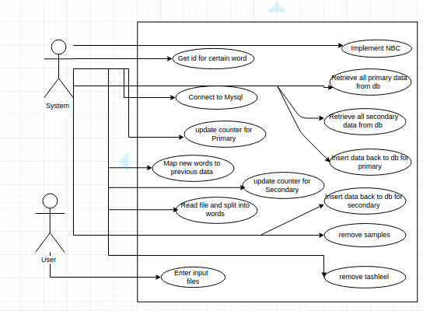
Figure 3.1(a) Use case for modwanna system

3.2.2 Frequency system (words and characters)
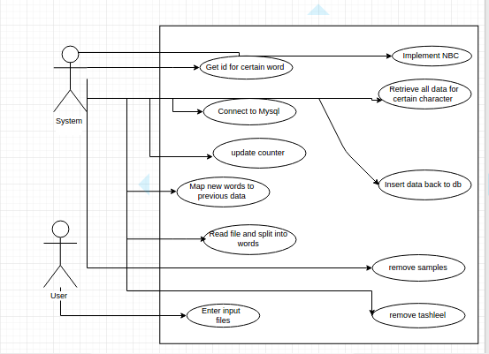
Figure 3.1(b) Use case for frequency system

3.2.3 Machine learning system
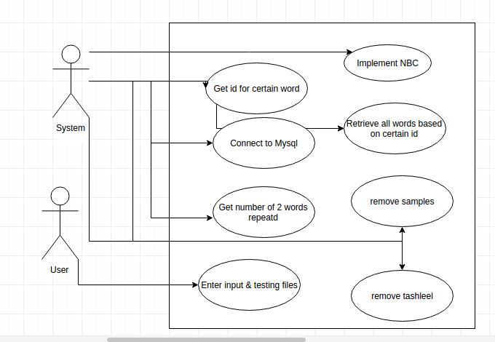
Figure 3.1(c) Use case for Machine learning

3.3 Sequence Diagrams
Frequency Characters
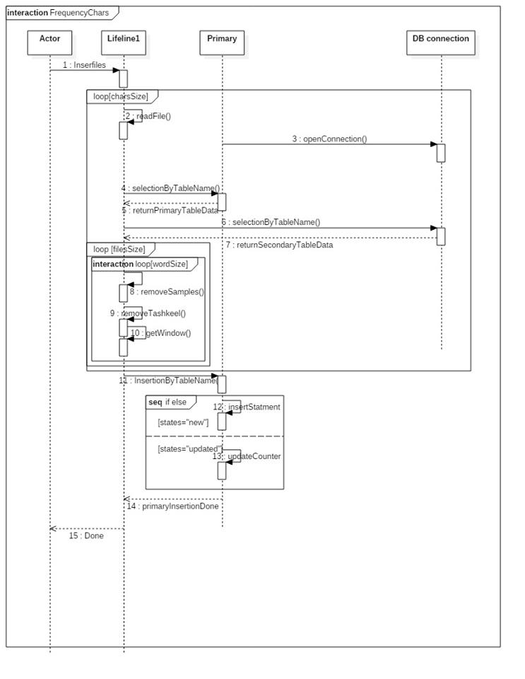
Figure 3.3(a) sequence diagram for frequency character system
Frequency Words
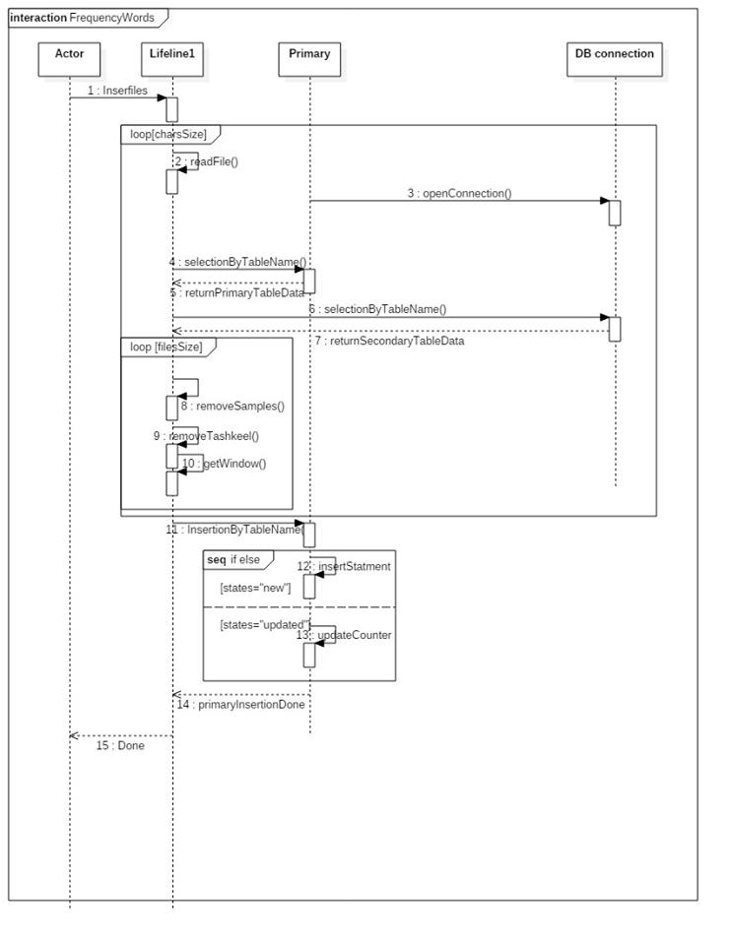
Figure 3.3(b) sequence diagram for frequency words system
Modwanna Characters
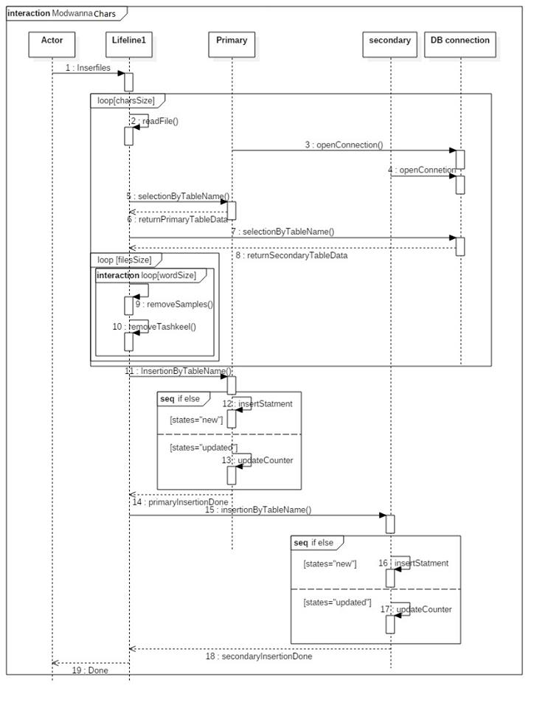
Figure 3.3(c) sequence diagram for modwanna character system

Modwanna Words
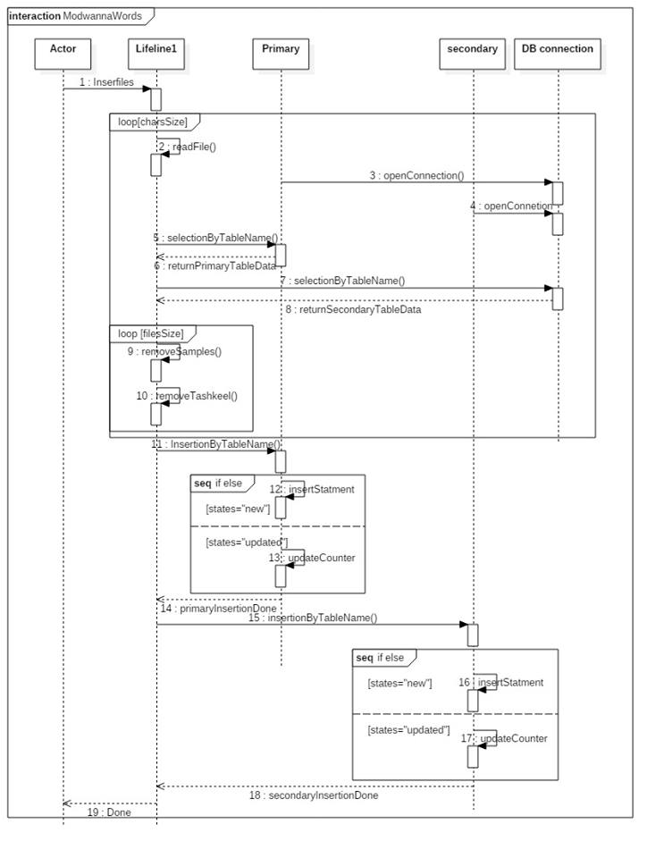
Figure 3.3(d) sequence diagram for modwanna words system
3.4 System test cases

When enter empty text:
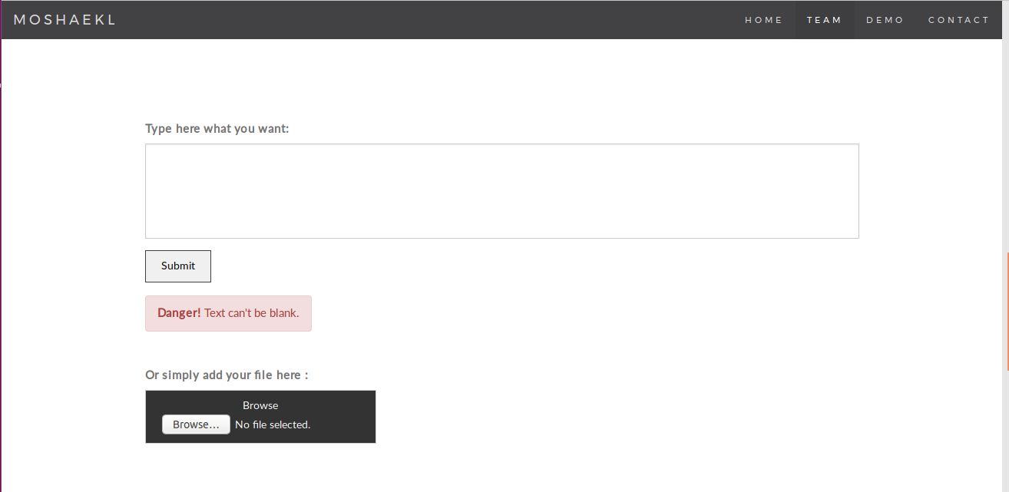

Test case:
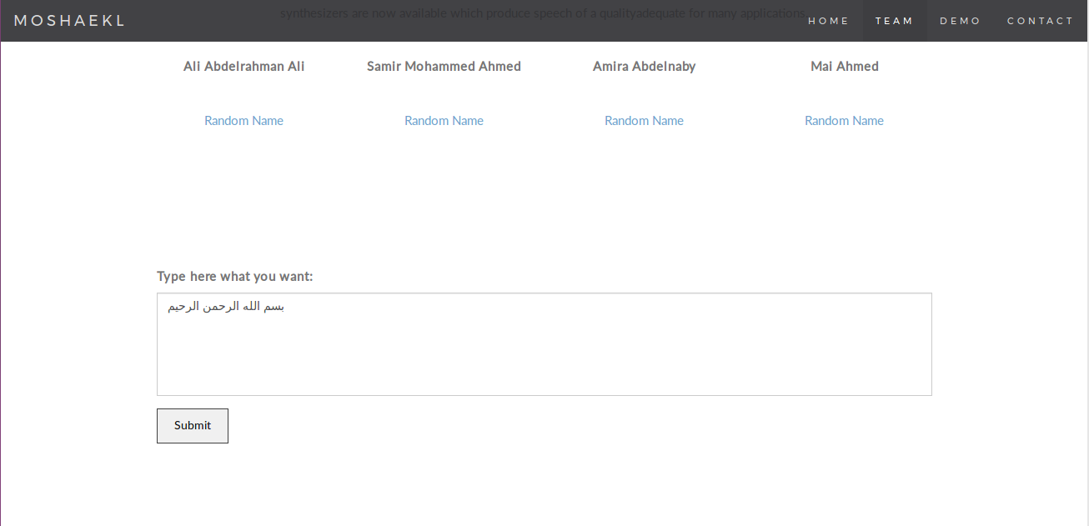

Output:
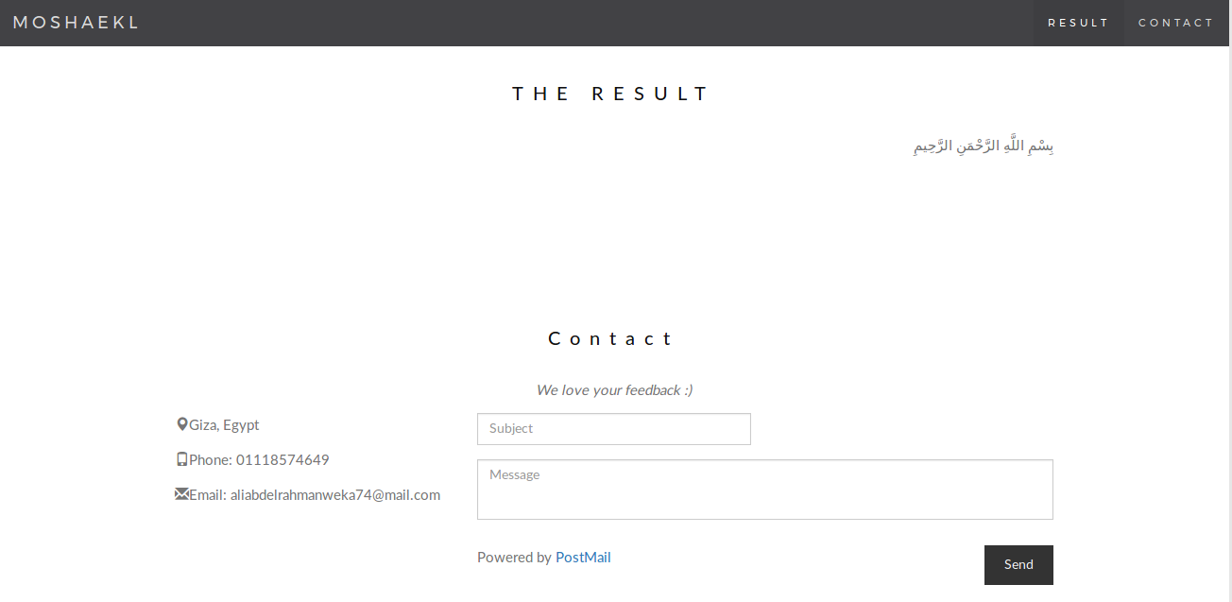

English or wrong test case:
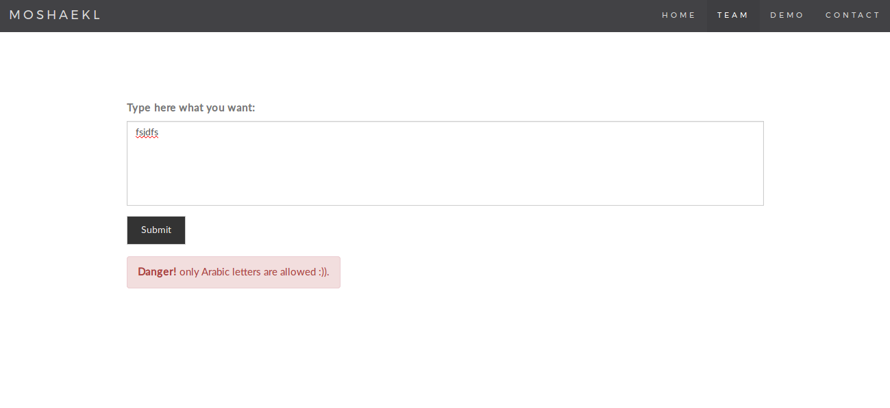

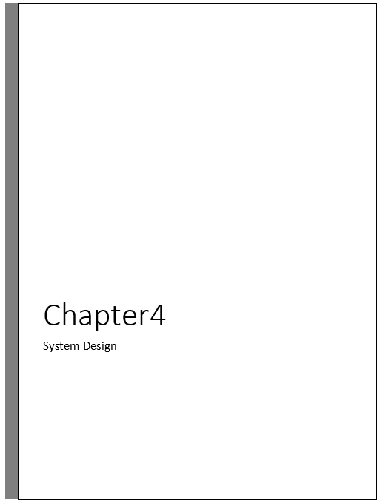
4.1 Project ERD
4.1.1 Conceptual
Characters Frequency

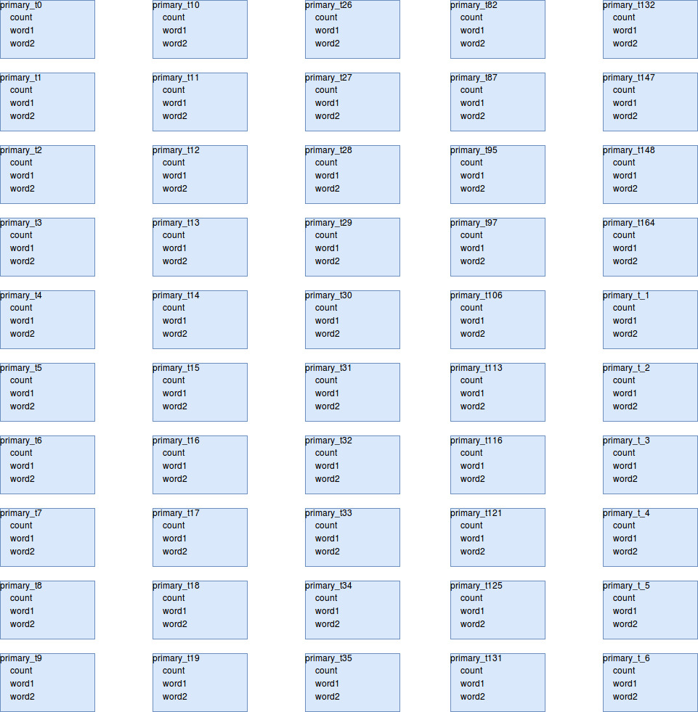

Figure 4.1.1(a) conceptual characters frequency ERD diagram

Words Frequency

Figure 4.1.1(b) conceptual words frequency ERD diagram

Characters Modwanna

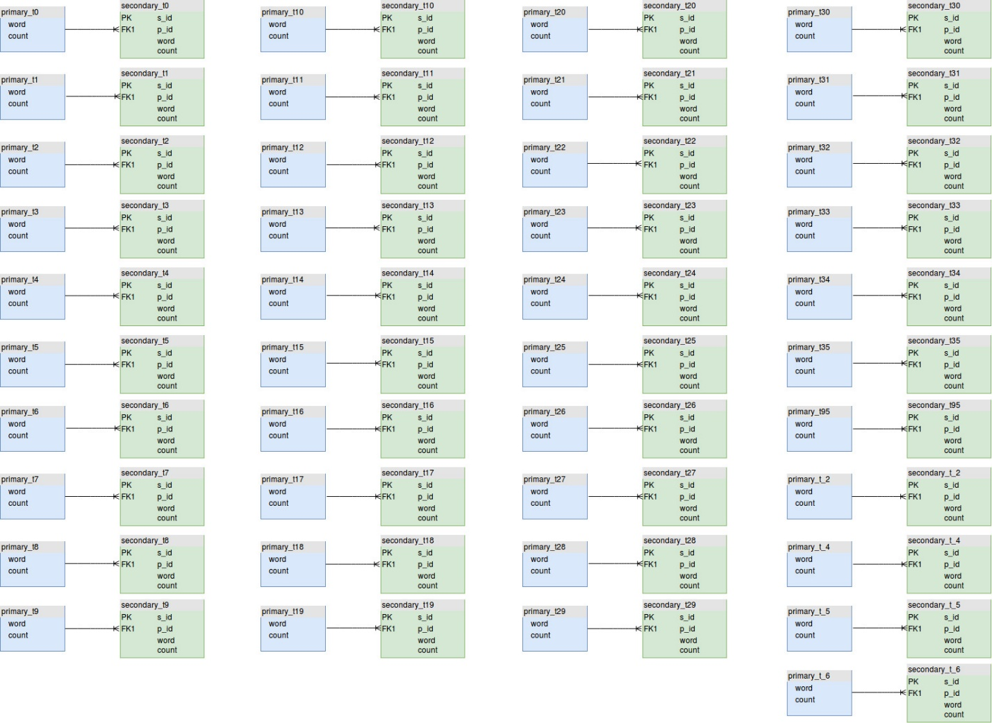
Figure 4.1.1(c) conceptual characters modwanna ERD diagram

Words Modwanna

Figure 4.1.1(d) conceptual words modwanna ERD diagram

4.1.2 Physical
Characters Frequency

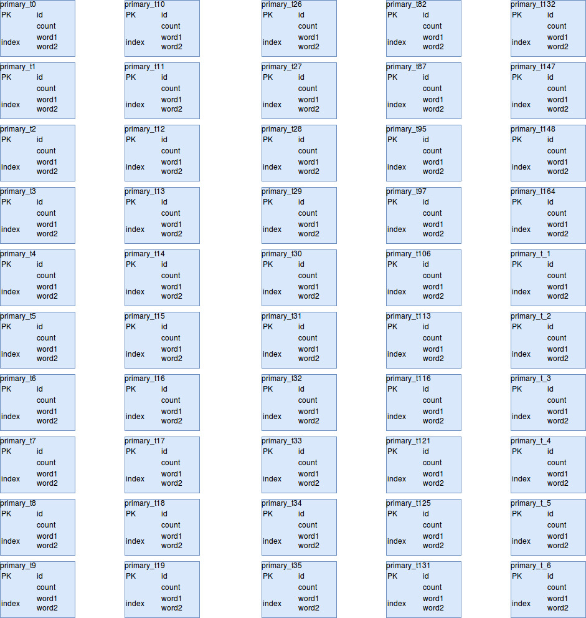
Figure 4.1.2(a) physical characters frequency ERD diagram

Words Frequency

Figure 4.1.2(b) physical words frequency ERD diagram

Characters Modwanna

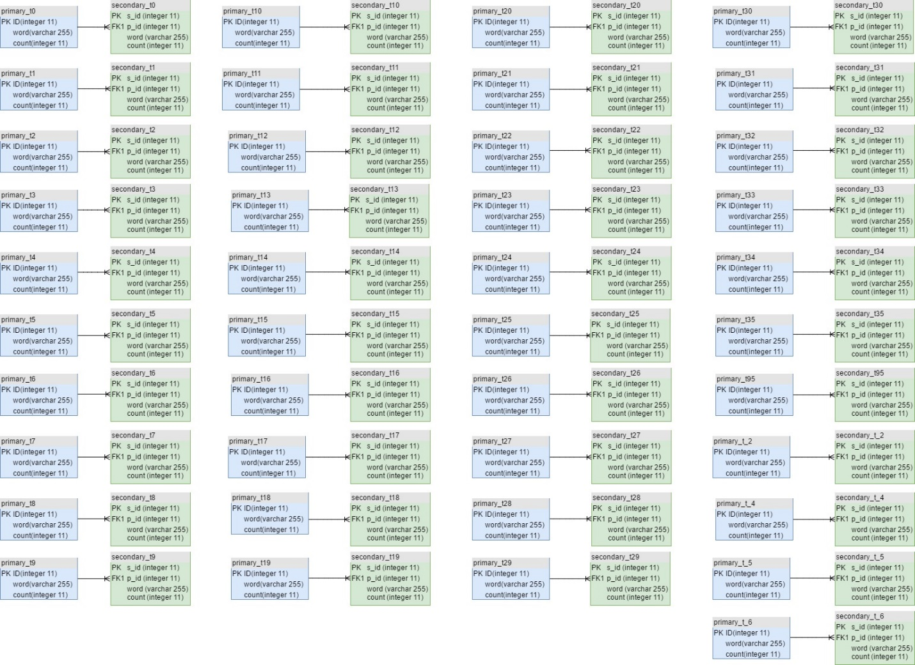
Figure 4.1.2(c) physical characters modwanna ERD diagram

Words Modwanna

Figure 4.1.2(d) physical words modwanna ERD diagram

4.2 Elementary Design

Home page:

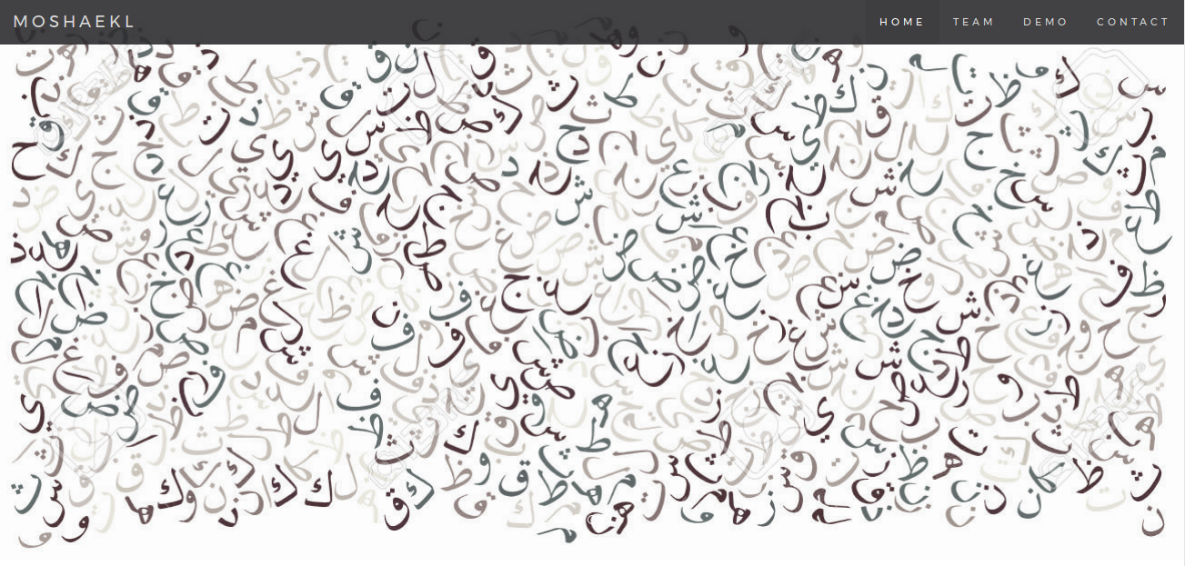
Our TEAM:
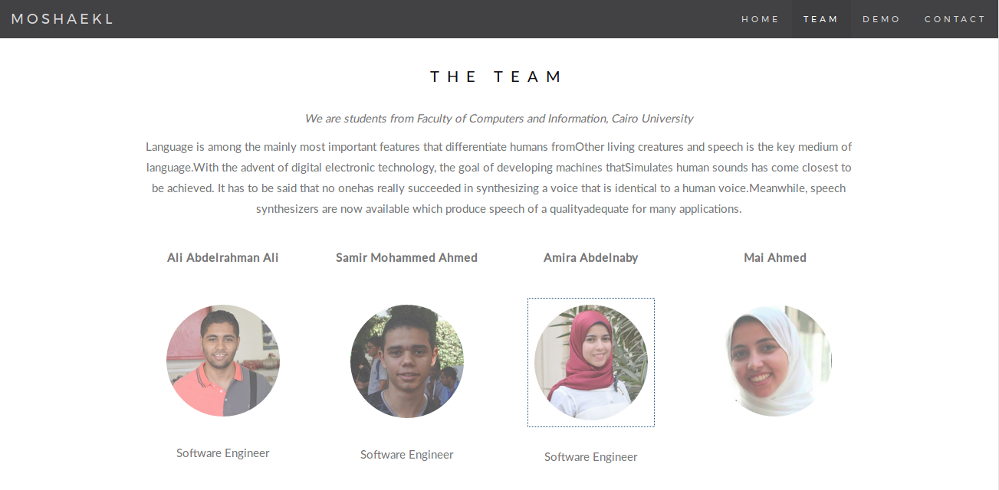

DEMO:
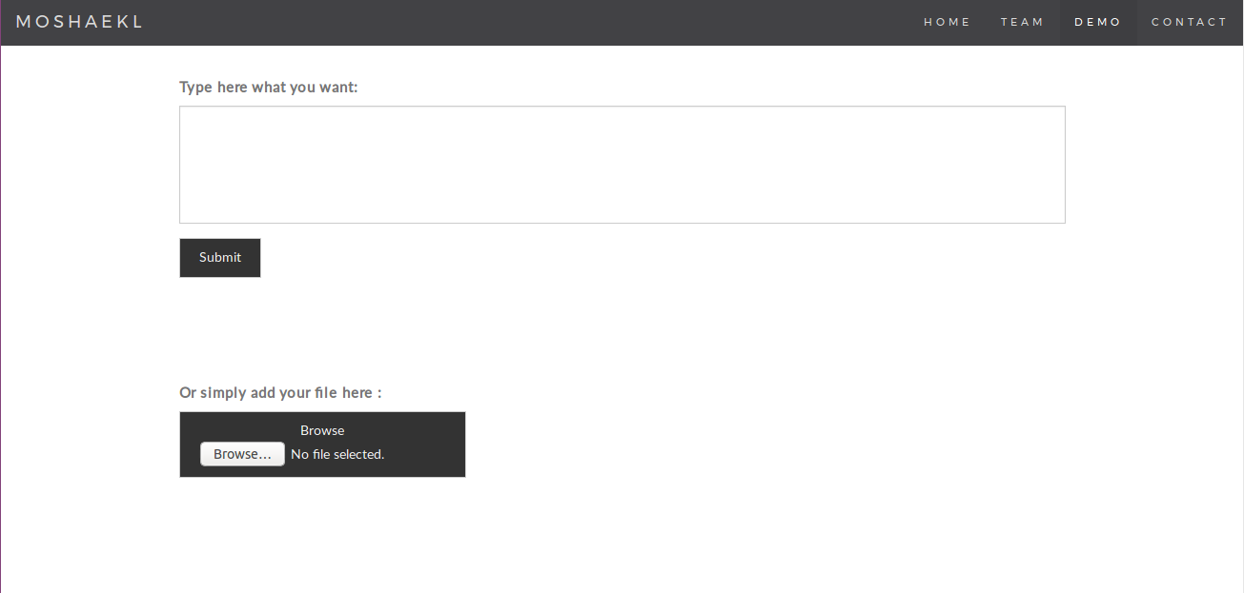

CONTACT US :
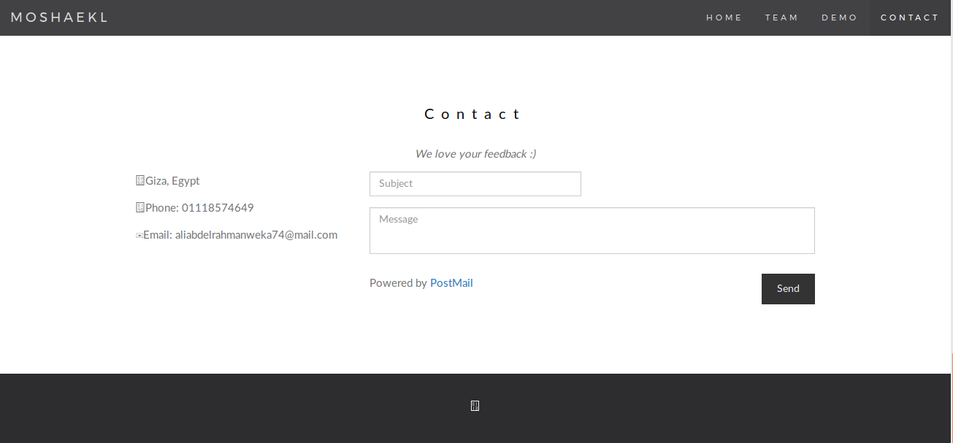

To insert file:
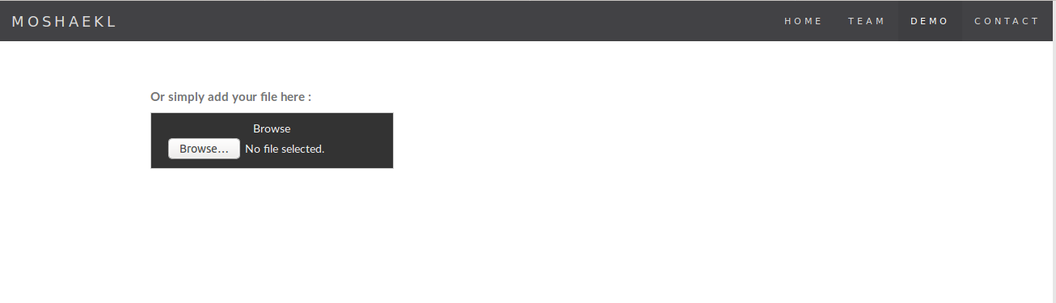

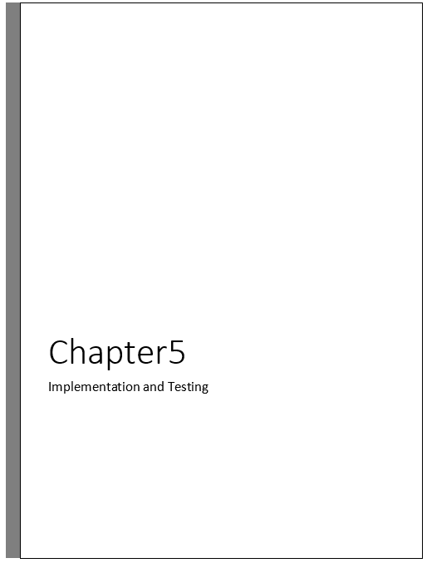
System Testing

Step No. | Test cases | Test data | Expected result | Actual result | Status(pass/fail)
1 | Check if area is empty | Text or File | Danger message | System success | Pass
2 | Check if entered text is not arabic | Text or File | Danger message | System success | Pass
3 | Check if input text is in arabic language | Text or File | نص مُشَكَل | System success | Pass
4 | Check if mail vaild in CONTACT form | Mail or user data | Sent message to user | System success | Pass

Table 5.1 table of System testing

Samples of the applied test cases:

Home page:

When click in TEAM buttom:
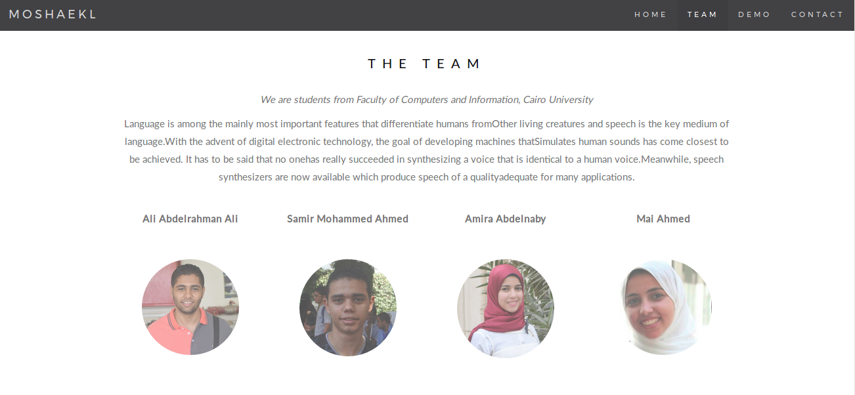
When click in one of team pictures:

When click in DEMO buttom:

When click in CONTACT buttom:

To insert file:

When enter enpty text:

Test case:

Output:

English or wrong test case:

SUMMARY

 | Window Size | Accuracy V1 |  | Accuracy V2
 | Window Size | بنية | اعراب | بنية | اعراب
 | 2 - 2 | 66.7 % | 66.05% | 77.25 % | 73.98 %
 | 1 - 3 | 65.6 % | 64.19 % | 77.18 % | 73.89 %
 | 1 - 1 | 65.81 % | 64.85 % | 77.49 % | 75.42 %
Unique words |  | 41710 |  | 151263
Non Unique Words |  | 263824 |  | 1254200
Table xs(a) table of System accuracy

Based on 2 Versions

Figure xs(a) accuracy chart based on versions

Based on Windows

Figure xs(b) accuracy chart based on windows

Based on tashkeel benya and Eraab

Figure xs(c) accuracy chart based on tashkeel benya and eraab

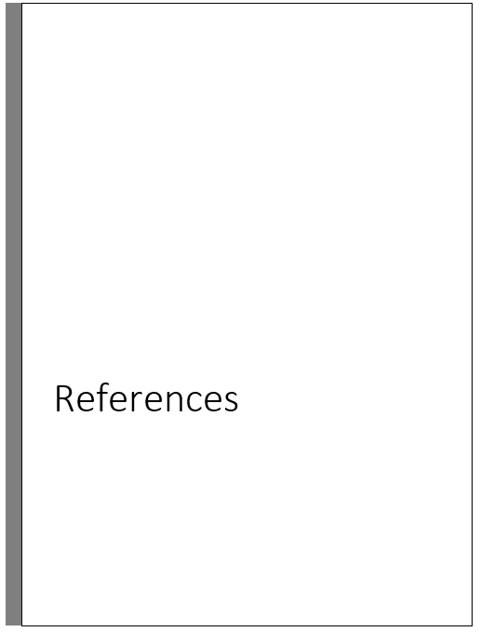

REFERENCES AND RESOURCES
Yasser H., Shady Q., Salah H., & Mohsen R. (2000). ARABTALK® An Implementation
for Arabic Text To Speech System. www.nemlar.org/ARAB-TALK-RDI.doc.

MBROLA. The MBROLA project towards a freely available multilingual speech
synthesizer. http://tcts.fpms.ac.be/synthesis/mbrola.html.

Wael H. & Mohsen R. (2000). Concatenative Arabic speech synthesis using large
database, In Proceedings of ICSLP2000, vol. 2, pp. 182-185, Beijing, China.

http://repository.um.edu.my/142/1/Arabic%20TTS%20Synthesizer.pdf

Thierry D. (1996). An Introduction to Text-to-Speech Synthesis. Kluwer Academic

Publishers, Dordrecht.

Todd K. & Stephen C. (2000). Microsoft Visual Basic. South-western Educational

Publishing.

Wael H. & Mohsen R. (2000). Concatenative Arabic speech synthesis using large

database, In Proceedings of ICSLP2000, vol. 2, pp. 182-185, Beijing, China.

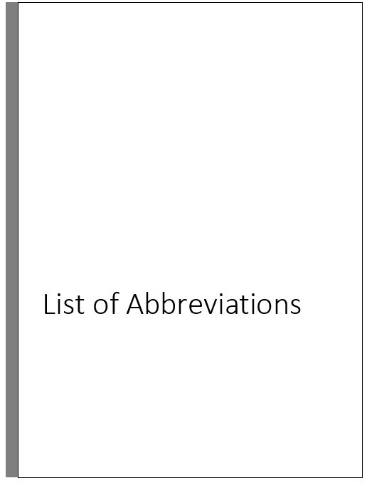 LIST OF SYMBOLS AND ABBREVIATIONS

ANN Artificial Neural Network

ASCII American Standard Character International Institute

BIDI Bi-Directional

DSP Digital Signal Processing

GTP Grapheme-To-Phoneme

HMM Hidden Markov Model

ICT Information Communication Technology

IPO Input-Process-Output Schematic

LPC Linear Prediction Coding

OCR Optical Character Recognition

RDI Research and Development International

SAPI Speech Application Programming Interface

SDK Software Development Kit

SDLC System Development Life Cycle

TTP Text-To-Phonetic

TTS Text-To-Speech

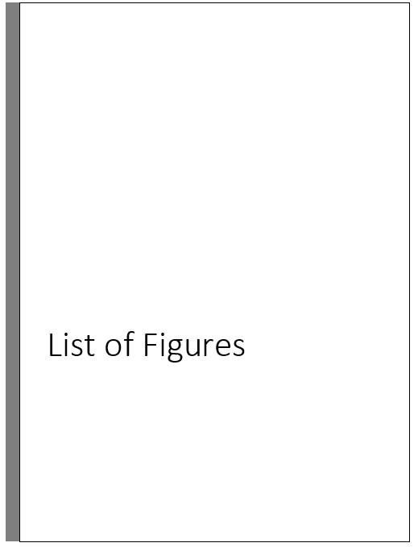
List of figures:

Figure 1.1 | Diagram of text to speach (TTS) | 4
Figure 1.5(b) | Gannet chart for project time plan | 9
Figure 3.1 | Use case for modwanna system | 20
Figure 3.1(b) | Use case for frequency system | 22
Figure 3.1(b) | Use case for Machne learning system | 23
Figure 3.3(a) | sequence diagram for frequency character system | 23
Figure 3.3(b) | sequence diagram for frequency words system | 24
Figure 3.3(c) | sequence diagram for modwanna character system | 25
Figure 3.3(d) | sequence diagram for modwanna words system | 26
Figure 4.1.1(a) | conceptual characters frequency ERD diagram | 30
Figure 4.1.1(b) | conceptual words frequency ERD diagram | 31
Figure 4.1.1(c) | conceptual characters modwanna ERD diagram | 32
Figure 4.1.1(d) | conceptual words modwanna ERD diagram | 33
Figure 4.1.2(a) | physical characters frequency ERD diagram | 34
Figure 4.1.2(b) | physical words frequency ERD diagram | 35
Figure 4.1.2(c) | physical characters modwanna ERD diagram | 36
Figure 4.1.2(d) | physical words modwanna ERD diagram | 37
Figure xs(a) | accuracy chart based on versions | 51
Figure xs(b) | accuracy chart based on windows | 52
Figure xs(c) | accuracy chart based on tashkeel benya and errab | 52

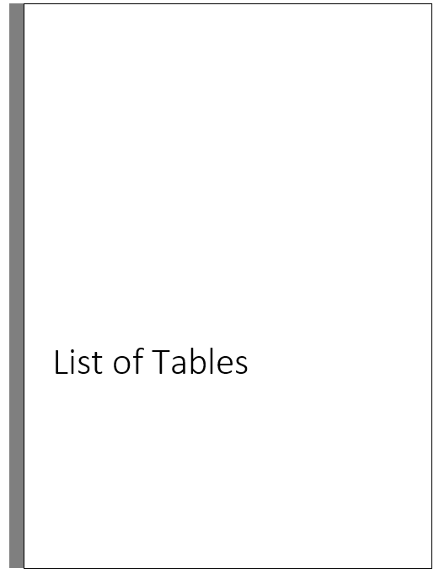

Table 2.1 | Summary of Text-To-Speech Existing Products | 16
Table 5.1 | table of System testing | 42
Table xs | table of System accuracy | 51

