Illness or Lithium? Separating Medication Effects From Disease Effects in the Bipolar Blood Transcriptome
Bipolar disorder is a mood disorder characterized by mania and depression with a high level of heritability, genetic influences making up 60-85% of the risk (Barnett, J. H., & Smoller, J. W., 2009). However, the pathophysiology of bipolar disorder is not well understood, with gene expression offering a means of gaining insight into the disease mechanisms. With this intention, Krebs et al. (2020) performed differential expression analysis on RNA-sequencing of whole blood samples taken from non-affected individuals, bipolar diagnosed individuals on lithium, and bipolar diagnosed individuals not on lithium. The issue is that almost every bipolar patient in the dataset is medicated, so any gene that differs between cases and controls may just be tracking lithium usage, not bipolar diagnosis. Lithium has previously been shown to raise neutrophil proportions in the blood (Kast R. E., 2008), which could shift gene expression in bulk samples without there being any change in the cells’ behavior (Wang et al., 2016). This means that any blood biomarker developed on a similarly largely medicated cohort would not be appropriate to generalize to patients who have never been treated and would likely benefit the most from a blood test. The follow up paper, Boltz et al. (2024), demonstrated that lithium’s effect on gene expression occurs only in bulk blood samples, not single cell types, further pointing to lithium’s effect being on cell composition rather than cell behavior. The question for us to address then is how much of lithium’s effect on gene expression is mediated through cell mix? Furthermore, Krebs et al. adjusted for lithium use when performing differential expression analysis for case vs control, eliminating part of what distinguished the two groups since only cases take lithium. We will see if the diagnosis signal changes when differential expression analysis is performed on control vs cases that don’t take lithium. Finally, we will investigate whether gene networks differ between control, BD on lithium, and BD off lithium, and whether any differences found are maintained when cell composition is removed from the expression matrix.
We hypothesize that a significant proportion of lithium’s effect on gene expression will run through the cell mix rather than directly, with this cell-mediated effect making it so that five ILR ratios built from cell fractions will be able to predict lithium usage as well as the 12,353 gene expression matrix, and so that the cell-mediated effect of age on gene expression increases in lithium-users (Salarda et al., 2021). We also expect to find detectable network differences between the control group, bipolar lithium-users, and bipolar non lithium users.
The dataset, GSE124326, consists of 480 whole-blood RNA-seq samples. The count matrix holds raw counts for 57,820 genes, and the series matrix holds 35 phenotype fields per sample. After the quality flag, 444 remain with all the fields intact (however, we may use data imputation techniques in order to fill in the missing fields): 226 bipolar I, 13 bipolar II, 205 controls. No bipolar II subject takes lithium, so all lithium contrasts are bipolar I only: 74 non-users against 152 users. The three variables consist of: diagnosis and lithium use as the exposure; age, sex, tobacco use, assessment group, RIN, sequencing plate and three deposited sequencing-metric PCs as covariates; the 22 deposited CIBERSORT LM22 cell fractions as the mediator. Both files are downloaded and opened, and sample identifiers match across them for all 480. For the purposes of deconvolution using CIBERSORT (Newman et al., 2015), we will use their reported numbers, and, as it is per sample deconvolution, we do not need to re-run them, even for the prediction contest since no data leakage is possible. Both of our other deconvolution methods, CIBERSORTx (Newman et al., 2019) and BayePrism, can also be run free of charge on our own computers. We have attached flowcharts that explain our methodologies for the techniques we plan to use, as well as our preprocessing pipeline.
To test our hypothesis of five ILR ratios being equally effective at predicting lithium usage as 12,343 genes we’ll be using Elastic net and Random forest (Greener et al., 2022). With our methodology pipeline (further illustrated in the “prediction contest” flowchart), we will perform a prediction contest using 3 fold CV, ensuring no data leakage by doing the deconvolutions and data normalizations within the splits. The 5 ratios are built using ILR (Egozcue et al., 2003) from the 6 remaining feasible cell counts after filtering cell counts with data that is mostly 0. This is done so that an increase in one quantity does not force the other quantities to decrease even if there was no absolute decrease in those quantities.
Mediation analysis will be performed in order to quantify how much of lithium’s effect on gene expression is direct and how much runs through the cell mix (Kartiosuo et al., 2024) (VanderWeele & Vansteelandt, 2014). This adds quantifiable numbers to the analysis, as well as bounds the data with the e-value (VanderWeele & Ding, 2017) deduced from the known literature about the unmeasured covariates, such as body fat, which is known to increase neutrophil count (Furuncuoğlu et al., 2016). Our goal will be to run different mediation analyses, switching up the exposure, mediator, and outcome to ask further questions which are informed by previous literature.
Several network analysis techniques including community detection and changes in hub nodes will be implemented after building the weighted networks from gene-gene correlations (Langfelder & Horvath, 2008) for the three groups: control (no lithium), BPD on lithium, and BPD not on lithium. These techniques will be utilized to look for module preservation across different groups, as well as potentially checking centrality and other relevant features of the different networks. (Will & Helms, 2016).
If ILR ratios are as effective as 12,343 genes at detecting lithium, we can expect from our prediction contest that the five ILR ratios fall within the equivalence margin that we declare for the gene set. If the gene set beats the ratios by more than that margin, this would argue against our hypothesis. Supporting results for our mediation analysis would be lithium raising the proportion of myeloid to lymphoid only, and this effect on cell composition making up a substantial portion of lithium’s effect on gene expression (Barr, R. D, 1983). Finding changes in cell proportions other than increasing myeloid to lymphoid ratio, or finding a more substantial direct effect of lithium on gene expression would not support our hypothesis. Finally, we expect to see different network structures, seen through features such as nodes or edges, across the three groups, as opposed to complete module preservation.
Our three arms- prediction, mediation, and networks- run independent from the others, so even if we run into issues with one arm, we can still obtain meaningful results from the other; however, there are some risks to the project that could lower its feasibility. One big risk is data leakage in our prediction arm; the prediction contest requires normalization and deconvolution must be performed in every fold, meaning many preprocessing repetitions and opportunities for issues to arise. Another risk is the possibility of conflicting results as our three deconvolution methods may disagree. However, this disagreement could then just become an error estimate for the mediation. Finally, it is possible that there isn’t enough data for our desired analyses, as there are only 226 subjects for the lithium vs no lithium comparison and only 74 subjects per group for the network analysis. One solution to this is to report the effect size so a null is at least informative.

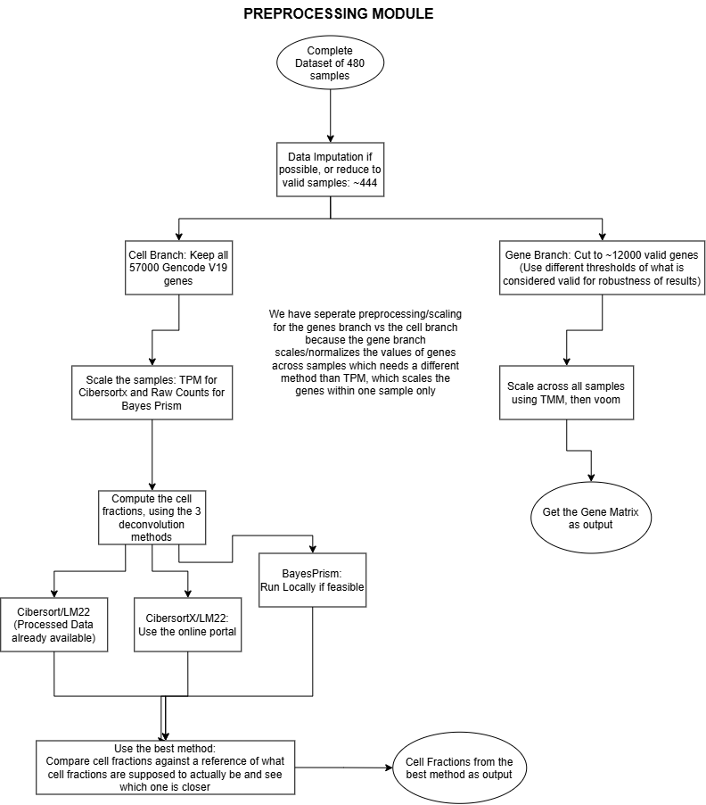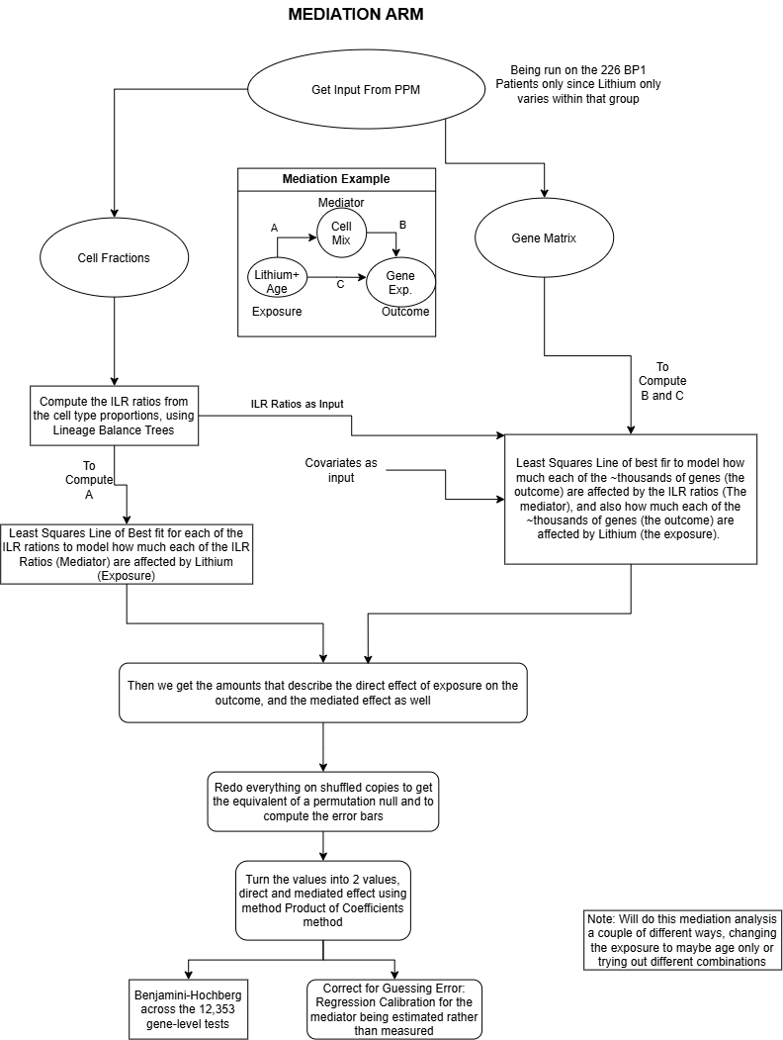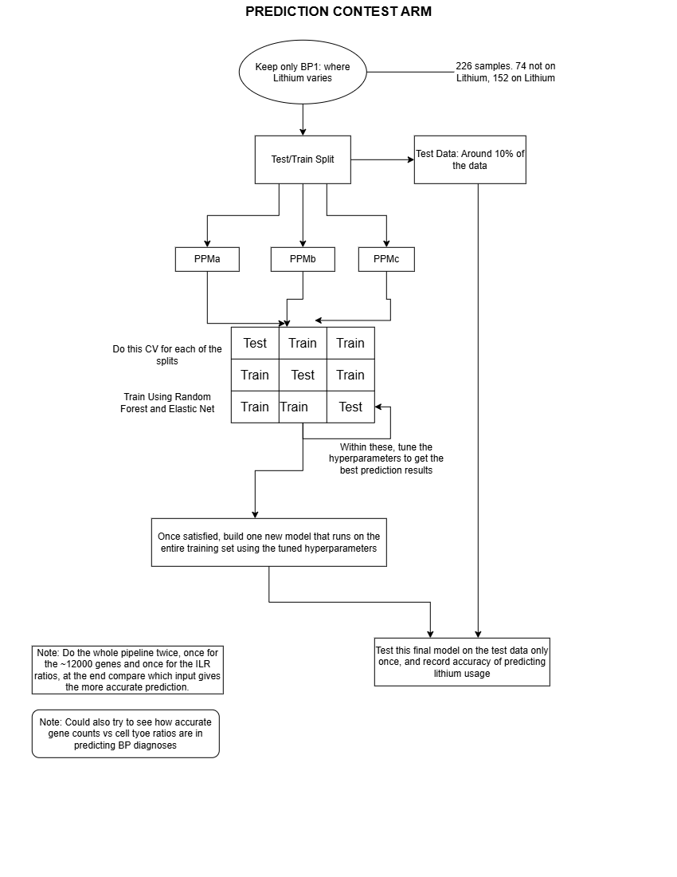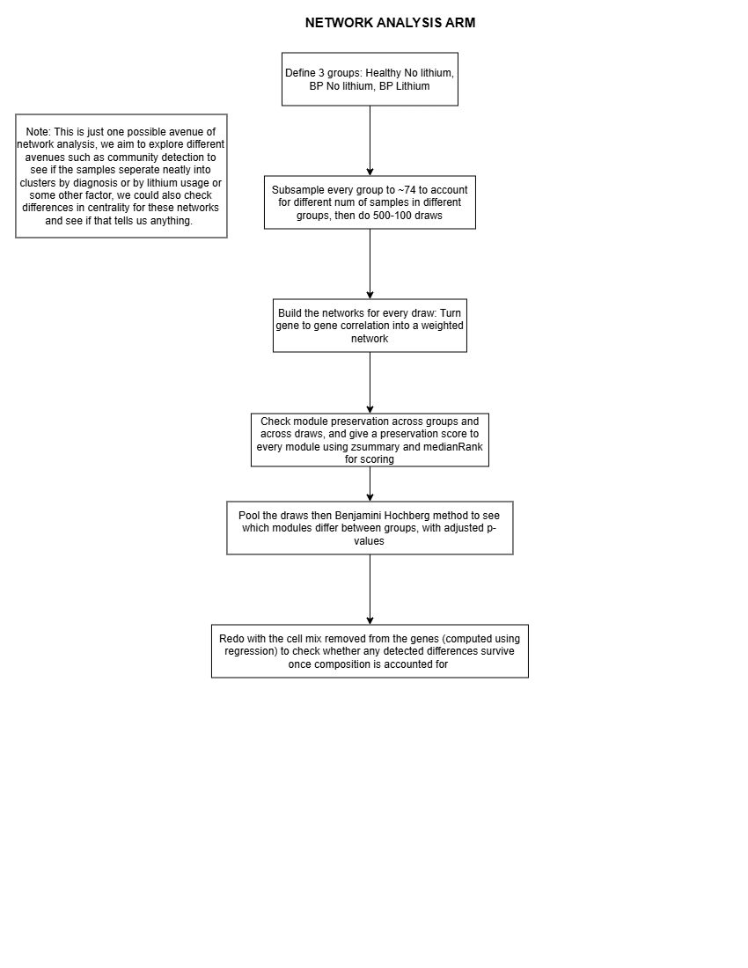

References

Arranz, M.J., Gallego-Fabrega, C., Martín-Blanco, A. et al. (2021). A genome-wide methylation study reveals X chromosome and childhood trauma methylation alterations associated with borderline personality disorder. Transl Psychiatry, 11(5). https://doi.org/10.1038/s41398-020-01139-z

Barr, R. D., & Galbraith, P. R. (1983). Lithium and hematopoiesis. Canadian Medical Association journal, 128(2), 123–126.

Barnett, J. H., & Smoller, J. W. (2009). The genetics of bipolar disorder. Neuroscience, 164(1), 331–343. https://doi.org/10.1016/j.neuroscience.2009.03.080

Boltz, T., Schwarz, T., Bot, M., Hou, K., Caggiano, C., Lapinska, S., Duan, C., Boks, M. P., Kahn, R. S., Zaitlen, N., Pasaniuc, B., & Ophoff, R. (2024). Cell-type deconvolution of bulk-blood RNA-seq reveals biological insights into neuropsychiatric disorders. American journal of human genetics, 111(2), 323–337. https://doi.org/10.1016/j.ajhg.2023.12.018

Kartiosuo, N., Nevalainen, J., Raitakari, O., Pahkala, K., & Auranen, K. (2024). Hypothesis-driven mediation analysis for compositional data: an application to gut microbiome. Biostatistics & Epidemiology, 8(1). https://doi.org/10.1080/24709360.2024.2360375

Kast R. E. (2008). How lithium treatment generates neutrophilia by enhancing phosphorylation of GSK-3, increasing HIF-1 levels and how this path is important during engraftment. Bone marrow transplantation, 41(1), 23–26. https://doi.org/10.1038/sj.bmt.1705872

Krebs, C. E., Ori, A. P. S., Vreeker, A., Wu, T., Cantor, R. M., Boks, M. P. M., Kahn, R. S., Olde Loohuis, L. M., & Ophoff, R. A. (2020). Whole blood transcriptome analysis in bipolar disorder reveals strong lithium effect. Psychological medicine, 50(15), 2575-2586. https://doi.org/10.1017/S0033291719002745

Newman, A.M., Steen, C.B., Liu, C.L. et al. (2019). Determining cell type abundance and expression from bulk tissues with digital cytometry. Nat Biotechnol, 37(7), 773–782. https://doi.org/10.1038/s41587-019-0114-2

Salarda, E. M., Zhao, N. O., Lima, C. N. N. C., & Fries, G. R. (2021). Mini-review: The anti-aging effects of lithium in bipolar disorder. Neuroscience letters, 759, 136051. https://doi.org/10.1016/j.neulet.2021.136051

Thorsten, W. Volkhard, H. (2016). PPIXpress: construction of condition-specific protein interaction networks based on transcript expression, Bioinformatics, 32(4), 571–578. https://doi.org/10.1093/bioinformatics/btv620

Wang, L., Oh, W. & Zhu, J. (2016). Disease-specific classification using deconvoluted whole blood gene expression. Sci Rep, 6(1). https://doi.org/10.1038/srep32976

Greener, J.G., Kandathil, S.M., Moffat, L. et al. (2022). A guide to machine learning for biologists. Nat Rev Mol Cell Biol, 23(1), 40–55. https://doi.org/10.1038/s41580-021-00407-0
Egozcue, J. J., Pawlowsky-Glahn, V., Mateu-Figueras, G., & Barceló-Vidal, C. (2003). Isometric logratio transformations for compositional data analysis. Mathematical Geology, 35(3), 279–300. https://doi.org/10.1023/A:1023818214614

Furuncuoğlu, Y., Tulgar, S., Dogan, A. N., Cakar, S., Tulgar, Y. K., & Cakiroglu, B. (2016). How obesity affects the neutrophil/lymphocyte and platelet/lymphocyte ratio, systemic immune-inflammatory index and platelet indices: a retrospective study. European Review for Medical and Pharmacological Sciences, 20(7), 1300–1306.

Langfelder, P., & Horvath, S. (2008). WGCNA: an R package for weighted correlation network analysis. BMC Bioinformatics, 9, 559. https://doi.org/10.1186/1471-2105-9-559

Newman, A. M., Liu, C. L., Green, M. R., Gentles, A. J., Feng, W., Xu, Y., Hoang, C. D., Diehn, M., & Alizadeh, A. A. (2015). Robust enumeration of cell subsets from tissue expression profiles. Nature Methods, 12(5), 453–457. https://doi.org/10.1038/nmeth.3337

VanderWeele, T. J., & Ding, P. (2017). Sensitivity analysis in observational research: introducing the E-value. Annals of Internal Medicine, 167(4), 268–274. https://doi.org/10.7326/M16-2607

VanderWeele, T. J., & Vansteelandt, S. (2014). Mediation analysis with multiple mediators. Epidemiologic Methods, 2(1), 95–115. https://doi.org/10.1515/em-2012-0010

