Agriculture Mechanize Research Institute (AMRI)
LIST OF MACHINERY/IMPLEMENTS TEST & TRIAL STORE.
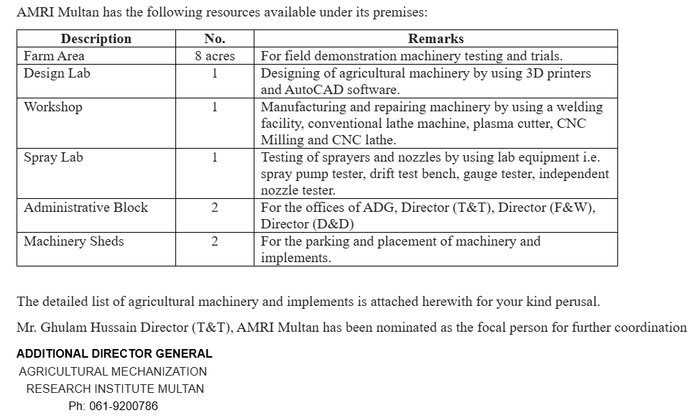
SR # | Name of Machinery /Implement | Qty | Remarks
 | Disk Plow | 1 No | Functional
 | Ditcher | 1 No | Functional
 | Chisel Plow | 1 No | Functional
 | Border Disk | 1 No | Functional
 | Post Hole Digger | 1 No | Functional
 | Fertilizer Spreader | 1 No | Functional
 | Disk Retoner | 1 No | Functional
 | Rice Straw Shredder | 1 No | Functional
 | MB Plough 5-tine (Local) | 1 No | Functional
 | Trencher along with cross | 1 No | Functional
 | Sprinkler Gun | 1 No | Functional
 | Jip Crane | 1 No | Functional
 | Wheat Bed Planter | 1 No | Functional
 | Double coulter Drill with Fertilizer | 1 No | Functional
 | Vegetable Seeder | 2 No | Functional
 | Vegetable Planter | 2 No | Functional
 | Maize Cob Harvester | 2 No | Functional
 | Mango Pruner | 2 No | Functional
 | Hydraulic Trolley | 1 No | Functional
 | Sugarcane Loader | 2 No | Functional
 | Sugarcane Crusher | 2 No | Functional
 | Tadder (Class) | 1 No | Functional
 | Rack (Class) | 1 No | Functional
 | Silage Bailer | 2 No | Functional
 | Sugarcane Loader (Local Made) | 1 No | Functional
 | Onion Harvester | 1 No | Functional
 | Hay Bailer | 1 No | Functional
 | Hay Buster Drill (Imported) | 1 No | Functional
 | Hay Buster Drill (Local) | 3 No | Functional
 | Rigger Vegetable | 1 No | Functional
 | Cotton Ball Stripper | 1 No | Functional
 | Fruit Picker | 1 No | Functional
 | Rotary Disk Harrow | 1 No | Functional
 | Wheat Bed & Farrow Drill | 1 No | Functional
 | Bud Cutter | 1 No | Functional
 | Wheat Wrapper | 1 No | Functional
 | AMRI Super Seeder (Old) | 1 No | Functional
 | Walk Behind Reaper | 1 No | Functional
 | ULV Sprayer | 1 No | Functional
 | Jecto/Canon Sprayer | 1 No | Functional
 | Vegetable Nursery Transplanter with Ridger (Local) | 1 No | Functional
 | Vegetable Nursery Transplanter (Imported) | 1 No | Functional
 | Hay Bailer (Local) | 1 No | Functional
 | Hay Bailer (Imported) | 1 No | Functional
 | Rotary Tillage and fertilizer seeder (Imported) | 1 No | Functional
 | Inter Tillage weeder (Cultivator) | 2 No | Functional
 | Trimmer | 1 No | Functional
 | Orchard Sprayer | 1 No | Functional
 | Speed Cultivator | 1 No | Functional
 | Sugarcane Base cutter | 1 No | Functional
 | Tadder (Imported) | 1 No | Functional
 | Rack (Imported) | 1 No | Functional
 | Vegetable Nursery Transplanter USA | 1 No | Functional
 | Vegetable Nursery Transplanter China | 1 No | Functional
 | Onion Harvester (Local) | 1 No | Functional
 | Rice Nursery Raising Machine | 1 No | Functional
 | Hot Water Treatment Plant | 1 No | Functional
 | Garlic Weeder (Local) | 1 No | Functional
 | Rotary Slasher (Sugarcane) | 1 No | Functional
 | Disc Harrow | 1 No | Functional
 | Fruit Picker | 1 No | Functional
 | Cotton Root Digger | 1 No | Functional
 | Cotton Stock Shredder | 1 No | Functional
 | Cotton Root Digger | 1 No | Functional
 | Cultivator (5-tine) | 1 No | Functional
 | Rotary Slusher (Cotton) | 1 No | Functional
 | Large Disc Harrow | 1 No | Functional
 | MB Plough 3-bottom (Imported) | 1 No | Functional
 | MB Plough 3-bottom (Local) | 1 No | Functional
 | MB Plough 2-bottom (Imported) | 1 No | Functional
 | Rice Transplanter | 1 No | Not Functional need some repair
 | Sub Soiler | 1 No | -do-
 | Rotary Slasher | 1 No | -do-
 | Spring Tine Cultivator | 1 No | -do-
 | Sugarcane set cutter | 1 No | -do-
 | Self-Leveling boom sprayer | 1 No | -do-
 | Bed Shipper Planter | 1 No | -do-
 | Granular Distributor | 1 No | -do-
 | AMRI Rotary Ditcher | 1 No | -do-
 | Precision Sprayer (Local Made) | 1 No | -do-
 | Para Plough | 1 No | -do-
 | Wheat Straw Bailer | 1 No | -do-
 | Runner Type Dry Sowing Drill | 1 No | -do-
 | Hand Fertilizer Spreader (AMRI Made) | 1 No | -do-
 | Sugarcane Harvester | 1 No | -do-
 | Chopper Blower | 1 No | -do-
 | Coulter Type (Drill Cotton) | 1 No | -do-
 | Hill Planter | 1 No | -do-
 | Bracketing Machine | 1 No | -do-
 | Rotary Harrow | 1 No | -do-
 | Mechanical Hitch Cutter | 1 No | -do-
 | Garlic Harvester | 2 No | -do-
 | Fodder Cutter/Wrapper | 2 No | -do-
 | Sugarcane Loader (Local Made) | 1 No | -do-
 | Garlic Harvester (Local Made) | 1 No | -do-
 | Forage Harvester | 1 No | -do-
 | Maize Rigger Planter | 1 No | -do-
 | Rotary Rigger | 1 No | -do-
 | Fodder Chopper Stationary | 1 No | -do-
 | Multicrop Planter | 1 No | -do-
 | White Fly Shaker | 1 No | -do-
 | Small disc Harrow | 1 No | -do-
 | MB Plough Small | 1 No | -do-
 | Cultivator (7-tine) | 1 No | -do-
 | Garlic Planter | 1 No | -do-
 | Fodder Cutter disc mover (local) | 1 No | -do-
 | Garlic Harvester (Imported) | 1 No | -do-
 | Wheat Straw Chopper Blower | 1 No | -do-
 | Rota Drill | 1 No | -do-
 | Rotary Drill | 1 No | -do-
 | Single Coulter Drill | 1 No | -do-
 | Carrot Washer (Engine) | 1 No | -do-
 | Carrot Washer (Tractor Mounted) | 1 No | -do-
 | Double Coulter Drill with fertilizer | 1 No | -do-
 | Sugarcane rotavator | 1 No | -do-
 | Garlic Planter | 1 No | -do-
 | Multi Crop Planter | 1 No | -do-
 | Fodder Cutter Cum Chopper | 1 No | -do-
 | Wheat Straw Baler | 1 No | -do-
 | Laser Land Leveler | 1 No | -do-

Director
Agriculture Engineering(T&T)
AMRI Multan

