**Name: ALI ABID CHAUHDARY.**

**Registration No: 213292.**

**Class: BSCS 7-B.**

## Joomla

**Introduction:**

Joomla is an award winning, free open source content management system. It is a powerful tool allowing you to build dynamic websites and online applications. It is written in PHP and uses MySQl database for data storage and uses object-oriented programming approach. It uses Model-View-Controller design architecture. It is a fully featured, fully customizable website creation and management tool. It is used by millions of individuals and business organizations across the globe. With over 100 million downloads and over 2 million active sites, Joomla has become one of the most popular open source CMS in the world.

**Why use Joomla?**

Joomla is0 a powerful an easy to use web content development tool. Following are some it’s salient features:

**1 Free and opensource:**

Joomla is a free open source , non-corporate backed , community driven software. You have free access to the source code. You can download it, learn the ins and outs, modify it and even improve it. Meaning you have free access rights to the software itself.

**2 Extremely versatile:**

It allows you to build all sorts of websites like e-commerce, media, education, cooperate, blogs and even personal websites etc.

**3 Easy to use:**

One of the beauties of Joomla is that it is easy to use. It is a one click download and easy to set up. Any type of user whether a student, a developer, a beginner or a retiree person learning to develop websites, can easily learn and use Joomla.

**4 Extensions:**

Joomla provide a vast variety of more than 10000 extensions, making it the perfect choice for any website.

**5 Multilingual is easy:**

Creating multilingual websites in Joomla is easy as it provides support for over 75 languages. This features serves everybody’s purpose.

**6 Powerful SEO tools:**

Joomla provides powerful search engine optimization tools ensuring easy access to your website all across the globe.

**7 Joomla is secure:**

Security is one of the greatest concerns these days while building websites. To ensure security Joomla uses 2 factors Authentication and B-Crypt Algorithm to protect your website from hackers.

**8 Joomla Forums:**

Joomla is an active global community. Joomla forum is the best place to visit when you are having issues and seek place. You can post your issues and get fixes. The issues immediately get addressed by the active Joomla community. It is also a friendly platform to meet other Joomla users around the world.

**9 Expert tutorials:**

There are many online video tutorials and documentations available. Joomla also provide extensive documentation. These tutorials make learning Joomla easy.

**10** **Free Templates:**

Joomla provides a large variety of free templates to suit your needs. You can easily download them. You can even customize them to suit you’re your needs.

**11 Responsive design:**

Nowadays responsive design is an essential component of every successful website. Joomla helps you create a completely responsive website

**Joomla success stories:**

Enormous high- profile websites are built using Joomla, a few them are mentioned below:

* The hill
* LA weekly
* Linux.com
* United Nations Regional Information Centre.
* Harvard University.
* U.S federal court of appeals.

**Exploring Joomla**

**The user perspective:**

**Installation:**

**Requirements:**

In order to install and configure Joomla there are three core requirements which must be met in order for Joomla to run. These requirements are listed below.

**PHP version:**

Joomla requires a PHP version higher than 5.3.10.

**Database :**

User must have a supported database installed on his/her machine. The databases that Joomla support are MySQl , PostgreSQl, Ms SQl server and MariaDb. I am using MySQL community version 8.0.17.0

**Web server:**

Joomla supports different web servers like Apache, Nignix and Microsoft IIS. I am suing XAMP apache server version 7.1.32.

I**nstallation process**:

In order with installation the above requirements must bed met. Below are the steps I followed to install Joomla.

**Installation steps:**

1. I went to the official apache site and downloaded the XAMPP web server version 7.1.32.
2. Then I downloaded MySQL community server as a database for Joomla.
3. I went to the official Joomla site and downloaded J0oomla package
4. I extracted the Joomla package in a folder named htdocs inside Xampp.
5. Then I ran the apache and MySql servers.
6. I typed localhost/joomla which took me to the installation page.
7. In the configuration page I filled credentials like site name, description, admin name and password etc.
8. After that I filled the database credentials and then selected the type of data I wanted on the demo site.
9. Then I completed the installation
10. After the installation , the demo website was created.

**Exploring:**

**Joomla Frontend:**

The page that is represented to the end user is called the front end of the website. In our case the front is the demo site I created.

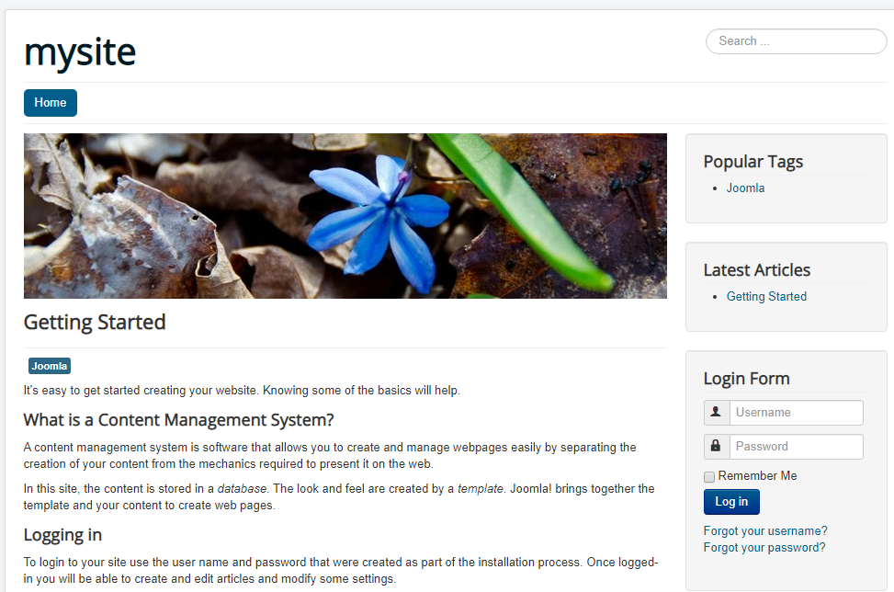

The front-end site that you are looking at is defined by a template of Joomla. There are two features of the template to consider. First is the actual design which includes elements like logo, colour and font etc. These are primarily controlled by cascading style sheets in the template file. The second component is positions. Now to understand this you can think of a template as a collection of boxes in which pieces of content is placed. These boxes are referred in Joomla as positions. The positions are determined by the template design. When a page is requested Joomla collects the required content and places it into the appropriate positions. There are different type of positions .First there is the main body position which is present in all Joomla templates. In this way there are positions on the left, right and top.

**Content types:**

The content that appears on the frontend can be divided into two types: The primary content and the secondary content. The primary content is the main article or the series of the articles that usually appear on the centre of the page. Everything else appearing on the page is called secondary content which are assigned to a particular template position. Each position can have many pieces of content. For example. the above demo site contains two menus and a login form at the right position. The secondary content is also referred to as modules. There are different type of modules that can be incorporated to your site using Joomla. For example, in our site the top menu module has a menu that links to other pages. This is how the frontend is structured by templates and modules.

**Joomla Backend (Administrator):**

The joomla backend is called the joomla administrator. This is where user’s can manipulate the look and feel and structure of their website.

To access I entered the site address and then backslash followed by the word administrator. This led to the administrator page as shown below:

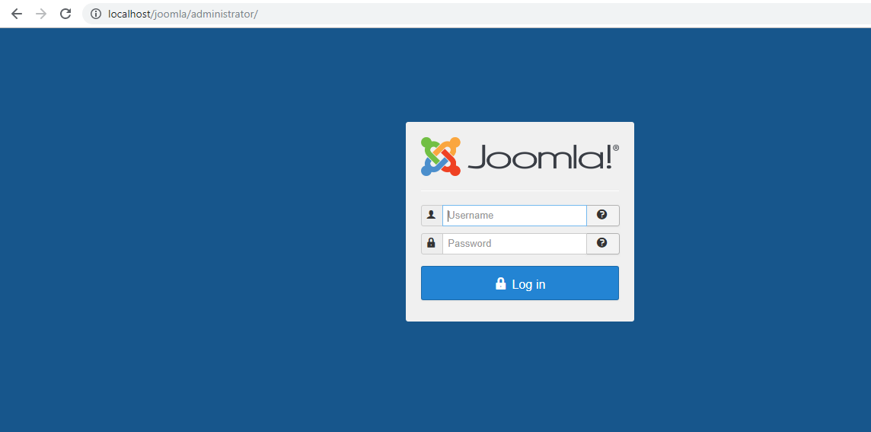

Now I entered the user name and password which I specified during installation and then I was taken to the page called control panel.

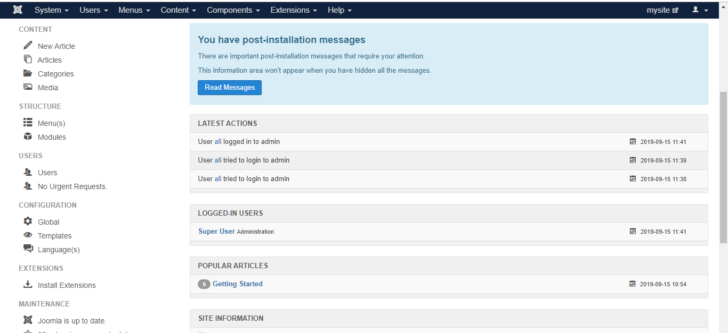

**Exploring the control panel:**

On the control panel page there are four main sections. At the top there is a main navigation panel which provides access to the core Joomla pages. Under the panel there is a title bar indicting your current position in Joomla control panel. The left5 panel provides shortcuts. Then there is a core content area panel. It displays the currently logged in users, popular articles and the most recently added articles. On some pages there is an additional panel called toolbar. The number of tools vary from page to page. 

Let us look at the main sections of the administrator accessed from the top menu.

**System menu:**

The first link on the system menu takes you back to the actual control panel page. The second link is the global configurations which contains the settings for your site. There are also options like clear cache and clear expired cache if you are having issues with your site. You can also view system information in the system menu.

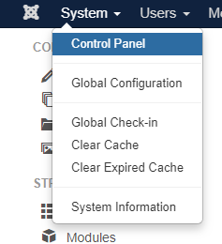

**User menu:**

Allows you to create user accounts for both admin and front end of the site. It has an excessive access control feature that allows you to set rules on content access and content editing. It has the following options:

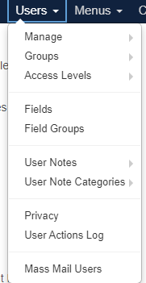

**Menu:**

This navigation menu helps to create, mange and configure menu items.

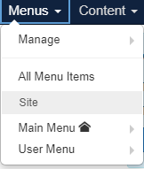

**Content menu:**

The actual content items are managed from the content menu. It’s structure is similar to the file and folders on the computer**.**

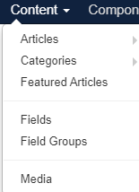

**Components:**

The components provide specific functionality. They provide dynamic functionality such as e-commerce or RSS feeds. The components are one type of Joomla extension.

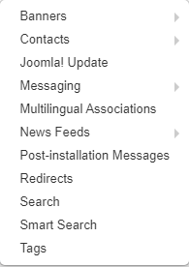

**Extensions:**

This menu item gives you access to extensions. Joomla has thousands of extensions.

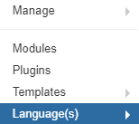

**Help:**

The last menu item is help which takes you to different websites, provide information and assistance.

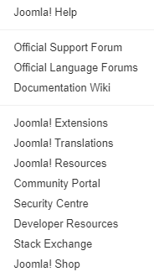

This was all about Joomla administrator page know we will go into the details of categories, menus, articles , templates, images and extensions.

**Categories:**

In Joomla we create content items called articles which resemble files on your computer. These are stored in categories like folders in your computer. You can access the category manager from the content manger. Here you can see that there are several categories listed. They are indented which shows that there are categories with in categories(sub categories). You can create your own category from the category manger.

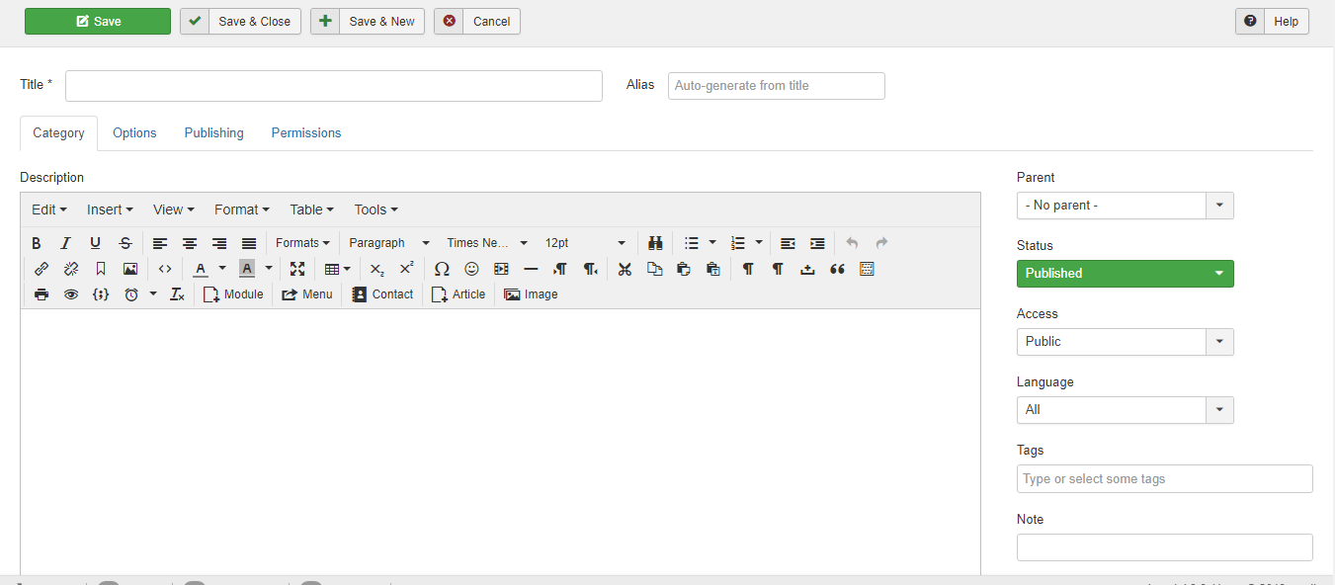

Here you can also set the category hierarchy. For example I created my own category named article.

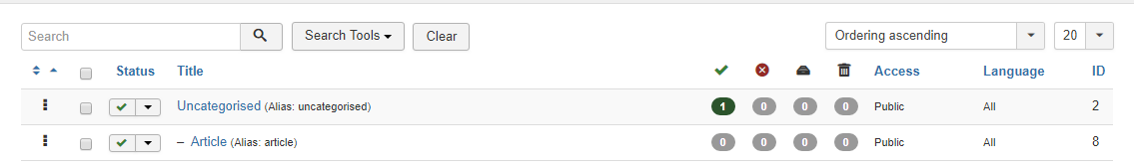

**Joomla Articles:**

You can create Joomla articles from the article manager. Select new article, than type title, now select the type of category where the article should be stored from the category select menu. Then start typing. You can also insert links in the article through the article editing tool. You can also filter and search articles through the search and filter menu in the article manger. I created a new article in category geography. You can also change the article status to unpublished, archived or trashed through the drop down menu on the article manager.

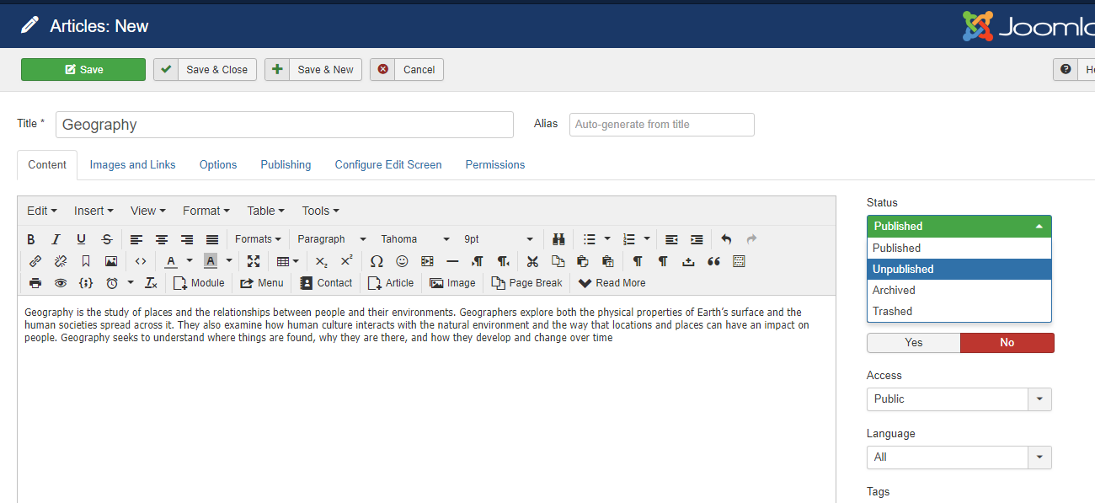

**Menus:**

In Joomla we first create content then we manage It with menus. You can create new menus, create links to an existing menu in the menu manager. You can also see existing menus through the menu manger. You can also select the menu type such as main menu or user menu. Below I created a new menu:

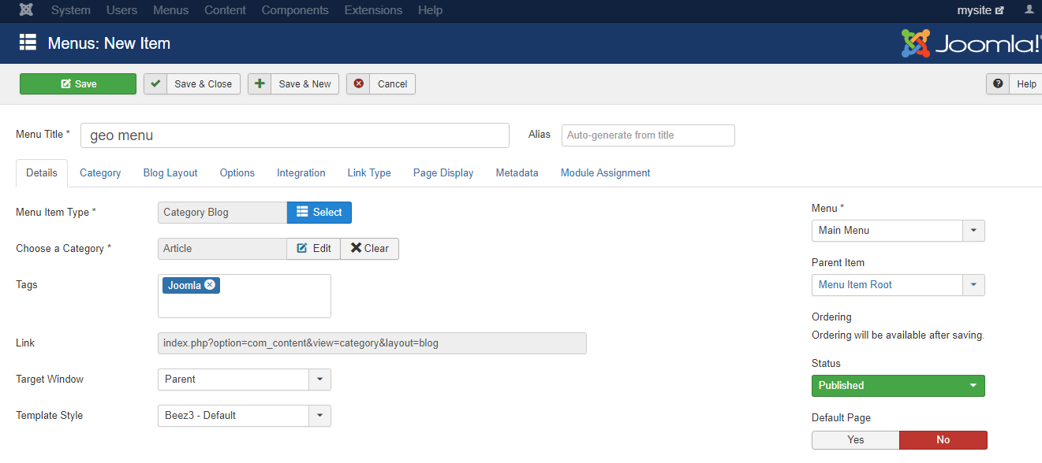

**Modules:**

In Joomla secondary content is managed by modules. Modules are assigned specific positions depending upon the template design. A single module can be assigned to many pages. To create a menu module go to modules in the extension menu here you can see the already present modules. I created a new menu module:

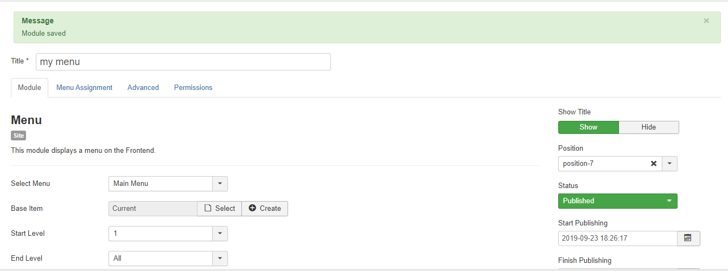

The module will be displayed on the found end. You can also change their positions.

**Joomla templates:**

In this we will see template manger, finding templates, installing templates, configuring templates and viewing template positions. Templates are a type of extensions and you can find them under the extension menu. You can also see the available templates.



You can download and add your templates as I added my own template as follows.

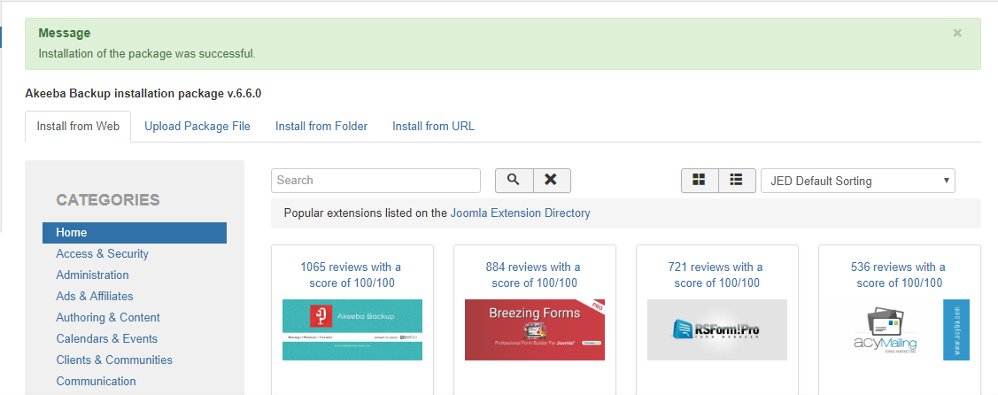

You can also change the default template as I changed for my site:

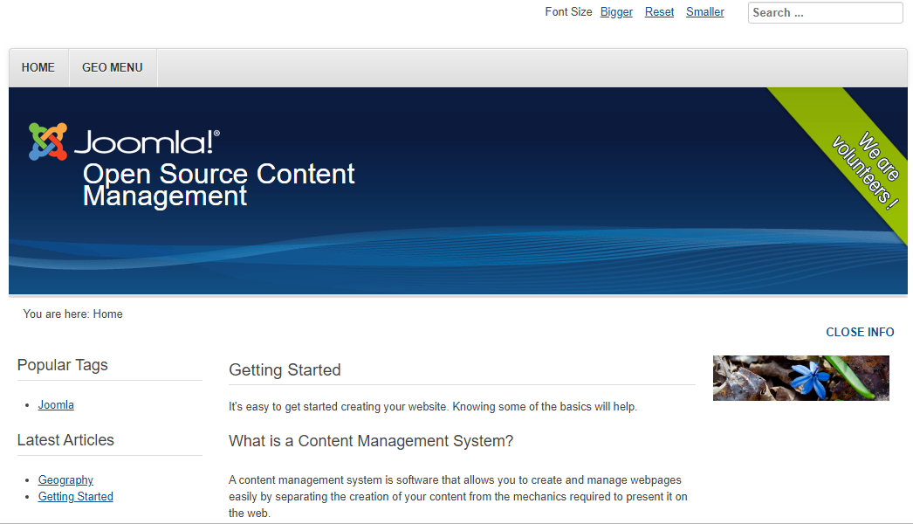

You can also configure your templates from the template manager as follows.

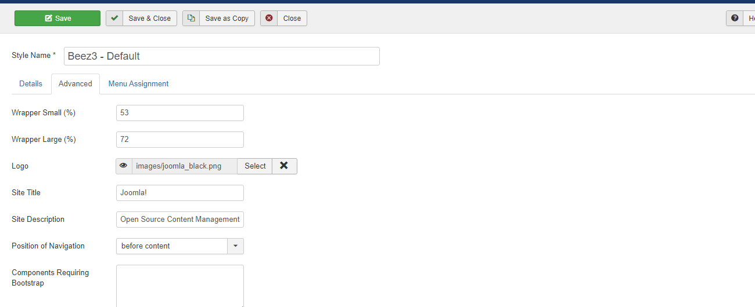

**Joomla Extensions:**

There are five types of Joomla extensions. These extensions provide extra functionality. They are;

* Components.
* Modules.
* Plugins.
* Templates.
* Languages.

To install the extension first find a suitable extension, download it and then install it. After that you can also configure the extension. I installed my extension:

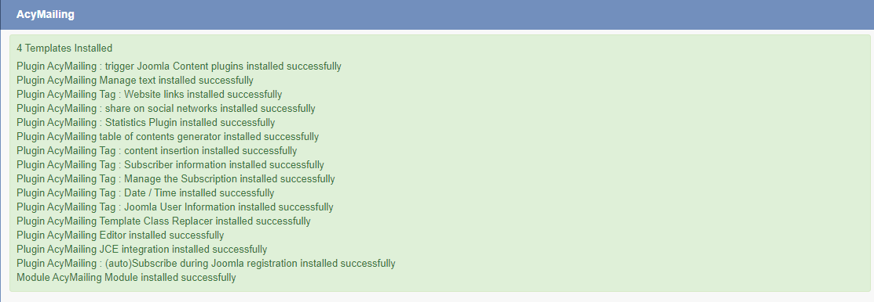

**Adding plug-ins:**

You can add plugins by visiting the plugins manager in the extensions menu.

I added the plugin from the previously installed extension as follows and I used a plugin to add custom code given in the coding section..:

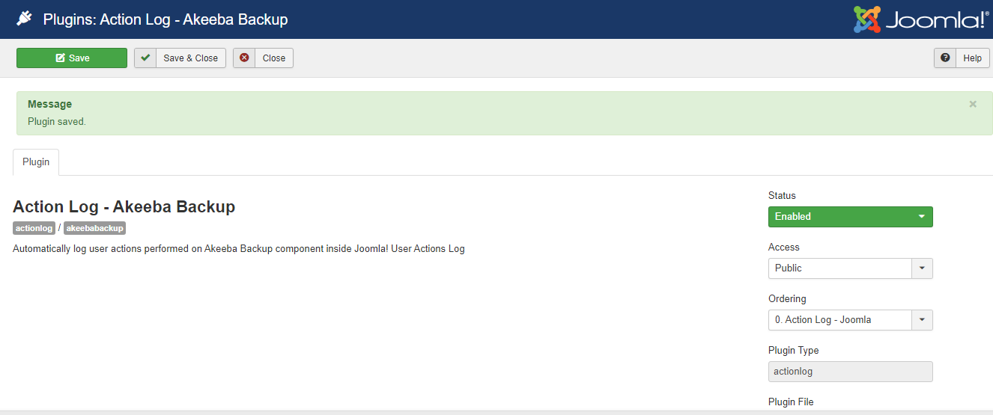

**Exploring Joomla as a coder:**

**Joomla Index.Php:**

Joomla is written in PHP. So whenever we visit a Joomla site we are directed to index.php rather than inde.htm. The index .php file of Joomla is the core and basic structure of every Joomla website. The index.php file of Joomla contains two type of code: one is a mixed code that will be transferred as it is, and the other one is php code which will be . In this way the index .php of Joomla serves as the backbone of every Joomla website.

**How to add Custom Code?:**

In order to write custom code in Joomla you can use **custom plug-ins** like Sorcerer(for Php), EXT Custom JSS/CSS, JT Custom Html code, JT random Html code. You can also add by using **custom code modules** like Blank Module, Compago Blank Module, Custom Html advanced and Custom Css class on selected pages.

**Adding Custom Code Examples:**

1 **Adding custom Html:**

I added custom html to our article using” What You See What You get” editor.

CODE:

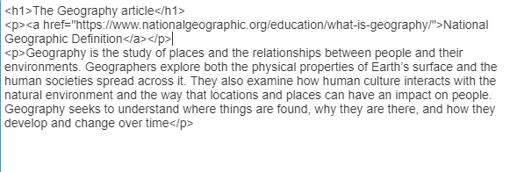

As you can see the changes were made to our Joomla site:

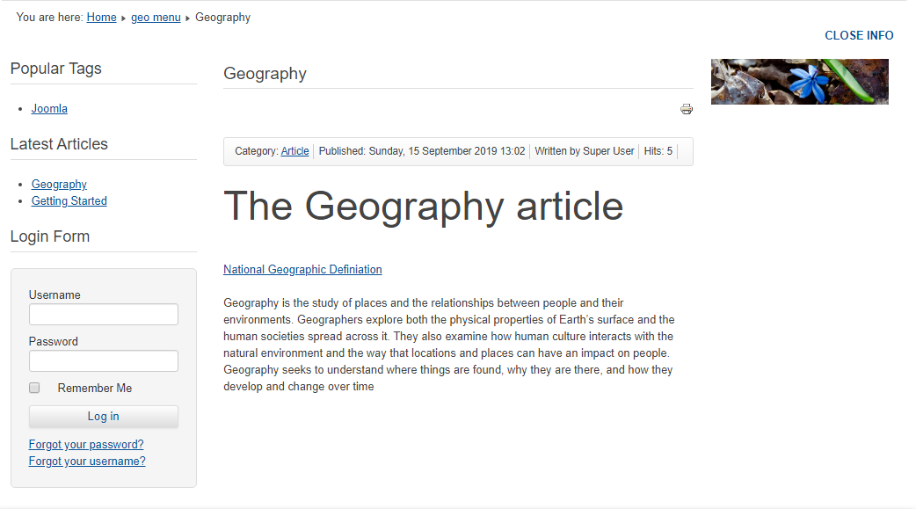

**Adding custom CSS using Custom CSS Plugin.**

I used a custom css adding plugin called **Custom Css** to add custom css to my site. I changed the background color, font size, padding and added a text shadow effect t through my custom css code.

**CODE:**

**.** .well {

padding: 20px;

background-color:yellow;

font-size: 20px;

}

.well ul {

text-shadow: 2px 2px red;

}

**Before:**

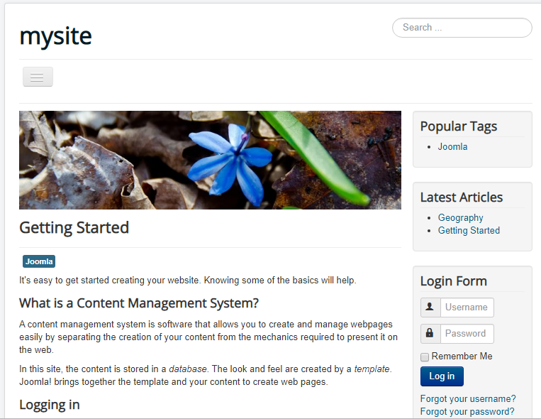

**After:**  
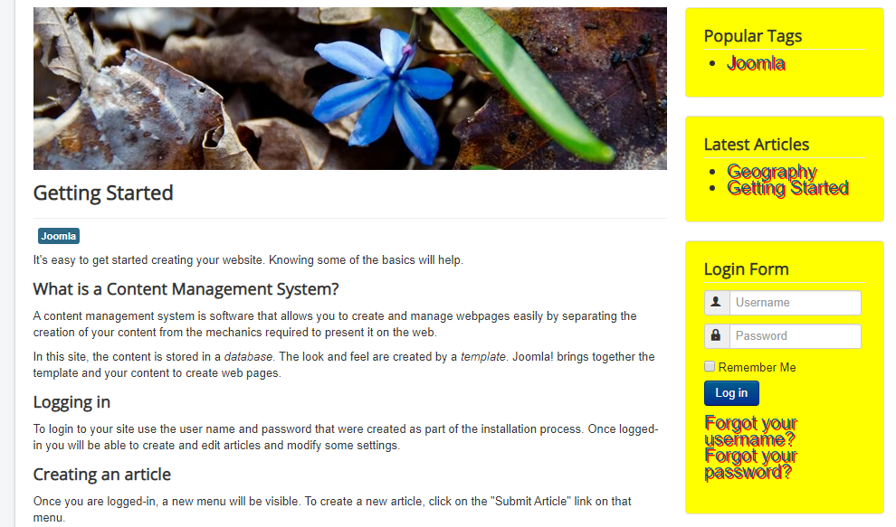

In the same way you can also add your own java script and php code to your own Joomla site using plugins and modules.

**Exploring Joomla as a Database Designer:**

Joomla data base storage structure is just like the Joomla file structure**. For example** components are going to be inside components database just like the components folder and

Modules are going to be inside the modules database just like the module folder etc.

**Accessing the Joomla Database:**

In order to access the Joomla database type localhost/dashboard in the url section. Then select phpMyAdmin. This will take you to the database. The database looks like this:

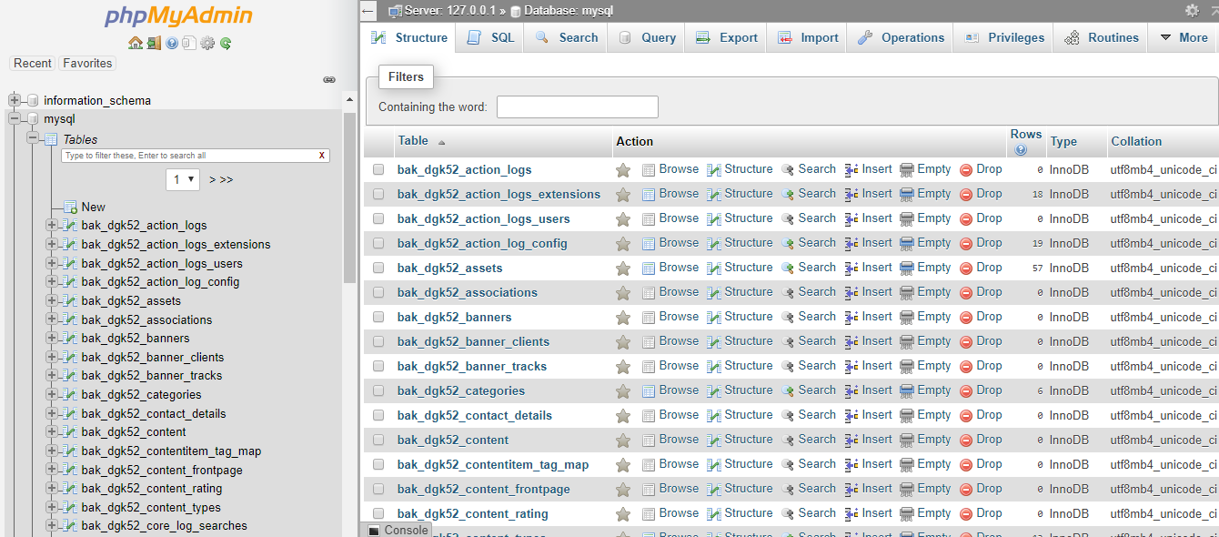

**The database Exploration:**

There are components, banners , modules, templates, users and menus etc in the database. Every time you install a component their will be new databases going to be created. Similarly, if you install a module, a new module database is going to be created. You can check all the available components, menus, templates etc that you have created in your Joomla site,by clicking on their respective databases. Like I am checking the available users insidethe database.

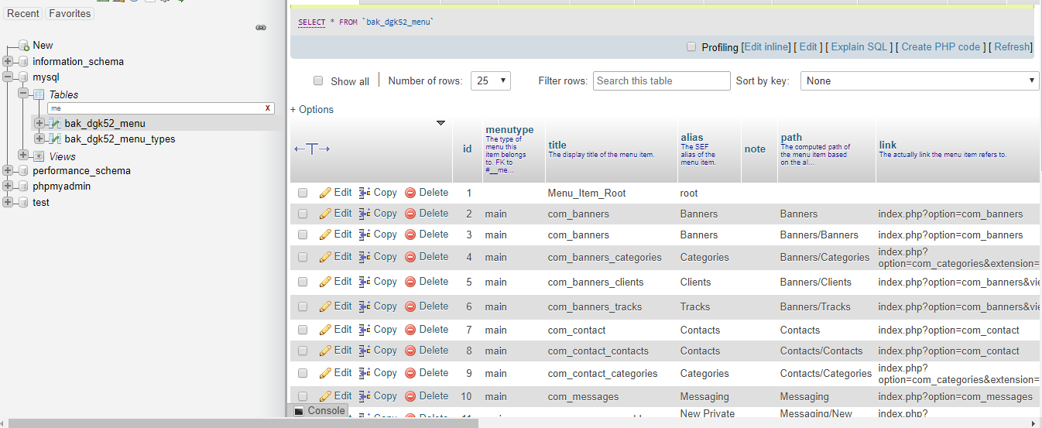

You can also explore the information schema. There are two things that you can do to your Joomla database whether you are an expert or not.

**1 Component Removal:**

When you install as new component a new database is created. But if you uninstall the component, the database for that component is not removed/deleted. You can easily remove the uninstalled components in the Joomla database manually

**2**.**When You forget your user password:**

When you forget your username or password you can easily get it through the user’s table in the database.

You can also perform plenty of other operations through the database.

**Conclusion:**

This assignment helped me to get a look and feel of an open source software like Joomla. These open source software are powerful tools for creating web content and online applications . Compared to traditional programming(from scratch)they provide thousands of already created templates. Extensions and plugins making them highly effective and useable. I am interested to work on more open source software like Joomla in the near future.

**REFERNCE LINKS:**

* <https://rockettheme.com/docs/joomla/platform>
* <https://blog.templatetoaster.com/what-is-joomla/>
* <https://www.techopedia.com/definition/3276/joomla>
* <https://stackideas.com/what-is-joomla>
* <https://magazine.joomla.org/issues/issue-aug-2018/item/3351-10-reasons-to-choose-joomla><https://www.youtube.com/watch?v=agMGyThdulE>
* <https://www.youtube.com/watch?v=Qjnc0H8utks>
* <https://www.youtube.com/watch?v=UxOpekItIkc>
* <https://www.youtube.com/watch?v=JSXASeWFge4>
* [https://www.cloudaccess.net/joomla-knowledgebase/96-joomla-3-1/article-manager/503-embedding-html-source-code-joomla-3-0.htmlhttps://www.cloudaccess.net/joomla-knowledgebase/96-joomla-3-1/article-manager/503-embedding-html-source-code-joomla-3-0.html](https://www.cloudaccess.net/joomla-knowledgebase/96-joomla-3-1/article-manager/503-embedding-html-source-code-joomla-3-0.html)