

Group  Members: | Amaan Khan (CT-25077)  Ammar (CT-25080)  Ali Ahmed (CT-25096)
Course: | Programming Fundamental (CT-175)
Submitted To: | Muhammad Abdullah
Project Name: | Visualizing Sorting Algorithms

Sorting Algorithms

Introduction
Sorting algorithms are key techniques in computer science. They arrange data in a certain order, be it ascending or descending, and are important. Sorting well not only makes data more readable, but also improves the performance of other algorithms, such as searching plus data analysis.

This report will discuss Bubble Sort, Insertion Sort and also Merge Sort; three popular algorithms. Every algorithm features a logic of its own, along with specific time complexity as well as application. Therefore the point of the report you see here is to show exactly how these algorithms function, compare performance, as well as identify the best places to put them into use.

Bubble Sort

Introduction
Bubble Sort is one of the simplest and most well-known sorting algorithms in computer science. It works by repeatedly comparing adjacent elements in an array and swapping them if they are in the wrong order. This process continues until the entire array is sorted, either in ascending or descending order.
Although Bubble Sort is not the most efficient algorithm for large datasets, it is an excellent way to understand the basic concepts of sorting, iteration, and comparison in programming.

Objective
The main objective of this program is to understand how the Bubble Sort algorithm works in sorting data. This includes learning how to take user input, store data in arrays, perform comparison and swapping operations, and finally display the sorted output to the user.

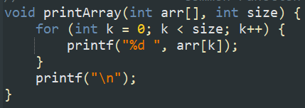
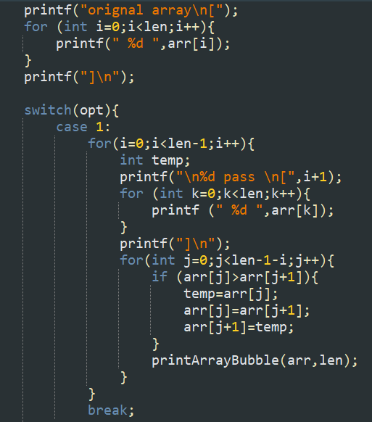
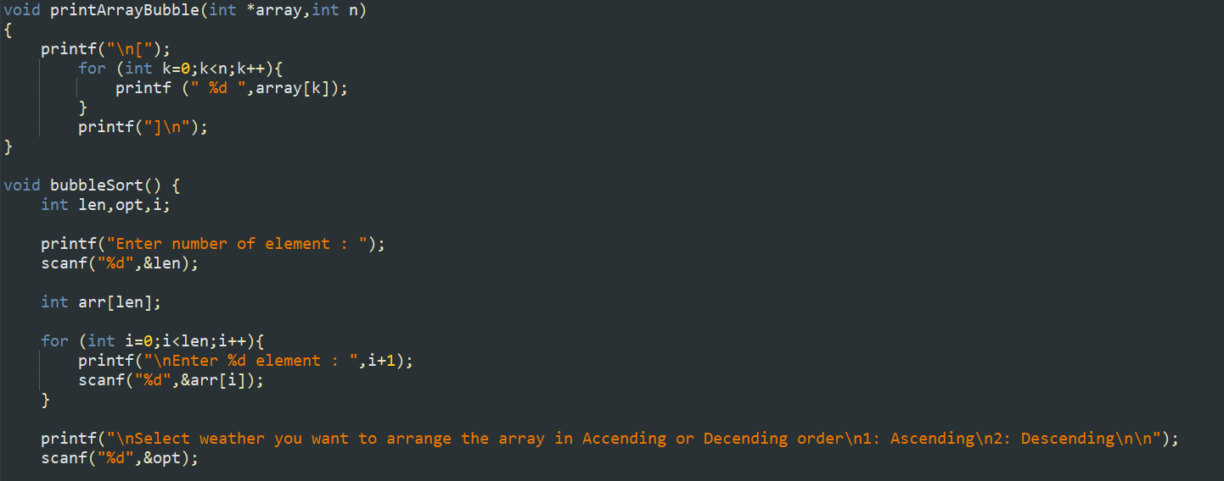

Explanation
Declaration:
The program declares variables for storing array length, user choice, and loop counters.
An array (arr )is created based on the length entered by the user.

Input:
The program asks the user to enter the total number of elements, then takes each element and stores it in the array.

Sorting Choice:
The user can choose between ascending or descending order. Based on the choice, the appropriate sorting logic runs.

Swapping:
Bubble Sort repeatedly compares each pair of adjacent elements. If they are not in the desired order, they are swapped.

Output:
After each swap round, the array is displayed, showing the gradual sorting process step by step.

Working and Output
The program starts by asking the user to enter the number of elements.
After the user provides the values, the array is displayed.
Then the user chooses the sorting order either ascending or descending.
During sorting, the algorithm compares each element with its neighbor.
If two elements are in the wrong order, they are swapped.
This process repeats until the entire list is sorted.
Finally, the sorted array is printed as the output on the screen.

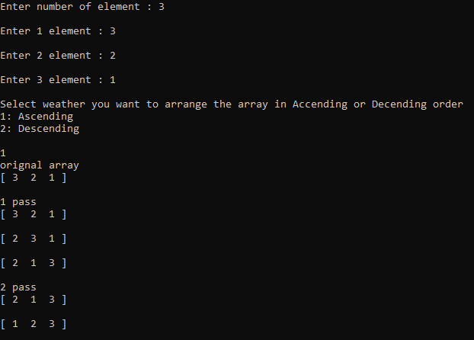
Time Complexity
Best Case: O(n) when the array is already sorted

Average Case: O(n²) for random data

Worst Case: O(n²) when the array is in reverse order

Space Complexity
Space Complexity: O(1)
Bubble Sort sorts the array in-place, meaning it doesn’t use any extra memory for another array. It only uses a few temporary variables for swapping.

Use Case
Bubble Sort is most effective when used with small datasets or when the list is almost sorted.
It’s commonly used for educational purposes to teach the basics of sorting, comparison, and iteration in programming.
In real-world applications, it’s often replaced by faster algorithms like Merge Sort, Quick Sort, or Heap Sort.

Conclusion
Bubble Sort is a fundamental and easy-to-understand algorithm that helps beginners learn how sorting works.
Although it’s inefficient for large datasets, it provides a clear example of how comparisons and swaps can gradually organize data.
Understanding Bubble Sort builds the foundation for learning more advanced and optimized sorting techniques.

Insertion Sort:
Insertion sort is considered one the simplest and intuitive sorting algorithms. The given program is designed to sort an array of integers entered by the user in ascending order. In this code, the sorting process begins with the first element being treated as sorted. Then, for each element, the program compares it with the previous elements using a nested while loop. If a smaller element is found, it performs a swap operation to shift the larger elements one position to the right until the correct position for the current element is found.

Objective:
The main objectives of this program is to understand the process of reading and storing array elements from the user. The implementation of the sorting algorithm and to display the sorted output to the user.

Code:
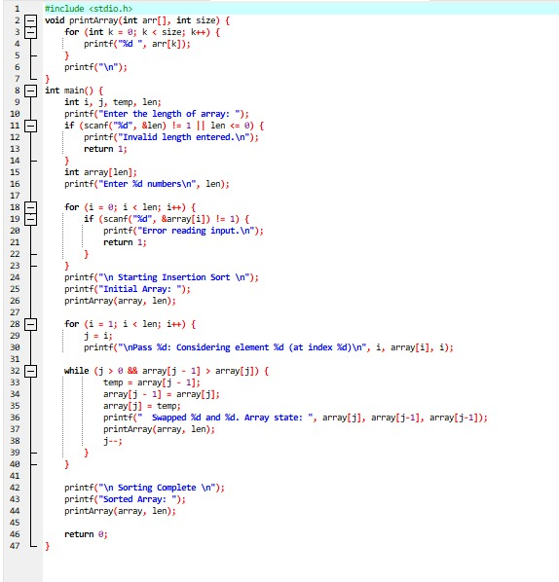

Explanation:
Header File:
Header files play an important role in programming languages. They serve as a bridge between the programmer and the compiler by providing the necessary declarations and definitions. The most common header file <stdio.h> which stands for Standard Input/Output Header is used to declare functions like:
• Printf (): Used to display output on the screen.
• Scanf (): Used to take input from the user.
Commonly used functions and definitions can be placed in a header file and reused in multiple programs increasing efficiency of programs.

Main Function:
This is the main function of every C program. Execution of a C program always begins from main (), regardless of where it is placed in the file. It is like an entry point of the program without it, the compiler would not know where to start executing instructions. The keyword int before main () means that the function returns an integer value to the operating system when the program finishes running.

Declaration:
- array[len]: This is a variable-length array that stores the integers entered by the user.
The size of the array (len) is provided by the user allowing flexibility in how many numbers can be sorted.
- temp: This is a used to store one element during a swap operation.
It helps in exchanging the positions of two array elements without losing data.
- i and j: i controls the outer loop, which iterates through each element of the array. j is used in the inner loop to compare and swap elements during the sorting process
Taking Input:
This code segment is responsible for determining the size of an array and then integrating that array with number of elements provided by the programmer.
-Printf("Enter the length of array: "): Displays the message on the screen by asking user to input length of the array.
-Scanf("%d", &len): Takes the user’s input and assigns it to len. This allows the program to create an array of the exact size required.
- Printf("Enter %d numbers\n", len): In this line, the format specifier %d is replaced at runtime by the value stored in the variable len, which represents the number of elements the user decided to sort. The format specifier \n is for changing line.
Sorting Process:
For Loop (Outer Loop): The sorting process begins with a for loop that runs from the first element to the last element of the array. It selects one element of the array that needs to be compared and possibly moved into its correct position. This loop ensures that every element is checked and placed properly to achieve a sorted array by the end of the sorting process.
Initializing j: Inside the outer loop, the variable j is initialized with the value of i. This means that j starts from the position of the current element selected by the outer loop. The purpose of j is to move from right to left through the already sorted array to compare element and swap them if necessary.
While Loop (Inner Loop): The inner while loop is responsible for comparing elements and swapping them if they are not present in the correct position. The condition j > 0 && array[j - 1] > array[j] checks if j has reached the beginning of the array and if the previous element is greater than the current element (array[j]).
temp: It is used to temporarily hold one of the elements during the swapping process. After the smaller element moves to the left j is then decremented to continue shifting if the elements are not in the correct position.
Display Sorted Array:
The final step confirms the result of sorting. It shows the user that the algorithm has successfully arranged the elements in ascending order.
- For Loop: This for loop runs from i = 0 to i = len - 1.
- array[i]: Accesses each element of the array one by one.
- printf("%d ", array[i]): Prints the current element followed by a space, so all numbers appear on the same line. The escape sequence \n is to change line.

Output:
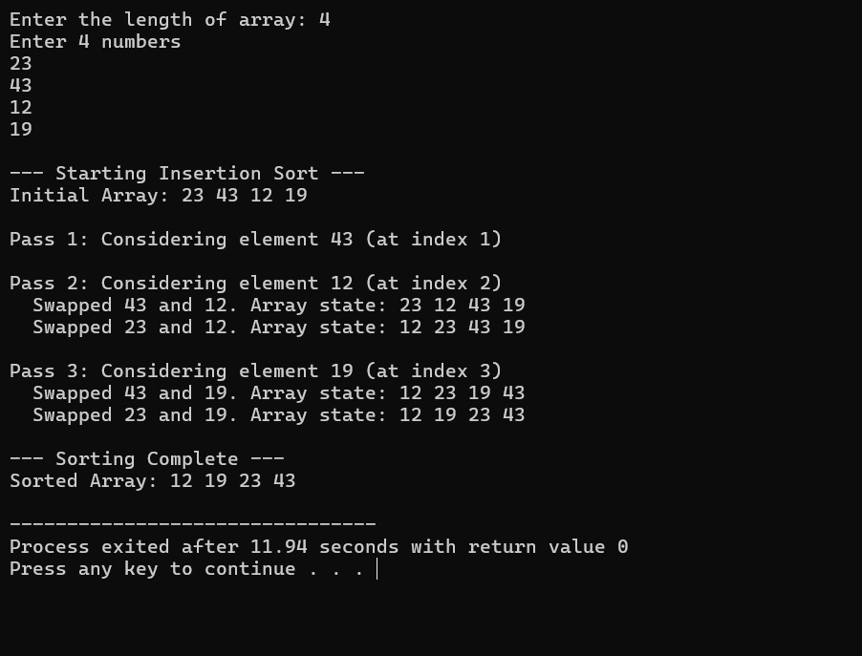

Working:
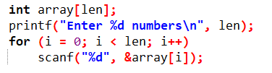
- Asks user to enter numbers and the loop is used to read len numbers and then store them in the array[i].

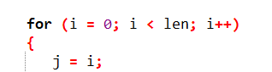
-This for loop is used to ensure each element is processed only once and goes from left to right. As the iterations goes on it takes the next unsorted element and finds its correct place. Initializing j is a crucial step as it marks the starting position of element before it starts to shift backwards.

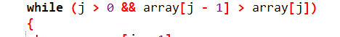
- The while loop only shifts when the left element is larger. It stops when it finds an element that is smaller or equal.It goes from right to left until each element slides to the correct position.
-array[j - 1] > array[j]: tells us that previous element is larger than current element.It is used to find correct place for the element.

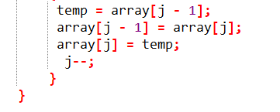
- It stores the previous element in temp.
- Moves the current element to its previous position
- Move previous element to current position
- Decrement operator is used to continue backward shifting process.

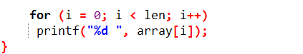
- After the insertion sort algorithm has completely finished organizing the array, this loop displays the final sorted array to the user.

Merge Sort

Program Overview:
This C program implements Merge Sort on an integer array input by the user. It uses a divide-and-conquer strategy to recursively divide the array into smaller subarrays, sorts them, and merges them back. The program includes detailed print statements for visualization of each step in the sorting process.

Key Components:
- Header Files:
#include <stdio.h>
#include <limits.h>
#include <stdlib.h>
- stdio.h for input/output functions.
- limits.h for INT_MAX used as a sentinel.
- stdlib.h for dynamic memory allocation (malloc and free) and program exit.
- Helper Function: printArray
void printArray(int *arr, int size)
- Prints all elements of the array.
- Used for visualizing intermediate results during sorting.
- Merge Function: Merge
void Merge(int arr[], int p, int q, int r, int size)
- Merges two sorted subarrays (arr[p..q] and arr[q+1..r]) into a single sorted array.
- Steps:
  - Calculate sizes n1 and n2.
  - Allocate memory for temporary left and right subarrays.
  - Copy elements into temporary arrays.
  - Append sentinel value INT_MAX at the end of each subarray to simplify comparison.
  - Merge elements back into the original array in order.
  - Print the merged subarray for visualization.
  - Free allocated memory to avoid memory leaks.
- Includes error handling if memory allocation fails.

Notes:
- The use of INT_MAX avoids using actual infinity.
- The printing part is just for visualization. Merge sort could be implemented without it too.
- Recursive Division Function: divideArray
void divideArray(int arr[], int p, int r, int size)
- Recursively divides the array until subarrays of size 1.
- Prints:
  - The current segment being divided.
  - Left and right subarrays before merging.
- Calls Merge to combine sorted subarrays.
- Main Function
int main()
- Prompts user for array length and elements.
- Calls divideArray to sort the array.
- Prints the final sorted array.

Sample Input/Output:
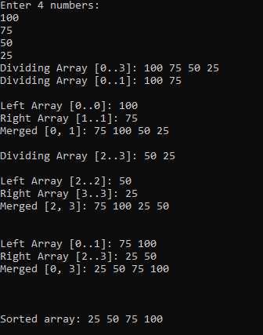

Key Features:
- Correct implementation of merge sort using dynamic memory allocation.
- Clear visualization of dividing and merging process.
- Proper memory management with malloc and free.
- Includes error handling for memory allocation failure.

Time & Space Complexity:
- Time Complexity: O(n log n) for all cases (best, average, worst).
- Space Complexity: O(n) due to temporary arrays for merging.

Use Case:
Best whenever utilizing particularly bigger volumes for details coupled using requirements associated in reliable forms that could provide assistance while stabilizing performance usually

Comparison Table
Algorithm | Best Case | Average Case | Worst Case | Space Complexity | Stability | Approach
Bubble Sort | O(n) | O(n²) | O(n²) | O(1) | Stable | Iterative
Insertion Sort | O(n) | O(n²) | O(n²) | O(1) | Stable | Iterative
Merge Sort | O(n log n) | O(n log n) | O(n log n) | O(n) | Stable | Recursive

Possible Improvements
- Implement hybrid sorting (e.g., combining Insertion Sort with Merge Sort for small subarrays).
- Optimize memory allocation in Merge Sort.
- Use parallel processing for large datasets.

Conclusion
Sorting algorithms form the foundation of efficient data manipulation in programming. While Bubble Sort and Insertion Sort are suitable for small or partially sorted datasets, Merge Sort excels with larger data volumes due to its logarithmic efficiency. Understanding these algorithms enhances one’s ability to choose the right technique for the right situation, balancing simplicity, speed, and memory efficiency.

