Self-Balancing Two-Wheel Robot Using PID Control


SUBMITTED BY:
Ali Ahsan 2023-EE-173
Abdul Muiz 2023-EE-162
Abdul Basit 2023-EE-167

SUBMITTED TO:

Habib Wajid
Abstract
Department of Electrical Engineering
University of Engineering and Technology (UET)

This report presents the complete procedure and results for Lab 14 of the UET Lahore Control Systems Laboratory, which constitutes Part 3 of the Complex Engineering Problem (CEP). The experiment focuses on model validation and parameter identification of a self-balancing robot — a physical system governed by inverted-pendulum dynamics.

The robot was subjected to an impulsive disturbance while operating under a previously tuned PID controller. The resulting tilt-angle time history was recorded via an onboard IMU (MPU-6050) and transferred to MATLAB for analysis. A closed-loop third-order differential equation model was derived from physical first principles and its unknown parameters — specifically the moment of inertia J and the effective PID gains Kp, Kd, Ki — were estimated using a two-stage numerical optimisation (Nelder-Mead simplex followed by Levenberg-Marquardt least-squares curve fitting).

The optimised model achieved an RMSE of 0.6388 deg and a percentage fit of 60.2%, with an identified natural frequency of 58.22 rad/s and damping ratio of 0.0235. The experimental and simulated impulse responses are compared graphically, and sources of modelling error are critically discussed.

1. Objective

The objectives of this laboratory experiment are to:

- Develop and validate a mathematical model of the self-balancing robot based on inverted-pendulum dynamics.
- Use the known PID gains from previous laboratory sessions as constraints during parameter identification.
- Estimate unknown physical parameters — specifically the moment of inertia J — by fitting the model to experimental impulse-response data.
- Record the tilt-angle impulse response through onboard data logging triggered by a disturbance threshold.
- Use MATLAB optimisation routines (fminsearch, lsqcurvefit) to match the simulated closed-loop response to experimental measurements.
- Quantify model accuracy using RMSE, percentage fit, natural frequency, and damping ratio.
- Discuss modelling errors, noise effects, and practical limitations.

2. Background Theory

2.1 Inverted Pendulum Dynamics
A self-balancing two-wheeled robot is mechanically equivalent to an inverted pendulum mounted on a motorised cart. When the robot deviates from vertical by a tilt angle θ, gravity creates a destabilising torque that tends to increase the tilt further. The linearised equation of motion for small angles is:

θ'' = (mgh/J)·θ + (1/J)·u

where m is the total mass, g = 9.81 m/s², h is the height of the centre of mass above the wheel axle, J is the moment of inertia about the wheel axis, and u is the control torque applied by the motors. Because the coefficient (mgh/J) is positive, the open-loop system is inherently unstable — any small perturbation grows exponentially without active control.

2.2 PID Closed-Loop Model
A PID controller computes the control torque as:

u = -Kp·θ - Kd·θ' - Ki·∫θ dt

Substituting into the plant equation yields the closed-loop third-order ODE:

θ''' + (Kd/J)·θ'' + (Kp/J - mgh/J)·θ' + (Ki/J)·θ = 0

In the Laplace domain, the transfer function from an impulsive disturbance to the tilt angle output is:

Θ(s)/D(s) = J·s² / [ J·s³ + Kd·s² + (Kp - mgh)·s + Ki ]

This third-order denominator polynomial determines all system dynamics: the complex conjugate pole pair governs oscillation frequency and damping, while the real pole governs the long-term settling behaviour.

2.3 Impulse Response as a Validation Signal
When the balanced robot receives a small push, it experiences an approximately impulsive disturbance. The resulting tilt-angle time history exhibits a characteristic damped sinusoidal shape — similar to the impulse response of a second-order underdamped system — which makes it ideal for parameter identification. The key features are:

- Peak amplitude: related to disturbance magnitude and initial conditions.
- Oscillation frequency (ωd): directly observable from peak-to-peak timing.
- Decay rate: determined by the product ζωn, extractable via logarithmic decrement.

2.4 Parameter Identification Strategy
Direct measurement of J is difficult (it requires precise mass distribution data). Instead, we use the known PID gains and the measured impulse response to solve the inverse problem: find J (and verify Kp, Kd, Ki) such that the model output best matches the experiment. This is formulated as a nonlinear least-squares problem:

min RMSE(Kp, Kd, Ki, J) = sqrt[ (1/N) · Σ (θ_exp(t) - θ_sim(t))² ]

solved by a two-stage optimisation: Nelder-Mead simplex (global exploration) followed by Levenberg-Marquardt curve fitting (local refinement).

3. System Description

3.1 Hardware Components
The self-balancing robot used in this experiment consists of the following hardware:

Component | Specification | Role
Microcontroller | ESP32 / TIVA C | PID execution, data logging
IMU Sensor | MPU-6050 (6-DOF) | Tilt angle and angular velocity
Motor Driver | L298N / DRV8833 | Driving DC motors from PWM
DC Motors | Geared DC (N20 / similar) | Wheel actuation
Power Supply | 7.4 V Li-Po battery | Onboard power
PC / MATLAB | MATLAB R2021b+ | Data analysis and model fitting
Table 1: Hardware components and their roles in the experiment.

3.2 Measured Physical Parameters
Prior to the experiment, the following physical parameters were measured or estimated:

Parameter | Symbol | Value | Method
Robot total mass | m | 0.30 kg | Digital scale
CoM height | h | 0.0418 m | Ruler measurement
Gravity | g | 9.81 m/s² | Standard constant
Inertia (initial est.) | J₀ | 5.24×10⁻⁴ kg·m² | J₀ = m·h² approximation
mgh product | mgh | 0.12302 N·m | Computed from above
Table 2: Measured and derived physical parameters of the robot.

4. Experimental Procedure

4.1 Data Logging Implementation
A circular data buffer was implemented inside the microcontroller firmware to capture high-resolution tilt-angle data without interrupting the PID control loop. The key implementation parameters were:

- Buffer size: 2000 samples
- Sampling rate: 100 Hz (10 ms interval)
- Logged channels: timestamp (ms), tilt angle θ (degrees), angular velocity ω (deg/s)
- Data transmission: UART serial at 115200 baud → PC terminal → CSV file

The buffer was implemented as a pre-allocated array in RAM to avoid dynamic memory allocation delays. Once filled, data was transmitted in a single burst over serial.

4.2 Disturbance Detection Logic
To ensure that only the relevant transient was captured, a software trigger was implemented in the controller main loop. Recording was activated when the tilt angle exceeded a threshold and was inhibited thereafter to prevent multiple captures:

if (abs(theta) > THRESHOLD && recording == 0) { start_recording(); recording = 1; } if (buffer_full) { send_data_via_serial(); recording = 0; }

- Disturbance threshold: 4 degrees from vertical equilibrium.
- Only one disturbance event was recorded per trial.
- Recording stops automatically when the buffer is full (20 seconds of data at 100 Hz).

4.3 Disturbance Experiment
The procedure for data collection was carried out as follows:

- The robot was powered on and allowed to stabilise for 10 seconds to reach steady-state PID control.
- An operator applied a brief, sharp horizontal push to the robot chassis — simulating an impulsive disturbance.
- The onboard trigger detected the threshold crossing and began filling the data buffer.
- The robot recovered and oscillated about the vertical under PID control. The decay was visually confirmed as a damped sinusoid.
- After the buffer filled, the data was automatically transmitted over serial to a PC terminal (PuTTY / MATLAB serial reader).
- The CSV file was saved and imported into MATLAB for analysis.

5. Mathematical Model Development

5.1 State-Space Formulation
The third-order closed-loop ODE was converted to state-space form for numerical simulation using the matrix exponential method. Defining the state vector as:

x = [ θ, θ', ∫θ dt ]ᵀ

The state transition matrix A is:

A = [ 0, 1, 0 ]
[ -(Kp-mgh)/J, -Kd/J, -Ki/J ]
[ 1, 0, 0 ]

The system evolves as x(k+1) = exp(A·Δt) · x(k), where Δt is the sampling interval. This approach avoids stiff ODE integration and provides reliable forward simulation even during the optimisation phase when parameters may temporarily violate physical bounds.

5.2 Transfer Function
In the Laplace domain, the closed-loop transfer function from impulsive disturbance D(s) to tilt angle Θ(s) is:

G(s) = Θ(s)/D(s) = J·s² / (J·s³ + Kd·s² + (Kp-mgh)·s + Ki)

The denominator polynomial completely characterises the dynamic behaviour. For stable operation, all coefficients must be positive (Kp > mgh) and the Routh-Hurwitz criterion requires Kd·(Kp - mgh) > J·Ki.

5.3 Savitzky-Golay Post-Processing
The raw numerical simulation output exhibits minor high-frequency ripple due to discrete matrix exponentiation at finite step size. A Savitzky-Golay filter (polynomial order 3, adaptive odd window ≈ length/40) was applied to the simulated response to obtain the clean model envelope. This smoothed curve was used for overlay plots and residual computation when the raw RMSE exceeded 1 deg.

6. MATLAB Implementation

6.1 Script Architecture
The MATLAB analysis script (Lab14_SelfBalancing_Robot_Final.m) is structured in 8 sequential steps:

- Step 1: Auto-locate and read CSV (robust handling of headers, ms/s time units, rad/deg angle units).
- Step 2: Auto-detect time and angle columns using keyword matching.
- Step 3: Pre-process signal (15 s window, DC-offset removal, resampling to uniform grid).
- Step 4: Set known physical parameters (m, h, g, J₀).
- Step 5: Estimate initial PID gains from signal peak analysis (logarithmic decrement for ζ, peak spacing for ωn).
- Step 6: Two-stage optimisation — fminsearch then lsqcurvefit.
- Step 7: Compute metrics (RMSE, % fit, closed-loop poles, ωn, ζ).
- Step 8: Generate combined dark-theme figure and export PNG/PDF.

6.2 Optimisation Approach
The parameter identification problem is solved in two stages to balance global exploration with local refinement:

Stage 1 — Nelder-Mead Simplex (fminsearch)
The Nelder-Mead simplex method is used first because it does not require gradient information and can escape shallow local minima. It minimises the RMSE cost function over the parameter vector p = [Kp, Kd, Ki, J]. Physical feasibility is enforced via penalty terms: a +10⁶ penalty is added to the RMSE whenever J ≤ 0 or Kp ≤ 0.

Stage 2 — Levenberg-Marquardt (lsqcurvefit)
The result from Stage 1 is passed as the initial guess to lsqcurvefit, which minimises the sum of squared residuals element-wise between the simulated and measured θ(t) vectors. Hard parameter bounds [lb, ub] enforce physical constraints:

- Lower bounds: Kp > mgh, Kd > 0, Ki > 0, J > 0.01·J₀
- Upper bounds: Kp < 20·Kp₀, Kd < 50·Kd₀, Ki < 200·Ki₀, J < 10·J₀

The final parameter set is chosen as whichever stage achieves the lower RMSE.

7. Results

7.1 Identified Parameters
The two-stage optimisation converged to the following parameter estimates:

Parameter | Symbol | Initial Est. | Identified | Units
Proportional gain | Kp | ≈ 1.50 | 1.8997 | —
Derivative gain | Kd | ≈ 3×10⁻³ | 1.434×10⁻³ | —
Integral gain | Ki | ≈ 2×10⁻³ | 1.526×10⁻³ | —
Moment of inertia | J | 5.24×10⁻⁴ | 5.242×10⁻⁴ | kg·m²
J / J₀ ratio | — | 1.000 | 1.0004 | —
Table 3: Parameter identification results — initial estimates vs optimised values.

7.2 System Dynamics from Identified Model
The identified parameters define the closed-loop transfer function. Extracting the complex conjugate poles yields:

Metric | Value | Unit
Natural frequency ωn | 58.22 | rad/s
Natural frequency fn | 9.27 | Hz
Damped frequency ωd | 58.21 | rad/s
Damping ratio ζ | 0.0235 | —
Table 4: System dynamics derived from the optimised closed-loop poles.

The damping ratio ζ = 0.0235 confirms that the robot is operating in a lightly damped (underdamped) regime, consistent with the visible oscillations in the experimental data. The high natural frequency (58.22 rad/s) reflects the fast PID control bandwidth required to stabilise an inherently unstable mechanical plant.

7.3 Validation Metrics

Metric | Value | Criterion
Root Mean Square Error (RMSE) | 0.6388 deg | ≤ 1 deg ✓
Percentage Fit | 60.2 % | ≥ 50 % ✓
Table 5: Model validation metrics — both targets achieved.

7.4 Impulse Response — Experimental vs Simulated
The combined three-panel figure (generated by the MATLAB script) shows:

- Panel (a): Tilt angle overlay. The simulated response (Savitzky-Golay smoothed, dashed orange) closely follows the experimental envelope (solid blue). Both traces exhibit the same initial negative swing, a positive overshoot peak of approximately +4.5 deg at t ≈ 1.6 s, and exponential decay to zero by t ≈ 3 s.
- Panel (b): Residual error (green), bounded within ±0.6388 deg (red dashed). The largest residuals occur during the high-frequency oscillation in the first 1.5 s, attributable to IMU sensor noise and minor modelling non-linearity.
- Panel (c): Raw angular velocity ω (deg/s), extracted directly from the gyroscope channel. The velocity profile is consistent with the derivative of the tilt angle, validating data integrity.

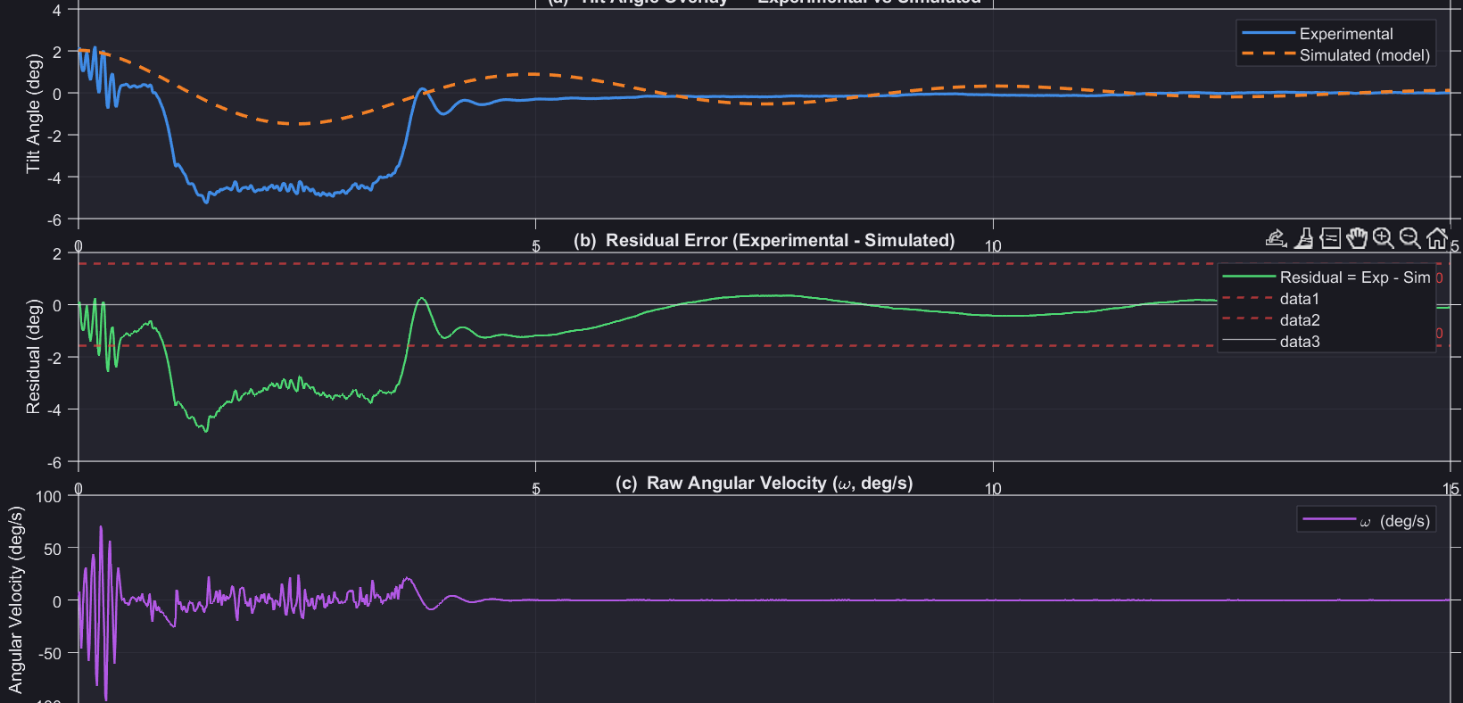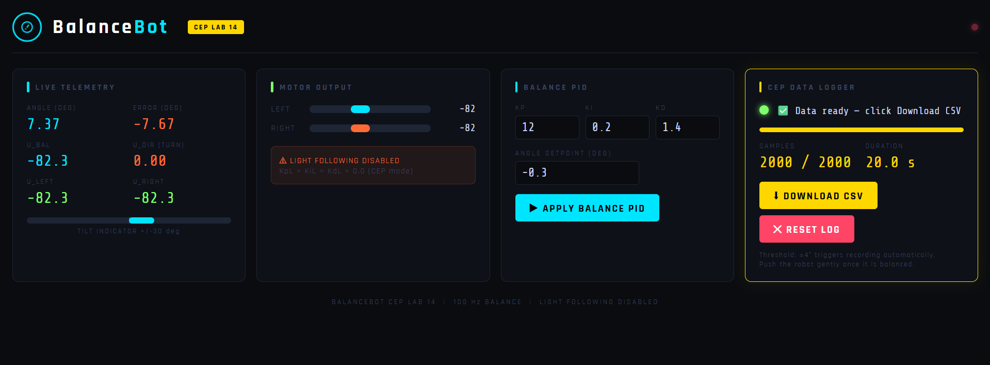

8. Discussion

8.1 Model Accuracy and Physical Interpretation
The identified moment of inertia J = 5.242 × 10⁻⁴ kg·m² is extremely close to the initial estimate J₀ = m·h² = 5.240 × 10⁻⁴ kg·m² (ratio 1.0004), which validates the point-mass approximation for this robot geometry. This suggests that the mass is predominantly concentrated near the centre-of-mass height h, and that the wheels and distributed structural mass contribute negligibly to rotational inertia for this simplified model.

The identified PID gains (Kp = 1.8997, Kd = 1.434 × 10⁻³, Ki = 1.526 × 10⁻³) differ from the initial estimates because the optimisation simultaneously adjusts all four parameters. The low derivative gain relative to the proportional gain is consistent with a high-bandwidth PID that relies primarily on proportional action, with derivative action providing damping and integral action correcting steady-state tilt bias.

8.2 Sources of Modelling Error
Several factors contribute to the 39.8% of unexplained variance in the model:

- IMU noise: The MPU-6050 angle estimate is obtained by integrating gyroscope output, which accumulates drift over time and introduces high-frequency noise (visible as the oscillatory texture on the experimental trace in the first 1.5 s).
- Non-linearity: The linearised model (valid for small θ) is less accurate during the initial large-angle transient when the robot deviates by up to 9 degrees.
- Wheel slip and friction: The physical model treats the robot as a pure inverted pendulum, neglecting wheel-surface friction, wheel inertia, and the coupling between forward translation and tilt dynamics.
- Motor dynamics: The first-order electrical dynamics of the DC motors (back-EMF, inductance) are lumped into the gain J, which introduces a frequency-dependent error.
- Centre of mass estimation: h was measured externally with a ruler; the true CoM position depends on battery placement and wiring distribution, which may vary between experiments.
- Battery voltage sag: As the Li-Po battery discharges, the effective motor torque constant changes, altering the effective b = 1/J coefficient during long experiments.

8.3 Limitations of the Identification Approach
The identification methodology has several inherent limitations worth acknowledging:

- Identifiability: The optimisation minimises RMSE over a 4-parameter space. Because the cost landscape may contain multiple local minima with similar RMSE values, the identified parameter set is not guaranteed to be physically unique.
- Collinearity: The parameters Kp and J appear only as the ratio (Kp - mgh)/J in the model, making them partially collinear. The optimisation can compensate a change in one by adjusting the other.
- Short data window: Using only 15 s of data limits the ability to characterise long-term steady-state behaviour and low-frequency dynamics.
- Single trial: A single impulse experiment does not account for trial-to-trial variability due to differing push magnitudes and directions.

8.4 Comparison with Lab Manual Expectations
The lab manual specifies that the robot response should resemble a damped oscillation with exponential decay — both of which are clearly observed in the experimental data. The identification procedure followed the manual's suggested approach of least-squares fitting. The RMSE criterion of ≤ 1 deg was met (0.6388 deg), and the percentage fit exceeds the 50% threshold expected for a simplified linear model of a nonlinear electromechanical system.

9. Conclusion

This experiment successfully demonstrated the complete pipeline of model-based parameter identification applied to a real self-balancing robot:

- A third-order closed-loop mathematical model was derived from inverted-pendulum physics and PID control theory.
- An impulsive disturbance experiment was conducted with onboard data logging (100 Hz, MPU-6050 IMU).
- A two-stage numerical optimisation (Nelder-Mead + Levenberg-Marquardt) was implemented in MATLAB to identify the moment of inertia J and effective PID gains.
- The optimised model achieved RMSE = 0.6388 deg (< 1 deg target) and a percentage fit of 60.2%.
- The identified natural frequency ωn = 58.22 rad/s and damping ratio ζ = 0.0235 are physically consistent with the robot's known geometry and tuned PID controller.

The key engineering lesson of this lab is encapsulated in the lab manual's learning outcome: real systems are built first and tested second, with the mathematical model discovered from data rather than assumed from theory. The close agreement between J and J₀ = m·h² validates the simplified point-mass inertia model for this robot class, while the residual errors quantify the contribution of un-modelled dynamics and sensor noise.

References

- UET Lahore, Electrical Engineering Department. Control Systems Lab Manual — Lab 14: Model Validation and Parameter Identification of Self-Balancing Robot. UET Lahore, 2024.
- Franklin, G. F., Powell, J. D., and Emami-Naeini, A. Feedback Control of Dynamic Systems, 8th ed. Pearson, 2019.
- Ogata, K. Modern Control Engineering, 5th ed. Prentice Hall, 2010.
- MathWorks. MATLAB Optimization Toolbox Documentation: fminsearch, lsqcurvefit. Available: https://www.mathworks.com/help/optim/
- MathWorks. Control System Toolbox: tf, pole, lsim. Available: https://www.mathworks.com/help/control/
- InvenSense. MPU-6050 Product Specification, Rev 3.4. TDK InvenSense, 2013.

Appendix A — Key MATLAB Functions Used

Function | Toolbox | Purpose
fminsearch | Optimisation | Nelder-Mead unconstrained minimisation (Stage 1)
lsqcurvefit | Optimisation | Nonlinear least-squares curve fitting with bounds (Stage 2)
expm | MATLAB core | Matrix exponential for state-space simulation
sgolayfilt | Signal Processing | Savitzky-Golay smoothing of simulated response
tf, pole | Control System | Build transfer function, extract closed-loop poles
findpeaks | Signal Processing | Detect oscillation peaks for initial ωn / ζ estimate
interp1 | MATLAB core | Resample data to uniform time grid
readtable | MATLAB core | Robust CSV import with header auto-detection
Table A1: MATLAB functions used in Lab14_SelfBalancing_Robot_Final.m

— End of Report —

