Self-Balancing Two-Wheel Robot Using PID Control


SUBMITTED BY:
Ali Ahsan 2023-EE-173
Abdul Muiz 2023-EE-162
Abdul Basit 2023-EE-167

SUBMITTED TO:

Habib Wajid
Self-Balancing Robot with Light Following (MIMO Control)
Department of Electrical Engineering
University of Engineering and Technology (UET)

1. Objective
The objective of this experiment was to design and implement a self-balancing robot capable of following a light source while maintaining dynamic stability. The system combines:
- A fast inner-loop PID controller for balancing
- A slow outer-loop PID controller for light-following
- Multi-rate MIMO (Multi-Input Multi-Output) control architecture
- Real-time telemetry and WiFi dashboard monitoring
The robot successfully demonstrates simultaneous stabilization and navigation behavior using hierarchical control principles.

2. Introduction
A self-balancing robot behaves like an inverted pendulum system, which is naturally unstable. To maintain balance, continuous feedback from an IMU sensor is required. In this experiment, additional light sensors (LDRs) were integrated so the robot could detect and move toward a light source.
The implemented system contains two interacting control loops:
Control Loop | Purpose | Frequency
Inner Loop | Balance stabilization | 100 Hz
Outer Loop | Light-following direction control | 20 Hz
This follows the frequency-decoupling principle described in the lab manual.

3. System Overview
The robot consists of the following major subsystems:
- ESP32 microcontroller
- MPU6050 IMU sensor
- TB6612FNG motor driver
- Two DC geared motors
- Three LDR light sensors
- WiFi-based telemetry dashboard
- Dual PID control architecture
The system uses:
- IMU data for tilt-angle estimation
- LDR sensor readings for light-direction estimation
- Motor differential control for turning

4. Hardware Components
Component | Purpose
ESP32 | Main controller
MPU6050 | Tilt angle measurement
TB6612FNG | Dual motor driver
DC Motors | Robot movement
LDR Sensors | Light detection
Li-ion Battery | Power supply
WiFi Dashboard | Real-time monitoring
The lab manual required at least two light sensors, while this implementation used a three-sensor arrangement (Left, Center, Right) for improved directional accuracy.

5. System Architecture

Block Diagram

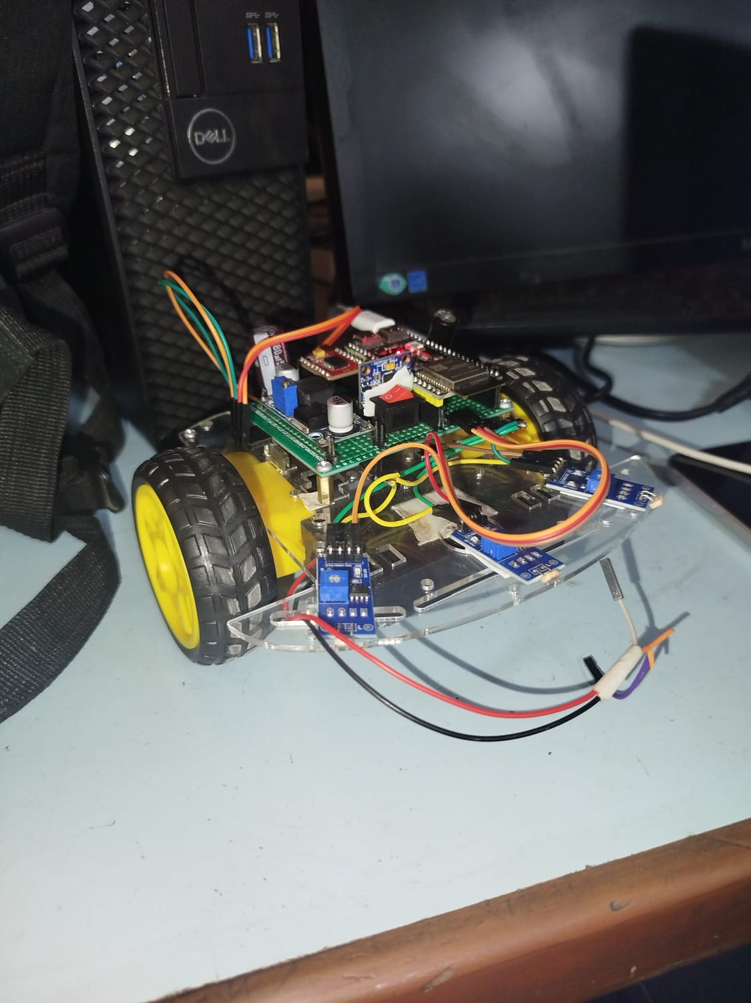
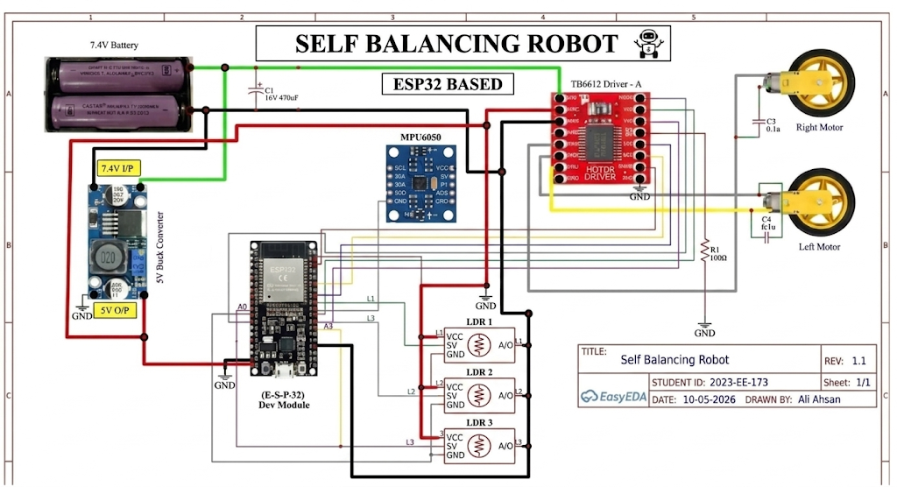The architecture follows the hierarchical control model specified in the lab manual.

6. Software Design
The software was implemented in Arduino C++ using ESP32 libraries.
Main libraries used:
#include <Wire.h>
#include <math.h>
#include <WiFi.h>
#include <WebServer.h>
The software contains:
- WiFi server
- Sensor acquisition
- Complementary filter
- Balance PID controller
- Light-following PID controller
- Real-time dashboard
- Telemetry system

7. MPU6050 Angle Estimation
The MPU6050 provides:
- Accelerometer data
- Gyroscope data
A complementary filter was used to estimate robot angle.
The accelerometer angle is computed as:
The complementary filter equation:
This filter combines:
- Fast gyroscope response
- Long-term accelerometer stability
Result:
- Smooth angle estimation
- Reduced sensor noise
- Stable balancing performance

8. Inner Loop – Balance PID Controller
The inner loop stabilizes the inverted pendulum system.
The implemented PID equation is:
Variable | Description
(e) | Balance error
(K_p) | Proportional gain
(K_i) | Integral gain
(K_d) | Derivative gain
Implemented gains:
float Kp = 12;
float Ki = 0.2;
float Kd = 1;
The loop executes every 10 ms (100 Hz).
Functions performed:
- Read IMU
- Estimate angle
- Compute PID
- Generate balance command
- Drive motors
The balance controller remained the primary fast subsystem as required in the lab manual.

9. Outer Loop – Light Following PID
The outer loop controls robot direction based on light intensity.
The light error is computed as:
e_{light}=L_{left}-L_{right}
Interpretation:
Condition | Meaning
(e_{light} > 0) | Light on left
(e_{light} < 0) | Light on right
(e_{light} = 0) | Robot aligned
The directional PID controller is:
Implemented gains:
float KpL = 0.050;
float KiL = 0.0;
float KdL = 0.006;
The outer loop runs every 50 ms (20 Hz).
This slower operation prevents disturbance to the balance loop.

10. MIMO Control Integration
The two control loops are combined using motor mixing equations:
u_{left}=u_{bal}+u_{dir}
u_{right}=u_{bal}-u_{dir}
Effects:
Motion Type | Cause
Forward/Backward | Balance controller
Turning | Light controller
This structure allows simultaneous balancing and steering.

11. Multi-Rate Control Implementation
Two timing loops were implemented:

Fast Loop (100 Hz)
Tasks:
- Read MPU6050
- Estimate angle
- Compute balance PID
- Drive motors
Code timing:
if (now - lastFast >= 10)

Slow Loop (20 Hz)
Tasks:
- Read LDR sensors
- Compute light error
- Compute directional PID
- Generate turn command
Code timing:
if (now - lastSlow >= 50)
This implementation matches the multi-rate architecture described in the lab manual.

12. Forward Motion Strategy
An additional feature was implemented using the center LDR sensor.
When the center sensor detects the brightest light:
forwardBoost = 1.2;
This slightly shifts the balance angle forward, causing the robot to move toward the light source while remaining balanced.
Advantages:
- Smooth forward motion
- Improved tracking behavior
- Reduced unnecessary turning

13. WiFi Dashboard
A real-time dashboard was developed using:
- HTML
- CSS
- JavaScript
- ESP32 WebServer
Dashboard features:
- Live angle display
- PID parameter tuning
- Motor output monitoring
- LDR sensor visualization
- Telemetry streaming
- Real-time control updates

14. Experimental Results
The robot successfully demonstrated:
- Stable balancing
- Directional turning toward light
- Real-time telemetry
- WiFi control
- Simultaneous balance and navigation
- Smooth turning behavior
- Forward movement toward aligned light
Light Position | Robot Response
Left | Turn left
Right | Turn right
Center | Move forward
No light | Maintain balance

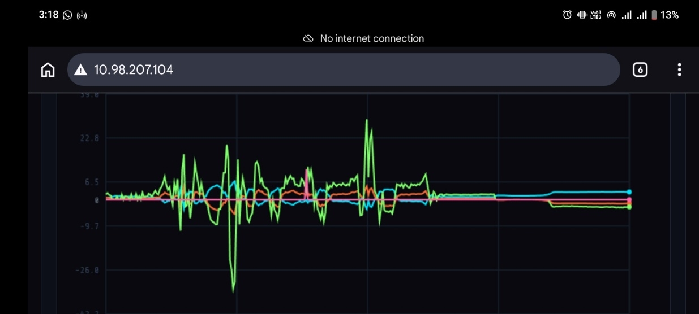
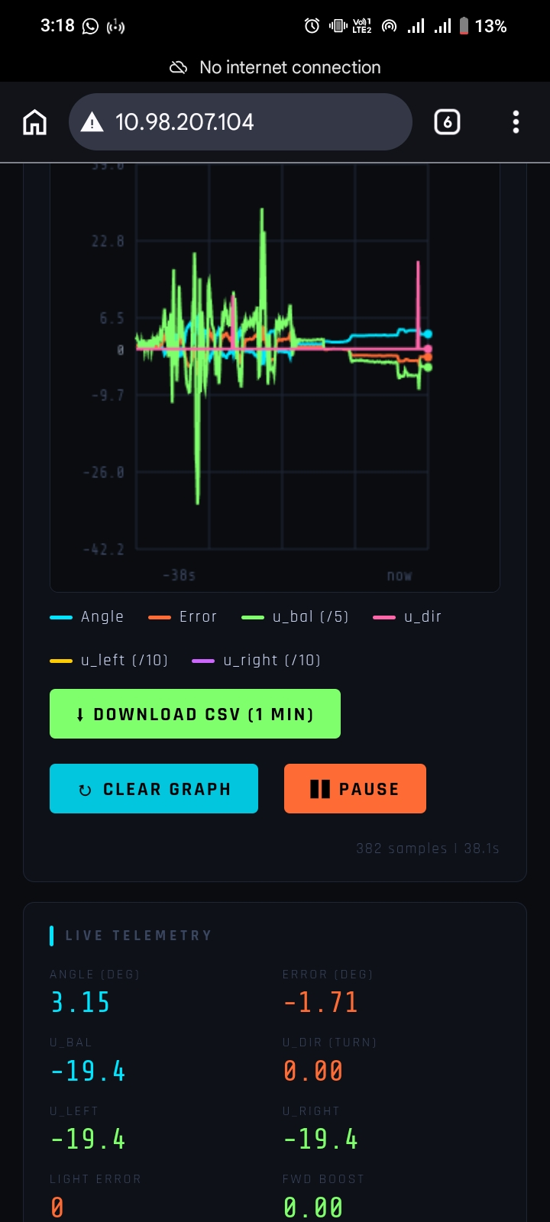

15. Tuning Procedure

Inner Loop Tuning
The balance PID was tuned first:
- Increase (K_p)
- Add (K_d) for damping
- Add small (K_i) to reduce steady-state error
Final tuned values:
Kp = 18.1
Ki = 0.16
Kd = 2.7

Outer Loop Tuning
The light PID was tuned second:
- Start with small (K_p^L)
- Increase until turning begins
- Add (K_d^L) to reduce oscillation
- Keep gains small
Final values:
KpL = 0.050
KiL = 0.0
KdL = 0.006

16. Challenges Faced
Several challenges were encountered during implementation:

Sensor Noise
- MPU6050 gyroscope drift
- LDR fluctuations due to ambient light

Stability Issues
- Excessive turning disturbed balance
- Large forward boost caused instability

PID Interaction
- Strong outer-loop gains affected inner-loop stability
- Careful frequency separation was necessary

Mechanical Vibrations
- Motor vibrations introduced noise into IMU readings

17. Discussion
The experiment successfully demonstrated a practical MIMO control system.
Key observations:
- Frequency decoupling simplified controller design
- Fast balance loop maintained stability
- Slow directional loop enabled navigation
- Small outer-loop gains prevented instability
- Hierarchical control improved robustness
The project clearly showed the transition from:
- Single-loop control
to
- Multi-objective robotic control
This aligns with the learning outcomes described in the lab manual.

18. Conclusion
A self-balancing light-following robot was successfully designed and implemented using ESP32 and MPU6050.
The system achieved:
- Stable balancing
- Light tracking
- Smooth directional control
- Multi-rate PID control
- Real-time telemetry monitoring
The experiment demonstrated:
- Practical PID implementation
- MIMO control architecture
- Frequency-decoupled control
- Real-time embedded systems integration
The robot successfully fulfilled the objectives and requirements of Lab 13.

