COMP5047 Resit Coursework – Task 3: Functional Model

Subsystem: CloudTables-Customer

(a) UML Use Case Diagram
The following use case diagram illustrates the key functional interactions between a Customer and the CloudTables-Customer subsystem. It highlights the system’s primary capabilities, with a particular emphasis on the 'Book Table' use case, as required by the coursework specification.
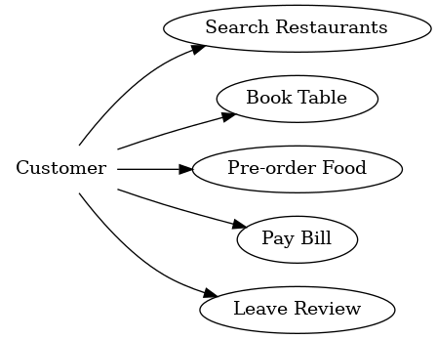
Actors:
- Customer
Use Cases:
- Search Restaurants: Enables customers to explore restaurants by location, name, or cuisine.
- Book Table: Allows customers to reserve a table at a selected restaurant, choosing a date, time, and party size.
- Pre-order Food: Facilitates the ordering of dishes in advance to streamline in-house dining.
- Pay Bill: Enables digital payment through integrated services.
- Leave Review: Lets customers rate their experience and provide feedback.

(b) Activity Diagram – Book Table Use Case
The activity diagram below models the detailed process flow of the 'Book Table' use case from the customer's perspective. It includes both customer and system actions, beginning from login and ending with either a successful table booking or an error if no availability is found.
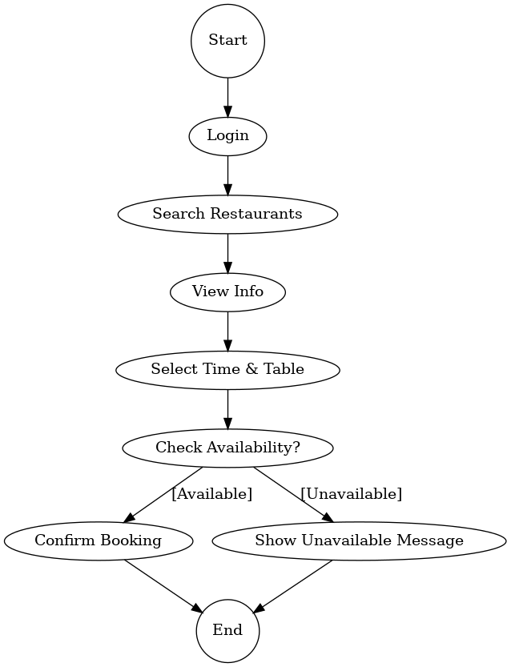
Actions:
- Login: The customer is authenticated.
- Search Restaurants: Customers browse potential restaurants.
- View Info: Restaurant details, such as seating availability and reviews, are displayed.
- Select Time & Table: The customer chooses a suitable time slot and party size.
- Check Availability: The system verifies if a table is free.
- Confirm Booking: Final step if a table is available.
- Show Unavailable Message: If no table matches the criteria, an appropriate message is shown.
This diagram supports the behavioral modeling of the subsystem and bridges into the detailed design phase with class and sequence diagrams.

