Task 4: Software Architectural Design
The CloudTables-Customer subsystem is designed using a microservices architecture style. Each major functionality is encapsulated in a self-contained service, communicating via RESTful APIs and operating independently. This architecture ensures modularity, scalability, and service isolation. The UML component diagram below models the subsystem structure, showing the service components and their interfaces.
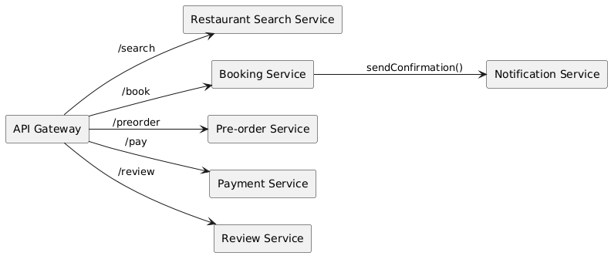
Interfaces & Responsibilities
The following table describes each microservice, its exposed (provided) interface, required interface dependencies, and responsibilities:
Component | Provided Interface | Required Interfaces | Description
API Gateway | IClientEndpoint | All internal services | Routes customer requests to appropriate services via REST APIs.
Restaurant Search | ISearchService | None | Enables customers to search/filter restaurants.
Booking Service | IBookingService | ITableAvailabilityService | Validates and stores table reservations.
Pre-order Service | IPreOrderService | IMenuService | Manages pre-selection of food for booked tables.
Payment Service | IPaymentGateway | IPaymentProviderService | Processes customer transactions securely.
Review Service | IReviewService | None | Captures and stores user reviews and ratings.
Notification Service | INotificationSender | IBookingService | Sends booking confirmation and status updates via email/sms.

Textual Specification Summary
Each component in the subsystem is modeled as an independent microservice exposing a single public-facing interface. Connectors between components are modeled as RESTful HTTP API calls. The 'API Gateway' provides the external access point for customers using the mobile interface. The 'Booking Service' is central to the subsystem’s workflow, coordinating with 'Search', 'Pre-order', 'Payment', 'Notification', and 'Review' services as needed.

