Task 5: Software Detailed Design
Task 5a – Structural Model
The structural design of the Booking Service component is presented using a UML class diagram. This model captures the internal classes, attributes, and operations relevant to table booking, and defines the interfaces required and provided. This class diagram ensures that the detailed design supports modularity and aligns with the subsystem's architecture.
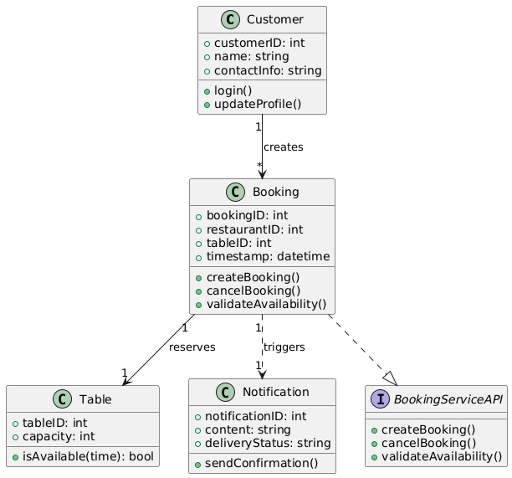
The main classes are:
-Customer: Represents the user making the reservation.
-Booking: Stores all reservation information.
-Table: Holds availability and capacity details.
-NotificationService: Used to send booking confirmation.
-IBookingService Interface: Describes the public API exposed by the Booking component.
Task 5b – Behaviour Model
The behaviour of the Booking Service component is described using a UML sequence diagram. This diagram demonstrates the internal logic when a customer attempts to book a table. It includes conditional logic for table availability and uses interaction fragments to model different outcomes.
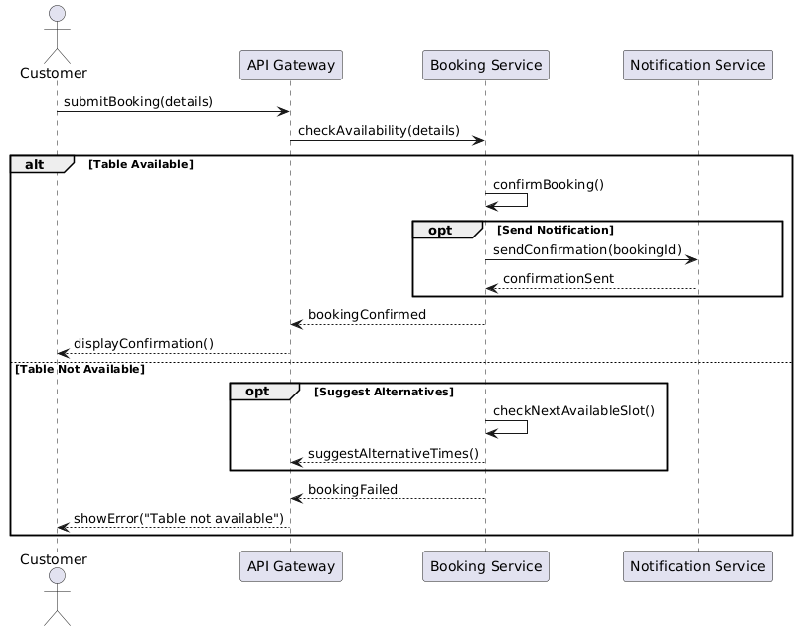
Flow Summary:
-The customer submits booking details to the Booking Service.
-The system checks table availability.
- If available, a booking is created and the NotificationService sends confirmation.
- If not available, an error message is returned.

