**USER INSTRUCTIONS**

**Survey Configurator App**

Year 2023  
Version 1.00

# Description of the App

## Purpose of the app

The Survey Configurator app is a powerful app designed to empower users to create and customize surveys effortlessly. With it is user-friendly interface and flexible options. By providing a wide range of question types, users can gather valuable feedback from respondents, enabling better decision making and enhancing their understanding of various topics.

# Understanding the user interface

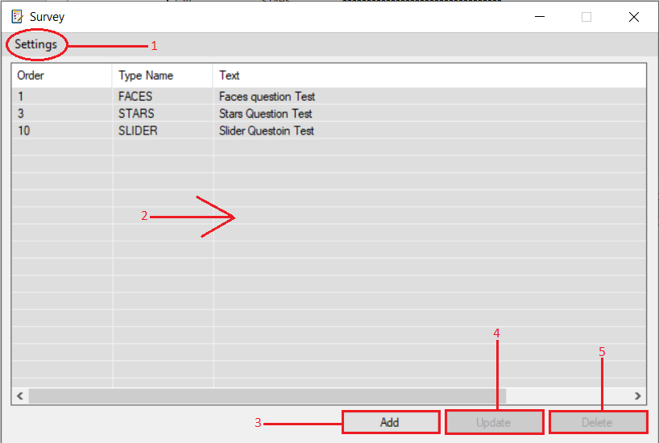

*Fig. 1* *Survey App*

## Settings: When you open the settings you will notice two important settings

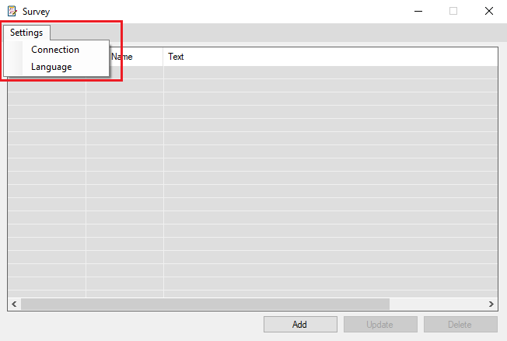

*Fig. 2 Settings*

### Connection: This setting is meant for system administrators who handle the technical aspects of the app. As a user you don’t need to worry about it.

* If you encounter “Connection Failed”, please seek assistance from the system administrator.

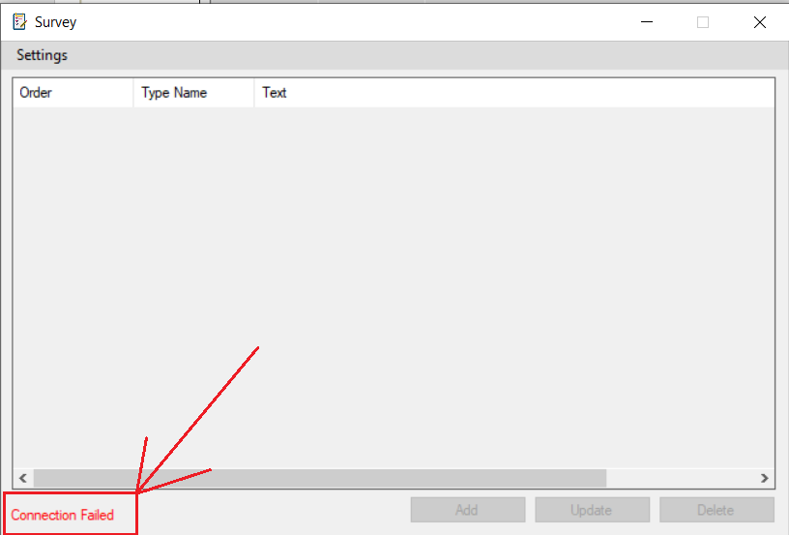

### Language: You have the power to change the language of the app interface to something that suits you.

* + - To open the language model just click in the language and the language dialog will pop up on the screen.
    - You can explore the available language from the drop-down menu.
    - Once you have selected your preferred language from the drop-down menu, click on the “**Save**” button to and the app will automatically restart.
    - Choose “**Cancel**” if you decide not to change the language, this will close the dialog.

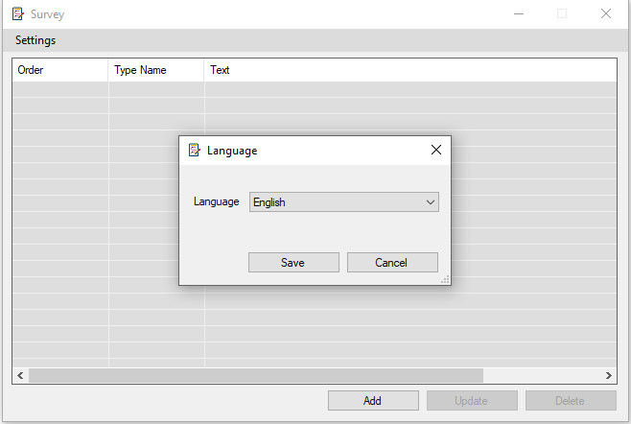

*Fig. 3 Language*

## List View: Displays all questions related to your survey.

* Click on column header to sort the questions ascending or descending

## Add: To add a new survey question

* + Click on the “**Add”** button, In the question dialog select the desired question type from the available options
    - **Understanding Question Types**

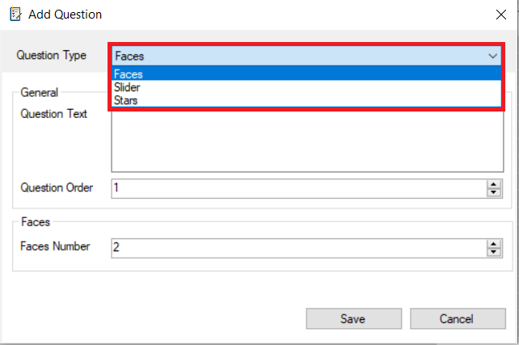

*Fig. 4 Question Types*

* + - **Faces Question: This question type allows you to choose the number of Faces that will appear in the survey which is representing different emotions or ratings**
    - **Slider Question: This question type allows you to customize the Slider in detail**
    - **Stars Question: This question type allows you to choose the number of Stars that will appear in the survey.**

### Required Inputs

* 1. For all question types you must provide the **Text** and **Order** of the question, make sure the length of the question text is greater than **10** characters and does not exceed **1500** characters.
  2. Enter a unique **order** number for the question, this is mean you can select an order that has not been used before in the survey.

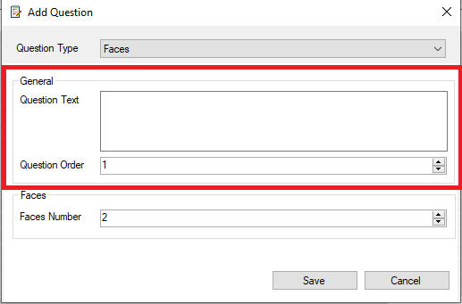

* 1. As you **select** different question types in the dialog the app’s user interface will dynamically adjust to accommodate the specific requirements of each question type.

#### Faces Question Requirements

* + Question **Text**: Provide a clear and concise question.
  + **Order** Number: Assign a unique number to determine the question's sequence.
  + **Faces** Number: Specify the range of 2 to 5 faces for respondents to select from.

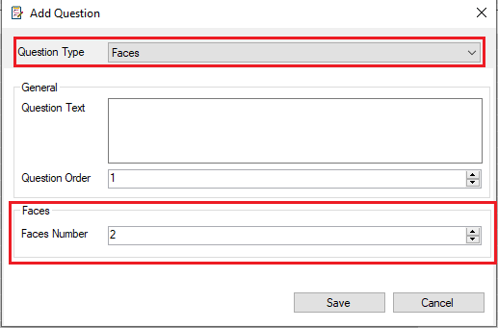

#### Slider Question Requirements

* + Question **Text**: Provide a clear and concise question.
  + **Order** Number: Assign a unique number to determine the question's sequence.
  + **Start** Value**:** Specifythe starting point of the slider range, the start value should be greater than or equal to **0** and less than the **End** value.
  + **End** Value**:** Specify the ending point of the slider range, the end value should be greater than the **Start** value and less than or equal to **100**.

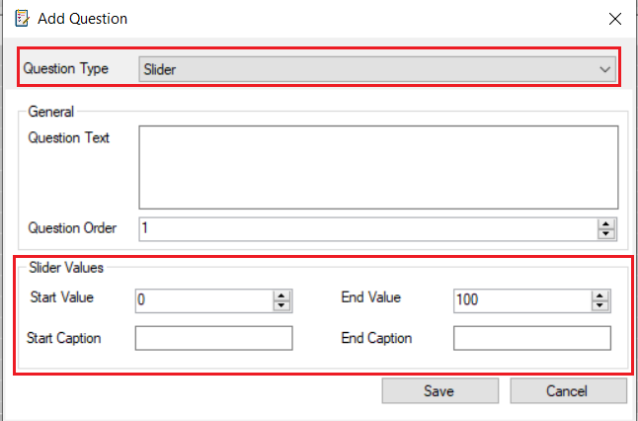

#### Stars Question Requirements

* + Question **Text**: Provide a clear and concise question.
  + **Order** Number: Assign a unique number to determine the question's sequence.
  + **Stars** Number: Specify the range of 1 to 10 star for respondents to select from.

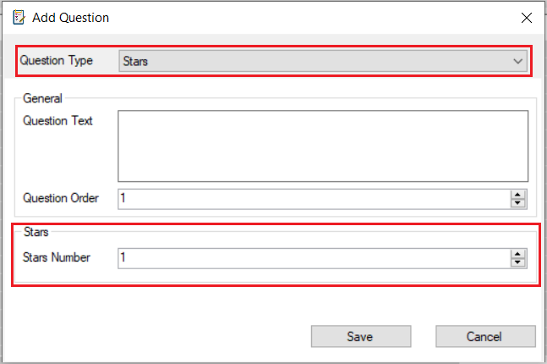

* 1. Click “**Save**” once you have entered the question requirements.
     + **Successfully Save**: If you have entered the question detail correctly, the dialog will close automatically.
     + **Save Failed:** If you miss any required fields or input incorrect information, the pop-up message will appear on the screen, indicating what you did wrong such as:

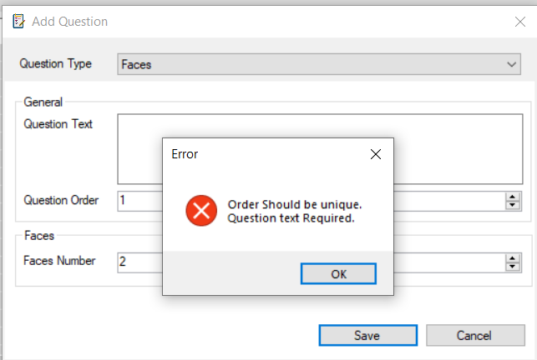

* 1. Click “**Cancel**” if you decide not to add the question, this will close the dialog.

### Update: To update the selected question

* 1. The **Update** button will inactive, that is mean you cannot update any question until you select one.

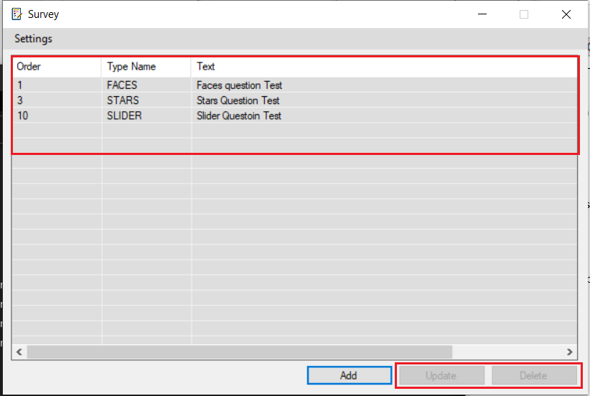

* 1. As you select a question the **Update** and **Delete** buttons will become active.

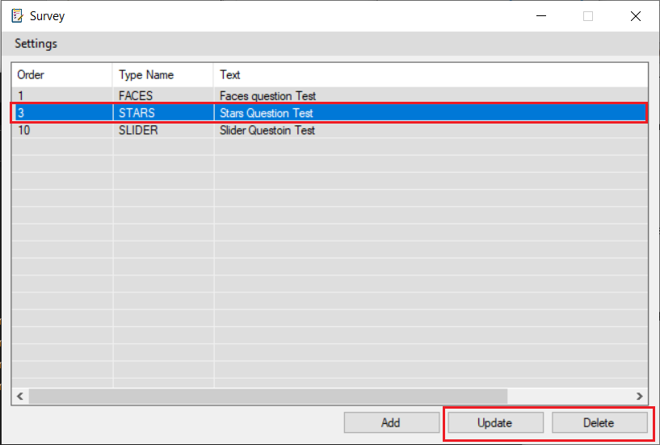

* 1. After you click on the update the same dialog of the Add question will appear
  2. You can modify the question detail except question type.
  3. Click “**Update**” to update the question.
  4. Click “**Cancel**” if you decide not to update the question, this will close the dialog.

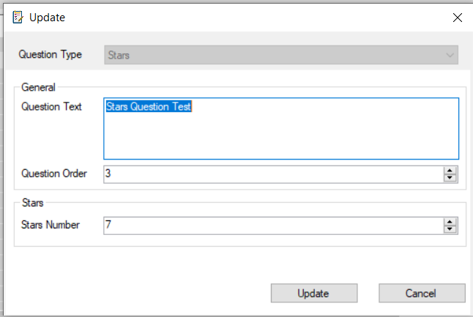

*Fig. 4 Update Question*

### Delete: To delete the selected question

* Select the question you want to delete.
* Click on the **Delete** button
* A pop up message will appear, asking you to confirm the operation

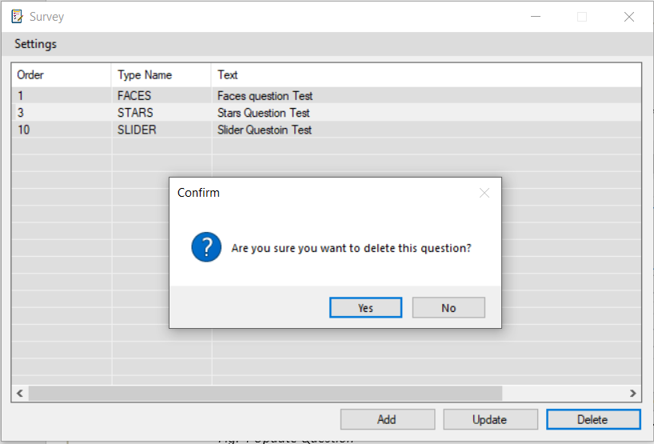

*Fig. 5 Delete Question*

In Conclusion, Survey Configurator is a powerful and friendly user interface, it offers a versatile platform for researchers, businesses, educators, and individuals.