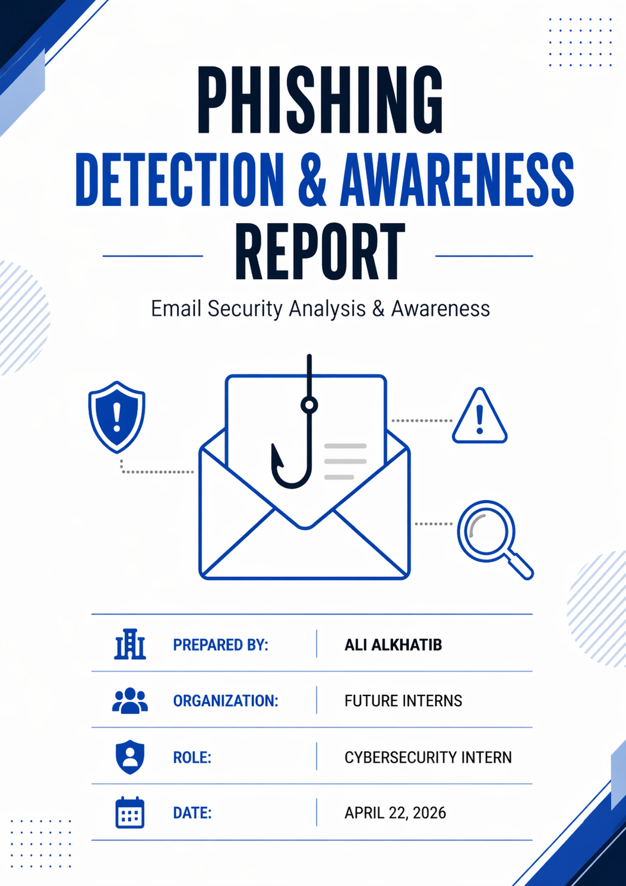

Introduction
Phishing attacks are one of the most common and effective cyber threats, targeting individuals and organizations by exploiting human behaviour rather than technical vulnerabilities. These attacks typically involve deceptive emails designed to trick users into clicking malicious links, revealing sensitive information, or downloading harmful content.
The purpose of this report is to analyse phishing email samples, identify common indicators of phishing attempts, and evaluate the associated risks. By understanding how these attacks are structured, this report also aims to provide practical awareness guidelines to help users recognize and avoid phishing attempts. This assessment focuses on safe and controlled analysis, ensuring that no interaction with malicious content is performed.

Phishing Email Analysis
This section examines selected phishing email samples to identify common characteristics and attack techniques used by cybercriminals.
Email Sample 1: Account Security Alert
From: security-alert@secure-support.com
To: user@example.com
Subject: ⚠️ Unusual Login Attempt
Dear User,
We detected a suspicious login attempt on your account.
Please verify your identity immediately to avoid account suspension.
Verify here: http://secure-login-verification[.]com
Failure to act within 24 hours may result in account lock.
Regards,
Security Team
Category | Details
Phishing Indicators | - Generic greeting  - Urgent message  - Suspicious link
Risk Classification | Phishing (High Risk)
How the attack works | The email tries to scare the user, so they click the link and enter their login details on a fake site.
Potential Impact | Account can be hacked and personal data may be stolen
Prevention tips | - Don’t click unknown links  - Check sender email  - Use official websites

Email Sample 2: Bank Reward
From: rewards@secure-bank.com
To: user@example.com
Subject: 🎁 You’ve Received a Reward!
Date: April 21, 2026
Dear Customer,
Congratulations! You have been selected to receive a special reward from your bank.
To claim your reward, please verify your account details below:
Verify here: http://bank-reward-claim[.]com
This offer expires soon.
Regards,
Rewards Team
Category | Details
Phishing Indicators | - Generic greeting  - Suspicious link  - Too good to be true offer
Risk Classification | Phishing (High Risk)
How the attack works | The email tricks the user by offering a reward so they click the link and enter their details on a fake site.
Potential Impact | Bank details or login info can be stolen.
Prevention tips | - Don’t trust random rewards  - Check the link  - Use the official bank website

Email Sample 3: Delivery Scam
From: delivery@fast-shipping.com
To: user@example.com
Subject: Delivery Failed – Action Needed
Date: April 21, 2026
Dear Customer,
We attempted to deliver your package but were unable to complete the delivery.
Please confirm your address and reschedule delivery:
http://delivery-update-info[.]com
Failure to respond may result in package return.
Regards,
Delivery Team
Category | Details
Phishing Indicators | - Generic greeting  - Creates urgency about delivery  - Contains an unknown link
Risk Classification | Phishing (High Risk)
How the attack works | The message pressures the user to click the link to fix a delivery issue, but the link leads to a fake page designed to collect personal details.
Potential Impact | User information such as address or login details could be exposed or misused
Prevention tips | - Avoid clicking links from unexpected emails  - Check delivery status from the official website  - Confirm sender legitimacy

Email Sample 4: Job offer scam
From: hr@global-careers-online.com
To: user@example.com
Subject: Job Opportunity - Immediate Hiring
Date: April 21, 2026
Dear Applicant,
We are pleased to inform you that you have been selected for a remote job opportunity with an international company.
To proceed, please submit your details and confirm your position using the link below:
http://job-confirmation-secure[.]com
Please respond within 24 hours to secure your position.
Best regards,
HR Department
Category | Details
Phishing Indicators | - Unexpected job offer  - Urgent response request  - Suspicious link
Risk Classification | Phishing (High Risk)
How the attack works | The attacker attracts the victim with a fake job offer and asks them to submit personal information through a malicious link.
Potential Impact | Personal data such as CV details, phone number, or ID information may be stolen and misused.
Prevention tips | - Be cautious of unexpected job offers  - Verify company authenticity and email  - Avoid submitting personal info through email links

Email Sample 5: Subscription Cancellation Scam
From: support@streaming-service.com
To: user@example.com
Subject: Your Subscription Has Been Cancelled
Date: April 21, 2026
Dear Customer,
Your subscription has been cancelled due to a billing issue.
To restore your access, please update your payment details using the link below:
http://subscription-reactivation[.]com
If no action is taken, your account will remain inactive.
Regards,
Customer Support

Category | Details
Phishing Indicators | - Unexpected account issue  - Urgent request to fix the problem  - Suspicious external link
Risk Classification | Phishing (High Risk)
How the attack works | The attacker creates a fake problem (cancelled subscription) to push the user into clicking the link and entering payment or login details
Potential Impact | Payment details or account credentials could be stolen and used for fraud
Prevention tips | - Check subscription on the official website  - Don’t trust email links  - Verify sender before acting

Email Sample 6: IT Security Compliance Notice
From: it-security@corp-supportdesk.com
To: user@example.com
Subject: Immediate Action Required: Password Compliance Update
Date: April 22, 2026
Dear User,
As part of our ongoing security improvements, all employees are required to update their account credentials to meet the new security compliance standards.
Our system has flagged your account as not yet updated, and access restrictions may be applied if no action is taken.
Please update your password and verify your account details using the secure link below:
http://secure-employee-password-check[.]com
This process should take less than 2 minutes to complete.
If you fail to complete the update within 24 hours, your account may be suspended to protect company data.
If you have already updated your password recently, please ignore this message.
Thank you for your cooperation.
Best regards,
IT Security Team
Corporate Helpdesk Services

Category | Details
Phishing Indicators | - Generic greeting  - Creates urgency (24 hour deadline)  - Suspicious external link (not company domain)  - Impersonates internal IT/security team  - Uses formal corporate language to appear legit
Risk Classification | Phishing (High Risk)
How the attack works | The attacker pretends to be part of the company’s IT security team and pressures the user to update their password length through a fake link.
Potential Impact | Compromise of user networks, unauthorized access to company systems, possible data breach
Prevention tips | - Always reset password from the official company website  - Don’t trust email links  - Verify sender domain  - Contact IT support directly

Phishing Summary Table
The table below summarizes the key characteristics and risk levels of all analyzed phishing emails.
Email | Type | Main Indicator | Risk Level
Email 1 | Security Alert | Urgency + fake link | High
Email 2 | Reward Scam | Too good to be true | High
Email 3 | Delivery Scam | Unknown link | High
Email 4 | Job Scam | Unexpected offer | High
Email 5 | Subscription scam | Fake issue + urgency | High
Email 6 | IT Password Scam | Impersonation + fake link | High

Key Observations
After analysing the phishing email samples, several common patterns were identified. Most emails used urgency, fake links, and generic messages to trick users. Attackers rely on human emotions such as fear and curiosity rather than technical weaknesses, making phishing attacks highly effective.

Common Phishing Patterns
- Urgency & Fear
  - “act now”
  - “account will be locked”
- Fake or Suspicious Links
  - External links not matching the actual website
  - Lookalike domains
- Generic Greetings
  - Dear User
  - Dear customer
- Impersonation
  - Pretending to be banks, IT team, delivery services
- Social Engineering
  - Fear (security alerts)
  - Greed (rewards)
  - Opportunity (jobs)

Awareness & Prevention Guidelines
To reduce the risk of phishing attacks, users should follow general security practices and remain cautious when working with emails, especially those that seem unusual or urgent.
Do’s (WHAT YOU SHOULD DO) | Don’ts (WHAT YOU SHOULDN’T DO)
Check if the email makes sense before reacting | Don’t panic or rush because of urgent messages or news
Look carefully at the sender’s email address | Don’t trust emails just because they look official
Think twice before clicking any link | Don’t click links without checking them first
Ask IT or a trusted person if unsure | Don’t try to handle suspicious emails alone
Use strong passwords and enable multi-factor authentication | Don’t reuse the same password everywhere
Stay updated about common scams | Don’t ignore security warnings

Organizational Protection
Organizations should implement multiple security measures to reduce phishing risks, including email filtering systems, employee awareness training, phishing simulation exercises, Multi-Factor Authentication (MFA), and proper incident response procedures.

Conclusion
Phishing attacks remain one of the most dangerous cybersecurity threats because they target human behaviour rather than technical systems.
The analysis shows that attackers use urgency, fake links, and social engineering techniques to deceive users.
Preventing phishing requires both strong security controls and continuous user awareness. Educated users play a critical role in protecting organizations from phishing attacks.

