**Exercise 1**

url: <https://blackboard.kfupm.edu.sa/webapps/portal/execute/tabs/tabAction?tab_tab_group_id=_1_1>

IP address: 198.11.1.87:443

Requests number: 116

Types: js, png, gif, css, jpeg, woff, json

Largest file: 19.6kB (tabAction?tab_tab_group_id=_1_1)

Take: 131 ms

**Exercise 2**

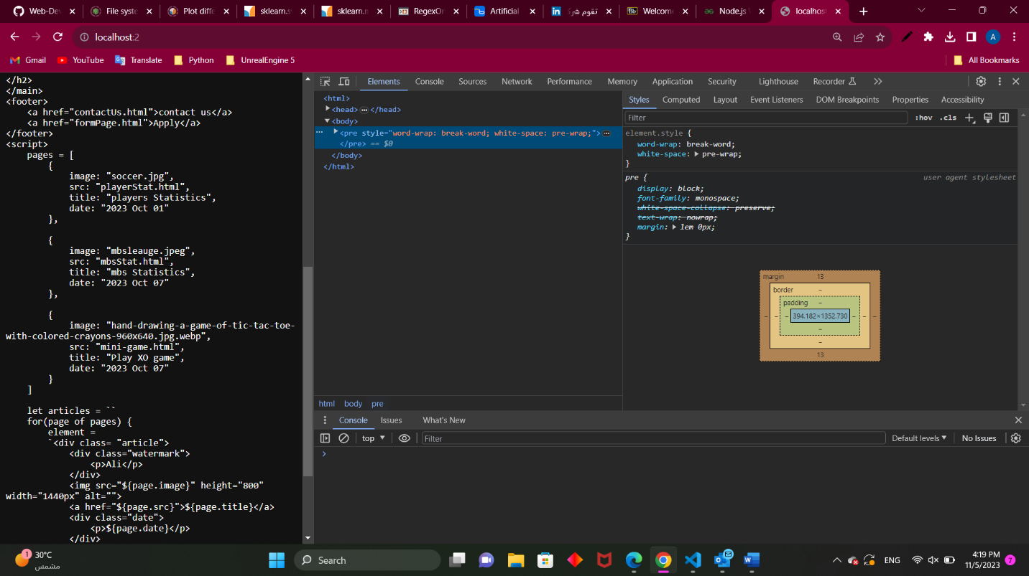

**Exercise 3**

alsannaa.co