**Colors:**

**Images:**



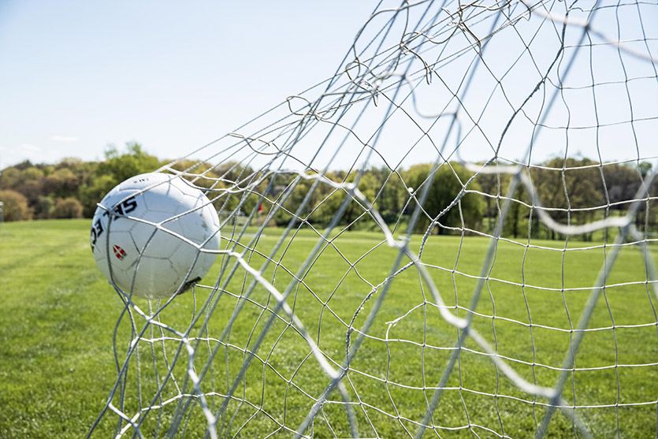

**Fonts:**

* Lato

<https://fonts.google.com/share?selection.family=Lato:ital,wght@0,100;1,100>