1. **differences between different types of SQL JOINs:**

Here are the different types of the JOINs in SQL:

* (INNER) JOIN: Returns records that have matching values in both tables
* LEFT (OUTER) JOIN: Returns all records from the left table, and the matched records from the right table
* RIGHT (OUTER) JOIN: Returns all records from the right table, and the matched records from the left table
* FULL (OUTER) JOIN: Returns all records when there is a match in either left or right table
* 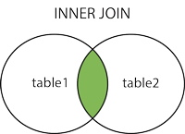  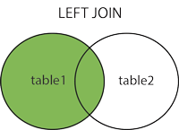  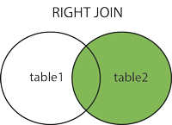  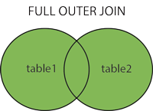

1. **Index**

A SQL index is a quick lookup table for finding records users need to search frequently. An index is small, fast, and optimized for quick lookups. It is very useful for connecting the relational tables and searching large tables. Notice that not only creating a primary key creates a unique SQL index.

1. **Subquery**

A subquery is a query that is nested inside a SELECT , INSERT , UPDATE , or DELETE statement, or inside another subquery. ... A subquery can be used anywhere an expression is allowed.

1. **denormalization and normalization**

Normalization is used to remove redundant data from the database and to store non-redundant and consistent data into it. Denormalization is used to combine multiple table data into one so that it can be queried quickly. ... Denormalization does not maintain any data integrity.

1. **1NF, 2NF, 3NF, BCNF**

1NF (First Normal Form) Rules

* Each table cell should contain a single value.
* Each record needs to be unique.

## 2NF (Second Normal Form) Rules

* Rule 1- Be in 1NF
* Rule 2- Single Column Primary Key that does not functionally dependant on any subset of candidate key relation

## 3NF (Third Normal Form) Rules

* Rule 1- Be in 2NF
* Rule 2- Has no transitive functional dependencies

- A transitive [functional dependency](https://www.guru99.com/dbms-functional-dependency.html) is when changing a non-key column, might cause any of the other non-key columns to chang

## BCNF (Boyce-Codd Normal Form)

Even when a database is in 3rd Normal Form, still there would be anomalies resulted if it has more than one **Candidate** Key.

Sometimes is BCNF is also referred as **3.5 Normal Form.**

1. **truncate and drop difference**

The DROP command is used to remove table definition and its contents. Whereas the TRUNCATE command is used to delete all the rows from the table.