LAB 4

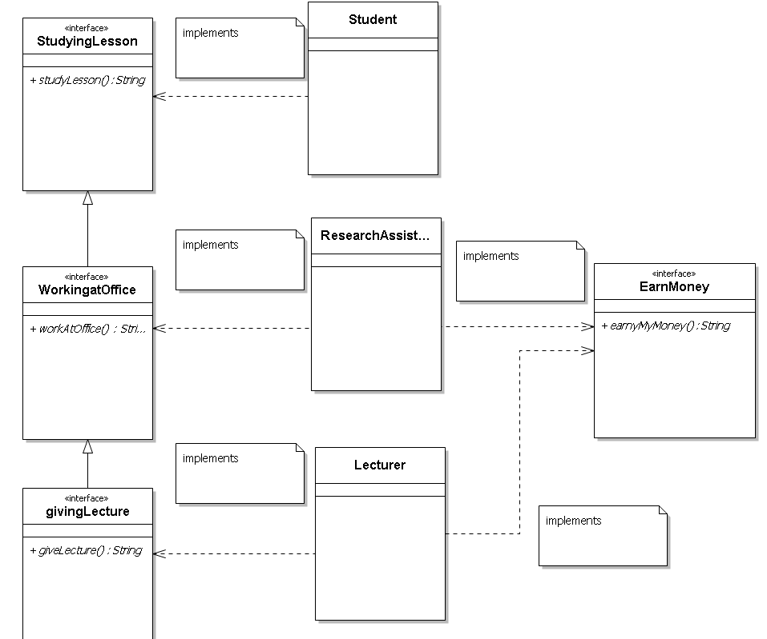

* studyLesson function return string of “I am studying as class name” .
* workAtOffice function return string of “I am working at office as class name””
* giveLecture function return string of "I give lecture as class name”
* earnMyMoney function return string of " I earn my money as "class name "
* In test class, you must define a Student instance, a ResearchAssistant instance and a Lecture instance with all their properties.