Kubernetes Pods — Quick Notes

What is a Pod?
- Smallest deployable unit in Kubernetes.
- Wraps one or more containers that share network (same IP) and storage (volumes).
- Usually 1 container per pod; multi-container pods share localhost and volumes (e.g. sidecar pattern).
- Pods are ephemeral — they don't self-heal; a Controller (Deployment, ReplicaSet, StatefulSet, etc.) manages their lifecycle.

Diagram
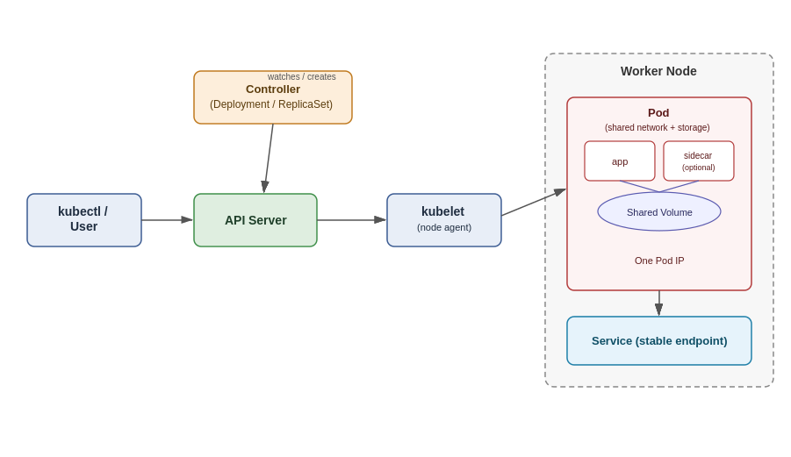

Pod Lifecycle (Phases)
Pending → Running → Succeeded / Failed (also Unknown if node unreachable)

Common kubectl Commands

Create / View
kubectl run mypod --image=nginx # create a pod quickly
kubectl apply -f pod.yaml # create/update from manifest
kubectl get pods # list pods
kubectl get pods -o wide # list with node/IP info
kubectl get pods -A # all namespaces
kubectl describe pod mypod # detailed info + events

Debug
kubectl logs mypod # view logs
kubectl logs mypod -c containername # logs of specific container
kubectl exec -it mypod -- /bin/bash # shell into pod
kubectl port-forward mypod 8080:80 # forward local port to pod

Manage
kubectl delete pod mypod # delete a pod
kubectl edit pod mypod # edit live pod (limited fields)
kubectl label pod mypod env=dev # add a label

Minimal Pod YAML
apiVersion: v1
kind: Pod
metadata:
name: mypod
labels:
app: myapp
spec:
containers:
- name: app
image: nginx:latest
ports:
- containerPort: 80

Key Points to Remember
- Pods are not self-healing — use a Deployment/ReplicaSet for resilience.
- Each Pod gets one unique IP in the cluster.
- Containers in the same Pod can talk via localhost.
- Use Services to expose Pods with a stable network identity.

