Superconductors

Introduction:

## R Markdown

# This is an R Markdown document. Markdown is a simple formatting syntax for authoring HTML, PDF, and MS Word documents. For more details on using R Markdown see <http://rmarkdown.rstudio.com>.

# When you click the Knit button a document will be generated that includes both content as well as the output of any embedded R code chunks within the document. You can embed an R code chunk like this:

summary(train4)

## Including Plots

# You can also embed plots, for example:

library(readxl)

## Warning: package 'readxl' was built under R version 4.1.2

train4 <- read_excel("train4.xlsx")  
View(train4)  
library("corrplot")

## Warning: package 'corrplot' was built under R version 4.1.2

## corrplot 0.92 loaded

corr_matrix <- cor(train4)  
  
# create a new df and order columns alphabetically  
train4_new <- train4[, order(colnames(train4))]  
  
# correlation  
train4_new.mat <- cor(train4_new)  
  
# remove unwanted rows and columns from the correlation matrix  
train4_new_mat <- train4_new.mat[42:82, 1:41] #41 x 41 square correlation  
  
# run plot  
corrplot(  
 train4_new_mat,  
 title = "Heat Map",  
 method = "circle",  
 type = "full",  
 tl.col = "black",  
 order = "hclust",  
 hclust.method = "ward.D2",  
 tl.cex = 1.2,  
 cl.cex=1.2,  
 outline = T,  
 mar=c(0,0,4,5),  
 sig.level = 0.05,  
  
)

## Warning in corrplot(train4_new_mat, title = "Heat Map", method = "circle", :  
## Not been able to calculate text margin, please try again with a clean new empty  
## window using {plot.new(); dev.off()} or reduce tl.cex

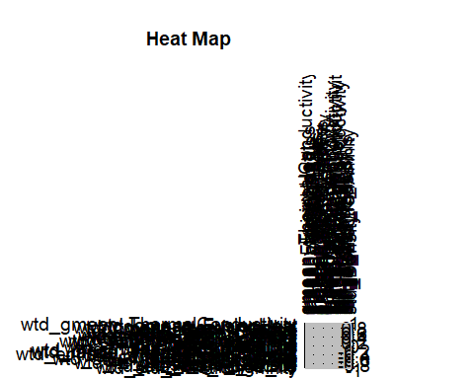

# with numbers and lower  
corrplot(corr_matrix,  
 method = 'number',  
 type = "lower")

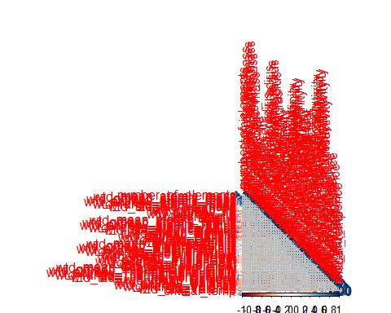

library("corrplot")  
cr <- cor(train4)  
#corrplot(cr)  
corrplot(cr, type="upper")

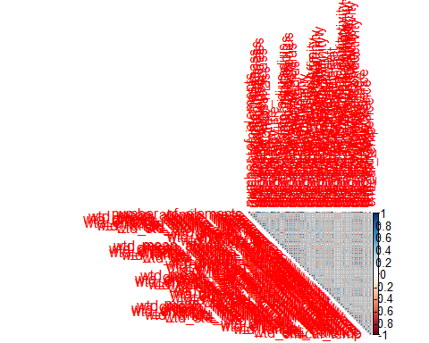

min_max <- function(x){  
 res <- (x - min(x))/(max(x)-min(x))  
 return(res)  
}  
newd<- as.data.frame(sapply(train4[,1:82],min_max))  
  
  
summary(newd)

## number_of_elements mean_atomic_mass wtd_mean_atomic_mass gmean_atomic_mass  
## Min. :0.0000 Min. :0.0000 Min. :0.0000 Min. :0.0000   
## 1st Qu.:0.2500 1st Qu.:0.3243 1st Qu.:0.2257 1st Qu.:0.2589   
## Median :0.3750 Median :0.3860 Median :0.2679 Median :0.2997   
## Mean :0.3894 Mean :0.3990 Mean :0.3286 Mean :0.3239   
## 3rd Qu.:0.5000 3rd Qu.:0.4626 3rd Qu.:0.3934 3rd Qu.:0.3574   
## Max. :1.0000 Max. :1.0000 Max. :1.0000 Max. :1.0000   
## wtd_gmean_atomic_mass entropy_atomic_mass wtd_entropy_atomic_mass  
## Min. :0.0000 Min. :0.0000 Min. :0.0000   
## 1st Qu.:0.1608 1st Qu.:0.4873 1st Qu.:0.3960   
## Median :0.1834 Median :0.6047 Median :0.5856   
## Mean :0.2733 Mean :0.5876 Mean :0.5433   
## 3rd Qu.:0.3437 3rd Qu.:0.7282 3rd Qu.:0.6942   
## Max. :1.0000 Max. :1.0000 Max. :1.0000   
## range_atomic_mass wtd_range_atomic_mass std_atomic_mass wtd_std_atomic_mass  
## Min. :0.0000 Min. :0.00000 Min. :0.0000 Min. :0.0000   
## 1st Qu.:0.3775 1st Qu.:0.08183 1st Qu.:0.3256 1st Qu.:0.2825   
## Median :0.5910 Median :0.12956 Median :0.4467 Median :0.4384   
## Mean :0.5558 Mean :0.16161 Mean :0.4394 Mean :0.4103   
## 3rd Qu.:0.7411 3rd Qu.:0.18657 3rd Qu.:0.5872 3rd Qu.:0.5309   
## Max. :1.0000 Max. :1.00000 Max. :1.0000 Max. :1.0000   
## mean_fie wtd_mean_fie gmean_fie wtd_gmean_fie   
## Min. :0.0000 Min. :0.0000 Min. :0.0000 Min. :0.0000   
## 1st Qu.:0.3714 1st Qu.:0.3737 1st Qu.:0.3381 1st Qu.:0.3619   
## Median :0.4153 Median :0.5290 Median :0.3759 Median :0.5049   
## Mean :0.4203 Mean :0.5089 Mean :0.3861 Mean :0.4803   
## 3rd Qu.:0.4488 3rd Qu.:0.6464 3rd Qu.:0.4162 3rd Qu.:0.5904   
## Max. :1.0000 Max. :1.0000 Max. :1.0000 Max. :1.0000   
## entropy_fie wtd_entropy_fie range_fie wtd_range_fie   
## Min. :0.0000 Min. :0.0000 Min. :0.0000 Min. :0.0000   
## 1st Qu.:0.5032 1st Qu.:0.3697 1st Qu.:0.2011 1st Qu.:0.2325   
## Median :0.6285 Median :0.4498 Median :0.5857 Median :0.4077   
## Mean :0.6021 Mean :0.4546 Mean :0.4387 Mean :0.3862   
## 3rd Qu.:0.7189 3rd Qu.:0.5208 3rd Qu.:0.6214 3rd Qu.:0.5517   
## Max. :1.0000 Max. :1.0000 Max. :1.0000 Max. :1.0000   
## std_fie wtd_std_fie mean_atomic_radius wtd_mean_atomic_radius  
## Min. :0.0000 Min. :0.0000 Min. :0.0000 Min. :0.0000   
## 1st Qu.:0.2284 1st Qu.:0.1941 1st Qu.:0.4053 1st Qu.:0.2565   
## Median :0.5331 Median :0.5394 Median :0.4490 Median :0.3119   
## Mean :0.4315 Mean :0.4676 Mean :0.4399 Mean :0.3469   
## 3rd Qu.:0.5958 3rd Qu.:0.7151 3rd Qu.:0.4874 3rd Qu.:0.4411   
## Max. :1.0000 Max. :1.0000 Max. :1.0000 Max. :1.0000   
## gmean_atomic_radius wtd_gmean_atomic_radius entropy_atomic_radius  
## Min. :0.0000 Min. :0.0000 Min. :0.0000   
## 1st Qu.:0.3422 1st Qu.:0.1648 1st Qu.:0.4979   
## Median :0.3792 Median :0.2607 Median :0.6213   
## Mean :0.3858 Mean :0.2920 Mean :0.5919   
## 3rd Qu.:0.4318 3rd Qu.:0.4120 3rd Qu.:0.7061   
## Max. :1.0000 Max. :1.0000 Max. :1.0000   
## wtd_entropy_atomic_radius range_atomic_radius wtd_range_atomic_radius  
## Min. :0.0000 Min. :0.0000 Min. :0.0000   
## 1st Qu.:0.4476 1st Qu.:0.3125 1st Qu.:0.1191   
## Median :0.6529 Median :0.6680 Median :0.1790   
## Mean :0.5942 Mean :0.5442 Mean :0.2139   
## 3rd Qu.:0.7489 3rd Qu.:0.8008 3rd Qu.:0.2508   
## Max. :1.0000 Max. :1.0000 Max. :1.0000   
## std_atomic_radius wtd_std_atomic_radius mean_Density wtd_mean_Density  
## Min. :0.0000 Min. :0.0000 Min. :0.0000 Min. :0.0000   
## 1st Qu.:0.3040 1st Qu.:0.3296 1st Qu.:0.1998 1st Qu.:0.1327   
## Median :0.5079 Median :0.6170 Median :0.2359 Median :0.1905   
## Mean :0.4468 Mean :0.5388 Mean :0.2705 Mean :0.2331   
## 3rd Qu.:0.6011 3rd Qu.:0.7595 3rd Qu.:0.2978 3rd Qu.:0.2840   
## Max. :1.0000 Max. :1.0000 Max. :1.0000 Max. :1.0000   
## gmean_Density wtd_gmean_Density entropy_Density wtd_entropy_Density  
## Min. :0.00000 Min. :0.000000 Min. :0.0000 Min. :0.0000   
## 1st Qu.:0.03903 1st Qu.:0.002924 1st Qu.:0.4677 1st Qu.:0.4043   
## Median :0.05926 Median :0.067053 Median :0.5581 Median :0.5182   
## Mean :0.15314 Mean :0.137966 Mean :0.5488 Mean :0.5025   
## 3rd Qu.:0.25648 3rd Qu.:0.255224 3rd Qu.:0.6774 3rd Qu.:0.6346   
## Max. :1.00000 Max. :1.000000 Max. :1.0000 Max. :1.0000   
## range_Density wtd_range_Density std_Density wtd_std_Density   
## Min. :0.0000 Min. :0.00000 Min. :0.0000 Min. :0.0000   
## 1st Qu.:0.2943 1st Qu.:0.07385 1st Qu.:0.2629 1st Qu.:0.2463   
## Median :0.3966 Median :0.09285 Median :0.3079 Median :0.3483   
## Mean :0.3836 Mean :0.12939 Mean :0.3186 Mean :0.3188   
## 3rd Qu.:0.4329 3rd Qu.:0.15196 3rd Qu.:0.3734 3rd Qu.:0.3803   
## Max. :1.0000 Max. :1.00000 Max. :1.0000 Max. :1.0000   
## mean_ElectronAffinity wtd_mean_ElectronAffinity gmean_ElectronAffinity  
## Min. :0.0000 Min. :0.0000 Min. :0.0000   
## 1st Qu.:0.1867 1st Qu.:0.2213 1st Qu.:0.0992   
## Median :0.2206 Median :0.3123 Median :0.1539   
## Mean :0.2322 Mean :0.2810 Mean :0.1628   
## 3rd Qu.:0.2588 3rd Qu.:0.3365 3rd Qu.:0.2033   
## Max. :1.0000 Max. :1.0000 Max. :1.0000   
## wtd_gmean_ElectronAffinity entropy_ElectronAffinity  
## Min. :0.0000 Min. :0.0000   
## 1st Qu.:0.1518 1st Qu.:0.5038   
## Median :0.2208 Median :0.6439   
## Mean :0.2185 Mean :0.6054   
## 3rd Qu.:0.2726 3rd Qu.:0.7614   
## Max. :1.0000 Max. :1.0000   
## wtd_entropy_ElectronAffinity range_ElectronAffinity wtd_range_ElectronAffinity  
## Min. :0.0000 Min. :0.0000 Min. :0.0000   
## 1st Qu.:0.3943 1st Qu.:0.2484 1st Qu.:0.1556   
## Median :0.4663 Median :0.3640 Median :0.3254   
## Mean :0.4600 Mean :0.3459 Mean :0.2713   
## 3rd Qu.:0.5238 3rd Qu.:0.3972 3rd Qu.:0.3507   
## Max. :1.0000 Max. :1.0000 Max. :1.0000   
## std_ElectronAffinity wtd_std_ElectronAffinity mean_FusionHeat   
## Min. :0.0000 Min. :0.0000 Min. :0.00000   
## 1st Qu.:0.2356 1st Qu.:0.1978 1st Qu.:0.07031   
## Median :0.3139 Median :0.2841 Median :0.08668   
## Mean :0.3003 Mean :0.2627 Mean :0.13432   
## 3rd Qu.:0.3451 3rd Qu.:0.3154 3rd Qu.:0.16122   
## Max. :1.0000 Max. :1.0000 Max. :1.00000   
## wtd_mean_FusionHeat gmean_FusionHeat wtd_gmean_FusionHeat entropy_FusionHeat  
## Min. :0.00000 Min. :0.00000 Min. :0.00000 Min. :0.0000   
## 1st Qu.:0.04592 1st Qu.:0.03711 1st Qu.:0.01050 1st Qu.:0.4096   
## Median :0.07739 Median :0.04802 Median :0.04493 Median :0.5466   
## Mean :0.13005 Mean :0.09463 Mean :0.09467 Mean :0.5374   
## 3rd Qu.:0.17458 3rd Qu.:0.12768 3rd Qu.:0.15468 3rd Qu.:0.6774   
## Max. :1.00000 Max. :1.00000 Max. :1.00000 Max. :1.0000   
## wtd_entropy_FusionHeat range_FusionHeat wtd_range_FusionHeat std_FusionHeat   
## Min. :0.0000 Min. :0.0000 Min. :0.00000 Min. :0.00000   
## 1st Qu.:0.3850 1st Qu.:0.1229 1st Qu.:0.02269 1st Qu.:0.08253   
## Median :0.5695 Median :0.1229 Median :0.03347 Median :0.09583   
## Mean :0.5232 Mean :0.2018 Mean :0.08004 Mean :0.16120   
## 3rd Qu.:0.6624 3rd Qu.:0.2214 3rd Qu.:0.10225 3rd Qu.:0.17510   
## Max. :1.0000 Max. :1.0000 Max. :1.00000 Max. :1.00000   
## wtd_std_FusionHeat mean_ThermalConductivity wtd_mean_ThermalConductivity  
## Min. :0.00000 Min. :0.0000 Min. :0.0000   
## 1st Qu.:0.08908 1st Qu.:0.1834 1st Qu.:0.1331   
## Median :0.10644 Median :0.2902 Median :0.1801   
## Mean :0.14933 Mean :0.2697 Mean :0.2003   
## 3rd Qu.:0.15514 3rd Qu.:0.3338 3rd Qu.:0.2434   
## Max. :1.00000 Max. :1.0000 Max. :1.0000   
## gmean_ThermalConductivity wtd_gmean_ThermalConductivity  
## Min. :0.00000 Min. :0.000000   
## 1st Qu.:0.02615 1st Qu.:0.002831   
## Median :0.04487 Median :0.016152   
## Mean :0.09380 Mean :0.072565   
## 3rd Qu.:0.13322 3rd Qu.:0.125755   
## Max. :1.00000 Max. :1.000000   
## entropy_ThermalConductivity wtd_entropy_ThermalConductivity  
## Min. :0.0000 Min. :0.0000   
## 1st Qu.:0.2802 1st Qu.:0.1554   
## Median :0.4521 Median :0.3384   
## Mean :0.4453 Mean :0.3348   
## 3rd Qu.:0.5889 3rd Qu.:0.4819   
## Max. :1.0000 Max. :1.0000   
## range_ThermalConductivity wtd_range_ThermalConductivity  
## Min. :0.0000 Min. :0.00000   
## 1st Qu.:0.2009 1st Qu.:0.07311   
## Median :0.9298 Median :0.14088   
## Mean :0.5835 Mean :0.15453   
## 3rd Qu.:0.9302 3rd Qu.:0.22885   
## Max. :1.0000 Max. :1.00000   
## std_ThermalConductivity wtd_std_ThermalConductivity mean_Valence   
## Min. :0.0000 Min. :0.0000 Min. :0.0000   
## 1st Qu.:0.1764 1st Qu.:0.1500 1st Qu.:0.2222   
## Median :0.6315 Median :0.5324 Median :0.3056   
## Mean :0.4602 Mean :0.4512 Mean :0.3664   
## 3rd Qu.:0.7154 3rd Qu.:0.7628 3rd Qu.:0.5000   
## Max. :1.0000 Max. :1.0000 Max. :1.0000   
## wtd_mean_Valence gmean_Valence wtd_gmean_Valence entropy_Valence   
## Min. :0.0000 Min. :0.0000 Min. :0.0000 Min. :0.0000   
## 1st Qu.:0.1861 1st Qu.:0.2133 1st Qu.:0.1819 1st Qu.:0.4953   
## Median :0.2697 Median :0.2692 Median :0.2390 Median :0.6391   
## Mean :0.3589 Mean :0.3428 Mean :0.3426 Mean :0.6049   
## 3rd Qu.:0.5044 3rd Qu.:0.4547 3rd Qu.:0.4858 3rd Qu.:0.7419   
## Max. :1.0000 Max. :1.0000 Max. :1.0000 Max. :1.0000   
## wtd_entropy_Valence range_Valence wtd_range_Valence std_Valence   
## Min. :0.0000 Min. :0.0000 Min. :0.0000 Min. :0.0000   
## 1st Qu.:0.3978 1st Qu.:0.1667 1st Qu.:0.1318 1st Qu.:0.1506   
## Median :0.5983 Median :0.3333 Median :0.1520 Median :0.2667   
## Mean :0.5400 Mean :0.3402 Mean :0.2121 Mean :0.2798   
## 3rd Qu.:0.6826 3rd Qu.:0.5000 3rd Qu.:0.2744 3rd Qu.:0.4000   
## Max. :1.0000 Max. :1.0000 Max. :1.0000 Max. :1.0000   
## wtd_std_Valence critical_temp   
## Min. :0.0000 Min. :0.0000   
## 1st Qu.:0.1023 1st Qu.:0.0290   
## Median :0.1667 Median :0.1081   
## Mean :0.2247 Mean :0.1861   
## 3rd Qu.:0.3401 3rd Qu.:0.3405   
## Max. :1.0000 Max. :1.0000

library("factoextra")

## Warning: package 'factoextra' was built under R version 4.1.2

## Loading required package: ggplot2

## Warning: package 'ggplot2' was built under R version 4.1.2

## Welcome! Want to learn more? See two factoextra-related books at https://goo.gl/ve3WBa

library("FactoMineR")

## Warning: package 'FactoMineR' was built under R version 4.1.2

# before the PCA analysis  
res.pca <- prcomp(train4[,c(1:81)], scale = TRUE)  
summary(res.pca)

## Importance of components:  
## PC1 PC2 PC3 PC4 PC5 PC6 PC7  
## Standard deviation 5.6156 2.9139 2.77708 2.53086 2.18279 1.75174 1.71290  
## Proportion of Variance 0.3893 0.1048 0.09521 0.07908 0.05882 0.03788 0.03622  
## Cumulative Proportion 0.3893 0.4941 0.58935 0.66843 0.72725 0.76513 0.80136  
## PC8 PC9 PC10 PC11 PC12 PC13 PC14  
## Standard deviation 1.58643 1.38293 1.26573 1.21695 1.08695 0.97701 0.89935  
## Proportion of Variance 0.03107 0.02361 0.01978 0.01828 0.01459 0.01178 0.00999  
## Cumulative Proportion 0.83243 0.85604 0.87582 0.89410 0.90869 0.92047 0.93046  
## PC15 PC16 PC17 PC18 PC19 PC20 PC21  
## Standard deviation 0.89208 0.79563 0.76303 0.66348 0.62570 0.55602 0.49481  
## Proportion of Variance 0.00982 0.00782 0.00719 0.00543 0.00483 0.00382 0.00302  
## Cumulative Proportion 0.94028 0.94810 0.95529 0.96072 0.96555 0.96937 0.97239  
## PC22 PC23 PC24 PC25 PC26 PC27 PC28  
## Standard deviation 0.48177 0.45580 0.40959 0.39968 0.38845 0.3711 0.33985  
## Proportion of Variance 0.00287 0.00256 0.00207 0.00197 0.00186 0.0017 0.00143  
## Cumulative Proportion 0.97526 0.97782 0.97989 0.98187 0.98373 0.9854 0.98686  
## PC29 PC30 PC31 PC32 PC33 PC34 PC35  
## Standard deviation 0.31984 0.30537 0.28801 0.27892 0.27287 0.24129 0.23554  
## Proportion of Variance 0.00126 0.00115 0.00102 0.00096 0.00092 0.00072 0.00068  
## Cumulative Proportion 0.98812 0.98927 0.99029 0.99125 0.99217 0.99289 0.99358  
## PC36 PC37 PC38 PC39 PC40 PC41 PC42  
## Standard deviation 0.22426 0.21502 0.19983 0.18811 0.18503 0.16253 0.15744  
## Proportion of Variance 0.00062 0.00057 0.00049 0.00044 0.00042 0.00033 0.00031  
## Cumulative Proportion 0.99420 0.99477 0.99526 0.99570 0.99612 0.99645 0.99675  
## PC43 PC44 PC45 PC46 PC47 PC48 PC49  
## Standard deviation 0.14428 0.13868 0.13456 0.13208 0.1262 0.12326 0.12100  
## Proportion of Variance 0.00026 0.00024 0.00022 0.00022 0.0002 0.00019 0.00018  
## Cumulative Proportion 0.99701 0.99725 0.99747 0.99769 0.9979 0.99807 0.99825  
## PC50 PC51 PC52 PC53 PC54 PC55 PC56  
## Standard deviation 0.11914 0.11255 0.11162 0.10131 0.09863 0.09771 0.09242  
## Proportion of Variance 0.00018 0.00016 0.00015 0.00013 0.00012 0.00012 0.00011  
## Cumulative Proportion 0.99843 0.99858 0.99874 0.99886 0.99898 0.99910 0.99921  
## PC57 PC58 PC59 PC60 PC61 PC62 PC63  
## Standard deviation 0.08503 0.08118 0.08045 0.07627 0.07243 0.06789 0.05995  
## Proportion of Variance 0.00009 0.00008 0.00008 0.00007 0.00006 0.00006 0.00004  
## Cumulative Proportion 0.99930 0.99938 0.99946 0.99953 0.99959 0.99965 0.99970  
## PC64 PC65 PC66 PC67 PC68 PC69 PC70  
## Standard deviation 0.05968 0.05650 0.05349 0.05107 0.04773 0.04298 0.04084  
## Proportion of Variance 0.00004 0.00004 0.00004 0.00003 0.00003 0.00002 0.00002  
## Cumulative Proportion 0.99974 0.99978 0.99981 0.99985 0.99988 0.99990 0.99992  
## PC71 PC72 PC73 PC74 PC75 PC76 PC77  
## Standard deviation 0.03832 0.03676 0.03457 0.02734 0.02483 0.02113 0.01819  
## Proportion of Variance 0.00002 0.00002 0.00001 0.00001 0.00001 0.00001 0.00000  
## Cumulative Proportion 0.99994 0.99995 0.99997 0.99998 0.99999 0.99999 0.99999  
## PC78 PC79 PC80 PC81  
## Standard deviation 0.01366 0.01096 0.008603 0.007042  
## Proportion of Variance 0.00000 0.00000 0.000000 0.000000  
## Cumulative Proportion 1.00000 1.00000 1.000000 1.000000

# Extract the eigenvalues/variances  
  
res.pca<-prcomp(train4,scale. = TRUE)

pca <- PCA(train4, scale.unit=TRUE, ncp=5, graph=T)

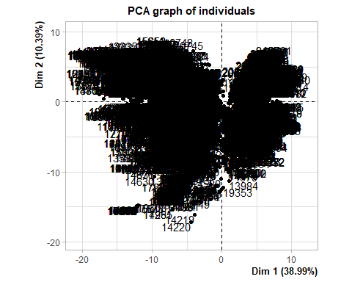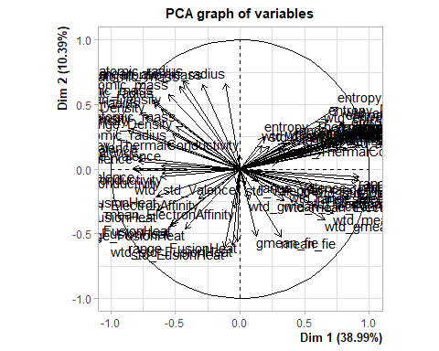

dimdesc(pca, proba = 0.05)[1:3]

## $Dim.1  
## $quanti  
## correlation p.value  
## range_fie 0.92046417 0.000000e+00  
## range_atomic_radius 0.91904268 0.000000e+00  
## wtd_entropy_atomic_radius 0.91778556 0.000000e+00  
## wtd_std_fie 0.91748375 0.000000e+00  
## wtd_std_atomic_radius 0.90113776 0.000000e+00  
## entropy_Valence 0.89176439 0.000000e+00  
## wtd_entropy_atomic_mass 0.87973401 0.000000e+00  
## entropy_fie 0.87923400 0.000000e+00  
## wtd_entropy_Valence 0.87629309 0.000000e+00  
## number_of_elements 0.87535434 0.000000e+00  
## std_fie 0.87131505 0.000000e+00  
## entropy_atomic_radius 0.86123082 0.000000e+00  
## std_atomic_radius 0.84056075 0.000000e+00  
## entropy_atomic_mass 0.82243946 0.000000e+00  
## range_ThermalConductivity 0.80867436 0.000000e+00  
## wtd_entropy_FusionHeat 0.80430780 0.000000e+00  
## entropy_ElectronAffinity 0.78446897 0.000000e+00  
## wtd_std_ThermalConductivity 0.78436087 0.000000e+00  
## std_ThermalConductivity 0.75894547 0.000000e+00  
## entropy_FusionHeat 0.75441643 0.000000e+00  
## wtd_mean_fie 0.72227709 0.000000e+00  
## range_atomic_mass 0.69955467 0.000000e+00  
## entropy_Density 0.68480768 0.000000e+00  
## critical_temp 0.66902484 0.000000e+00  
## wtd_gmean_fie 0.65693036 0.000000e+00  
## wtd_entropy_Density 0.65074563 0.000000e+00  
## wtd_std_atomic_mass 0.63176259 0.000000e+00  
## wtd_entropy_fie 0.61762155 0.000000e+00  
## range_ElectronAffinity 0.58416110 0.000000e+00  
## wtd_std_ElectronAffinity 0.57589779 0.000000e+00  
## std_atomic_mass 0.55321568 0.000000e+00  
## wtd_entropy_ElectronAffinity 0.53933799 0.000000e+00  
## std_ElectronAffinity 0.51424829 0.000000e+00  
## wtd_range_fie 0.47779881 0.000000e+00  
## range_Density 0.42402538 0.000000e+00  
## wtd_std_Density 0.40022557 0.000000e+00  
## wtd_range_ElectronAffinity 0.38367867 0.000000e+00  
## wtd_range_ThermalConductivity 0.34996606 0.000000e+00  
## wtd_mean_ElectronAffinity 0.33809853 0.000000e+00  
## mean_fie 0.31701654 0.000000e+00  
## mean_ThermalConductivity 0.29620194 0.000000e+00  
## std_Density 0.22826110 2.178196e-249  
## entropy_ThermalConductivity 0.18940244 6.279825e-171  
## wtd_mean_ThermalConductivity 0.17076247 7.570906e-139  
## range_Valence 0.14129766 3.023857e-95  
## gmean_fie 0.12860001 4.338743e-79  
## wtd_gmean_ElectronAffinity 0.06980364 2.186663e-24  
## std_Valence 0.04090541 2.417922e-09  
## range_FusionHeat -0.02055268 2.725618e-03  
## wtd_std_Valence -0.02747752 6.143021e-05  
## mean_ElectronAffinity -0.04129886 1.697919e-09  
## wtd_std_FusionHeat -0.06075596 7.513841e-19  
## mean_atomic_radius -0.11342657 7.926033e-62  
## std_FusionHeat -0.11765823 2.030178e-66  
## mean_atomic_mass -0.28868269 0.000000e+00  
## gmean_ElectronAffinity -0.31767723 0.000000e+00  
## wtd_range_FusionHeat -0.42532385 0.000000e+00  
## gmean_atomic_radius -0.43730065 0.000000e+00  
## gmean_atomic_mass -0.46554120 0.000000e+00  
## wtd_range_atomic_mass -0.49355092 0.000000e+00  
## wtd_range_Density -0.52343837 0.000000e+00  
## mean_FusionHeat -0.52899113 0.000000e+00  
## wtd_mean_FusionHeat -0.54398504 0.000000e+00  
## wtd_mean_atomic_mass -0.55531207 0.000000e+00  
## wtd_range_atomic_radius -0.56486605 0.000000e+00  
## wtd_gmean_ThermalConductivity -0.60308214 0.000000e+00  
## wtd_range_Valence -0.60708527 0.000000e+00  
## mean_Density -0.61054661 0.000000e+00  
## gmean_ThermalConductivity -0.61551155 0.000000e+00  
## wtd_gmean_FusionHeat -0.64409026 0.000000e+00  
## gmean_FusionHeat -0.64829636 0.000000e+00  
## wtd_mean_atomic_radius -0.66938644 0.000000e+00  
## wtd_gmean_atomic_mass -0.67216169 0.000000e+00  
## wtd_mean_Density -0.73433523 0.000000e+00  
## wtd_gmean_atomic_radius -0.77268185 0.000000e+00  
## mean_Valence -0.78662037 0.000000e+00  
## gmean_Valence -0.79361492 0.000000e+00  
## wtd_mean_Valence -0.81445591 0.000000e+00  
## wtd_gmean_Valence -0.82539165 0.000000e+00  
## gmean_Density -0.84446153 0.000000e+00  
## wtd_gmean_Density -0.87301402 0.000000e+00  
##   
## attr(,"class")  
## [1] "condes" "list"   
##   
## $Dim.2  
## $quanti  
## correlation p.value  
## gmean_atomic_radius 0.68167713 0.000000e+00  
## mean_atomic_radius 0.66504058 0.000000e+00  
## mean_atomic_mass 0.65644178 0.000000e+00  
## gmean_atomic_mass 0.63929439 0.000000e+00  
## wtd_mean_atomic_mass 0.57529754 0.000000e+00  
## wtd_gmean_atomic_mass 0.53587674 0.000000e+00  
## wtd_mean_atomic_radius 0.51633720 0.000000e+00  
## entropy_FusionHeat 0.47673743 0.000000e+00  
## mean_Density 0.46398703 0.000000e+00  
## wtd_gmean_atomic_radius 0.43750465 0.000000e+00  
## wtd_mean_Density 0.40344396 0.000000e+00  
## entropy_Density 0.38191494 0.000000e+00  
## wtd_entropy_FusionHeat 0.36005144 0.000000e+00  
## entropy_atomic_mass 0.34484284 0.000000e+00  
## wtd_range_atomic_mass 0.33231029 0.000000e+00  
## wtd_entropy_Density 0.32310756 0.000000e+00  
## gmean_Density 0.31649483 0.000000e+00  
## wtd_gmean_Density 0.29871581 0.000000e+00  
## entropy_atomic_radius 0.28634199 0.000000e+00  
## wtd_range_Density 0.26996354 0.000000e+00  
## number_of_elements 0.25460952 8.013862e-312  
## entropy_ElectronAffinity 0.25206096 1.899392e-305  
## entropy_Valence 0.25103947 6.505063e-303  
## entropy_ThermalConductivity 0.24904279 5.420126e-298  
## entropy_fie 0.24348872 1.544223e-284  
## wtd_entropy_atomic_mass 0.23132177 2.993597e-256  
## range_Density 0.22192520 1.666650e-235  
## wtd_entropy_Valence 0.21726943 1.411601e-225  
## wtd_std_ThermalConductivity 0.21319731 4.404216e-217  
## range_atomic_mass 0.20607990 1.173004e-202  
## wtd_entropy_fie 0.20530750 4.006428e-201  
## range_ThermalConductivity 0.19517664 1.377324e-181  
## wtd_range_ThermalConductivity 0.19479479 7.153866e-181  
## wtd_entropy_ElectronAffinity 0.19077407 1.982001e-173  
## wtd_range_atomic_radius 0.18899701 3.415364e-170  
## critical_temp 0.18711175 8.538577e-167  
## wtd_entropy_atomic_radius 0.18283110 3.247462e-159  
## wtd_mean_ThermalConductivity 0.17936794 3.215705e-153  
## std_Density 0.17330578 5.122922e-143  
## std_atomic_mass 0.16591035 4.502477e-131  
## std_ThermalConductivity 0.15904763 1.765521e-120  
## wtd_std_Density 0.14830786 7.688343e-105  
## wtd_std_atomic_mass 0.12588009 7.848046e-76  
## wtd_entropy_ThermalConductivity 0.11141295 1.056165e-59  
## gmean_Valence 0.08941303 5.324612e-39  
## mean_Valence 0.06219686 1.108918e-19  
## mean_ThermalConductivity 0.06037699 1.233762e-18  
## wtd_range_Valence 0.02332677 6.695946e-04  
## wtd_gmean_ThermalConductivity -0.03475167 4.006161e-07  
## gmean_ThermalConductivity -0.05864941 1.138246e-17  
## range_atomic_radius -0.06176945 1.965100e-19  
## range_fie -0.08570388 5.839791e-36  
## wtd_std_fie -0.09058521 5.478348e-40  
## range_Valence -0.09275429 7.532435e-42  
## wtd_range_fie -0.10904607 2.962440e-57  
## wtd_std_Valence -0.11033541 1.395723e-58  
## std_Valence -0.11799068 8.700596e-67  
## wtd_std_atomic_radius -0.13096386 5.600872e-82  
## wtd_std_ElectronAffinity -0.13130401 2.128488e-82  
## wtd_range_ElectronAffinity -0.17236895 1.790575e-141  
## range_ElectronAffinity -0.17939302 2.912712e-153  
## std_fie -0.18091637 6.943638e-156  
## gmean_FusionHeat -0.20667041 7.811820e-204  
## std_atomic_radius -0.21271336 4.381935e-216  
## std_ElectronAffinity -0.21438203 1.551538e-219  
## gmean_ElectronAffinity -0.23137046 2.323850e-256  
## wtd_gmean_ElectronAffinity -0.23833055 2.393993e-272  
## wtd_mean_ElectronAffinity -0.24087723 2.495171e-278  
## mean_ElectronAffinity -0.30386218 0.000000e+00  
## wtd_gmean_FusionHeat -0.32428766 0.000000e+00  
## wtd_mean_fie -0.34592732 0.000000e+00  
## wtd_gmean_fie -0.39372832 0.000000e+00  
## mean_FusionHeat -0.42535096 0.000000e+00  
## wtd_mean_FusionHeat -0.44636614 0.000000e+00  
## wtd_range_FusionHeat -0.46339928 0.000000e+00  
## gmean_fie -0.51908230 0.000000e+00  
## mean_fie -0.52408945 0.000000e+00  
## range_FusionHeat -0.56051346 0.000000e+00  
## wtd_std_FusionHeat -0.59069348 0.000000e+00  
## std_FusionHeat -0.61134638 0.000000e+00  
##   
## attr(,"class")  
## [1] "condes" "list"   
##   
## $Dim.3  
## $quanti  
## correlation p.value  
## wtd_entropy_ThermalConductivity 0.68321723 0.000000e+00  
## wtd_std_Valence 0.64580114 0.000000e+00  
## range_Valence 0.63133780 0.000000e+00  
## std_Valence 0.58536906 0.000000e+00  
## wtd_entropy_fie 0.58200794 0.000000e+00  
## entropy_ThermalConductivity 0.57343410 0.000000e+00  
## wtd_entropy_ElectronAffinity 0.54880498 0.000000e+00  
## range_FusionHeat 0.47445960 0.000000e+00  
## wtd_std_FusionHeat 0.46712185 0.000000e+00  
## std_Density 0.44986330 0.000000e+00  
## std_FusionHeat 0.44016177 0.000000e+00  
## wtd_entropy_Density 0.42136393 0.000000e+00  
## range_Density 0.41615003 0.000000e+00  
## range_ElectronAffinity 0.40041365 0.000000e+00  
## wtd_std_Density 0.37209554 0.000000e+00  
## mean_FusionHeat 0.36381373 0.000000e+00  
## std_ElectronAffinity 0.36302687 0.000000e+00  
## wtd_std_ElectronAffinity 0.35406723 0.000000e+00  
## wtd_mean_Valence 0.35025512 0.000000e+00  
## wtd_mean_FusionHeat 0.34661815 0.000000e+00  
## mean_Valence 0.34157900 0.000000e+00  
## gmean_fie 0.33900866 0.000000e+00  
## mean_ElectronAffinity 0.33585141 0.000000e+00  
## std_atomic_mass 0.33498785 0.000000e+00  
## range_atomic_mass 0.30696842 0.000000e+00  
## wtd_gmean_Valence 0.30195072 0.000000e+00  
## wtd_entropy_Valence 0.30191882 0.000000e+00  
## wtd_gmean_FusionHeat 0.29789638 0.000000e+00  
## wtd_std_atomic_mass 0.29338235 0.000000e+00  
## gmean_FusionHeat 0.28887915 0.000000e+00  
## wtd_mean_Density 0.28687515 0.000000e+00  
## mean_fie 0.28250884 0.000000e+00  
## entropy_fie 0.27933930 0.000000e+00  
## entropy_atomic_radius 0.27573143 0.000000e+00  
## gmean_Valence 0.27392631 0.000000e+00  
## entropy_ElectronAffinity 0.27274639 0.000000e+00  
## entropy_Density 0.24890423 1.185366e-297  
## wtd_entropy_FusionHeat 0.23744745 2.734582e-270  
## wtd_range_FusionHeat 0.23162605 6.144149e-257  
## mean_Density 0.22689063 2.386834e-246  
## number_of_elements 0.22335091 1.365638e-238  
## wtd_entropy_atomic_radius 0.22119393 6.259242e-234  
## gmean_ElectronAffinity 0.22060879 1.128279e-232  
## entropy_Valence 0.21270633 4.530384e-216  
## wtd_gmean_atomic_radius 0.19422870 8.175360e-180  
## wtd_gmean_Density 0.19253300 1.152796e-176  
## entropy_atomic_mass 0.18581969 1.734197e-164  
## wtd_range_Density 0.18299026 1.710200e-159  
## wtd_mean_atomic_mass 0.18078365 1.177680e-155  
## entropy_FusionHeat 0.17742541 6.561092e-150  
## wtd_gmean_ThermalConductivity 0.17241498 1.504371e-141  
## wtd_mean_atomic_radius 0.17026823 4.806763e-138  
## gmean_Density 0.16331523 5.183589e-127  
## wtd_range_atomic_mass 0.15842074 1.552969e-119  
## wtd_entropy_atomic_mass 0.15019643 1.653360e-107  
## gmean_ThermalConductivity 0.12945478 3.971103e-80  
## wtd_range_Valence 0.12738383 1.266825e-77  
## wtd_gmean_atomic_mass 0.10370126 6.355040e-52  
## mean_atomic_mass 0.05446844 1.896493e-15  
## wtd_range_atomic_radius 0.03674694 8.327960e-08  
## wtd_mean_ElectronAffinity 0.02758685 5.741283e-05  
## range_fie 0.01558255 2.307284e-02  
## std_fie -0.02126057 1.932922e-03  
## gmean_atomic_mass -0.03798606 3.011970e-08  
## range_atomic_radius -0.04130919 1.682152e-09  
## std_atomic_radius -0.04469708 7.005865e-11  
## wtd_mean_ThermalConductivity -0.05505559 9.454669e-16  
## wtd_gmean_ElectronAffinity -0.06788064 3.800818e-23  
## wtd_std_atomic_radius -0.08810064 6.557393e-38  
## wtd_range_ElectronAffinity -0.13351733 3.685527e-85  
## wtd_std_fie -0.13800671 6.588525e-91  
## wtd_gmean_fie -0.16612006 2.100548e-131  
## gmean_atomic_radius -0.17605024 1.370420e-147  
## wtd_mean_fie -0.19096452 8.878314e-174  
## mean_ThermalConductivity -0.19512477 1.723152e-181  
## critical_temp -0.19900969 7.464744e-189  
## wtd_range_ThermalConductivity -0.20451624 1.469433e-199  
## mean_atomic_radius -0.26974046 0.000000e+00  
## range_ThermalConductivity -0.27440666 0.000000e+00  
## wtd_std_ThermalConductivity -0.29175148 0.000000e+00  
## std_ThermalConductivity -0.32058964 0.000000e+00  
## wtd_range_fie -0.40641062 0.000000e+00  
##   
## attr(,"class")  
## [1] "condes" "list"

# creating new df with reduced features  
dfnew = data.frame()  
dfnew <- train4[,c("range_fie" , "range_atomic_radius" , "wtd_entropy_atomic_radius" , "wtd_std_fie"   
 , "wtd_std_atomic_radius" , "entropy_Valence" , "wtd_entropy_atomic_mass" , "entropy_fie"   
 , "wtd_entropy_Valence"  
 , "number_of_elements" , "wtd_gmean_Density" , "std_fie" , "entropy_atomic_radius" , "gmean_Density"   
 , "std_atomic_mass" , "wtd_gmean_Valence" , "entropy_atomic_mass" , "mean_atomic_radius"   
 , "gmean_atomic_radius"   
 , "mean_atomic_mass" , "gmean_atomic_mass" , "std_FusionHeat" , "wtd_std_FusionHeat"   
 , "wtd_mean_atomic_mass"   
 , "range_FusionHeat" , "wtd_gmean_atomic_mass" , "mean_fie" , "gmean_fie" , "wtd_entropy_atomic_radius"   
 , "entropy_FusionHeat" , "mean_Density" , "wtd_range_FusionHeat" , "wtd_mean_FusionHeat"   
 , "wtd_gmean_atomic_radius")]  
head(dfnew)

## # A tibble: 6 x 34  
## range_fie range_atomic_radius wtd_entropy_atomi~ wtd_std_fie wtd_std_atomic_r~  
## <dbl> <dbl> <dbl> <dbl> <dbl>  
## 1 811. 205 1.21 356. 69.2  
## 2 811. 205 1.20 355. 68.0  
## 3 811. 205 1.13 355. 67.8  
## 4 811. 205 1.17 355. 68.5  
## 5 811. 205 1.26 356. 70.6  
## 6 811. 205 1.33 358. 73.3  
## # ... with 29 more variables: entropy_Valence <dbl>,  
## # wtd_entropy_atomic_mass <dbl>, entropy_fie <dbl>,  
## # wtd_entropy_Valence <dbl>, number_of_elements <dbl>,  
## # wtd_gmean_Density <dbl>, std_fie <dbl>, entropy_atomic_radius <dbl>,  
## # gmean_Density <dbl>, std_atomic_mass <dbl>, wtd_gmean_Valence <dbl>,  
## # entropy_atomic_mass <dbl>, mean_atomic_radius <dbl>,  
## # gmean_atomic_radius <dbl>, mean_atomic_mass <dbl>, ...

dfnew_matrix <- cor(dfnew)  
dfnew_new <- dfnew[, order(colnames(dfnew))]  
  
# correlation  
dfnew_new.mat <- cor(dfnew_new)  
  
# remove unwanted rows and columns from the correlation matrix  
dfnew_new_mat <- dfnew_new.mat[18:34, 1:17] #41 x 41 square correlation  
  
# run plot  
corrplot(  
 dfnew_new_mat,  
 title = "Heat Map",  
 method = "circle",  
 type = "full",  
 tl.col = "black",  
 order = "hclust",  
 hclust.method = "ward.D2",  
 tl.cex = 1.2,  
 cl.cex=1.2,  
 outline = T,  
 mar=c(0,0,4,5),  
 sig.level = 0.05,  
  
)

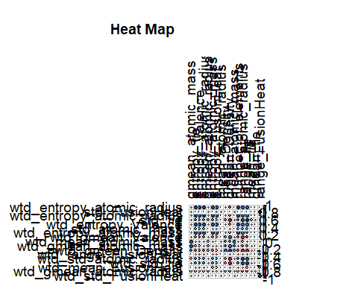

fviz_contrib(res.pca, choice = "var", axes = 1, top = 17)

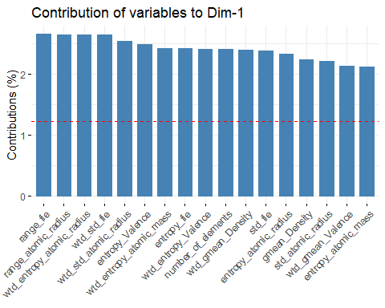

# Contributions of variables to PC2  
fviz_contrib(res.pca, choice = "var", axes = 2, top = 17)

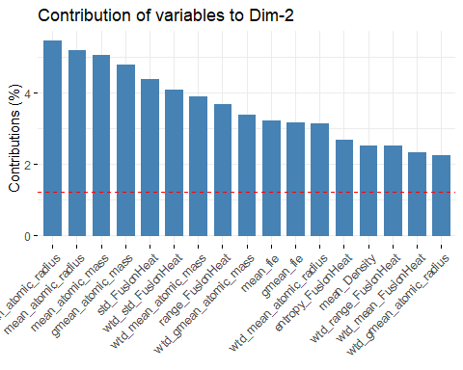

fviz_contrib(res.pca, choice = "var", axes = 1:2, top = 17)

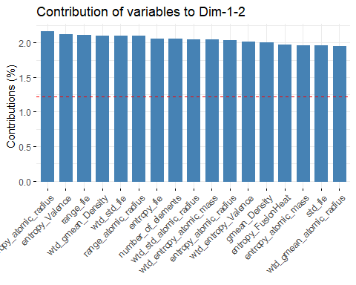

fviz_pca_var(res.pca, col.var = "contrib",  
 gradient.cols = c("#00AFBB", "#E7B800", "#FC4E07")  
 )

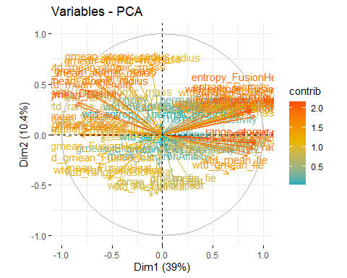

library("factoextra")  
fviz_eig(res.pca)

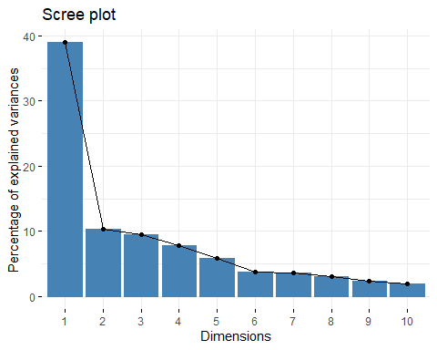

get_eig(res.pca)

## eigenvalue variance.percent cumulative.variance.percent  
## Dim.1 3.197402e+01 3.899271e+01 38.99271  
## Dim.2 8.522273e+00 1.039302e+01 49.38573  
## Dim.3 7.750981e+00 9.452416e+00 58.83814  
## Dim.4 6.414113e+00 7.822089e+00 66.66023  
## Dim.5 4.793358e+00 5.845559e+00 72.50579  
## Dim.6 3.103236e+00 3.784435e+00 76.29022  
## Dim.7 2.935335e+00 3.579677e+00 79.86990  
## Dim.8 2.517540e+00 3.070171e+00 82.94007  
## Dim.9 1.919869e+00 2.341304e+00 85.28138  
## Dim.10 1.602099e+00 1.953779e+00 87.23516  
## Dim.11 1.496689e+00 1.825231e+00 89.06039  
## Dim.12 1.186767e+00 1.447277e+00 90.50766  
## Dim.13 9.562231e-01 1.166126e+00 91.67379  
## Dim.14 8.168746e-01 9.961886e-01 92.66998  
## Dim.15 8.081725e-01 9.855762e-01 93.65555  
## Dim.16 6.331548e-01 7.721400e-01 94.42769  
## Dim.17 5.823045e-01 7.101274e-01 95.13782  
## Dim.18 4.948232e-01 6.034430e-01 95.74126  
## Dim.19 4.083654e-01 4.980066e-01 96.23927  
## Dim.20 3.772613e-01 4.600747e-01 96.69935  
## Dim.21 2.821501e-01 3.440855e-01 97.04343  
## Dim.22 2.432141e-01 2.966026e-01 97.34003  
## Dim.23 2.313789e-01 2.821694e-01 97.62220  
## Dim.24 1.840713e-01 2.244772e-01 97.84668  
## Dim.25 1.676687e-01 2.044740e-01 98.05115  
## Dim.26 1.522261e-01 1.856416e-01 98.23680  
## Dim.27 1.377349e-01 1.679694e-01 98.40477  
## Dim.28 1.337016e-01 1.630507e-01 98.56782  
## Dim.29 1.152702e-01 1.405734e-01 98.70839  
## Dim.30 1.022925e-01 1.247469e-01 98.83314  
## Dim.31 9.281349e-02 1.131872e-01 98.94632  
## Dim.32 8.073964e-02 9.846298e-02 99.04479  
## Dim.33 7.778120e-02 9.485513e-02 99.13964  
## Dim.34 7.414602e-02 9.042198e-02 99.23006  
## Dim.35 5.813544e-02 7.089688e-02 99.30096  
## Dim.36 5.540346e-02 6.756520e-02 99.36853  
## Dim.37 4.931143e-02 6.013589e-02 99.42866  
## Dim.38 4.619792e-02 5.633893e-02 99.48500  
## Dim.39 3.990563e-02 4.866540e-02 99.53367  
## Dim.40 3.538367e-02 4.315082e-02 99.57682  
## Dim.41 3.423373e-02 4.174845e-02 99.61857  
## Dim.42 2.605810e-02 3.177817e-02 99.65034  
## Dim.43 2.476183e-02 3.019736e-02 99.68054  
## Dim.44 2.057096e-02 2.508653e-02 99.70563  
## Dim.45 1.918792e-02 2.339990e-02 99.72903  
## Dim.46 1.810256e-02 2.207629e-02 99.75110  
## Dim.47 1.739759e-02 2.121657e-02 99.77232  
## Dim.48 1.591674e-02 1.941066e-02 99.79173  
## Dim.49 1.516501e-02 1.849391e-02 99.81022  
## Dim.50 1.463569e-02 1.784841e-02 99.82807  
## Dim.51 1.418925e-02 1.730396e-02 99.84538  
## Dim.52 1.266441e-02 1.544440e-02 99.86082  
## Dim.53 1.245629e-02 1.519060e-02 99.87601  
## Dim.54 1.026163e-02 1.251419e-02 99.88853  
## Dim.55 9.551321e-03 1.164795e-02 99.90017  
## Dim.56 9.534663e-03 1.162764e-02 99.91180  
## Dim.57 8.529773e-03 1.040216e-02 99.92220  
## Dim.58 7.219275e-03 8.803994e-03 99.93101  
## Dim.59 6.588780e-03 8.035097e-03 99.93904  
## Dim.60 6.348146e-03 7.741642e-03 99.94678  
## Dim.61 5.704030e-03 6.956134e-03 99.95374  
## Dim.62 5.244311e-03 6.395501e-03 99.96014  
## Dim.63 4.600197e-03 5.609996e-03 99.96575  
## Dim.64 3.579661e-03 4.365440e-03 99.97011  
## Dim.65 3.561120e-03 4.342829e-03 99.97445  
## Dim.66 3.186982e-03 3.886563e-03 99.97834  
## Dim.67 2.848705e-03 3.474031e-03 99.98181  
## Dim.68 2.582506e-03 3.149397e-03 99.98496  
## Dim.69 2.249312e-03 2.743064e-03 99.98771  
## Dim.70 1.843828e-03 2.248571e-03 99.98996  
## Dim.71 1.657275e-03 2.021067e-03 99.99198  
## Dim.72 1.467499e-03 1.789633e-03 99.99377  
## Dim.73 1.350994e-03 1.647553e-03 99.99541  
## Dim.74 1.191890e-03 1.453524e-03 99.99687  
## Dim.75 7.460413e-04 9.098065e-04 99.99778  
## Dim.76 6.161272e-04 7.513747e-04 99.99853  
## Dim.77 4.455887e-04 5.434008e-04 99.99907  
## Dim.78 3.309852e-04 4.036405e-04 99.99948  
## Dim.79 1.866172e-04 2.275820e-04 99.99970  
## Dim.80 1.195923e-04 1.458443e-04 99.99985  
## Dim.81 7.397678e-05 9.021558e-05 99.99994  
## Dim.82 4.949803e-05 6.036345e-05 100.00000

fviz_pca_ind(res.pca,  
 col.ind = "cos2", # Color by the quality of representation  
 gradient.cols = c("#00AFBB", "#E7B800", "#FC4E07"),  
 repel = TRUE # Avoid text overlapping  
)

## Warning: ggrepel: 21263 unlabeled data points (too many overlaps). Consider  
## increasing max.overlaps

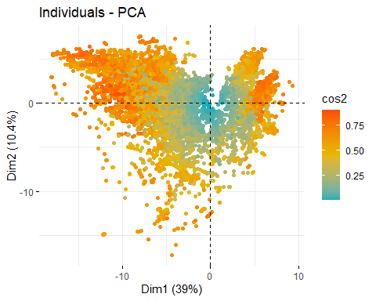

fviz_pca_var(res.pca,  
 col.var = "contrib", # Color by contributions to the PC  
 gradient.cols = c("#00AFBB", "#E7B800", "#FC4E07"),  
 repel = TRUE # Avoid text overlapping  
)

## Warning: ggrepel: 73 unlabeled data points (too many overlaps). Consider  
## increasing max.overlaps

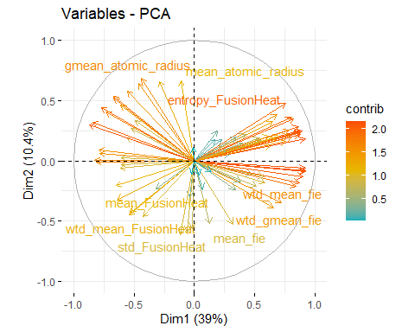

pr_var <- res.pca$sdev ^ 2  
pve <- pr_var / sum(pr_var)  
plot(pve, xlab = "Principal Component", ylab = "Proportion of Variance Explained", ylim = c(0,1), type = 'b')

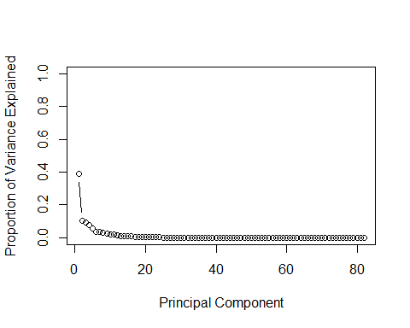

# Cumulative PVE plot  
plot(cumsum(pve), xlab = "Principal Component", ylab = "Cumulative Proportion of Variance Explained", ylim =c(0,1), type = 'b')

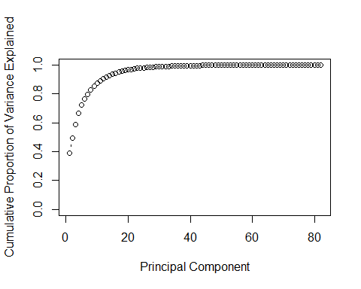

# Rotate loadings

library(ggplot2)  
theme_set(theme_bw())  
  
homes.pca <- data.frame(res.pca$x[, 1:2]) # we only need the first two principal components  
ggplot(homes.pca, aes(y = PC1, x = PC2)) + geom_point(col = 'tomato2')

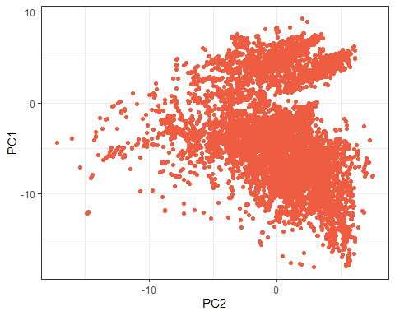

comp <- data.frame(res.pca$x[,1:5])  
# Plot  
plot(comp, pch=16, col=rgb(0,0,0,0.5))

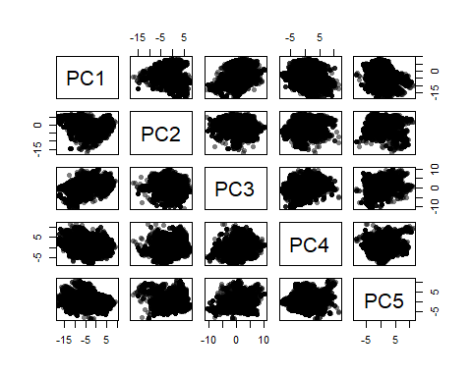

library(rgl)

## Warning: package 'rgl' was built under R version 4.1.2

# Multi 3D plot  
plot3d(comp$PC1, comp$PC2, comp$PC3)

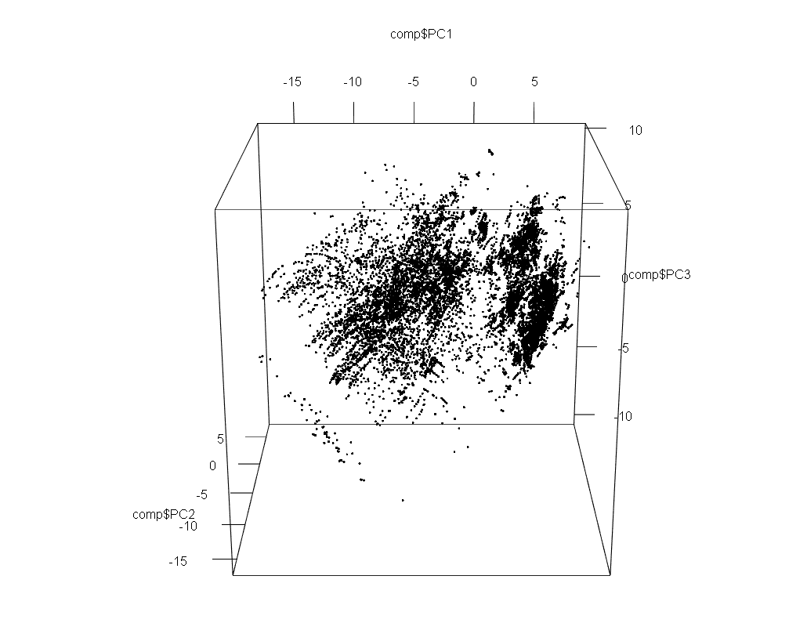

plot3d(comp$PC1, comp$PC3, comp$PC4)

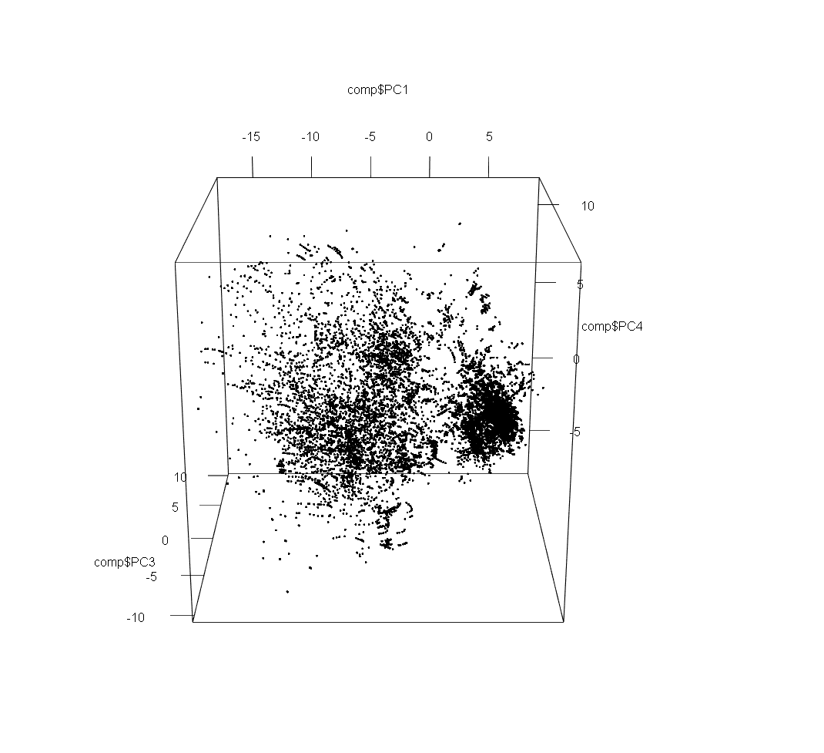

# From scree plot elbow occurs at k = 4  
# Apply k-means with k=4  
k <- kmeans(comp, 4, nstart=25, iter.max=1000)  
library(RColorBrewer)  
library(scales)

## Warning: package 'scales' was built under R version 4.1.2

palette(alpha(brewer.pal(9,'Set1'), 0.5))  
plot(comp, col=k$clust, pch=16)

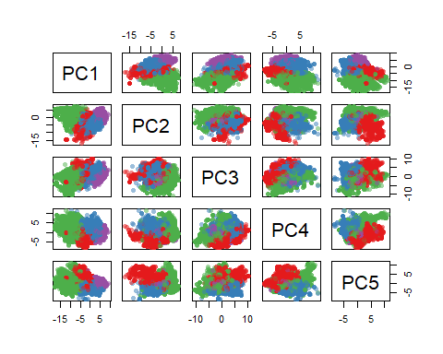

# 3D plot  
plot3d(comp$PC1, comp$PC2, comp$PC3, col=k$clust)

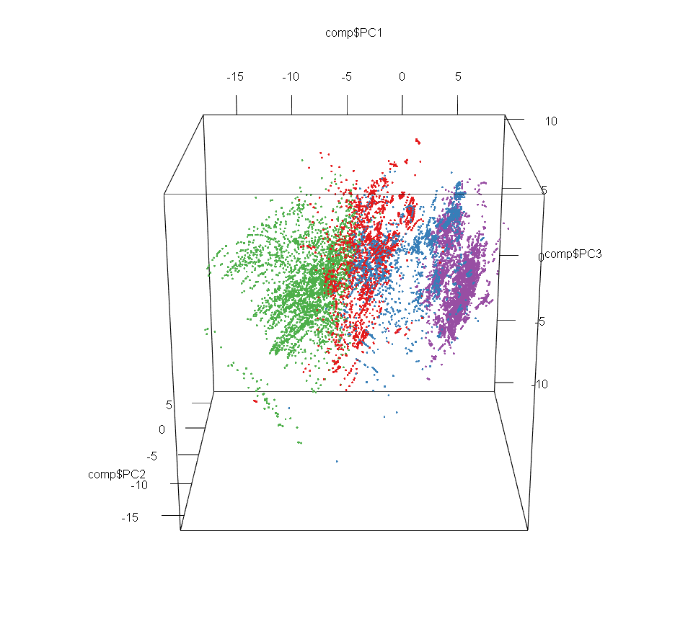

plot3d(comp$PC1, comp$PC3, comp$PC4, col=k$clust)

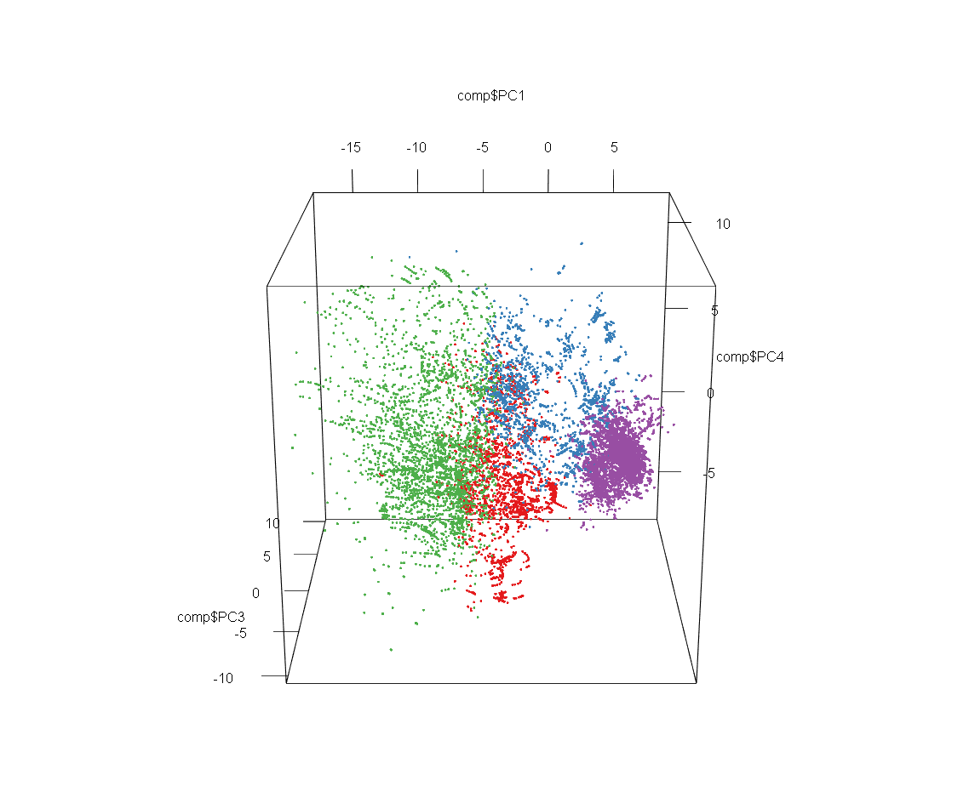

library(ggpubr)

## Warning: package 'ggpubr' was built under R version 4.1.2

ggqqplot(train4$critical_temp)

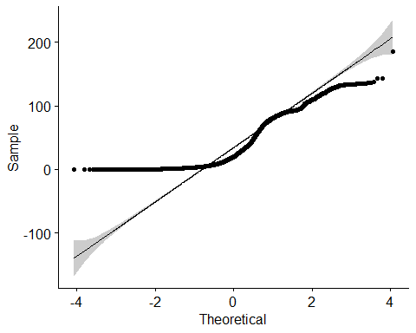

lmcriticaltemp = lm(critical_temp~range_fie + range_atomic_radius + wtd_entropy_atomic_radius + wtd_std_fie   
 + wtd_std_atomic_radius + entropy_Valence + wtd_entropy_atomic_mass + entropy_fie + wtd_entropy_Valence  
 + number_of_elements + wtd_gmean_Density + std_fie + entropy_atomic_radius + gmean_Density   
 + std_atomic_mass + wtd_gmean_Valence + entropy_atomic_mass + mean_atomic_radius + gmean_atomic_radius   
 + mean_atomic_mass + gmean_atomic_mass + std_FusionHeat + wtd_std_FusionHeat + wtd_mean_atomic_mass   
 + range_FusionHeat + wtd_gmean_atomic_mass + mean_fie + gmean_fie + wtd_entropy_atomic_radius   
 + entropy_FusionHeat + mean_Density + wtd_range_FusionHeat + wtd_mean_FusionHeat   
 + wtd_gmean_atomic_radius, data = train4)  
summary(lmcriticaltemp)

##   
## Call:  
## lm(formula = critical_temp ~ range_fie + range_atomic_radius +   
## wtd_entropy_atomic_radius + wtd_std_fie + wtd_std_atomic_radius +   
## entropy_Valence + wtd_entropy_atomic_mass + entropy_fie +   
## wtd_entropy_Valence + number_of_elements + wtd_gmean_Density +   
## std_fie + entropy_atomic_radius + gmean_Density + std_atomic_mass +   
## wtd_gmean_Valence + entropy_atomic_mass + mean_atomic_radius +   
## gmean_atomic_radius + mean_atomic_mass + gmean_atomic_mass +   
## std_FusionHeat + wtd_std_FusionHeat + wtd_mean_atomic_mass +   
## range_FusionHeat + wtd_gmean_atomic_mass + mean_fie + gmean_fie +   
## wtd_entropy_atomic_radius + entropy_FusionHeat + mean_Density +   
## wtd_range_FusionHeat + wtd_mean_FusionHeat + wtd_gmean_atomic_radius,   
## data = train4)  
##   
## Residuals:  
## Min 1Q Median 3Q Max   
## -79.63 -13.29 0.12 13.09 162.75   
##   
## Coefficients:  
## Estimate Std. Error t value Pr(>|t|)   
## (Intercept) -2.673e+01 4.570e+00 -5.850 5.00e-09 ***  
## range_fie 1.144e-01 5.578e-03 20.513 < 2e-16 ***  
## range_atomic_radius 2.608e-03 1.597e-02 0.163 0.87030   
## wtd_entropy_atomic_radius 6.552e+01 3.605e+00 18.175 < 2e-16 ***  
## wtd_std_fie 4.413e-02 8.319e-03 5.305 1.14e-07 ***  
## wtd_std_atomic_radius 3.080e-01 3.935e-02 7.828 5.19e-15 ***  
## entropy_Valence 1.593e+02 4.295e+00 37.083 < 2e-16 ***  
## wtd_entropy_atomic_mass 8.469e+00 3.062e+00 2.766 0.00568 **   
## entropy_fie -4.211e+02 1.539e+01 -27.359 < 2e-16 ***  
## wtd_entropy_Valence -4.740e+01 2.444e+00 -19.397 < 2e-16 ***  
## number_of_elements 5.755e+00 6.196e-01 9.289 < 2e-16 ***  
## wtd_gmean_Density 1.663e-03 2.182e-04 7.623 2.57e-14 ***  
## std_fie -3.602e-01 1.619e-02 -22.246 < 2e-16 ***  
## entropy_atomic_radius 3.075e+02 1.596e+01 19.267 < 2e-16 ***  
## gmean_Density -2.680e-03 3.049e-04 -8.789 < 2e-16 ***  
## std_atomic_mass 1.999e-01 2.283e-02 8.757 < 2e-16 ***  
## wtd_gmean_Valence -8.131e+00 2.779e-01 -29.258 < 2e-16 ***  
## entropy_atomic_mass -7.323e+01 4.331e+00 -16.908 < 2e-16 ***  
## mean_atomic_radius 2.684e+00 1.008e-01 26.617 < 2e-16 ***  
## gmean_atomic_radius -3.115e+00 1.100e-01 -28.314 < 2e-16 ***  
## mean_atomic_mass 5.459e-03 6.632e-02 0.082 0.93439   
## gmean_atomic_mass 9.992e-02 6.828e-02 1.463 0.14341   
## std_FusionHeat 2.781e+00 1.930e-01 14.406 < 2e-16 ***  
## wtd_std_FusionHeat -1.498e+00 7.375e-02 -20.318 < 2e-16 ***  
## wtd_mean_atomic_mass -1.215e+00 6.087e-02 -19.965 < 2e-16 ***  
## range_FusionHeat -8.512e-01 7.007e-02 -12.149 < 2e-16 ***  
## wtd_gmean_atomic_mass 1.084e+00 5.807e-02 18.661 < 2e-16 ***  
## mean_fie -5.577e-01 4.192e-02 -13.305 < 2e-16 ***  
## gmean_fie 6.236e-01 4.194e-02 14.870 < 2e-16 ***  
## entropy_FusionHeat -6.185e+00 2.102e+00 -2.943 0.00325 **   
## mean_Density 1.631e-03 2.255e-04 7.233 4.88e-13 ***  
## wtd_range_FusionHeat 3.559e-01 3.940e-02 9.033 < 2e-16 ***  
## wtd_mean_FusionHeat -2.487e-01 3.494e-02 -7.116 1.14e-12 ***  
## wtd_gmean_atomic_radius 5.227e-01 1.845e-02 28.337 < 2e-16 ***  
## ---  
## Signif. codes: 0 '***' 0.001 '**' 0.01 '*' 0.05 '.' 0.1 ' ' 1  
##   
## Residual standard error: 20.73 on 21229 degrees of freedom  
## Multiple R-squared: 0.6344, Adjusted R-squared: 0.6338   
## F-statistic: 1116 on 33 and 21229 DF, p-value: < 2.2e-16

library(rpart)

## Warning: package 'rpart' was built under R version 4.1.2

fit <- rpart(critical_temp~range_fie + range_atomic_radius + wtd_entropy_atomic_radius + wtd_std_fie   
 + wtd_std_atomic_radius + entropy_Valence + wtd_entropy_atomic_mass + entropy_fie + wtd_entropy_Valence  
 + number_of_elements + wtd_gmean_Density + std_fie + entropy_atomic_radius + gmean_Density   
 + std_atomic_mass + wtd_gmean_Valence + entropy_atomic_mass + mean_atomic_radius + gmean_atomic_radius   
 + mean_atomic_mass + gmean_atomic_mass + std_FusionHeat + wtd_std_FusionHeat + wtd_mean_atomic_mass   
 + range_FusionHeat + wtd_gmean_atomic_mass + mean_fie + gmean_fie + wtd_entropy_atomic_radius   
 + entropy_FusionHeat + mean_Density + wtd_range_FusionHeat + wtd_mean_FusionHeat   
 + wtd_gmean_atomic_radius,  
 method="anova", data=newd)  
printcp(fit)

##   
## Regression tree:  
## rpart(formula = critical_temp ~ range_fie + range_atomic_radius +   
## wtd_entropy_atomic_radius + wtd_std_fie + wtd_std_atomic_radius +   
## entropy_Valence + wtd_entropy_atomic_mass + entropy_fie +   
## wtd_entropy_Valence + number_of_elements + wtd_gmean_Density +   
## std_fie + entropy_atomic_radius + gmean_Density + std_atomic_mass +   
## wtd_gmean_Valence + entropy_atomic_mass + mean_atomic_radius +   
## gmean_atomic_radius + mean_atomic_mass + gmean_atomic_mass +   
## std_FusionHeat + wtd_std_FusionHeat + wtd_mean_atomic_mass +   
## range_FusionHeat + wtd_gmean_atomic_mass + mean_fie + gmean_fie +   
## wtd_entropy_atomic_radius + entropy_FusionHeat + mean_Density +   
## wtd_range_FusionHeat + wtd_mean_FusionHeat + wtd_gmean_atomic_radius,   
## data = newd, method = "anova")  
##   
## Variables actually used in tree construction:  
## [1] range_atomic_radius std_atomic_mass wtd_entropy_Valence  
## [4] wtd_gmean_Density wtd_gmean_Valence   
##   
## Root node error: 728.94/21263 = 0.034282  
##   
## n= 21263   
##   
## CP nsplit rel error xerror xstd  
## 1 0.499047 0 1.00000 1.00007 0.0083088  
## 2 0.102224 1 0.50095 0.50109 0.0054271  
## 3 0.042031 2 0.39873 0.39930 0.0051075  
## 4 0.021732 3 0.35670 0.35752 0.0046578  
## 5 0.015561 5 0.31323 0.31543 0.0044826  
## 6 0.011056 6 0.29767 0.29918 0.0043998  
## 7 0.010000 7 0.28662 0.28769 0.0042865

plotcp(fit)

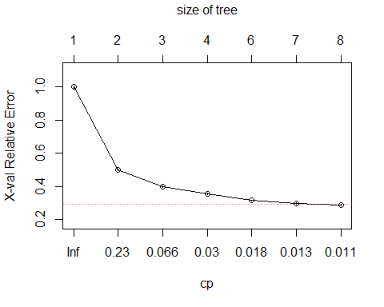

plot(fit, uniform=TRUE,  
 main="Regression Tree for critical_temp ")  
text(fit, use.n=TRUE, all=TRUE, cex=.8)

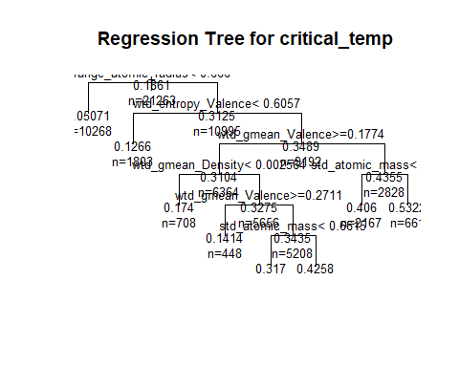

# prune the tree  
pfit<- prune(fit, cp=0.011)   
plot(pfit, uniform=TRUE,  
 main="Pruned Regression Tree for critical_temp")  
text(pfit, use.n=TRUE, all=TRUE, cex=.8)

