به نام خد ا
علی عطااللهی
810199461
1:

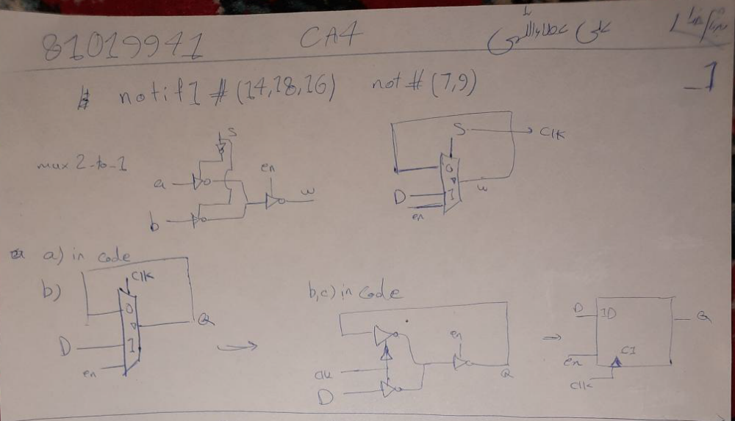
`timescale 1ns/1ns
module mux2_to_1 (input a,b,s,en,output w);
wire i,j;
notif1 #(14,18,16) n1(i,a,j);
notif1 #(14,18,16) n2(i,b,s);
not #(7,9) n3(j,s);
notif1 #(14,18,16) n4(w,i,en);
endmodule
module D_latch(input d,clk,en,output q);
mux2_to_1 mx(q,d,clk,en,q);
endmodule

`timescale 1ns/1ns
module CA4_E1_TB_1 ();
logic dd=1,c=1,enn=1;
wire qq;
D_latch xx(dd,c,enn,qq);
always #200 c=~c ;
initial begin
#100 dd=0;
#200 dd=1;
#200 $stop;
end
endmodule
module CA4_E1_TB_2 ();
logic dd=1,c=1,enn=1;
wire qq;
D_latch xx(dd,c,enn,qq);
always #200 c=~c ;
initial begin
#200 dd=0;
#200 dd=1;
#200 $stop;
end
endmodule

2:
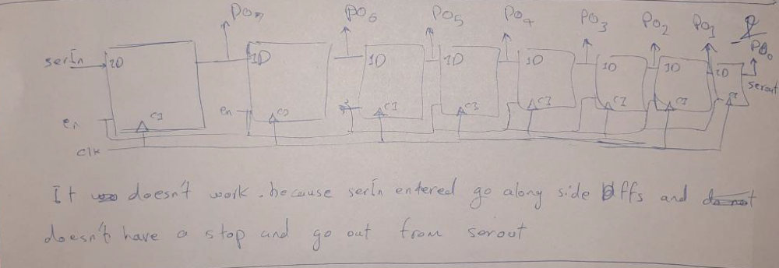
`timescale 1ns/1ns
module mux2_to_1 (input a,b,s,en,output w);
wire i,j;
notif1 #(14,18,16) n1(i,a,j);
notif1 #(14,18,16) n2(i,b,s);
not #(7,9) n3(j,s);
notif1 #(14,18,16) n4(w,i,en);
endmodule
module D_latch(input d,clk,en,output q);
mux2_to_1 mx(q,d,clk,en,q);
endmodule
module register8withDlatch(input serIn,clk,en,output [7:0] po);
wire [8:0] d;
assign d[8]=serIn;
genvar k;
generate
for(k=8;k>0;k=k-1) begin : registerGates
D_latch dd(d[k],clk,en,d[k-1]);
end
endgenerate
assign po=d[7:0];
endmodule

`timescale 1ns/1ns
module CA4_E2_TB ();
logic serr=0,c=1,enn=1;
wire[7:0] ppoo;
register8withDlatch xx(serr,c,enn,ppoo);
always #200 c=~c ;
initial begin
#1050 serr=1;
#200 serr=0;
#1000 $stop;
end
endmodule
3:
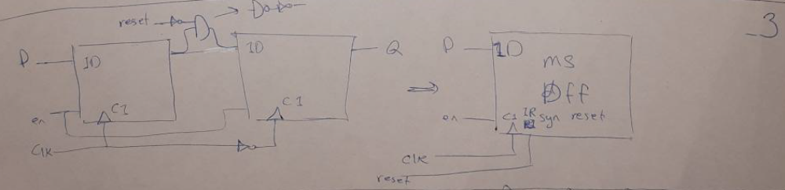
`timescale 1ns/1ns
module mux2_to_1 (input a,b,s,en,output w);
wire i,j;
notif1 #(14,18,16) n1(i,a,j);
notif1 #(14,18,16) n2(i,b,s);
not #(7,9) n3(j,s);
notif1 #(14,18,16) n4(w,i,en);
endmodule
module D_latch(input d,clk,en,output q);
mux2_to_1 mx(q,d,clk,en,q);
endmodule
module ms_DFF(input d,clk,reset,en,output q);
wire i,j,k,d2,q1;
not #(7,9) n1(i,reset);
not #(7,9) n2(j,clk);
nand #(14,10) o1(k,i,q1);
not #(7,9) n3(d2,k);
D_latch dl1(d,clk,en,q1);
D_latch dl2(d2,j,en,q);
endmodule

`timescale 1ns/1ns
module CA4_E3_TB_1 ();
logic dd=1,c=1,enn=1,resett=0;
wire qq;
ms_DFF xx(dd,c,resett,enn,qq);
always #300 c=~c ;
initial begin
#1000
#1000 dd=0;
#2000 dd=1;
#1900 resett=1;
#2000 $stop;
end
endmodule
module CA4_E3_TB_2 ();
logic dd=1,c=1,enn=1,resett=0;
wire qq;
ms_DFF xx(dd,c,resett,enn,qq);
always #500 c=~c ;
initial begin
#1000
#1000 dd=0;
#2000 dd=1;
#2000 resett=1;
#2000 $stop;
end
endmodule

4:
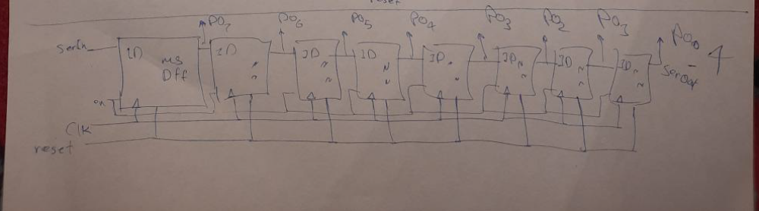
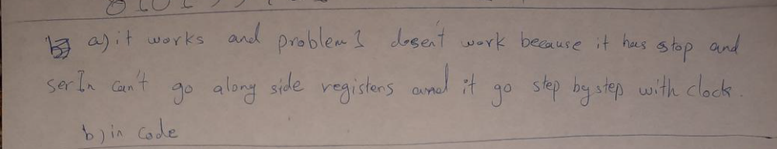
`timescale 1ns/1ns
module mux2_to_1 (input a,b,s,en,output w);
wire i,j;
notif1 #(14,18,16) n1(i,a,j);
notif1 #(14,18,16) n2(i,b,s);
not #(7,9) n3(j,s);
notif1 #(14,18,16) n4(w,i,en);
endmodule
module D_latch(input d,clk,en,output q);
mux2_to_1 mx(q,d,clk,en,q);
endmodule
module ms_DFF(input d,clk,reset,en,output q);
wire i,j,k,d2,q1;
not #(7,9) n1(i,reset);
not #(7,9) n2(j,clk);
nand #(14,10) o1(k,i,q1);
not #(7,9) n3(d2,k);
D_latch dl1(d,clk,en,q1);
D_latch dl2(d2,j,en,q);
endmodule
module register8withMSDFF(input serIn,clk,reset,en,output [7:0] po);
wire [8:0] d;
assign d[8]=serIn;
genvar k;
generate
for(k=8;k>0;k=k-1) begin : registerGates
ms_DFF dd(d[k],clk,reset,en,d[k-1]);
end
endgenerate
assign po=d[7:0];
endmodule
module register8withAlways(input serIn,clk,reset,en,output logic [7:0] po);
always @(posedge clk) begin
if(reset)
#50 po<=8'b0;
else
#50 po<={serIn,po[7:1]};
end
endmodule

`timescale 1ns/1ns
module CA4_E4_TB ();
logic serr=0,c=1,enn=1,resett=0;
wire[7:0] ppoo1,ppoo2;
register8withMSDFF xx1(serr,c,resett,enn,ppoo1);
register8withAlways xx2(serr,c,resett,enn,ppoo2);
always #100 c=~c ;
initial begin
#3000
#50 serr=1;
#200 serr=0;
#200 serr=0;
#200 serr=1;
#200 serr=1;
#200 serr=0;
#200 serr=0;
#200 serr=1;
#200 serr=0;
#1000 $stop;
end
endmodule

5:
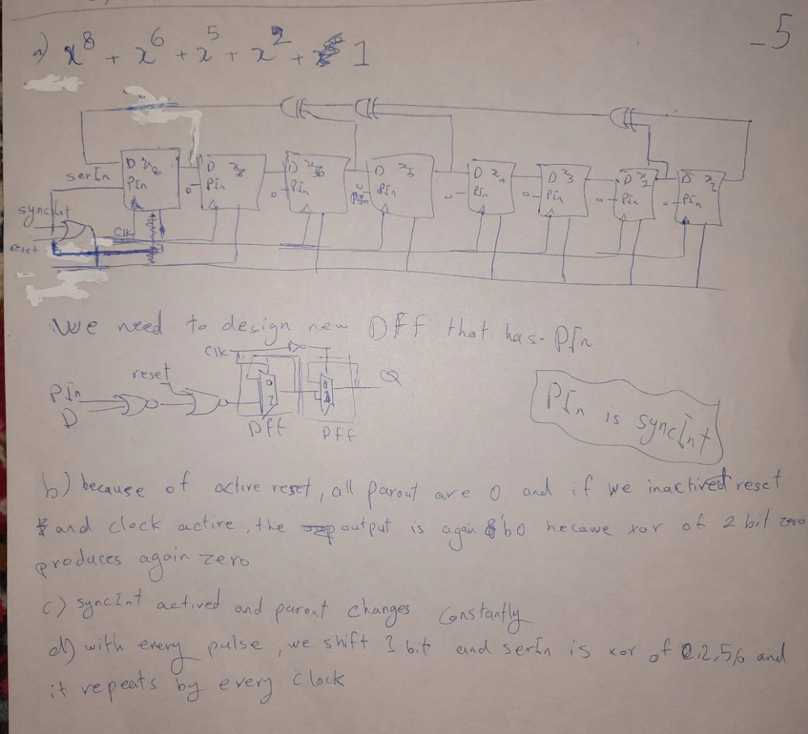
`timescale 1ns/1ns
module mux2_to_1 (input a,b,s,en,output w);
wire i,j;
notif1 #(14,18,16) n1(i,a,j);
notif1 #(14,18,16) n2(i,b,s);
not #(7,9) n3(j,s);
notif1 #(14,18,16) n4(w,i,en);
endmodule
module D_latch(input d,clk,en,output q);
mux2_to_1 mx(q,d,clk,en,q);
endmodule
module new_ms_DFF(input d,clk,syncInt,reset,en,output q);
wire i,j,clkbar,d2,q1;
not #(7,9) n1(clkbar,clk);
nor #(8,18) n2(i,d,reset);
nor #(8,18) n3(j,i,syncInt);
D_latch dl1(j,clk,en,q1);
D_latch dl2(q1,clkbar,en,q);
endmodule
module new_register8withMSDFF(input clk,syncInt,reset,en,output [7:0] po);
wire [8:0] d,preset;
wire reset_;
assign d[8]=d[0];
genvar k;
generate
for(k=8;k>0;k=k-1) begin : registerGates
new_ms_DFF dd(d[k],clk,preset[k],reset_,en,d[k-1]);
end
endgenerate
assign po=d[7:0];
assign reset_= (reset|syncInt);
assign preset= 8'b10000000 ? syncInt : 8'b0;
endmodule
module LFSR(input clk,syncInt,reset,en,output [7:0] po);
wire [8:0] d,preset;
wire reset_;
assign d[8]=d[0];
genvar k;
generate
for(k=8;k>0;k=k-1) begin : registerGates
new_ms_DFF dd(d[k],clk,preset[k],reset_,en,d[k-1]);
end
endgenerate
assign po=d[7:0];
assign reset_= (reset|syncInt);
assign preset= 8'b10000000 ? syncInt : 8'b0;
endmodule
`timescale 1ns/1ns
module CA4_E5_TB ();
logic c=1,synccInt=1,enn=1,resett=0;
wire[7:0] ppoo1;
new_register8withMSDFF xx1(c,synccInt,resett,enn,ppoo1);
always #100 c=~c ;
initial begin
#3000
#1000 $stop;
end
endmodule

