Guidelines for posting queries on MDB

Step 1:
- Open web browser and enter www.vulms.vu.edu.pk.
- Enter your roll number as student ID and password given to you at the time of admission

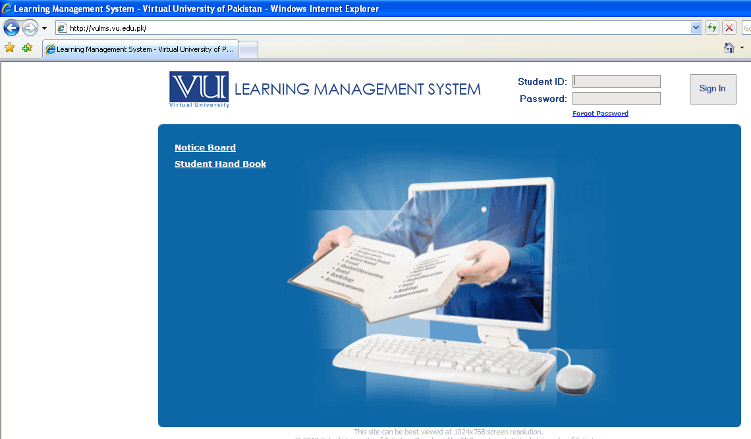

Step 2:
After successfully login to VULMS, you can see the courses you have in this semester
Click the MDB tab of this course.

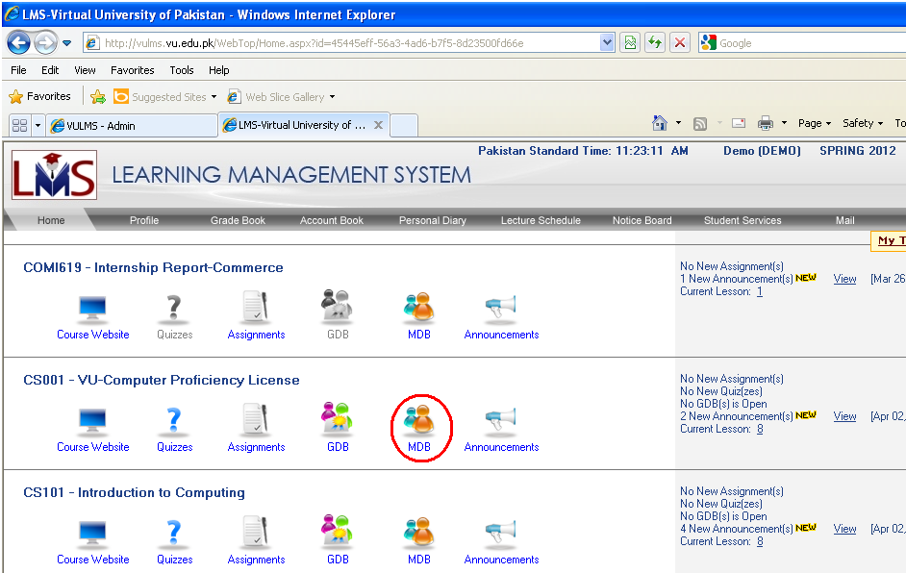

Step 3:
Now you click ‘View’ link to post a query against a lecture.

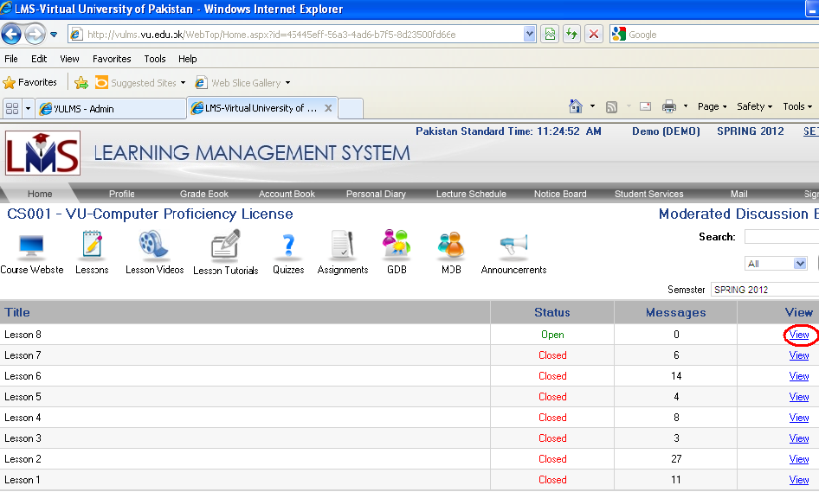

Step 4:
Now click “Post Message” button to post a question.

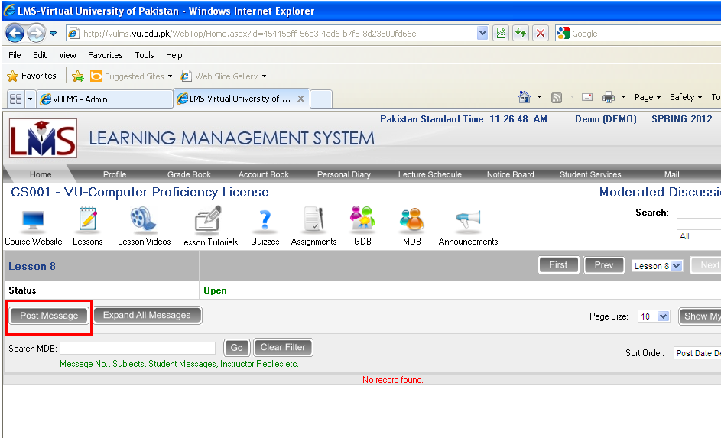

Step 5:
After selecting “Post Message”, a window will open where you post your question.

