

**Group Members:**

|  |
| --- |
| **Name** |
| Ali Awais |
| Tehreem Jamal |

**Semester Project:**

**“Smart Egg Incubator”**

**Internet of Things**

**Assignment#4**

**Description:**

We are creating a smart egg incubator that will be user friendly and will produce more valuable production and hatching for different types of eggs. In our project we are building an IOT based smart egg incubator that automatically controls and monitors the level of temperature and humidity inside the incubator through sensors and automatically collects the data and sends it to our web Based IOT Platform (Node-Red) for visualization. Cooling (Fan) and heating (Light bulb) systems are installed that help in maintaining the temperature and humidity inside the incubator. Eggs are placed inside the incubator containing the rotating tray that automatically turns the eggs after some time so that eggs remain in good condition.

**Motivation:**

The motivation and objective behind this project is to provide the solution to automate the egg hatching process through IoT where users can monitor the temperature and humidity inside the incubator through node red web application.

**Users:**

* Poultry Farms
* Person living in Rural Areas
* Small Poultry Businesses

**Functionalities of Node Red:**

* Accepts data (Temperature and Humidity) from the IOT Device Using MQTT Dashboard for Visualization containing tabs
  + Home
  + Temperature
  + Humidity
* Show data in the form of Graph
* Show data in the form of Gauge.

**Block Diagram of Whole IOT Solution:**

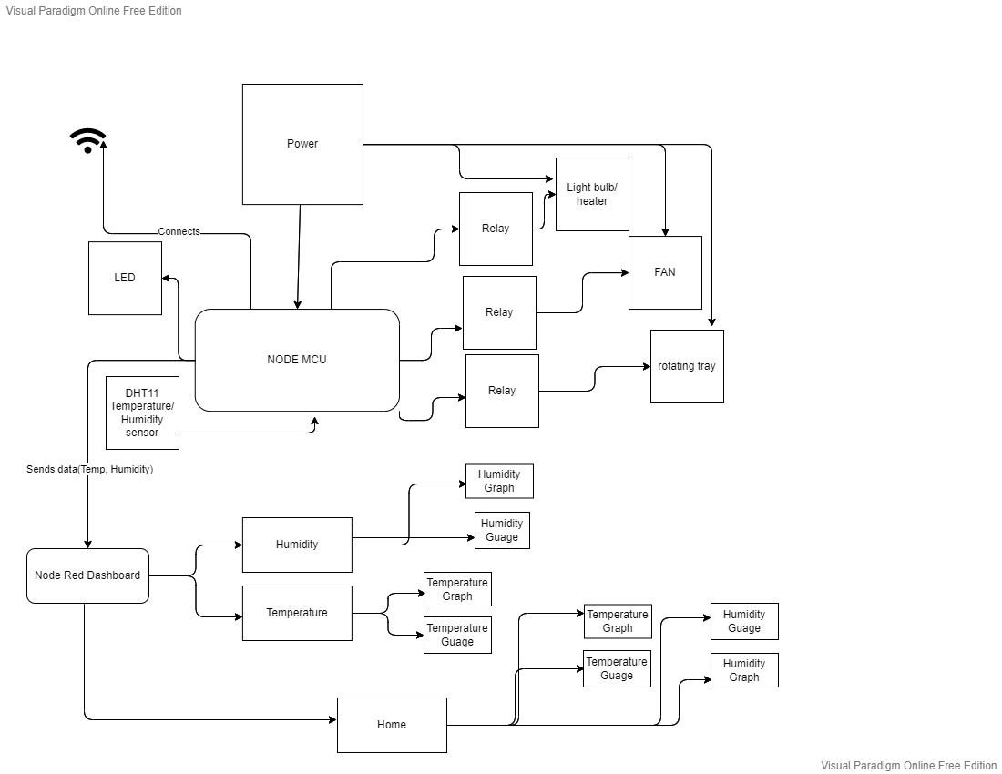

1. **Libraries**

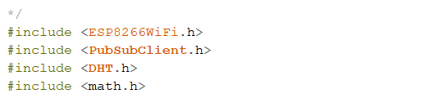

1. **Variable declaration:**

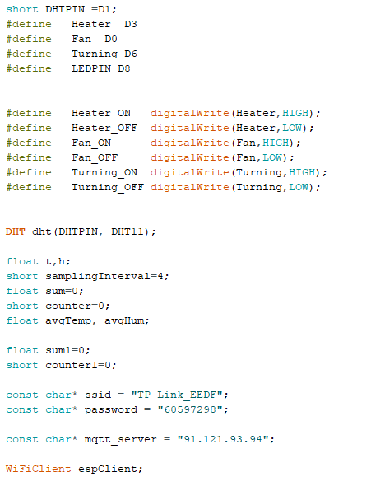

1. **Function to build Wi-Fi-connect**

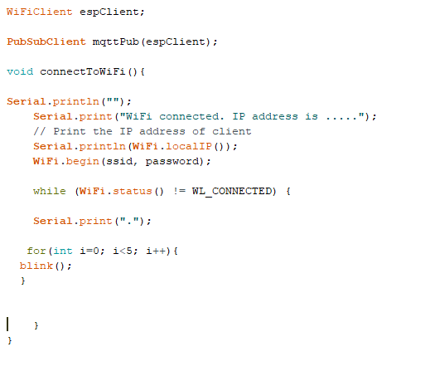

1. **Function to build MQTT-connect**

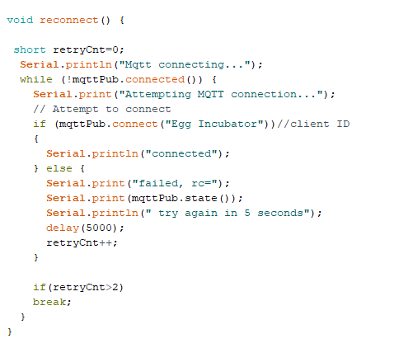

1. **Function to note the Temp+Hum readings**

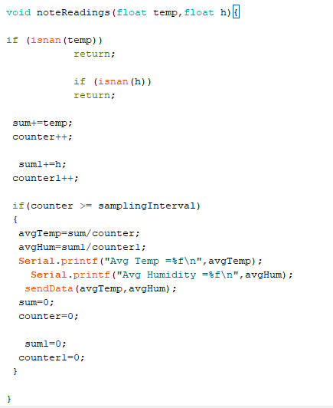

1. **Function to control Temp**

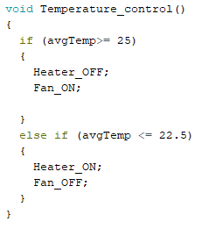

1. Function to Turn-ON the rotating tray

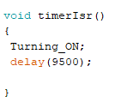

1. **Function to blink the small LED**

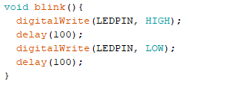

1. **Function to send or publish data to Node-RED**

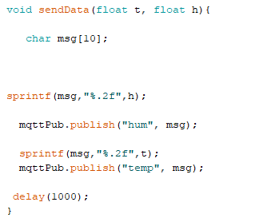

1. **SETUP function**

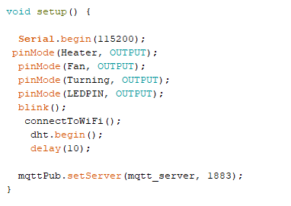

1. **Loop function**

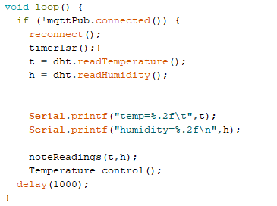

1. **JSON format of data**

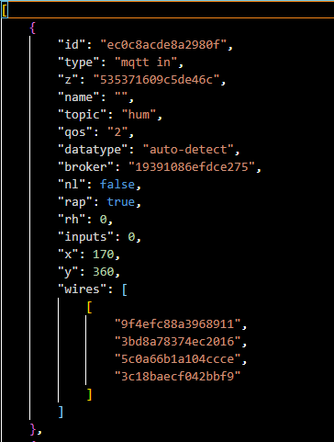

1. **Online IOT Platform (Node Red)**

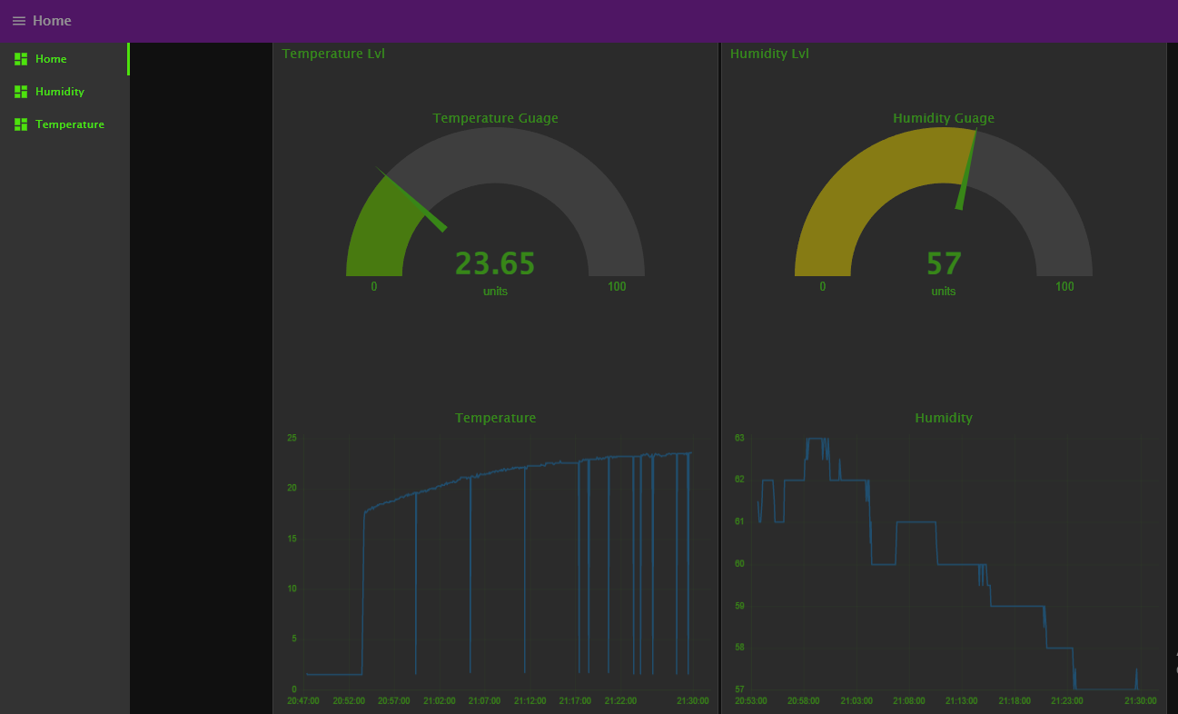

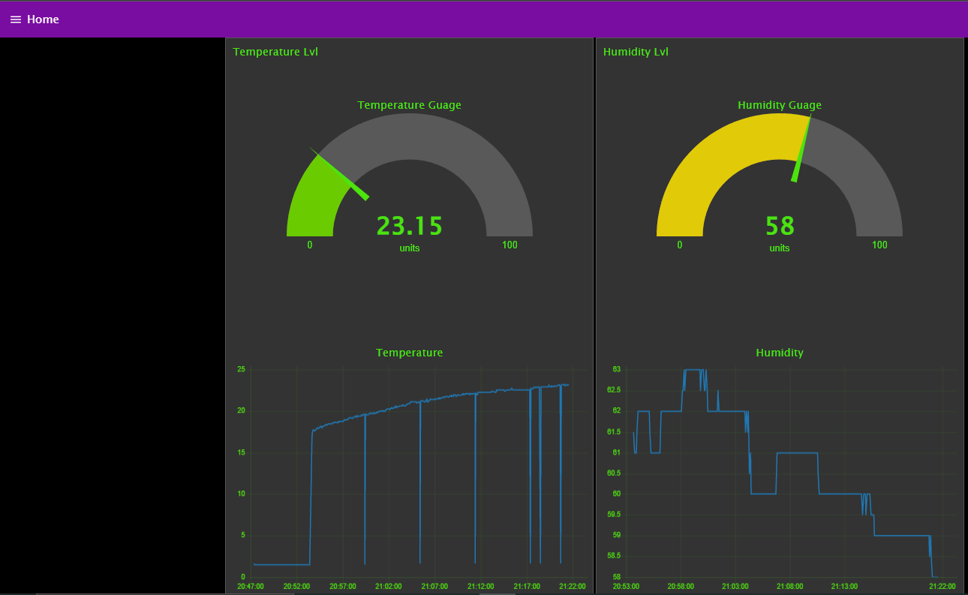

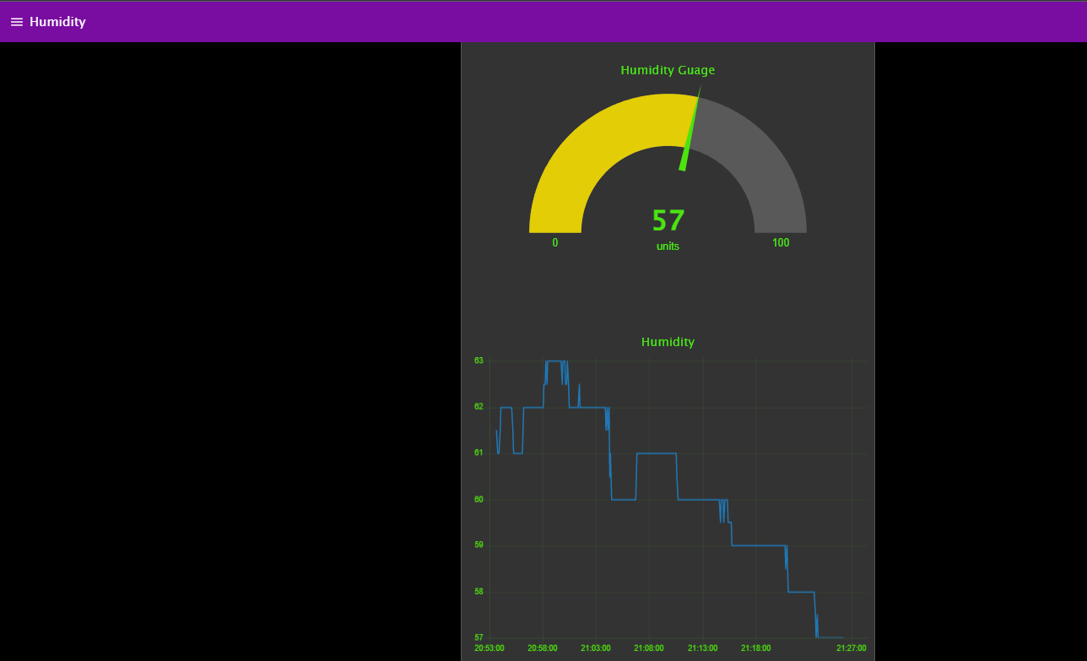

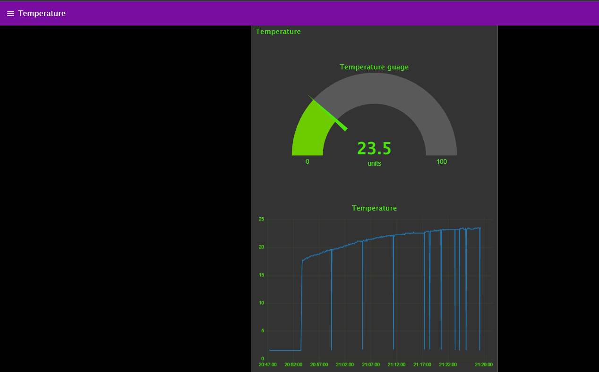

|  |  |  |
| --- | --- | --- |
|  | **Task 1 info** | **Task 2 info** |
| **Part-1** | Sending data about temperature | Sending data about Humidity |
| **Part-2** | Nothing To receive | Nothing To receive |

**Receiving data from IoT thing**



**Humidity:**



**Temperature:**



**JSON format:**

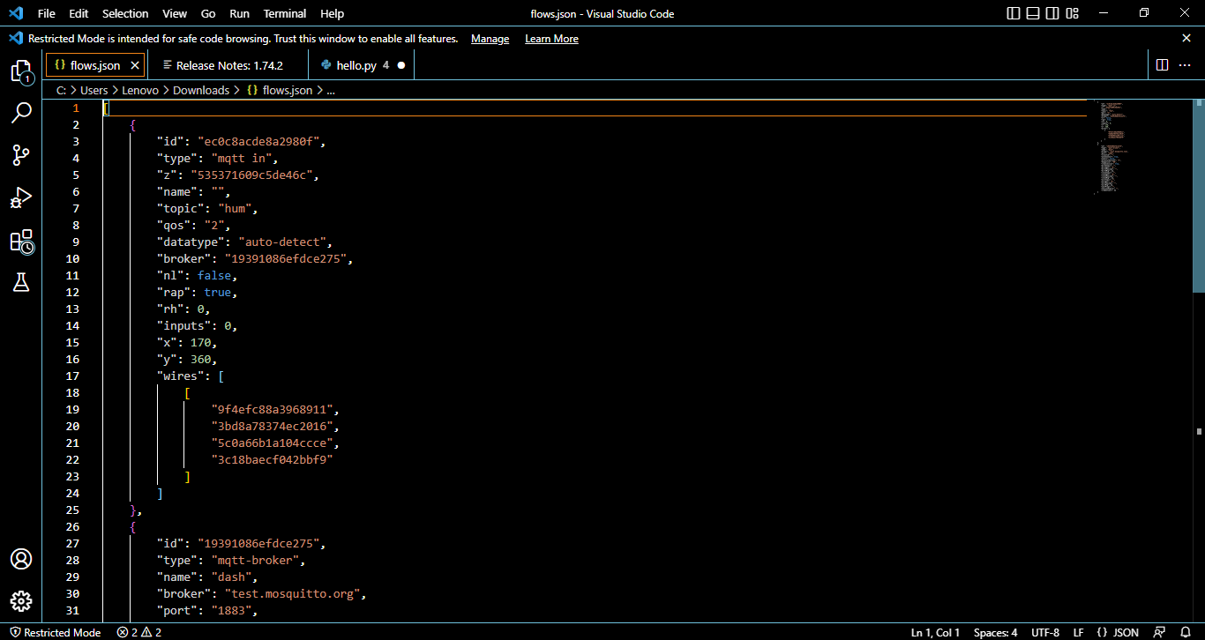

**Project Code:**

