

**Lab Manual**

# Web Engineering Fall 2020

|  |  |
| --- | --- |
| Instructor | Engr. Bakhar Muhammad |
| Student Name | ALI AZHAR |
| CMSID | 350236 |
| Department | Computer Science |
| Semester | 8th |

Lab 1.2 Lab Tasks

1. Create a webpage that includes an image of your favorite animal, a hyperlink to a website that provides information about that animal, and a list of interesting facts about the animal.

The result Screenshot of the code should be pasted here.

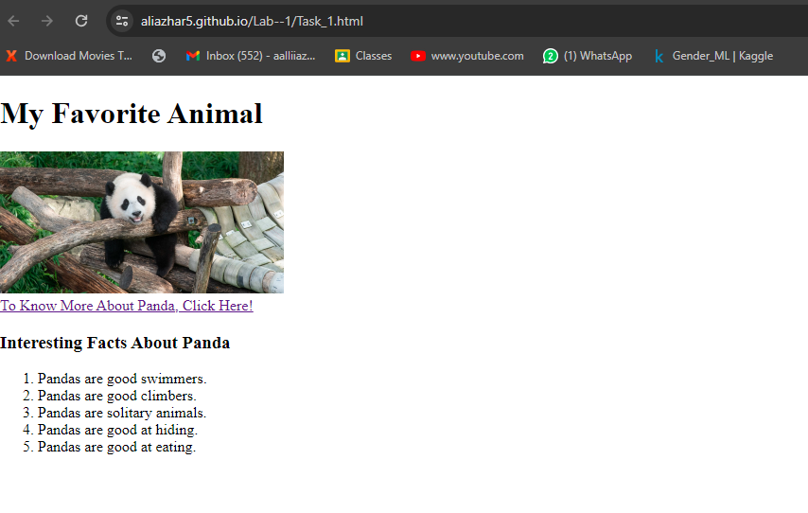

1. Build a webpage that showcases your favorite recipes. Use a table to organize the recipes by meal type (breakfast, lunch, dinner, dessert) and include an image of each dish. Use headers to indicate the recipe names and paragraph tags to provide instructions and ingredient lists.

The result Screenshot of the code should be pasted here.

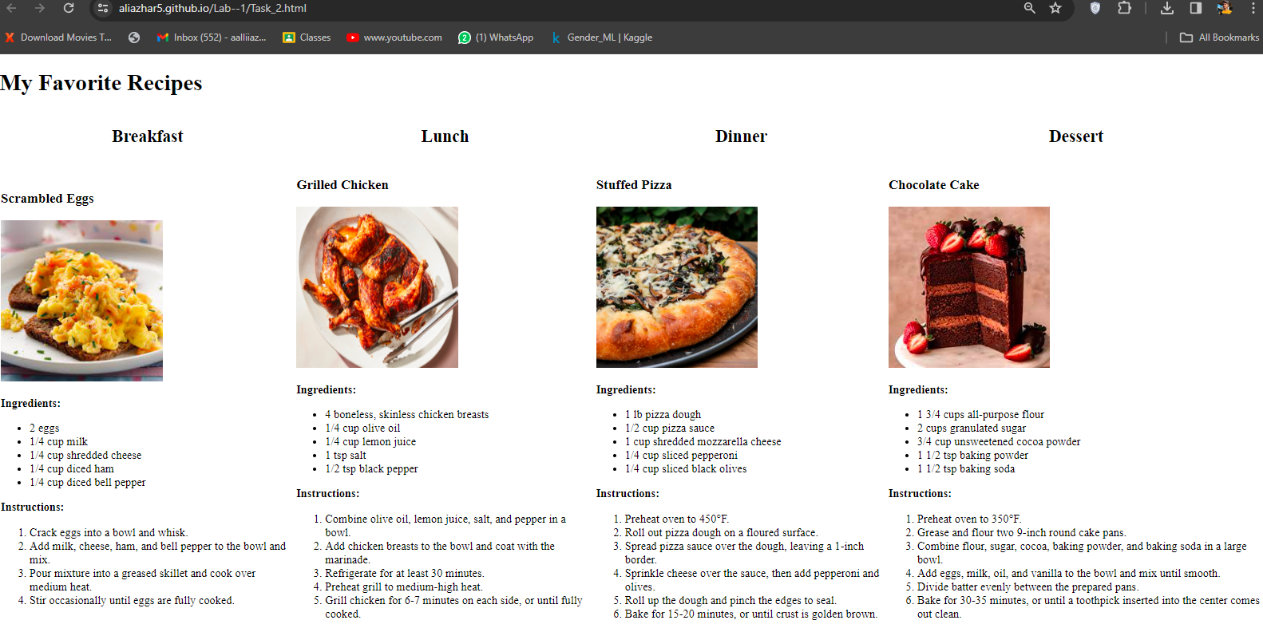

1. Develop a webpage that includes a list of your favorite books. Use hyperlinks to link to the book's page on Amazon or Goodreads and use a table to organize the books by genre. Include preformatted text to display quotes from each book.

The result Screenshot of the code should be pasted here.

**Link of Github pages:** <https://aliazhar5.github.io/Lab--1/>