Mental Health & Wellbeing Tracker – Project Plan

Mental Health & Wellbeing Tracker – Project Plan (Oct 2025 – May 2026)

Student: Ali Rehman
Programme: BSc (Hons) Computer Science
Duration: 6 Oct 2025 – 1 May 2026

1. Introduction and Background
Mental wellbeing is a critical issue in modern university life. Students face increasing academic and social pressures, contributing to anxiety, stress, and depression. While numerous wellbeing applications exist, few integrate robust data management, analytics, and machine learning to generate actionable insights. Moreover, many existing tools raise ethical and privacy concerns regarding sensitive mental health data.

This project aims to design and implement a Mental Health and Wellbeing Tracker that securely stores simulated wellbeing data—such as mood, activity, sleep, and journal entries—and leverages artificial intelligence to identify trends, patterns, and correlations. The project’s emphasis on synthetic data ensures privacy, compliance, and ethical integrity, making it suitable for an academic research context.

2. Aims and Objectives
Aim: To design and develop an intelligent, ethical, and data-driven wellbeing tracking system integrating database, API, machine learning, and visualisation components.

Objectives:

1. Design a relational database schema using SQL Server Management Studio (SSMS) to store structured wellbeing data.

2. Create a Python-based synthetic data generator to simulate realistic wellbeing logs.

3. Develop a Node.js and Express REST API to enable CRUD operations and data retrieval.
4. Implement a Python FastAPI machine learning service for sentiment analysis and mood prediction.
5. Build a web-based dashboard using HTML, CSS, and Chart.js (or Power BI) for data visualisation.
6. Evaluate system functionality, usability, data accuracy, and ethical compliance using synthetic datasets.
7. Document findings comprehensively in a dissertation with academic rigour and reflection.

Methodology and Approach
The project follows an iterative, milestone-driven methodology. Each stage—database, API, ML, frontend, and evaluation—builds upon the previous one to form a complete end-to-end data pipeline.

Phase Breakdown:
- Planning & Research (Oct–Nov 2025): Define scope, conduct literature review, and identify ethical considerations (GDPR compliance, consent design).
- Database Development (Oct–Nov 2025): Design ERD, implement schema in SSMS, and load synthetic data.
- API Development (Nov–Dec 2025): Build REST API endpoints with JWT authentication and validation.
- ML/AI Integration (Dec 2025–Mar 2026): Develop sentiment and mood prediction models using VADER, scikit-learn, and optional transformers.
- Frontend Dashboard (Feb–Mar 2026): Visualise trends, correlations, and recommendations.
- Evaluation & Dissertation (Mar–May 2026): Conduct usability tests, ethical review, write dissertation.

4. Technologies and Tools
- Database: Microsoft SQL Server (SSMS)
- Backend: Node.js, Express.js, JWT Authentication
- Machine Learning: Python (FastAPI, VADER, scikit-learn, transformers)
- Frontend: HTML, CSS, Chart.js / Power BI
- Tools: Visual Studio Code, GitHub, Postman, Power BI
- Data Ethics: Synthetic datasets, anonymisation, consent and export/delete functions

5. Ethical and Legal Considerations
The project will not involve real user data. All information will be synthetically generated to reflect plausible wellbeing patterns. Data handling practices will follow GDPR principles: transparency, minimisation, and purpose limitation. The project will include an “About & Limitations” page detailing the non-clinical purpose of the system. Ethical approval documentation will be prepared as part of the deliverables.

6. Deliverables and Success Criteria
Deliverables:
- Functional prototype: Database + API + ML + Dashboard
- ERD and SQL scripts
- API documentation and test collection
- Evaluation report (usability and accuracy results)
- Dissertation with appendices

Success Criteria:
- Secure and normalised database schema
- Functioning API endpoints with authentication
- Working ML models for sentiment and prediction
- Visual dashboards showing meaningful insights
- Evidence of evaluation and ethical compliance
- Well-structured dissertation and repository

7. Timeline and Milestones
See the excel file for a clearer project plan timeline :
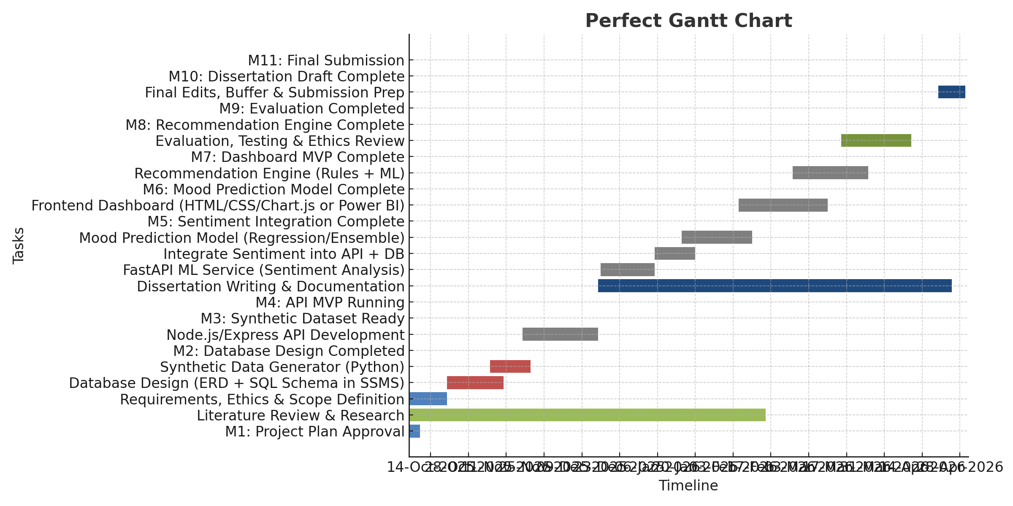

Key Milestones:
M1 – Project Plan Approval (10 Oct 2025)
M2 – Database Design Completed (10 Nov 2025)
M3 – Synthetic Dataset Ready (20 Nov 2025)
M4 – API MVP Running (15 Dec 2025)
M5 – Sentiment Integration Complete (20 Jan 2026)
M6 – Mood Prediction Model Complete (10 Feb 2026)
M7 – Dashboard MVP Complete (10 Mar 2026)
M8 – Recommendation Engine Complete (25 Mar 2026)
M9 – Evaluation Completed (10 Apr 2026)
M10 – Dissertation Draft Complete (20 Apr 2026)
M11 – Final Submission (1 May 2026)

Outcome:
By May 2026, the Mental Health & Wellbeing Tracker will demonstrate technical depth, interdisciplinary understanding, and ethical awareness—showcasing an intelligent wellbeing system built with robust database, API, and AI integration.

