Mental Health & Wellbeing Tracker – Refined Project Plan (Oct 2025 – May 2026)
Student: Ali Rehman (100690479)
Programme: BSc (Hons) Computer Science
Duration: 6 Oct 2025 – 1 May 2026

1. Introduction and Background
Mental wellbeing is a critical issue in modern university life. Students face increasing academic and social pressures, contributing to anxiety, stress, and depression. While numerous wellbeing applications exist, few integrate robust data management, analytics, and machine learning to generate actionable insights. Moreover, many existing tools raise ethical and privacy concerns regarding sensitive mental health data.
This project aims to design and implement a Mental Health and Wellbeing Tracker that securely stores simulated wellbeing data—such as mood, activity, sleep, and journal entries—and leverages artificial intelligence to identify trends, patterns, and correlations. The project’s emphasis on synthetic data ensures privacy, compliance, and ethical integrity, making it suitable for an academic research context.

2. Aim and Objectives
Aim: To design and develop an intelligent, ethical, and data-driven wellbeing tracking system integrating database, API, machine learning, and visualisation components.
- 1. Design and implement a relational database schema using SQL Server Management Studio (SSMS) to manage structured wellbeing data.
- 2. Develop a Python-based synthetic data generator to simulate realistic wellbeing logs for testing and validation.
- 3. Build a Node.js and Express REST API for secure data transactions between frontend and database, including user authentication.
- 4. Implement a Python FastAPI microservice to provide sentiment analysis and mood prediction capabilities using AI/ML techniques.
- 5. Create and evaluate a responsive web dashboard (HTML/CSS/Chart.js or Power BI) for data visualisation and user insights.

3. Methodology and Approach
The project adopts an iterative and milestone-driven development methodology inspired by Agile principles. Development will progress in phases—database design, API development, machine learning integration, frontend visualisation, and evaluation—each building upon the previous one. The initial phase will focus on defining requirements and designing the SQL schema. Subsequent phases will develop and integrate the API and machine learning modules. Regular testing and validations will be conducted to ensure data consistency and security. Weekly progress reviews and GitHub commits will maintain project momentum, while two built-in lag periods will provide buffer time for unforeseen challenges. Ethical considerations such as anonymity, consent, and data minimisation will underpin every stage of development.

4. Technologies and Tools
- Database: Microsoft SQL Server (SSMS)
- Backend: Node.js, Express.js, JWT Authentication
- Machine Learning: Python (FastAPI, VADER, scikit-learn, transformers)
- Frontend: HTML, CSS, Chart.js / Power BI
- Tools: Visual Studio Code, GitHub, Postman
- Data Ethics: Synthetic datasets, anonymisation, consent and export/delete controls

5. Ethical and Legal Considerations
The project involves no real personal data. All datasets will be synthetically generated to mimic realistic wellbeing patterns. Data handling and storage will adhere to GDPR principles of transparency, minimisation, and lawful processing. An 'About & Limitations' page will clarify that the system serves as a research and educational prototype, not a clinical tool. Ethical approval documentation will accompany the final submission, demonstrating responsible data management practices.

6. Deliverables and Success Criteria
Deliverables:
- • Functional prototype: Database + API + ML + Dashboard
- • ERD and SQL scripts
- • API documentation and test cases
- • Evaluation report (usability, functionality, and ethics)
- • Dissertation with appendices and references
Success Criteria:
- • Normalised and secure database schema with integrity constraints
- • Functional API endpoints secured by JWT authentication
- • Integrated ML models producing sentiment and prediction outputs
- • Interactive and user-friendly data visualisation dashboard
- • Demonstrated ethical compliance and complete project documentation

7. Project Timeline and Milestones
The project timeline spans from October 2025 to May 2026, incorporating two two-week lag periods for unforeseen delays or revisions. The following table outlines key milestones and contingency periods:
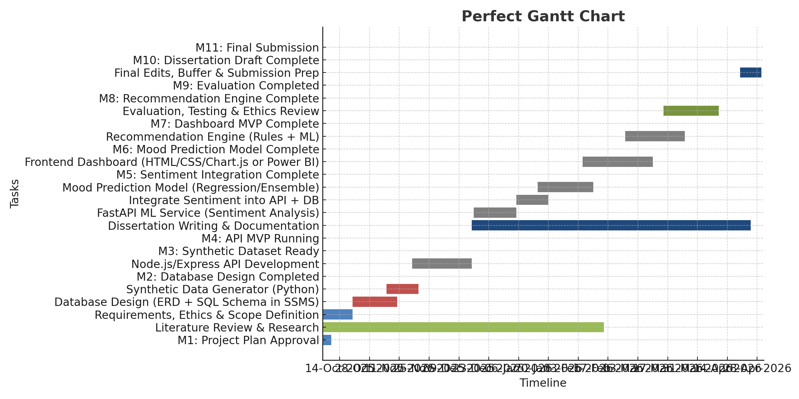
Milestone | Target Date | Description
M1 – Project Plan Approval | 10 Oct 2025 | Initial approval of refined project plan
M2 – Database Design Completed | 10 Nov 2025 | ERD and SQL schema finalised in SSMS
M3 – Synthetic Data Generator Ready | 20 Nov 2025 | Python script and sample CSVs completed
Lag 1 – Contingency Period | 15–31 Dec 2025 | Two-week lag for adjustments and testing
M4 – API MVP Running | 15 Jan 2026 | Core API endpoints and authentication completed
M5 – ML Integration Complete | 10 Feb 2026 | Sentiment and mood prediction integrated
M6 – Dashboard MVP Complete | 10 Mar 2026 | Frontend dashboard connected to API
Lag 2 – Contingency Period | 15–31 Mar 2026 | Two-week buffer for bug fixes or delays
M7 – Evaluation Completed | 10 Apr 2026 | Usability and ethical testing concluded
M8 – Dissertation Draft Complete | 20 Apr 2026 | Full draft of dissertation completed
M9 – Final Submission | 1 May 2026 | System and dissertation submission

8. Outcome
By May 2026, the Mental Health & Wellbeing Tracker will demonstrate technical depth, interdisciplinary understanding, and ethical awareness. It will showcase a functional wellbeing tracking system that integrates a secure database, REST API, AI-driven analytics, and a visual dashboard, supported by professional documentation and ethical reflection.

