

**Welcome to Smallpdf**   
Ready to take document management to the next level?

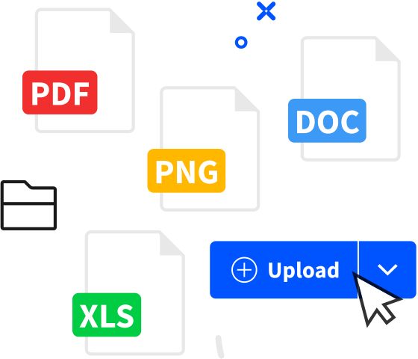

**Digital Documents—All In One Place**

With the new Smallpdf experience, you can freely upload, organize, and share digital   
documents. When you enable the [‘Storage’ option](https://bit.ly/smallpdf-preferences-en), we’ll also store all processed files here.

|  |  |
| --- | --- |
| **Enhance Documents in One Click**  When you right-click on a file, we’ll present you with an array of options to convert, compress, or modify it. |  |



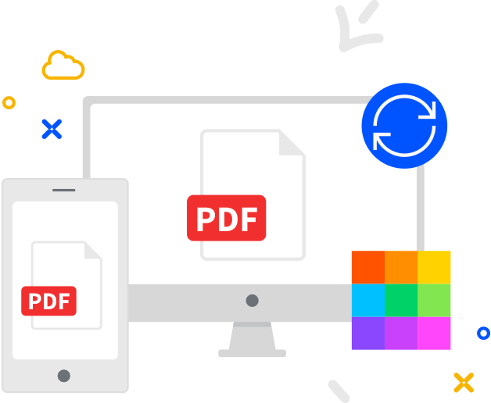

**Access Files Anytime, Anywhere**

You can access files stored on Smallpdf from your computer, phone, or tablet. We’ll also sync files from the [Smallpdf Mobile App](https://bit.ly/smallpdf-download-en) to our online portal



**Collaborate With Others**

Forget mundane administrative tasks. With Smallpdf, you can request e-signatures, send large files, or even enable the [Smallpdf G Suite](https://bit.ly/smallpdf-chrome-extension) [App](https://bit.ly/smallpdf-chrome-extension) for your entire organization.

