به نظرم توی برنامه پروژه پایانترم ترم دومم، اون هینت ها باید براساس استثناهایی باشد که داخل متد setUsername پرتاب می شود و داخل کنترلر ئ براساس این استثناها باید setHint ها انجام شود.

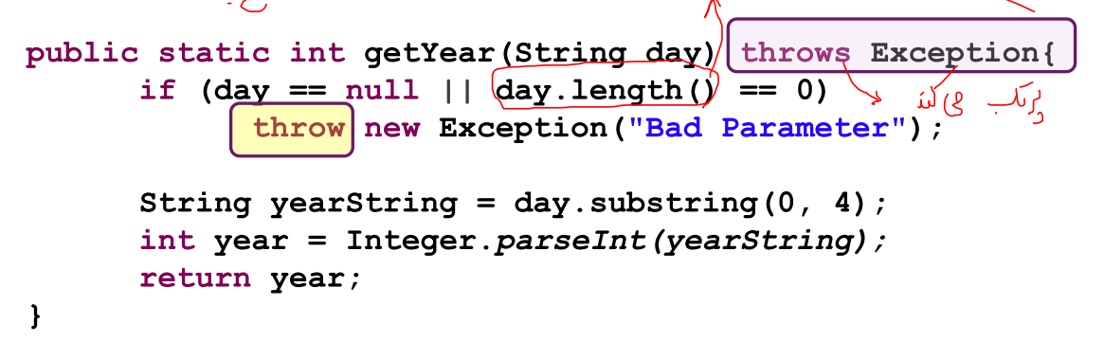

use of the Icon instead of image

how a textField just get number in its input?

mitoonam be jay e loginmanager va loginstudnet kollan yek class logIn bezanam.az code haye tekrari ham jelogiri mishavad.(hamintor baray e sign up)

seprator

spinner

tooltip text

sakht e calendar e shamsi.

\*\*fit to widh and fit to height in scroll pane fix its anchor pane to own(scroll pane)

FXMLLoader loader = new FXMLLoader(getClass().getResource("path");

ManagerPanelController9 controller = loader.getController();

AnchorPane content = loader.load();

controller.methodName(..);

injoori mian controller e ye file e fxml ro az graphicesh joda mikonan.

bad mitooni method haye tooye controller ro az biroon e controller seda bezani va ...

(be jaye static tarif kardan va estefade az auxiliary(sabk e khodam.)).

\*\*for that a node get all space of its parent go to the layout in scene builder and set its size "use computed size".

\*\*above mainpage in exaSys write a text that for example if we be in signUp manager, is writed to the that text "mainpage>signUpManager"

\*\*set background color for image view : put view on a stack pane and add a vBox on that stack pane and change background color of that stackPane.

i created User.java class and dont forget that refactory student and manager class with this.

when user click on nextQuestionBtn, must be checked that now question complete be writed.

vase pastStepBtn mitoone kollan gheire faal she va karbar vaghti khast az definingExam bere be designingExam ye dialog bezanam ke "aya az sehhate ettelatat motmaeenin. rah e bargashti joz enseraf nist."

dakhel e khod e class haye manager va student va tooye method haye set va get check kon dorosti e username va password ro.