
EGE UNIVERSITY
FACULTY OF ENGINEERING
COMPUTER ENGINEERING DEPARTMENT

ADVANCED OBJECT ORIENTED PROGRAMMING
2024–2025 SPRİNG SEMESTER

PROJECT REPORT

DELIVERY DATE
20/06/2025

PREPARED BY
05220000163 , Maher Labbad
05220000969 , Ali Emre Bulut
05220000058 , Furkan Aksu
05220000375 , Utku Özmelioğlu
İçindekiler
Class: AdminPanel.java 20
Code Explanation 20
Class: AdminUser.java 29
Code Explanation 29
Class: BusJourney.java 30
Code Explanation 30
Class: BusJourneyBuilder.java 31
Code Explanation 31
Class: BusSeatSelectionScreen.java 32
Code Explanation 32
Class: CancelReservationScreen.java 35
Code Explanation 36
Class: FilterByDestination.java 38
Code Explanation 38
Class: FilterStrategy.java 39
Code Explanation 39
Class: FlightJourney.java 40
Code Explanation 40
Class: FlightJourneyBuilder.java 41
Code Explanation 41
Class: FlightSeatSelectionScreen.java ********* 42
Code Explanation 42
Class: Journey.java 47
Code Explanation 47
Class: JourneyBuilder.java 47
Code Explanation 48
Class: JourneyListScreen.java 49
Code Explanation 49
Class: LoginScreen.java 51
Code Explanation 51
Class: MainMenu.java 52
Code Explanation 52
Class: NormalUser.java 53
Code Explanation 53
Class: RegisterScreen.java 54
Code Explanation 54
Class: ReservationDatabase.java ************* 55
Code Explanation 55
Class: SingletonUser.java 63
Code Explanation 63
Class: User.java 64
Code Explanation 64
Class: UserDatabase.java 65
Code Explanation 65
Class: UserFactory.java 65
Code Explanation 66
Class: JunitTest 67

UML
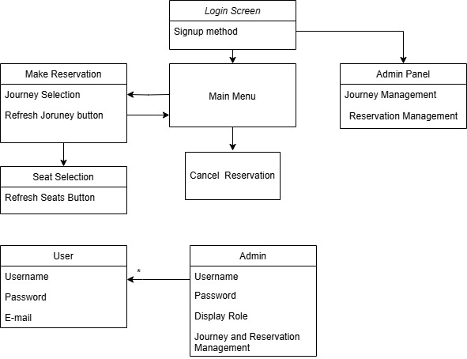

User Manuel
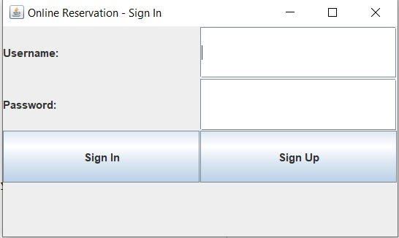
📘 User Manual – Login Page
🔹 Login Page
This page allows users to securely access the reservation system. Both new and returning users must authenticate here before booking bus or flight tickets.
✔ Features:
- Username and Password fields: Enter your registered credentials.
- Login Button: Click to sign in to your account.
- Forgot Password Link: Reset your password if you cannot log in.
- Sign Up Option: If you don’t have an account, click "Register" to create one.
🚦 Notes:
- Make sure you enter the correct email and password.
- The system supports both bus and flight ticket reservations. Once logged in, you can access both services from the dashboard.
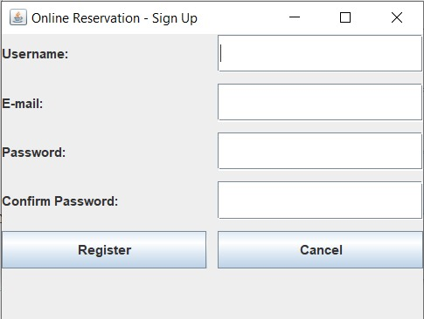
📘 User Manual – Sign Up Page
🔹 Sign Up Page
This page allows new users to create an account and access the reservation system for booking bus and flight tickets.
✔ Features:
- User Name Field: Enter your user name.
- Email Address Field: Provide a valid email address that will be used for communication and notifications.
- Password Field: Choose a strong password (at least 8 characters) for account security.
- Confirm Password Field: Re-enter your password to confirm.
- Sign Up Button: Click to create your account.
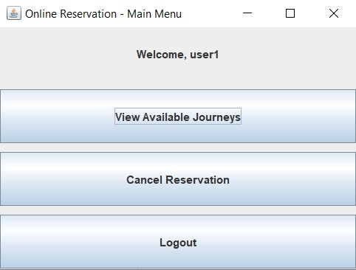
📘 User Manual – Main Menu
🔹 Main Menu
After logging in, users are directed to the Main Menu. This interface allows access to the core functions of the ticket reservation system. The following options are available:

🟩 1. View Available Journeys
This option allows users to search for available bus and flight routes.
Features:
- Filter journeys by departure and arrival cities.
- Search by date, time, or transport type (bus or flight).
- View matching results and proceed to book a selected journey.
How to Use:
Click this option, enter the required search criteria, and select a journey to proceed with a reservation.

🟨 2. Cancel Reservations
Allows users to cancel previously made bookings.
Features:
- View past reservations by user account or reservation number.
- Select a reservation to cancel.
- The status of the reservation will be updated to Cancelled.
How to Use:
Click the option, choose the reservation you wish to cancel, and confirm the cancellation.

🟥 3. Logout
Logs the user out of the system securely and returns them to the login page.
How to Use:
Click the Logout button. The session will end and you will be redirected to the login screen.
Tip: Always log out when using the system on a public or shared computer.
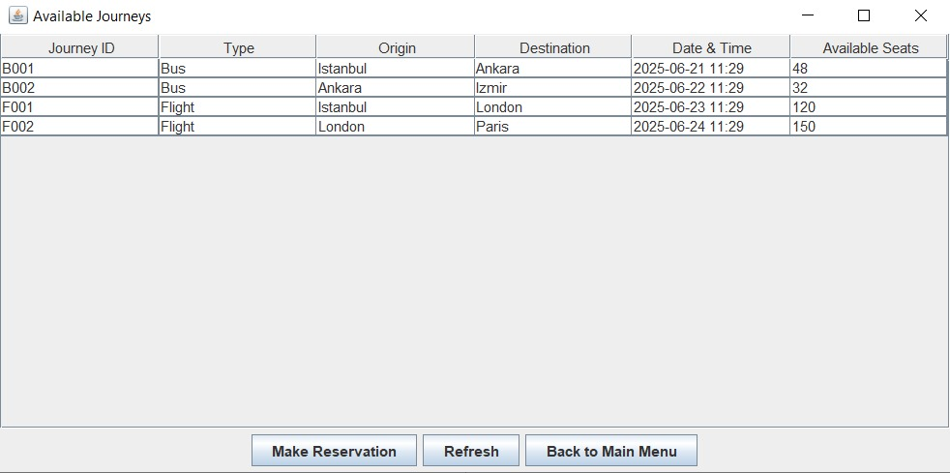User Manual: Reservation Screen
Overview
This screen displays available journeys and allows you to make reservations. You can view journey details and perform various actions.
Screen Layout
Journey List Table
The table shows all available journeys with the following columns:
- Journey ID: Unique identifier for each journey (e.g., B001, F002)
- Type: Transportation type (Bus or Flight)
- Origin: Departure city
- Destination: Arrival city
- Date & Time: Scheduled departure date and time
- Available Seats: Number of open seats remaining
Action Buttons
Three buttons appear below the journey list:
- Make Reservation: Select this to book a journey
- Refresh: Updates the journey list with current availability
- Back to Main Menu: Returns to the main application menu
How To Use
Viewing Available Journeys
- The system automatically displays all available journeys when you open this screen
- Review the information in each column to find your desired trip
Making a Reservation
- Note the Journey ID of the trip you want to book
- Click the "Make Reservation" button
- Follow the subsequent prompts to complete your booking
Refreshing the List
- Click "Refresh" if you want to check for:
  - Newly added journeys
  - Updated seat availability
  - Recent changes to the schedule
Returning to Main Menu
- Click "Back to Main Menu" at any time to exit this screen
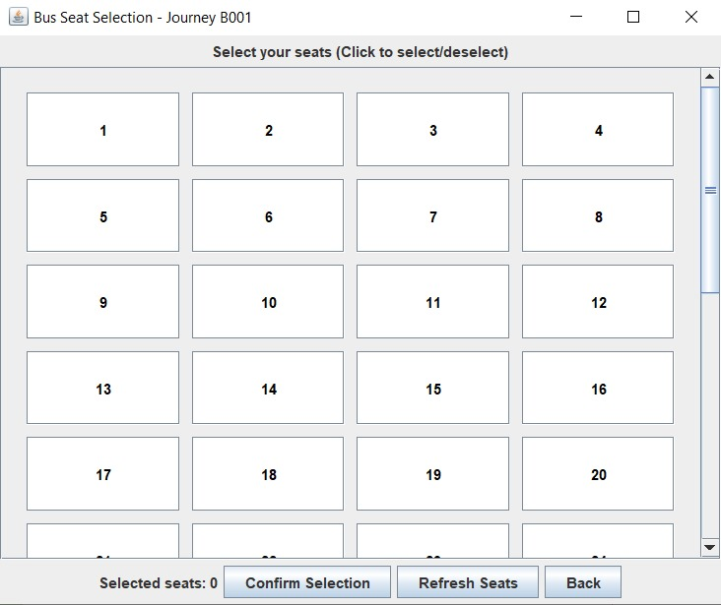
User Manual: Seat Selection Screen
Overview
This screen allows you to select seats for your chosen journey. You can view available seats, select/deselect them, and confirm your choices.
Screen Layout
Seat Grid
- Seats are displayed in a numbered grid (1 to 20 in this example).
- Available seats are shown as clickable buttons.
- Selected seats are highlighted (typically in a different color).
- Booked seats (if any) are grayed out or marked as unavailable.
Information Panel
- Selected seats: 0 (counter updates as you select/deselect seats).
Action Buttons
- Confirm Selection – Proceeds to the next step after choosing seats.
- Refresh Seats – Updates seat availability in case of recent changes.
- Back – Returns to the previous screen without confirming selections.
How to Use
Selecting Seats
- Click on an available seat number to select it.
- The seat will be highlighted, and the "Selected seats" counter will increase.
- Click again to deselect if you change your mind.
Confirming Your Selection
- After choosing your desired seats, click "Confirm Selection" to proceed.
- If no seats are selected, the button may be disabled.
Refreshing Seat Availability
- Click "Refresh Seats" to check for real-time updates (e.g., if seats were booked by another user).
Going Back
- Click "Back" to return to the journey list without saving selections.
User Manual: My Reservations Screen
Overview
This screen displays your current reservations, including details such as the reservation ID, journey information, selected seats, and status. You can manage your bookings by canceling them or refreshing the list.
Screen Layout
Reservations Table
The table lists all active reservations with the following columns:
- Reservation ID: A unique identifier for your booking (e.g., RES1750408254734).
- Journey ID: The ID of the booked trip (e.g., B001 for Bus 001).
- Seats: The seat numbers you have reserved (e.g., [1]).
- Status: Current status of the reservation (e.g., Active, Cancelled, Completed).
Action Buttons
- Cancel Reservation – Allows you to cancel the selected reservation.
- Refresh – Updates the list to show the latest reservation status.
- Back to Main Menu – Returns to the main dashboard.
How to Use
Viewing Reservations
- The system automatically displays your active reservations upon opening this screen.
- Check the Status column to confirm if your booking is still valid.
Canceling a Reservation
- Ensure the correct reservation is listed.
- Click "Cancel Reservation".
- A confirmation prompt may appear—confirm to proceed.
- The Status will update to Cancelled (refresh if needed).
Refreshing the List
- Click "Refresh" to check for updates, such as:
  - Recently canceled bookings.
  - Changes in reservation status.
Returning to the Main Menu
- Click "Back to Main Menu" to exit this screen.
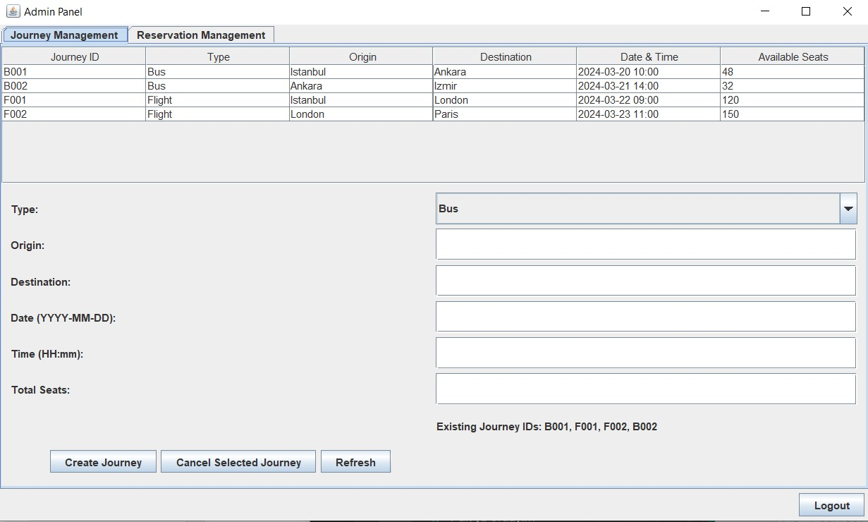
User Manual: Journey Management Screen
Overview
This screen allows administrators to view, create, and manage journeys (bus/flight routes). It displays all existing journeys and provides tools to add new ones or cancel existing ones.

Screen Layout
1. Journeys List Table
Displays all available journeys with the following details:
- Journey ID (e.g., B001, F002)
- Type (Bus or Flight)
- Origin (Departure city)
- Destination (Arrival city)
- Date & Time (Departure schedule in YYYY-MM-DD HH:mm format)
- Available Seats (Remaining capacity)
2. Journey Creation Form
Fields to define a new journey:
- Type (Bus/Flight dropdown)
- Origin (Text input)
- Destination (Text input)
- Date (YYYY-MM-DD format)
- Time (HH:mm 24-hour format)
- Total Seats (Numeric input)
3. Action Buttons
- Create Journey → Adds a new journey based on the form inputs.
- Cancel Selected Journey → Removes the highlighted journey from the list.
- Refresh → Updates the journey list in real-time.
4. Information Section
- Existing Journey IDs → Lists all current journey IDs for reference (e.g., B001, F001, F002, B002).

How to Use
Viewing Existing Journeys
- The table automatically loads all available journeys.
- Check Available Seats to monitor capacity.
Adding a New Journey
- Fill in the form fields:
  - Select Type (Bus/Flight).
  - Enter Origin and Destination.
  - Set Date and Time.
  - Specify Total Seats.
- Click "Create Journey" to add it to the system.
Canceling a Journey
- Ensure the journey is listed in the table.
- Click "Cancel Selected Journey" (may require confirmation).
- The journey will be removed from the list (refresh if needed).
Refreshing the List
- Click "Refresh" to sync with the latest journey data.
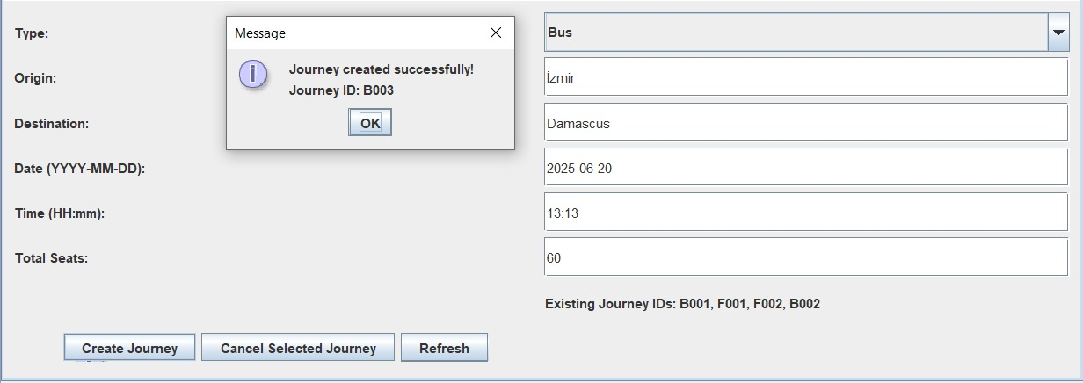
User Manual: Journey Creation Confirmation Screen
Overview
This screen appears after successfully creating a new journey. It confirms the journey details and provides options to manage journeys further.

Screen Layout
1. Success Message
- "Journey created successfully!" → Confirmation that the journey was added.
- "Journey ID: B003" → The auto-generated unique ID for the new journey.
2. Journey Details Display
Shows the newly created journey's information:
- Type: Bus
- Origin: Izmir
- Destination: Damascus
- Date: 2025-06-20
- Time: 13:13
- Total Seats: 60
3. Action Buttons
- OK → Returns to the Journey Management screen.
- Create Journey → Opens the form to add another journey.
- Cancel Selected Journey → Removes a highlighted journey (if applicable).
- Refresh → Updates the journey list.
4. Existing Journey IDs Reference
- Lists all current journey IDs (e.g., B001, F001, F002, B002).

How to Use
After Successful Creation
- Verify the journey details in the confirmation message.
- Click OK to return to the main Journey Management screen.
Creating Another Journey
- Click "Create Journey" to open the journey form again.
- Fill in the new journey’s details and submit.
Managing Existing Journeys
- Use "Cancel Selected Journey" to remove a journey (if needed).
- Click "Refresh" to ensure the latest journey list is displayed.
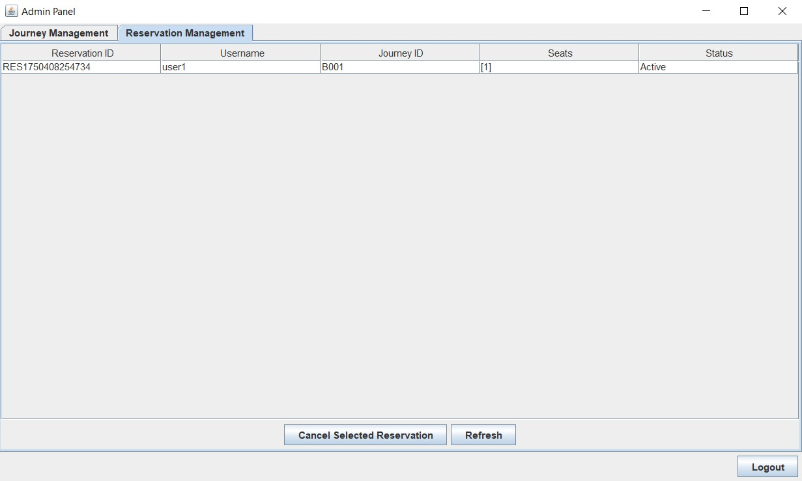
User Manual: Admin Panel - Reservation Management Screen
Overview
This screen allows administrators to view and manage all customer reservations. Admins can monitor active bookings, cancel reservations if needed, and refresh the list for real-time updates.

Screen Layout
1. Reservation Information Section
Displays all active reservations with the following details:
- Reservation ID (e.g., RES1750408254734)
- Username (e.g., user1)
- Journey ID (e.g., B001)
- Seats (e.g., [1])
- Status (e.g., Active, Cancelled, Completed)
2. Action Buttons
- Cancel Selected Reservation → Cancels the highlighted reservation
- Refresh → Updates the reservation list
- Logout → Exits the admin panel

How to Use
Viewing Reservations
- The system automatically loads all active reservations
- Check the Status column to see current booking states
Canceling a Reservation
- Ensure the correct reservation is displayed
- Click "Cancel Selected Reservation"
- Confirm the cancellation when prompted
- The status will update to "Cancelled" (refresh if needed)
Refreshing the List
- Click "Refresh" to:
  - View newly made reservations
  - See updated status changes
  - Check for recently canceled bookings
Logging Out
- Click "Logout" to securely exit the admin panel

Class: AdminPanel.java
• Purpose: Allows admin users to manage journeys and reservations within the system.
• Design Pattern Usage:
- Observer: Dynamically updates table data using JTable components, enabling real-time synchronization between the data model and the user interface whenever changes occur.
- MVC: Clearly separates the user interface (View), logic operations (Controller), and data handling (Model), improving modularity, maintainability, and scalability of the application.

Code Explanation
package com.project;
import java.awt.BorderLayout;
import java.awt.FlowLayout;
import java.awt.GridLayout;
import java.time.LocalDateTime;
import java.util.List;
import javax.swing.BorderFactory;
import javax.swing.JButton;
import javax.swing.JComboBox;
import javax.swing.JFrame;
import javax.swing.JLabel;
import javax.swing.JOptionPane;
import javax.swing.JPanel;
import javax.swing.JScrollPane;
import javax.swing.JTabbedPane;
import javax.swing.JTable;
import javax.swing.JTextField;
import javax.swing.SwingUtilities;
import javax.swing.table.DefaultTableModel;
public class AdminPanel extends JFrame {
private User currentUser;
private JTable journeyTable;
private JTable reservationTable;
private DefaultTableModel journeyTableModel;
private DefaultTableModel reservationTableModel;
public AdminPanel(User user) {
this.currentUser = user;
setTitle("Admin Panel");
setSize(1000, 600);
setDefaultCloseOperation(DISPOSE_ON_CLOSE);
setLocationRelativeTo(null);
// Main panel with border layout
setLayout(new BorderLayout());
// Create tabbed pane
JTabbedPane tabbedPane = new JTabbedPane();
// Journey Management Tab
JPanel journeyPanel = createJourneyPanel();
tabbedPane.addTab("Journey Management", journeyPanel);
refreshJourneyTable();
// Reservation Management Tab
JPanel reservationPanel = createReservationPanel();
tabbedPane.addTab("Reservation Management", reservationPanel);
add(tabbedPane, BorderLayout.CENTER);
// Bottom panel for logout
JPanel bottomPanel = new JPanel(new FlowLayout(FlowLayout.RIGHT));
JButton logoutButton = new JButton("Logout");
logoutButton.addActionListener(e -> {
dispose();
new LoginScreen();
});
bottomPanel.add(logoutButton);
add(bottomPanel, BorderLayout.SOUTH);
refreshJourneyTable();
setVisible(true);
}
private JPanel createJourneyPanel() {
JPanel panel = new JPanel(new BorderLayout());
// Create journey table
String[] columns = {"Journey ID", "Type", "Origin", "Destination", "Date & Time", "Available Seats"};
journeyTableModel = new DefaultTableModel(columns, 0) {
@Override
public boolean isCellEditable(int row, int column) {
return false;
}
};
journeyTable = new JTable(journeyTableModel);
JScrollPane journeyScrollPane = new JScrollPane(journeyTable);
panel.add(journeyScrollPane, BorderLayout.CENTER);
// Create journey form panel
JPanel formPanel = new JPanel(new GridLayout(8, 2, 5, 5));
formPanel.setBorder(BorderFactory.createEmptyBorder(10, 10, 10, 10));
JComboBox<String> typeCombo = new JComboBox<>(new String[]{"Bus", "Flight"});
JTextField originField = new JTextField();
JTextField destinationField = new JTextField();
JTextField dateField = new JTextField();
JTextField timeField = new JTextField();
JTextField seatsField = new JTextField();
JLabel existingIdsLabel = new JLabel("Existing Journey IDs: " + String.join(", ", ReservationDatabase.getExistingJourneyIds()));
formPanel.add(new JLabel("Type:"));
formPanel.add(typeCombo);
formPanel.add(new JLabel("Origin:"));
formPanel.add(originField);
formPanel.add(new JLabel("Destination:"));
formPanel.add(destinationField);
formPanel.add(new JLabel("Date (YYYY-MM-DD):"));
formPanel.add(dateField);
formPanel.add(new JLabel("Time (HH:mm):"));
formPanel.add(timeField);
formPanel.add(new JLabel("Total Seats:"));
formPanel.add(seatsField);
formPanel.add(new JLabel(""));
formPanel.add(existingIdsLabel);
// Create button panel
JPanel buttonPanel = new JPanel(new FlowLayout(FlowLayout.CENTER));
JButton createButton = new JButton("Create Journey");
JButton cancelButton = new JButton("Cancel Selected Journey");
JButton refreshButton = new JButton("Refresh");
createButton.addActionListener(e -> {
try {
String type = (String) typeCombo.getSelectedItem();
String origin = originField.getText().trim();
String destination = destinationField.getText().trim();
String date = dateField.getText().trim();
String time = timeField.getText().trim();
String seatsStr = seatsField.getText().trim();
// Validate inputs with specific error messages
StringBuilder errorMessage = new StringBuilder();
if (origin.isEmpty()) {
errorMessage.append("• Origin field cannot be empty\n");
}
if (destination.isEmpty()) {
errorMessage.append("• Destination field cannot be empty\n");
}
// Check if origin and destination are different
if (!origin.isEmpty() && !destination.isEmpty() && origin.equalsIgnoreCase(destination)) {
errorMessage.append("• Origin and destination cannot be the same\n");
}
if (date.isEmpty()) {
errorMessage.append("• Date field cannot be empty\n");
} else if (!date.matches("\\d{4}-\\d{2}-\\d{2}")) {
errorMessage.append("• Date must be in YYYY-MM-DD format\n");
} else {
try {
// Parse the date and check if it's in the future
LocalDateTime journeyDateTime = LocalDateTime.parse(date + "T" + time + ":00");
LocalDateTime now = LocalDateTime.now();
if (journeyDateTime.isBefore(now)) {
errorMessage.append("• Journey date and time must be in the future\n");
}
} catch (Exception ex) {
errorMessage.append("• Invalid date or time format\n");
}
}
if (time.isEmpty()) {
errorMessage.append("• Time field cannot be empty\n");
} else if (!time.matches("\\d{2}:\\d{2}")) {
errorMessage.append("• Time must be in HH:mm format\n");
} else {
try {
// Parse time and check if it's valid
String[] timeParts = time.split(":");
int hours = Integer.parseInt(timeParts[0]);
int minutes = Integer.parseInt(timeParts[1]);
if (hours < 0 || hours > 23) {
errorMessage.append("• Hours must be between 00 and 23\n");
}
if (minutes < 0 || minutes > 59) {
errorMessage.append("• Minutes must be between 00 and 59\n");
}
} catch (Exception ex) {
errorMessage.append("• Invalid time format\n");
}
}
if (seatsStr.isEmpty()) {
errorMessage.append("• Seats field cannot be empty\n");
} else {
try {
int seats = Integer.parseInt(seatsStr);
if (seats <= 0) {
errorMessage.append("• Number of seats must be positive\n");
} else if (type.equals("Bus") && seats % 4 != 0) {
errorMessage.append("• Bus journeys must have seats in multiples of 4\n");
} else if (type.equals("Flight") && seats % 6 != 0) {
errorMessage.append("• Flight journeys must have seats in multiples of 6\n");
}
} catch (NumberFormatException ex) {
errorMessage.append("• Seats must be a valid number\n");
}
}
if (errorMessage.length() > 0) {
JOptionPane.showMessageDialog(this,
"Please correct the following errors:\n\n" + errorMessage.toString(),
"Validation Error",
JOptionPane.ERROR_MESSAGE);
return;
}
// Create journey ID (B001, F001, etc.)
String prefix = type.equals("Bus") ? "B" : "F";
int nextNumber = getNextJourneyNumber(type);
String journeyId = prefix + String.format("%03d", nextNumber);
// Add to database
if (ReservationDatabase.addJourney(journeyId, type, origin, destination, date + " " + time, Integer.parseInt(seatsStr))) {
JOptionPane.showMessageDialog(this,
String.format("Journey created successfully!\nJourney ID: %s", journeyId));
refreshJourneyTable();
clearForm(typeCombo, originField, destinationField, dateField, timeField, seatsField);
// Update existing IDs label
existingIdsLabel.setText("Existing Journey IDs: " + String.join(", ", ReservationDatabase.getExistingJourneyIds()));
} else {
JOptionPane.showMessageDialog(this,
String.format("Failed to create journey!\nJourney ID %s might already exist.", journeyId),
"Error",
JOptionPane.ERROR_MESSAGE);
}
} catch (Exception ex) {
JOptionPane.showMessageDialog(this,
"An unexpected error occurred: " + ex.getMessage(),
"Error",
JOptionPane.ERROR_MESSAGE);
}
});
cancelButton.addActionListener(e -> {
int selectedRow = journeyTable.getSelectedRow();
if (selectedRow == -1) {
JOptionPane.showMessageDialog(this, "Please select a journey to cancel!");
return;
}
String journeyId = (String) journeyTableModel.getValueAt(selectedRow, 0);
String type = (String) journeyTableModel.getValueAt(selectedRow, 1);
String origin = (String) journeyTableModel.getValueAt(selectedRow, 2);
String destination = (String) journeyTableModel.getValueAt(selectedRow, 3);
String dateTime = (String) journeyTableModel.getValueAt(selectedRow, 4);
int confirm = JOptionPane.showConfirmDialog(this,
"Are you sure you want to cancel this journey?\n\n" +
"Journey ID: " + journeyId + "\n" +
"Type: " + type + "\n" +
"From: " + origin + "\n" +
"To: " + destination + "\n" +
"Date & Time: " + dateTime,
"Confirm Cancellation",
JOptionPane.YES_NO_OPTION);
if (confirm == JOptionPane.YES_OPTION) {
ReservationDatabase.JourneyCancellationResult result = ReservationDatabase.cancelJourney(journeyId);
if (result.isSuccess()) {
StringBuilder message = new StringBuilder("Journey cancelled successfully!");
// Add information about cancelled reservations
List<String> cancelledReservations = result.getCancelledReservations();
if (!cancelledReservations.isEmpty()) {
message.append("\n\nThe following reservations were also cancelled:\n");
for (String res : cancelledReservations) {
message.append("• ").append(res).append("\n");
}
}
JOptionPane.showMessageDialog(this, message.toString());
refreshJourneyTable();
refreshReservationTable(); // Also refresh the reservation table
// Update existing IDs label
existingIdsLabel.setText("Existing Journey IDs: " + String.join(", ", ReservationDatabase.getExistingJourneyIds()));
} else {
JOptionPane.showMessageDialog(this, "Failed to cancel journey!");
}
}
});
refreshButton.addActionListener(e -> {
refreshJourneyTable();
existingIdsLabel.setText("Existing Journey IDs: " + String.join(", ", ReservationDatabase.getExistingJourneyIds()));
});
buttonPanel.add(createButton);
buttonPanel.add(cancelButton);
buttonPanel.add(refreshButton);
formPanel.add(buttonPanel);
panel.add(formPanel, BorderLayout.SOUTH);
return panel;
}
private JPanel createReservationPanel() {
JPanel panel = new JPanel(new BorderLayout());
// Create reservation table
String[] columns = {"Reservation ID", "Username", "Journey ID", "Seats", "Status"};
reservationTableModel = new DefaultTableModel(columns, 0) {
@Override
public boolean isCellEditable(int row, int column) {
return false;
}
};
reservationTable = new JTable(reservationTableModel);
JScrollPane reservationScrollPane = new JScrollPane(reservationTable);
panel.add(reservationScrollPane, BorderLayout.CENTER);
// Create button panel
JPanel buttonPanel = new JPanel(new FlowLayout(FlowLayout.CENTER));
JButton cancelButton = new JButton("Cancel Selected Reservation");
JButton refreshButton = new JButton("Refresh");
cancelButton.addActionListener(e -> {
int selectedRow = reservationTable.getSelectedRow();
if (selectedRow == -1) {
JOptionPane.showMessageDialog(this, "Please select a reservation to cancel!");
return;
}
String reservationId = (String) reservationTableModel.getValueAt(selectedRow, 0);
String username = (String) reservationTableModel.getValueAt(selectedRow, 1);
String journeyId = (String) reservationTableModel.getValueAt(selectedRow, 2);
String seats = (String) reservationTableModel.getValueAt(selectedRow, 3);
int confirm = JOptionPane.showConfirmDialog(this,
"Are you sure you want to cancel this reservation?\n" +
"Username: " + username + "\n" +
"Journey ID: " + journeyId + "\n" +
"Seats: " + seats,
"Confirm Cancellation",
JOptionPane.YES_NO_OPTION);
if (confirm == JOptionPane.YES_OPTION) {
if (ReservationDatabase.cancelReservation(username, reservationId)) {
JOptionPane.showMessageDialog(this, "Reservation cancelled successfully!");
refreshReservationTable();
} else {
JOptionPane.showMessageDialog(this, "Failed to cancel reservation!");
}
}
});
refreshButton.addActionListener(e -> refreshReservationTable());
buttonPanel.add(cancelButton);
buttonPanel.add(refreshButton);
panel.add(buttonPanel, BorderLayout.SOUTH);
refreshReservationTable();
return panel;
}
private void refreshJourneyTable() {
journeyTableModel.setRowCount(0);
List<ReservationDatabase.Journey> journeys = ReservationDatabase.getAllJourneys();
for (ReservationDatabase.Journey journey : journeys) {
Object[] row = {
journey.getId(),
journey.getType(),
journey.getOrigin(),
journey.getDestination(),
journey.getDateTime(),
journey.getAvailableSeats()
};
journeyTableModel.addRow(row);
}
}
private void refreshReservationTable() {
reservationTableModel.setRowCount(0);
List<ReservationDatabase.Reservation> reservations = ReservationDatabase.getAllReservations();
for (ReservationDatabase.Reservation res : reservations) {
Object[] row = {
res.getReservationId(),
res.getUsername(),
res.getJourneyId(),
res.getSeatNumbersString(),
"Active"
};
reservationTableModel.addRow(row);
}
}
private void clearForm(JComboBox<String> typeCombo, JTextField... fields) {
typeCombo.setSelectedIndex(0);
for (JTextField field : fields) {
field.setText("");
}
}
private int getNextJourneyNumber(String type) {
String prefix = type.equals("Bus") ? "B" : "F";
int nextNumber = 1;
// Keep incrementing until we find an available ID
while (ReservationDatabase.isJourneyIdExists(prefix + String.format("%03d", nextNumber))) {
nextNumber++;
}
return nextNumber;
}
public static void main(String[] args) {
SwingUtilities.invokeLater(() -> {
// For testing purposes
User adminUser = new AdminUser("admin", "admin");
new AdminPanel(adminUser);
});
}
}

Class: AdminUser.java
- Purpose: Represents admin-type users, providing user-type-specific behaviors.
- Design Pattern Usage:
  - Factory Method: Created by UserFactory to manage different user types. Defines an interface for creating objects but lets subclasses decide which specific class to instantiate, promoting flexibility and decoupling the client code from the actual object creation process.

Code Explanation

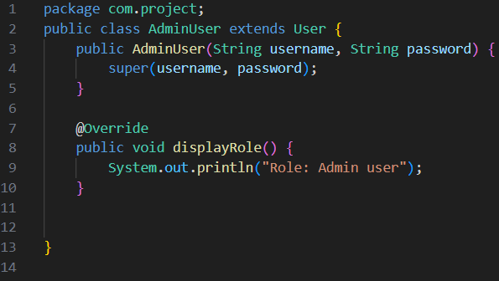

Class: BusJourney.java
• Purpose: Represents a bus journey, providing specific attributes and behaviors.
• Design Pattern Usage:
- Inheritance: Extends the Journey class, specializing for bus journeys. Enables new classes to acquire properties and behaviors from existing classes, promoting code reuse and establishing a clear hierarchical relationship between general and specialized types.

Code Explanation
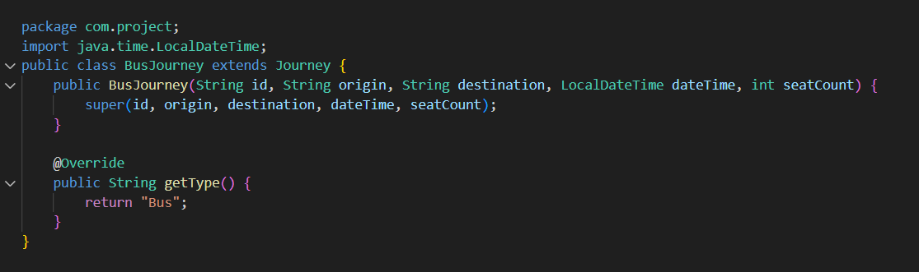

Class: BusJourneyBuilder.java
• Purpose: Manages step-by-step creation of BusJourney objects.
• Design Pattern Usage:
- Builder Pattern: Simplifies the creation of complex bus journey objects. Facilitates the step-by-step construction of complex Reservation objects, allowing the inclusion of optional features like seat selection, meal preferences, and special discounts without cluttering the creation logic.

Code Explanation
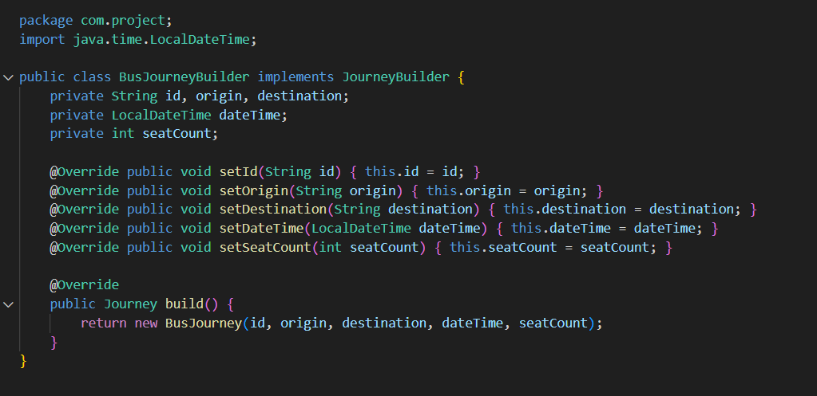

Class: BusSeatSelectionScreen.java
• Purpose: Provides a graphical interface for selecting bus seats.
• Design Pattern Usage:
- Singleton: Manages user sessions using SingletonUser. The Singleton pattern ensures that a class has only one instance and provides a global point of access to that instance.
- Facade: Simplifies seat reservation processes via ReservationDatabase.

Code Explanation

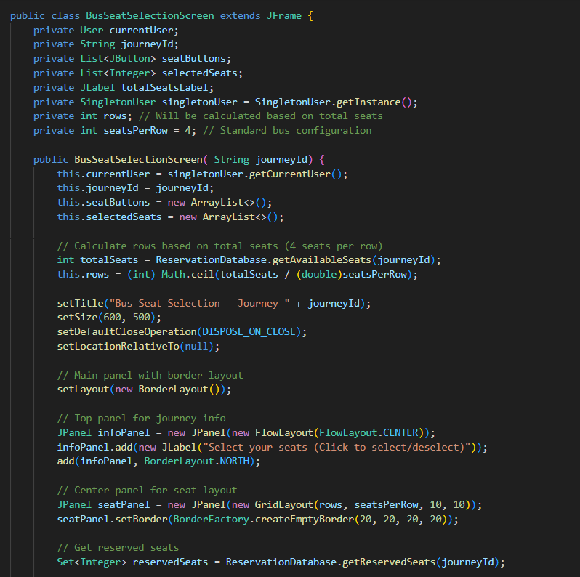
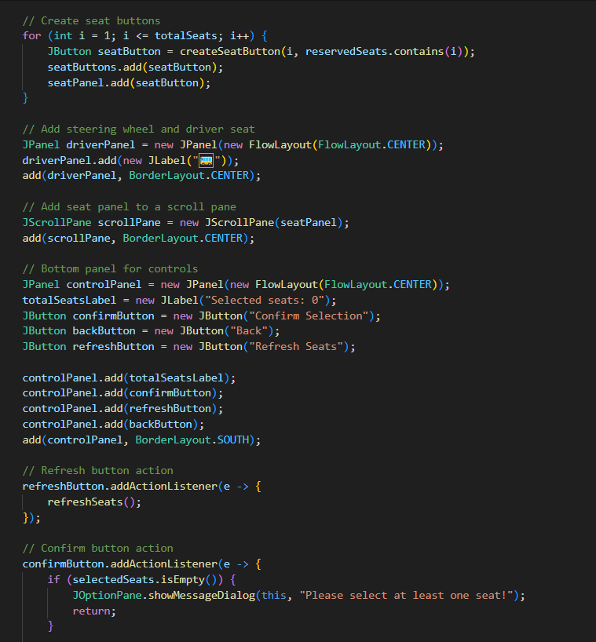
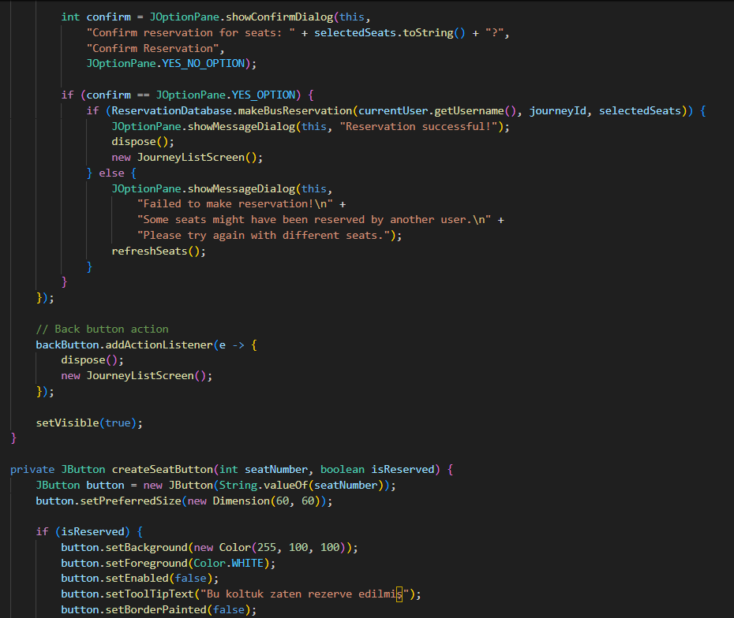
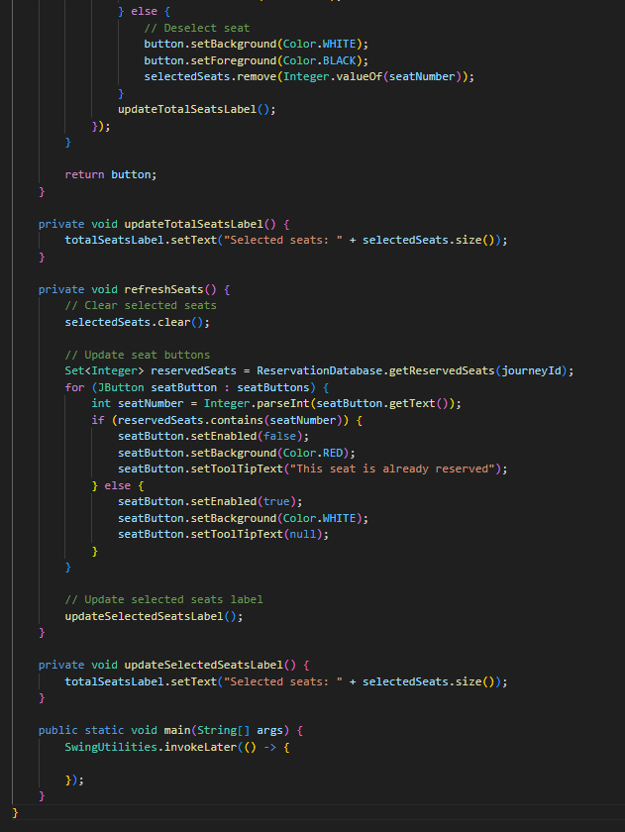

Class: CancelReservationScreen.java
• Purpose: Allows users to cancel their existing reservations.
• Design Pattern Usage:
- Singleton: Retrieves user session details through SingletonUser. It is commonly used for managing shared resources like configuration settings or logging, where having multiple instances could lead to inconsistent behavior or excessive memory use.

- Facade: Simplifies reservation cancellations through ReservationDatabase by providing a unified interface that hides the complexity of database operations and business rules behind a single method call.

Code Explanation
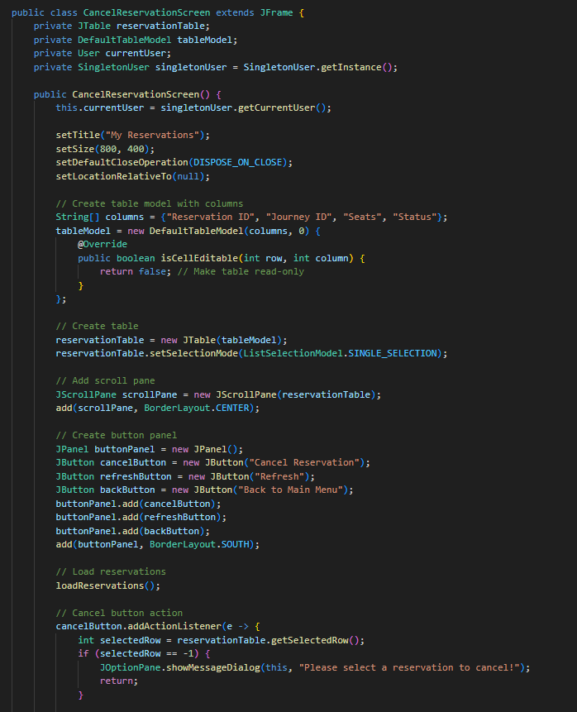
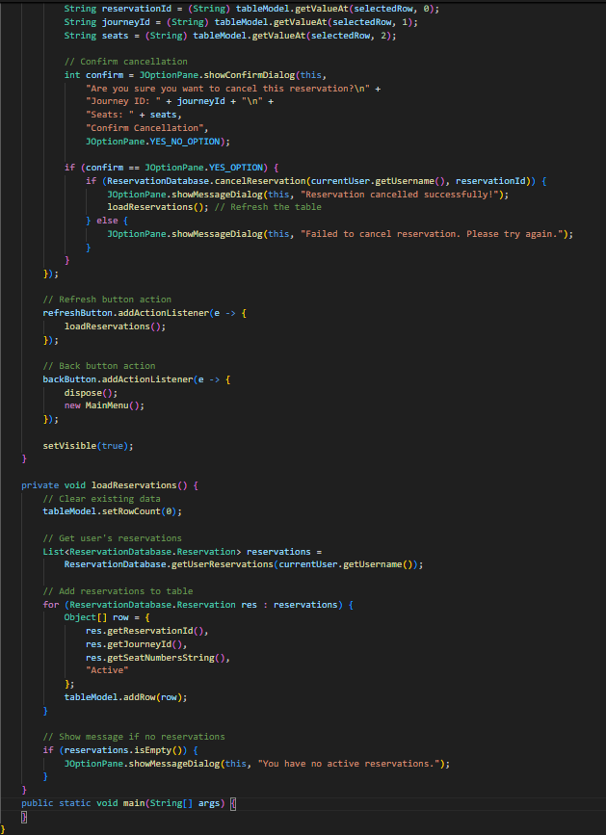

Class: FilterByDestination.java
• Purpose: Filters journeys based on their destination.
• Design Pattern Usage:
- Strategy Pattern: Allows easy interchange of different filtering algorithms. The Strategy pattern defines a family of algorithms, encapsulates each one, and makes them interchangeable, allowing the algorithm to vary independently from the clients that use it.

Code Explanation
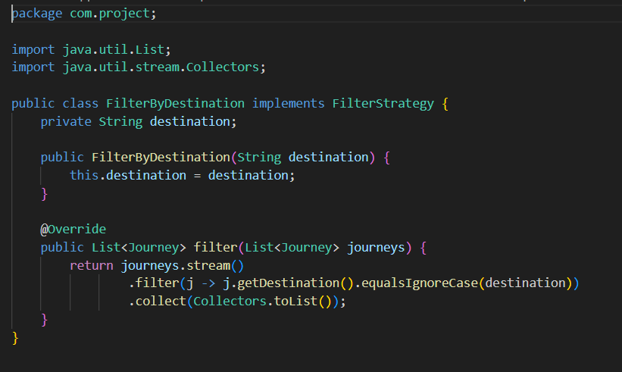

Class: FilterStrategy.java
• Purpose: Provides a common interface for journey filtering strategies.
• Design Pattern Usage:
- Strategy Pattern: Abstracts journey filtering by various criteria. It promotes flexibility and cleaner code by eliminating conditional logic and enabling the behavior of a class to be selected at runtime through composition rather than inheritance.

Code Explanation

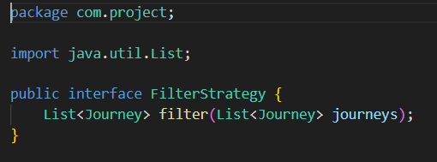

Class: FlightJourney.java
• Purpose: Represents a flight journey, specializing the generic journey class.
• Design Pattern Usage:
- Inheritance: Inherits properties from the abstract Journey class.

Code Explanation
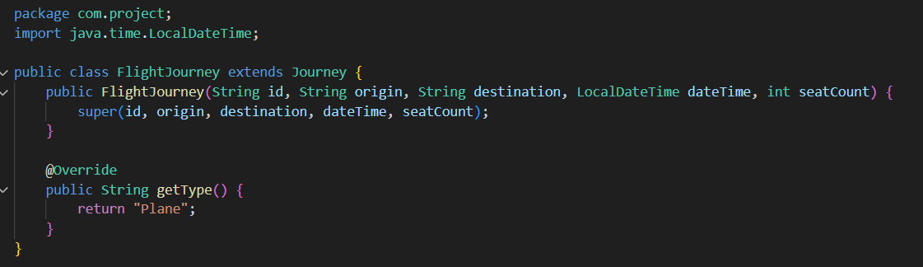

Class: FlightJourneyBuilder.java
• Purpose: Manages the step-by-step creation of flight journey objects.
• Design Pattern Usage:
- Builder Pattern: Simplifies the complex creation of flight journey instances. It separates the construction logic from the actual object structure, which makes the code more readable, maintainable, and flexible when building objects with many optional parameters.

Code Explanation

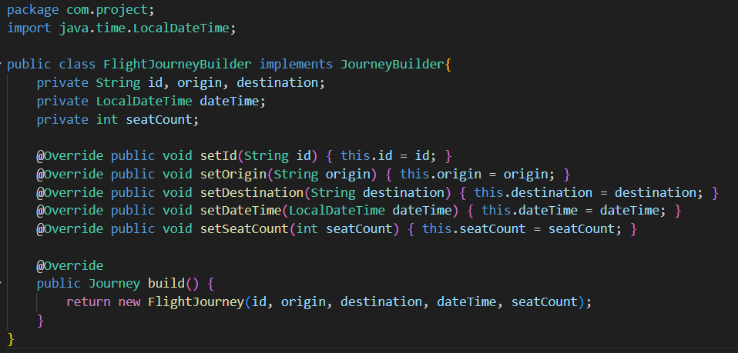

Class: FlightSeatSelectionScreen.java *********
• Purpose: Provides a graphical interface for selecting airplane seats.
• Design Pattern Usage:
- Singleton: Manages user sessions via SingletonUser.
- Facade: Simplifies reservation processes using ReservationDatabase.

Code Explanation
package com.project;
import java.awt.BorderLayout;
import java.awt.Color;
import java.awt.Dimension;
import java.awt.FlowLayout;
import java.awt.GridLayout;
import java.util.ArrayList;
import java.util.List;
import java.util.Set;
import javax.swing.BorderFactory;
import javax.swing.JButton;
import javax.swing.JFrame;
import javax.swing.JLabel;
import javax.swing.JOptionPane;
import javax.swing.JPanel;
import javax.swing.JScrollPane;
import javax.swing.SwingConstants;
import javax.swing.SwingUtilities;
public class FlightSeatSelectionScreen extends JFrame {
private User currentUser;
private String journeyId;
private List<JButton> seatButtons;
private List<String> selectedSeats;
private JLabel totalSeatsLabel;
private SingletonUser singletonUser = SingletonUser.getInstance();
private int rows; // Will be calculated based on total seats
private String[] seatLetters = {"A", "B", "C", "D", "E", "F"}; // Standard 6-seat configuration
public FlightSeatSelectionScreen( String journeyId) {
this.currentUser = singletonUser.getCurrentUser();
this.journeyId = journeyId;
this.seatButtons = new ArrayList<>();
this.selectedSeats = new ArrayList<>();
// Calculate rows based on total seats (6 seats per row)
int totalSeats = ReservationDatabase.getAvailableSeats(journeyId);
this.rows = (int) Math.ceil(totalSeats / 6.0);
setTitle("Flight Seat Selection - Journey " + journeyId);
setSize(800, 600);
setDefaultCloseOperation(DISPOSE_ON_CLOSE);
setLocationRelativeTo(null);
// Main panel with border layout
setLayout(new BorderLayout());
// Top panel for journey info
JPanel infoPanel = new JPanel(new FlowLayout(FlowLayout.CENTER));
infoPanel.add(new JLabel("Select your seats (Click to select/deselect)"));
add(infoPanel, BorderLayout.NORTH);
// Center panel for seat layout
JPanel seatPanel = new JPanel(new GridLayout(rows + 1, seatLetters.length + 1, 5, 5));
seatPanel.setBorder(BorderFactory.createEmptyBorder(20, 20, 20, 20));
// Add column headers (seat letters)
seatPanel.add(new JLabel("")); // Empty corner cell
for (String letter : seatLetters) {
JLabel label = new JLabel(letter, SwingConstants.CENTER);
label.setPreferredSize(new Dimension(40, 30));
seatPanel.add(label);
}
// Get reserved seats
Set<Integer> reservedSeats = ReservationDatabase.getReservedSeats(journeyId);
// Create seat buttons
for (int row = 1; row <= rows; row++) {
// Add row number
JLabel rowLabel = new JLabel(String.valueOf(row), SwingConstants.CENTER);
rowLabel.setPreferredSize(new Dimension(40, 30));
seatPanel.add(rowLabel);
// Add seats for this row
for (String letter : seatLetters) {
String seatNumber = row + letter;
int seatCode = getSeatCode(seatNumber);
JButton seatButton = createSeatButton(seatNumber, reservedSeats.contains(seatCode));
seatButtons.add(seatButton);
seatPanel.add(seatButton);
}
}
// Add seat panel to a scroll pane
JScrollPane scrollPane = new JScrollPane(seatPanel);
add(scrollPane, BorderLayout.CENTER);
// Bottom panel for controls
JPanel controlPanel = new JPanel(new FlowLayout(FlowLayout.CENTER));
totalSeatsLabel = new JLabel("Selected seats: 0");
JButton confirmButton = new JButton("Confirm Selection");
JButton backButton = new JButton("Back");
JButton refreshButton = new JButton("Refresh Seats");
controlPanel.add(totalSeatsLabel);
controlPanel.add(confirmButton);
controlPanel.add(refreshButton);
controlPanel.add(backButton);
add(controlPanel, BorderLayout.SOUTH);
// Refresh button action
refreshButton.addActionListener(e -> {
refreshSeats();
});
// Confirm button action
confirmButton.addActionListener(e -> {
if (selectedSeats.isEmpty()) {
JOptionPane.showMessageDialog(this, "Please select at least one seat!");
return;
}
int confirm = JOptionPane.showConfirmDialog(this,
"Confirm reservation for seats: " + getSelectedSeatNumbers() + "?",
"Confirm Reservation",
JOptionPane.YES_NO_OPTION);
if (confirm == JOptionPane.YES_OPTION) {
// Convert seat numbers to integers for the database
List<Integer> seatCodes = new ArrayList<>();
for (String seat : selectedSeats) {
seatCodes.add(getSeatCode(seat));
}
if (ReservationDatabase.makeFlightReservation(currentUser.getUsername(), journeyId, seatCodes)) {
JOptionPane.showMessageDialog(this, "Reservation successful!");
dispose();
new JourneyListScreen();
} else {
JOptionPane.showMessageDialog(this,
"Failed to make reservation!\n" +
"Some seats might have been reserved by another user.\n" +
"Please try again with different seats.");
refreshSeats();
}
}
});
// Back button action
backButton.addActionListener(e -> {
dispose();
new JourneyListScreen();
});
setVisible(true);
}
private JButton createSeatButton(String seatNumber, boolean isReserved) {
JButton button = new JButton(seatNumber);
button.setPreferredSize(new Dimension(40, 30));
if (isReserved) {
button.setBackground(new Color(255, 100, 100)); // Daha belirgin kırmızı
button.setForeground(Color.WHITE); // Yazı rengini beyaz yap
button.setEnabled(false);
button.setToolTipText("Bu koltuk zaten rezerve edilmiş");
button.setBorderPainted(false); // Kenarlığı kaldır
} else {
button.setBackground(Color.WHITE);
button.setForeground(Color.BLACK);
button.setFocusPainted(false);
button.setBorderPainted(true);
// Add click action
button.addActionListener(e -> {
if (button.getBackground() == Color.WHITE) {
// Select seat
button.setBackground(new Color(100, 255, 100)); // Daha belirgin yeşil
button.setForeground(Color.BLACK);
selectedSeats.add(seatNumber);
} else {
// Deselect seat
button.setBackground(Color.WHITE);
button.setForeground(Color.BLACK);
selectedSeats.remove(seatNumber);
}
updateTotalSeatsLabel();
});
}
return button;
}
private void updateTotalSeatsLabel() {
totalSeatsLabel.setText("Selected seats: " + selectedSeats.size());
}
private int getSeatCode(String seatText) {
// Extract row number and column letter
int row = Integer.parseInt(seatText.substring(0, seatText.length() - 1));
char col = seatText.charAt(seatText.length() - 1);
// Create a unique code: row * 100 + column index
return (row - 1) * 100 + (col - 'A');
}
private void refreshSeats() {
// Clear selected seats
selectedSeats.clear();
// Update seat buttons
Set<Integer> reservedSeats = ReservationDatabase.getReservedSeats(journeyId);
for (JButton seatButton : seatButtons) {
String seatText = seatButton.getText();
int seatCode = getSeatCode(seatText);
if (reservedSeats.contains(seatCode)) {
seatButton.setEnabled(false);
seatButton.setBackground(new java.awt.Color(255, 100, 100));
seatButton.setForeground(java.awt.Color.WHITE);
seatButton.setToolTipText("Bu koltuk zaten rezerve edilmiş");
seatButton.setBorderPainted(false);
} else {
seatButton.setEnabled(true);
seatButton.setBackground(java.awt.Color.WHITE);
seatButton.setForeground(java.awt.Color.BLACK);
seatButton.setToolTipText(null);
seatButton.setBorderPainted(true);
}
}
// Update selected seats label
updateSelectedSeatsLabel();
}
private void updateSelectedSeatsLabel() {
totalSeatsLabel.setText("Selected seats: " + selectedSeats.size());
}
private String getSelectedSeatNumbers() {
return selectedSeats.toString();
}
public static void main(String[] args) {
SwingUtilities.invokeLater(() -> {
});
}
}

Class: Journey.java
• Purpose: Abstracts the general concept of a journey and provides common attributes.
• Design Pattern Usage:
- Template Method: Subclasses (BusJourney and FlightJourney) define their own methods for journey type information, allowing each to customize behavior specific to their mode of travel while sharing a common structure from the base class.

Code Explanation
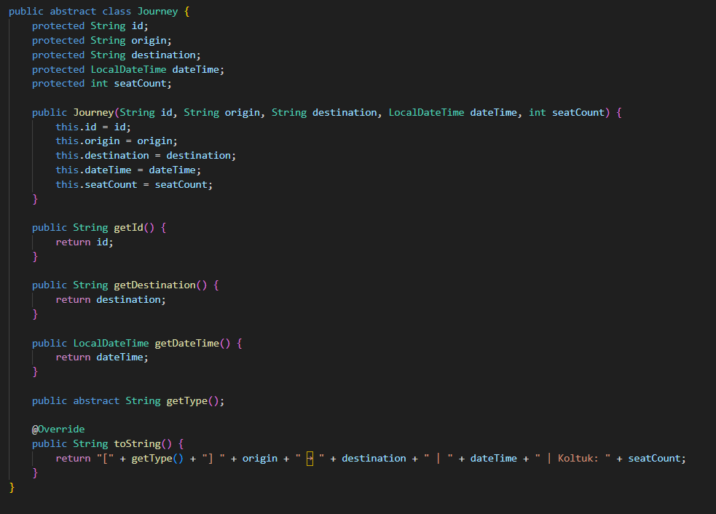

Class: JourneyBuilder.java
• Purpose: Defines a common interface for building journey objects.
• Design Pattern Usage:
- Builder Pattern: Standardizes the object creation process. This pattern improves code readability and flexibility by allowing clients to build objects with various configurations without needing multiple constructors.

Code Explanation
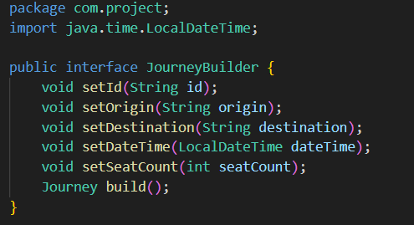

Class: JourneyListScreen.java
- Purpose: Displays available journeys and allows users to make reservations.
- Design Pattern Usage:
  - Facade: Simplifies database interactions using ReservationDatabase.
  - Singleton: Manages user sessions through SingletonUser.

Code Explanation
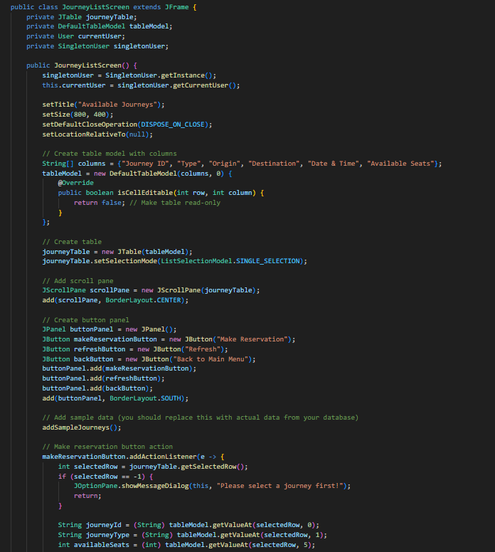
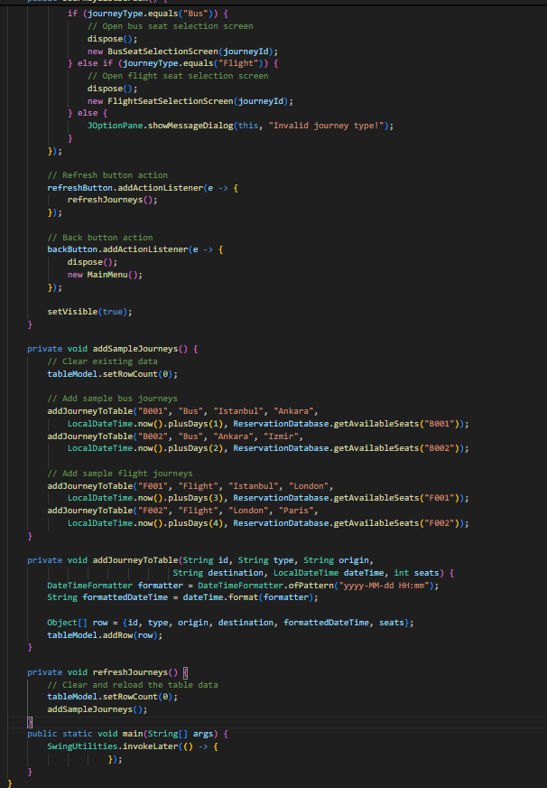

Class: LoginScreen.java
• Purpose: Provides a secure and straightforward user login interface.
• Design Pattern Usage:
- Singleton: Maintains and manages single user sessions.
- Factory Method: Uses UserFactory to create user instances.

Code Explanation
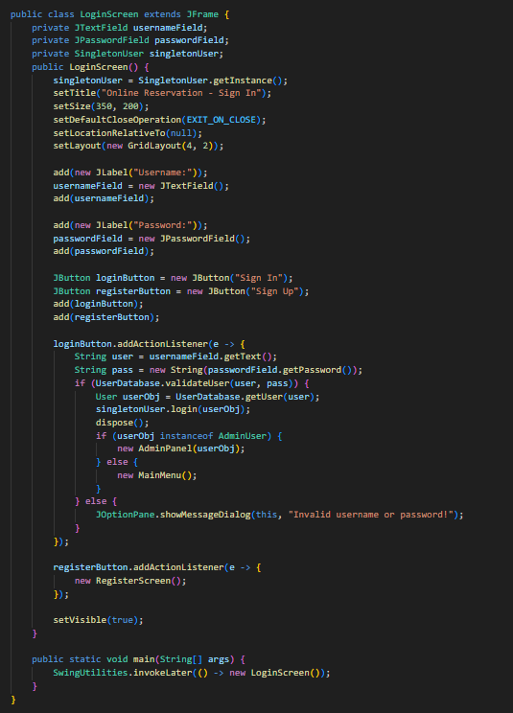

Class: MainMenu.java
• Purpose: Provides users with access to core functionalities within the application.
• Design Pattern Usage:
- Singleton: Manages user session information centrally.

Code Explanation
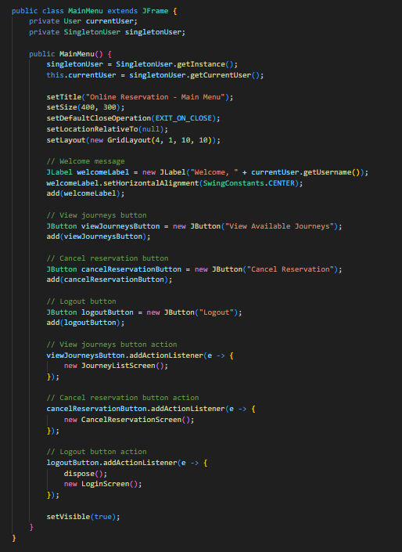

Class: NormalUser.java
- Purpose: Represents normal user types within the application.
- Design Pattern Usage:
  - Factory Method: Users are created through UserFactory. This pattern improves flexibility and scalability by isolating the object creation process, making it easier to introduce new types without changing the existing code structure.

Code Explanation
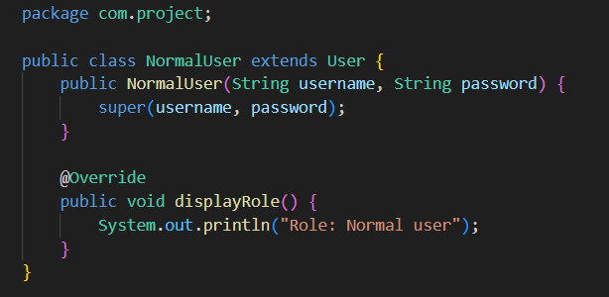

Class: RegisterScreen.java
• Purpose: Provides an interface for users to register by entering necessary details.
• Design Pattern Usage:
- Facade: Simplifies user registration processes via UserDatabase.

Code Explanation
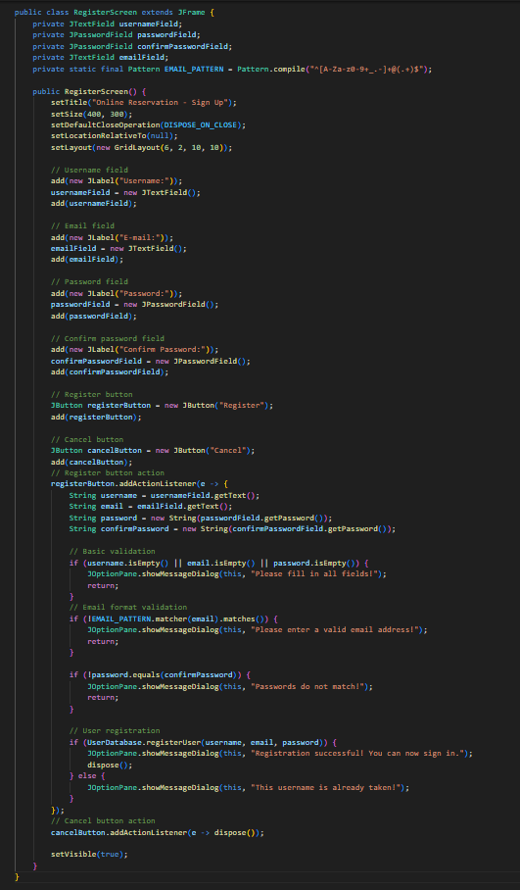

Class: ReservationDatabase.java *************
• Purpose: Central structure for managing journey and reservation data.
• Design Pattern Usage:
- Facade: Offers simple and standardized methods for data operations.

Code Explanation
package com.project;
import java.util.ArrayList;
import java.util.HashMap;
import java.util.HashSet;
import java.util.List;
import java.util.Map;
import java.util.Set;
import java.util.stream.Collectors;
public class ReservationDatabase {
private static Map<String, List<Reservation>> userReservations = new HashMap<>();
private static Map<String, Integer> journeySeats = new HashMap<>();
private static Map<String, Set<Integer>> reservedSeats = new HashMap<>();
private static List<Journey> journeys = new ArrayList<>();
static {
// Initialize sample journey seats
journeySeats.put("B001", 48);
journeySeats.put("B002", 32);
journeySeats.put("F001", 120);
journeySeats.put("F002", 150);
// Initialize reserved seats for each journey
for (String journeyId : journeySeats.keySet()) {
reservedSeats.put(journeyId, new HashSet<>());
}
// Add sample journeys
addJourney("B001", "Bus", "Istanbul", "Ankara", "2024-03-20 10:00", 48);
addJourney("B002", "Bus", "Ankara", "Izmir", "2024-03-21 14:00", 32);
addJourney("F001", "Flight", "Istanbul", "London", "2024-03-22 09:00", 120);
addJourney("F002", "Flight", "London", "Paris", "2024-03-23 11:00", 150);
}
public static boolean addJourney(String id, String type, String origin, String destination, String dateTime, int seats) {
// Check if journey ID already exists (only if not in static initialization)
if (journeySeats.containsKey(id) && !Thread.currentThread().getStackTrace()[2].getMethodName().equals("<clinit>")) {
return false;
}
// Validate journey type
if (!type.equals("Bus") && !type.equals("Flight")) {
return false;
}
// Validate seats based on journey type
if (type.equals("Bus") && seats % 4 != 0) {
return false;
} else if (type.equals("Flight") && seats % 6 != 0) {
return false;
}
// Add journey
journeys.add(new Journey(id, type, origin, destination, dateTime, seats));
journeySeats.put(id, seats);
reservedSeats.put(id, new HashSet<>());
return true;
}
public static List<String> getExistingJourneyIds() {
return new ArrayList<>(journeySeats.keySet());
}
public static boolean isJourneyIdExists(String id) {
return journeySeats.containsKey(id);
}
public static List<Journey> getAllJourneys() {
return new ArrayList<>(journeys);
}
public static List<Reservation> getAllReservations() {
List<Reservation> allReservations = new ArrayList<>();
for (List<Reservation> userRes : userReservations.values()) {
allReservations.addAll(userRes);
}
return allReservations;
}
public static boolean makeReservation(String username, String journeyId, int seats) {
// Check if journey exists and has enough seats
if (!journeySeats.containsKey(journeyId)) {
return false;
}
int availableSeats = journeySeats.get(journeyId);
if (seats > availableSeats) {
return false;
}
// Create new reservation
Reservation reservation = new Reservation(username, journeyId, seats);
// Add to user's reservations
userReservations.computeIfAbsent(username, k -> new ArrayList<>()).add(reservation);
// Update available seats
journeySeats.put(journeyId, availableSeats - seats);
return true;
}
public static boolean makeBusReservation(String username, String journeyId, List<Integer> seatNumbers) {
// Check if journey exists
if (!journeySeats.containsKey(journeyId)) {
return false;
}
// Check if any of the selected seats are already reserved
Set<Integer> journeyReservedSeats = reservedSeats.get(journeyId);
for (Integer seatNumber : seatNumbers) {
if (journeyReservedSeats.contains(seatNumber)) {
return false;
}
}
// Create new reservation
Reservation reservation = new Reservation(username, journeyId, seatNumbers);
// Add to user's reservations
userReservations.computeIfAbsent(username, k -> new ArrayList<>()).add(reservation);
// Mark seats as reserved
journeyReservedSeats.addAll(seatNumbers);
// Update available seats
int currentSeats = journeySeats.get(journeyId);
journeySeats.put(journeyId, currentSeats - seatNumbers.size());
return true;
}
public static boolean makeFlightReservation(String username, String journeyId, List<Integer> seatNumbers) {
// Check if journey exists
if (!journeySeats.containsKey(journeyId)) {
return false;
}
// Check if any of the selected seats are already reserved
Set<Integer> journeyReservedSeats = reservedSeats.get(journeyId);
for (Integer seatNumber : seatNumbers) {
if (journeyReservedSeats.contains(seatNumber)) {
return false;
}
}
// Create new reservation
Reservation reservation = new Reservation(username, journeyId, seatNumbers);
// Add to user's reservations
userReservations.computeIfAbsent(username, k -> new ArrayList<>()).add(reservation);
// Mark seats as reserved
journeyReservedSeats.addAll(seatNumbers);
// Update available seats
int currentSeats = journeySeats.get(journeyId);
journeySeats.put(journeyId, currentSeats - seatNumbers.size());
return true;
}
public static boolean cancelReservation(String username, String reservationId) {
List<Reservation> userRes = userReservations.get(username);
if (userRes == null) {
return false;
}
// Find the reservation to cancel
Reservation reservationToCancel = null;
for (Reservation res : userRes) {
if (res.getReservationId().equals(reservationId)) {
reservationToCancel = res;
break;
}
}
if (reservationToCancel == null) {
return false;
}
// Return seats to journey
String journeyId = reservationToCancel.getJourneyId();
int currentSeats = journeySeats.getOrDefault(journeyId, 0);
journeySeats.put(journeyId, currentSeats + reservationToCancel.getSeats());
// Remove reservation
userRes.remove(reservationToCancel);
return true;
}
public static List<Reservation> getUserReservations(String username) {
return userReservations.getOrDefault(username, new ArrayList<>());
}
public static int getAvailableSeats(String journeyId) {
return journeySeats.getOrDefault(journeyId, 0);
}
public static Set<Integer> getReservedSeats(String journeyId) {
return reservedSeats.getOrDefault(journeyId, new HashSet<>());
}
public static class JourneyCancellationResult {
private boolean success;
private List<String> cancelledReservations;
public JourneyCancellationResult(boolean success, List<String> cancelledReservations) {
this.success = success;
this.cancelledReservations = cancelledReservations;
}
public boolean isSuccess() {
return success;
}
public List<String> getCancelledReservations() {
return cancelledReservations;
}
}
public static JourneyCancellationResult cancelJourney(String journeyId) {
// Check if journey exists
if (!journeySeats.containsKey(journeyId)) {
return new JourneyCancellationResult(false, new ArrayList<>());
}
// Collect all reservations for this journey
List<String> cancelledReservations = new ArrayList<>();
for (Map.Entry<String, List<Reservation>> entry : userReservations.entrySet()) {
String username = entry.getKey();
List<Reservation> userRes = entry.getValue();
// Find and collect reservations for this journey
List<Reservation> journeyReservations = userRes.stream()
.filter(res -> res.getJourneyId().equals(journeyId))
.collect(Collectors.toList());
// Add to cancelled reservations list
for (Reservation res : journeyReservations) {
cancelledReservations.add(String.format("%s (User: %s, Seats: %s)",
res.getReservationId(), username, res.getSeatNumbersString()));
}
// Remove these reservations
userRes.removeAll(journeyReservations);
}
// Remove journey from all collections
journeys.removeIf(j -> j.getId().equals(journeyId));
journeySeats.remove(journeyId);
reservedSeats.remove(journeyId);
return new JourneyCancellationResult(true, cancelledReservations);
}
public static class Reservation {
private String username;
private String journeyId;
private int seats;
private String reservationId;
private List<Integer> seatNumbers;
private String type; // "Bus" or "Flight"
public Reservation(String username, String journeyId, int seats) {
this.username = username;
this.journeyId = journeyId;
this.seats = seats;
this.reservationId = generateReservationId();
this.seatNumbers = new ArrayList<>();
this.type = journeyId.startsWith("F") ? "Flight" : "Bus";
}
public Reservation(String username, String journeyId, List<Integer> seatNumbers) {
this.username = username;
this.journeyId = journeyId;
this.seats = seatNumbers.size();
this.reservationId = generateReservationId();
this.seatNumbers = new ArrayList<>(seatNumbers);
this.type = journeyId.startsWith("F") ? "Flight" : "Bus";
}
private String generateReservationId() {
return "RES" + System.currentTimeMillis();
}
public String getReservationId() {
return reservationId;
}
public String getJourneyId() {
return journeyId;
}
public String getUsername() {
return username;
}
public int getSeats() {
return seats;
}
public List<Integer> getSeatNumbers() {
return seatNumbers;
}
public String getSeatNumbersString() {
if (seatNumbers.isEmpty()) {
return String.valueOf(seats);
}
if (type.equals("Flight")) {
// Convert hash codes back to seat numbers (e.g., 10A, 10B, etc.)
List<String> formattedSeats = new ArrayList<>();
for (Integer seatCode : seatNumbers) {
int row = (seatCode / 100) + 1;
int col = seatCode % 100;
String letter = String.valueOf((char)('A' + col));
formattedSeats.add(row + letter);
}
return formattedSeats.toString();
} else {
// For bus, just return the seat numbers
return seatNumbers.toString();
}
}
}
public static class Journey {
private String id;
private String type;
private String origin;
private String destination;
private String dateTime;
private int availableSeats;
public Journey(String id, String type, String origin, String destination, String dateTime, int availableSeats) {
this.id = id;
this.type = type;
this.origin = origin;
this.destination = destination;
this.dateTime = dateTime;
this.availableSeats = availableSeats;
}
public String getId() {
return id;
}
public String getType() {
return type;
}
public String getOrigin() {
return origin;
}
public String getDestination() {
return destination;
}
public String getDateTime() {
return dateTime;
}
public int getAvailableSeats() {
return availableSeats;
}
}
}

Class: SingletonUser.java
• Purpose: Centrally manages the user's session throughout the application.
• Design Pattern Usage:
- Singleton: Ensures a consistent user session throughout the application.

Code Explanation
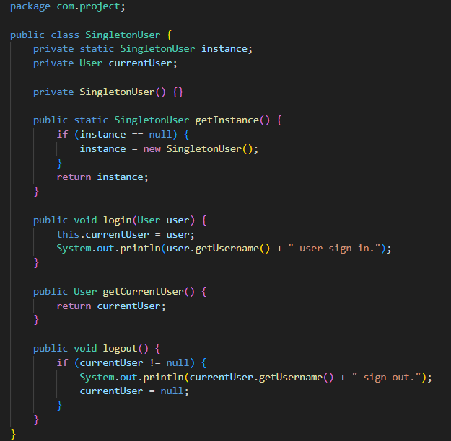

Class: User.java
• Purpose: Abstracts user information and provides common user methods.
• Design Pattern Usage:
- Template Method: Subclasses (NormalUser, AdminUser) implement their own method to specify user roles.

Code Explanation
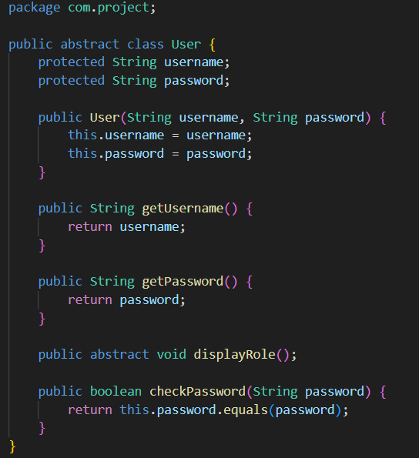

Class: UserDatabase.java
• Purpose: Stores and manages user data.
• Design Pattern Usage:
- Facade: Provides simplified methods for user-related operations.

Code Explanation
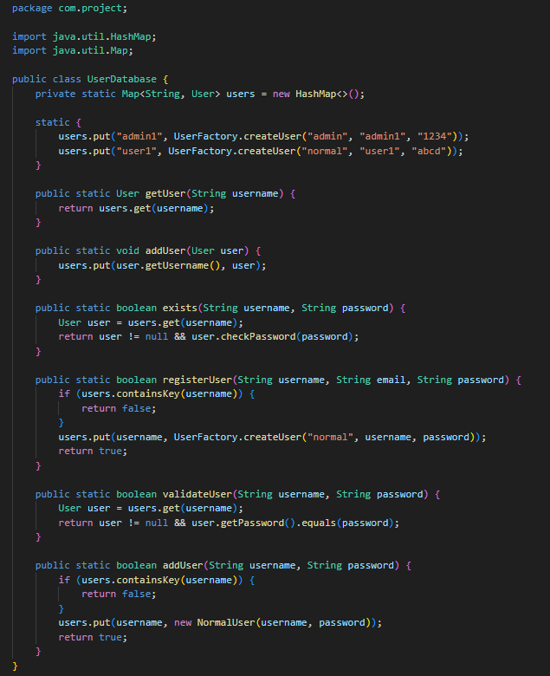

Class: UserFactory.java
• Purpose: Generates appropriate user instances based on user type.
• Design Pattern Usage:
- Factory Method: Simplifies and abstracts user creation processes. The Factory Method pattern defines an interface for creating an object, but allows subclasses to decide which class to instantiate. It helps promote flexibility and reuse by decoupling the object creation process from the main application logic.

Code Explanation
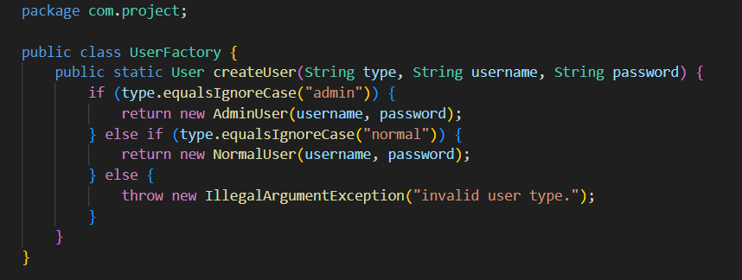

Class: JunitTest

Class Name: JourneyTest

Purpose:
The JourneyTest class is a unit test designed to verify the functionality of the Journey class, specifically focusing on the correctness of the toString() method output.

Description:

It uses the JUnit 5 testing framework to perform automated testing.

The test method testJourneyToString() creates an instance of a subclass TestJourney (which extends Journey) with sample data including journey ID, origin, destination, date/time, and seat count.

The test asserts that the string representation of the Journey object (toString() output) contains key information: the origin city, destination city, and seat count, ensuring these fields are correctly included in the string format.

The inner static class TestJourney overrides the abstract method getType() from the Journey class to provide a concrete implementation required for instantiation.

This test ensures that when a Journey object is converted to a string, it correctly reflects essential journey details, supporting reliability and correctness in displaying journey information.
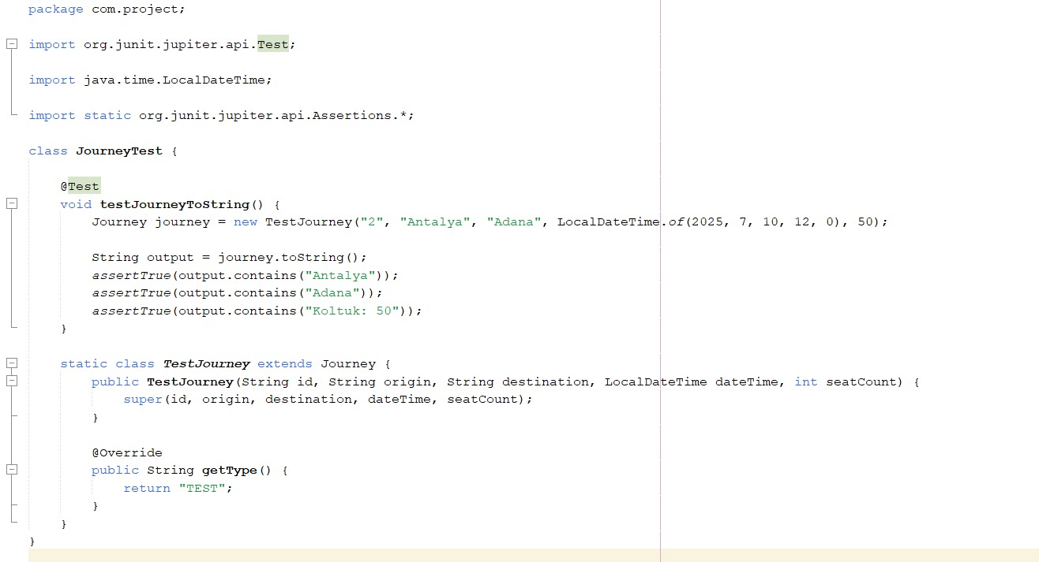
Class Name: BusJourneyBuilderTest

Purpose:
The BusJourneyBuilderTest class is a unit test that verifies the functionality of the BusJourneyBuilder class, ensuring it correctly constructs a BusJourney object with the specified properties.

Description:

This test uses the JUnit 5 testing framework to automate the validation process.

The test method testBuildBusJourney() initializes a BusJourneyBuilder instance and sets various journey details such as ID, origin, destination, departure date and time, and seat count.

It then calls the build() method to create a Journey object, which is expected to be an instance of BusJourney.

The test asserts that the returned object is indeed a BusJourney and that all fields (ID, origin, destination, date/time, seat count) match the values provided to the builder.

This confirms that the builder pattern implementation correctly constructs a fully initialized BusJourney object, ensuring proper encapsulation and object creation.
