DATABASE MANAGEMENT SYSTEMS
CENG 3005

PROJECT REPORT

Lecturer:
Assoc. Prof. Dr. Tuğba ÖNAL SÜZEK
Date: 28 December 2025

1. Team Members
The project team consists of the following 3 members:
- Ali Emre Meşe - 220709061
- Görkem Can – 220709078
- Özay Kaya - 220709055

2. Project Name and Purpose
Project Name: Airline Management System
Purpose: The primary objective of this project is to design and implement a high-performance relational database capable of managing and analyzing massive aviation datasets. By transforming over 1 million raw flight records into a 3NF normalized structure and an expanded RDF-style metrics table containing 23.8 million rows, we aim to provide a scalable platform for complex analytical queries. This system enables efficient tracking of flight schedules, carrier performances, and detailed delay statistics that are computationally prohibitive in standard spreadsheet formats.

Project Repository (GitHub): The complete SQL schema, Python ETL scripts, EER diagrams, and analysis queries are maintained in our repository.
- GitHub Repository URL: https://github.com/AliEmreMese/CENG3005_Airline_Management_System

3. Changes and Additions Since Phase I
While the foundational tables were established in Phase I, significant refinements were made in Phase II to ensure data integrity and to support large-scale analytical processing.
A. Refinement of Geographical Linkages
- Relationship Integrity: Although the States, Cities, and Airports tables existed, Phase II focused on populating the Foreign Key (FK) relationships that were incomplete or mismatched.
- String-to-ID Mapping: A custom mapping logic was implemented to resolve raw string data (e.g., "NY") into corresponding full state names ("New York") to properly link the Cities and States tables via state_id.
B. Vertical Expansion of Flight Metrics (Major Addition)
- From Wide to Deep: The most critical architectural change is the implementation of the flight_metrics table. In Phase I, performance metrics were planned as static columns. In Phase II, these were pivoted into a vertical (RDF-style) schema.
- Massive Data Volume: This refinement increased the database scale from 1 million records to 23.8 million metric records, enabling more complex aggregate functions and statistical reporting.
C. Normalization of Operational Data
- Cancellations Decomposition: To further adhere to 3NF principles, cancellation details were isolated into a dedicated cancellations table, removing optional (NULL-heavy) columns from the main flights table.
D. Implementation of Logic Layers
- Stored Procedures: We added the GetStateTotalDelay procedure, which utilizes IN/OUT parameters to perform dynamic, high-speed calculations across millions of rows.
- Views: The flight_summary_view was created to provide an abstraction layer, simplifying the 5-table join required to view basic flight information into a single virtual table.
E. Data Sanitization
- ID Normalization: We addressed the issue of non-sequential auto-incrementing IDs in the cities table, ensuring a clean and continuous primary key sequence for better indexing and storage efficiency.
F. Updated EER Diagram
The diagram below represents the finalized relational structure of the Airline Management System:
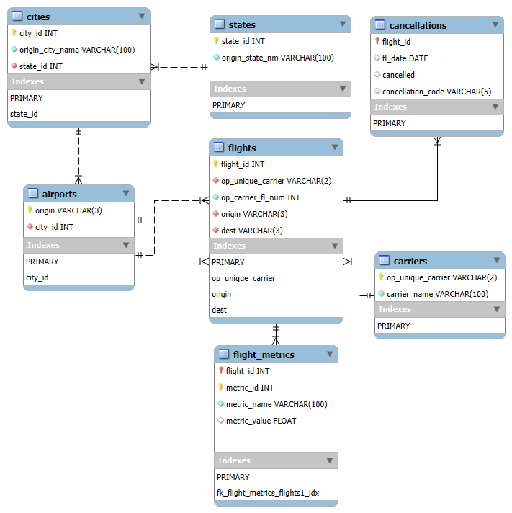

4. Data Loading and Pre-processing
The data ingestion process for the Airline Management System was executed in two primary phases: structural setup via SQL and automated data loading via a custom ETL (Extract, Transform, Load) pipeline developed in Python.
A. Data Sources
The primary data source is the "Flight Data 2024" dataset available on Kaggle.
- Source URL: https://www.kaggle.com/datasets/hrishitpatil/flight-data-2024
- Raw Format: The source is a flat CSV file containing 1,048,575 flight records with 35 operational columns.
B. Specialized Code and Pre-processing
To handle the scale and complexity of the dataset, several specialized Python scripts were developed (available in the /scripts directory of our GitHub Repository):
- Normalization & Mapping: Raw data contained city names with state abbreviations (e.g., "Kodiak, AK"). Our pre-processing code utilized a mapping dictionary to resolve these abbreviations into full state names ("Alaska") to maintain referential integrity with the States table.
- RDF-Style Metric Extraction: A dedicated script was used to pivot the 35 raw columns into a vertical flight_metrics table. This transformation converted approximately 23.8 million individual performance data points from string/header format into indexed numerical values.
- ID Sequence Correction: We implemented a cleanup script to reset AUTO_INCREMENT values and handle duplicate entries caused by the INSERT IGNORE logic during the initial ingestion phase.
C. Data Completeness
Did we upload all data? Yes, 100% of the raw dataset was successfully migrated into the relational structure.
- All 1,048,575 flight records were loaded into the flights table.
- Approximately 23.8 million operational metrics were extracted and loaded into the flight_metrics table.
- The entire geographical hierarchy (States, Cities, and Airports) was fully populated and linked, ensuring no orphan records exist in the system.
D. Data Verification Queries
To verify the successful migration of the large dataset into the normalized schema:
SELECT 'flights' AS table_name, COUNT(*) AS row_count FROM flights
UNION ALL
SELECT 'flight_metrics', COUNT(*) FROM flight_metrics
UNION ALL
SELECT 'airports', COUNT(*) FROM airports
UNION ALL
SELECT 'cities', COUNT(*) FROM cities
UNION ALL
SELECT 'states', COUNT(*) FROM states
UNION ALL
SELECT 'carriers', COUNT(*) FROM carriers
UNION ALL
SELECT 'cancellations', COUNT(*) FROM cancellations;

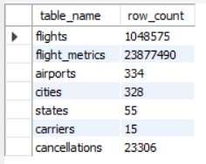

5. Software and Hardware Platform
Although the project was primarily developed using MySQL Workbench on Windows, the following technical specifications define the exact environment used for development, data processing, and database management:
- Operating System: Windows 11
- Database Management System: MySQL Workbench 8.0.43
- Database Server: MySQL Community Server 9.4.0
- ETL & Processing Platform: Python 3.x was utilized as the primary engine for pre-processing the 1.05 million flight records and executing the high-volume data load into the relational schema.
- Integration: The development environment leveraged the mysql-connector-python library to bridge the Python ETL scripts with the MySQL Server instance, ensuring seamless data migration and relationship mapping.

6. User’s Guide for Advanced Database Objects
This section provides a technical overview and usage instructions for the specialized objects implemented in the Airline Management System to simplify data analysis and improve query performance.
A. Analytical Views
Object Name: flight_summary_view
Description: This view serves as an abstraction layer designed to simplify the interaction with our 3NF normalized schema. Instead of requiring the user to manually perform a 5-table join, this view automatically consolidates data from the flights, carriers, airports, cities, states, and cancellations tables into a single, human-readable format.
- Key Features:
  - Displays full carrier names instead of codes.
  - Maps origin airports directly to their respective cities and states.
  - Provides an immediate check on cancellation status for each flight.
Usage Example:
SELECT * FROM flight_summary_view LIMIT 10;

B. Stored Procedures
Object Name: GetStateTotalDelay
Description: This is a high-performance analytical procedure designed to calculate the cumulative departure delay for a specific state. It demonstrates the use of IN and OUT parameters to process millions of rows from the flight_metrics table efficiently.
- Logic:
  - Input (IN): Accepts a string parameter (state_name_param) representing the target state.
  - Processing: It executes an aggregate SUM function on the metric_value column, filtering for 'dep_delay' metrics.
  - Output (OUT): Returns the total calculated delay as a float value to the calling environment.
Usage Example:
SET @total_delay = 0;

CALL GetStateTotalDelay('California', @total_delay);

SELECT @total_delay AS 'California Total Departure Delay';

7. Outputs of Selected Stored Procedures and Views
This section demonstrates the successful execution and results of the most significant database objects developed for the system.
A. Output of the "GetStateTotalDelay" Stored Procedure
Why it is challenging: This procedure is the most challenging component of our analytical layer because it requires joining five different tables—flight_metrics, flights, airports, cities, and states—while performing an aggregate SUM operation over a dataset exceeding 23.8 million records. Ensuring performance while handling IN/OUT parameters was a critical technical hurdle.
Execution Script:
SET @total_delay_minutes = 0;
CALL GetStateTotalDelay('Texas', @total_delay_minutes);
SELECT @total_delay_minutes AS 'Total Departure Delay for Texas (Minutes)';

Expected Output:
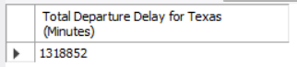
Note: The output provides the real-time calculated sum of all departure delays for flights originating from Texas airports.

B. Output of the "flight_summary_view"
Why it is interesting: This view is particularly interesting because it transforms the rigid 3NF geographical hierarchy (States -> Cities -> Airports) and carrier codes into a flat, human-readable report. It provides a comprehensive operational snapshot of the flight's origin, carrier name, and cancellation status in a single query.
Execution Script:
SELECT * FROM flight_summary_view
WHERE state = 'California'
LIMIT 10;

Expected Output:
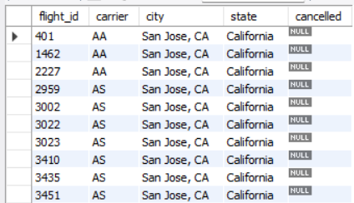
Note: The output demonstrates the view's ability to successfully resolve multiple foreign key relationships into descriptive strings, such as full state names and carrier identities.

8. System Limitations and Future Improvements
A. System Limitations
- Static Nature: The system relies on historical 2024 data and lacks real-time flight updates via API.
- Storage Requirements: The vertical schema for the 23.8 million metric records results in a larger storage footprint compared to flat files.
- Interface: The current system is accessed via SQL queries and lacks a graphical user interface (GUI) or access control.
B. Suggested Improvements
- GUI Development: Implementing a visual dashboard to trigger procedures and display results for non-technical users.
- Performance Optimization: Applying table partitioning on the flight_metrics table to speed up analysis on the 24-million-row dataset.
- Live Integration: Connecting the database to live aviation data streams for real-time delay monitoring and predictive analysis.

9. Full Relational Table Specification (DDL)
This section provides the comprehensive structural definition of the Airline Management System. It details the schema's architecture, including data types, constraints, and relational dependencies designed to maintain integrity across 23.8 million records.
A. Schema Overview
The following table summarizes the primary role and key constraints of each relational entity:
Table Name | Primary Key | Foreign Key References | Purpose
states | state_id | None | Stores unique US state names.
cities | city_id | states(state_id) | Geographical grouping of locations.
airports | origin (IATA) | cities(city_id) | Unique airport codes and city links.
carriers | op_unique_carrier | None | Unique airline identification codes.
flights | flight_id | carriers, airports | Core flight operational records.
flight_metrics | metric_id | flights(flight_id) | Granular operational performance data.
cancellations | flight_id | flights(flight_id) | Tracks flight disruption details.
B. Data Definition Language (DDL) and Sample Values
The SQL code below defines the exact table structures. As per project requirements, sample data values are included as comments for each attribute.
CREATE TABLE states (
state_id INT NOT NULL AUTO_INCREMENT, -- Sample Value: 10
origin_state_nm VARCHAR(100) NOT NULL, -- Sample Value: 'New York'
PRIMARY KEY (state_id)
);

-- City Mapping with State Dependency
CREATE TABLE cities (
city_id INT NOT NULL AUTO_INCREMENT, -- Sample Value: 245
origin_city_name VARCHAR(100) NOT NULL, -- Sample Value: 'Buffalo'
state_id INT NOT NULL, -- Sample Value: 10
PRIMARY KEY (city_id),
FOREIGN KEY (state_id) REFERENCES states(state_id) -- Ensures city belongs to a valid state
);

CREATE TABLE airports (
origin VARCHAR(3) NOT NULL, -- Sample Value: 'BUF'
city_id INT NOT NULL, -- Sample Value: 245
PRIMARY KEY (origin),
FOREIGN KEY (city_id) REFERENCES cities(city_id)
);

CREATE TABLE flights (
flight_id INT NOT NULL AUTO_INCREMENT, -- Sample Value: 1048575
op_unique_carrier VARCHAR(2) NOT NULL, -- Sample Value: 'DL' (Delta Airlines)
op_carrier_fl_num INT NOT NULL, -- Sample Value: 452
origin VARCHAR(3) NOT NULL, -- Sample Value: 'BUF'
dest VARCHAR(3) NOT NULL, -- Sample Value: 'ATL'
PRIMARY KEY (flight_id),
FOREIGN KEY (op_unique_carrier) REFERENCES carriers(op_unique_carrier),
FOREIGN KEY (origin) REFERENCES airports(origin)
);

-- Performance Metrics (RDF-style Vertical Structure)
CREATE TABLE flight_metrics (
metric_id INT NOT NULL AUTO_INCREMENT, -- Sample Value: 23877490
flight_id INT NOT NULL, -- Sample Value: 1048575
metric_name VARCHAR(100) NOT NULL, -- Sample Value: 'air_time'
metric_value FLOAT, -- Sample Value: 124.5
PRIMARY KEY (metric_id),
FOREIGN KEY (flight_id) REFERENCES flights(flight_id)
);

CREATE TABLE cancellations (
flight_id INT NOT NULL, -- Sample Value: 1048575
fl_date DATE NOT NULL, -- Sample Value: '2024-05-12'
cancelled INT NOT NULL, -- Sample Value: 1 (True)
cancellation_code VARCHAR(1) DEFAULT NULL, -- Sample Value: 'B' (Weather)
PRIMARY KEY (flight_id),
FOREIGN KEY (flight_id) REFERENCES flights(flight_id)
);

CREATE TABLE carriers (
op_unique_carrier VARCHAR(2) NOT NULL,
carrier_name VARCHAR(100) DEFAULT NULL,
PRIMARY KEY (op_unique_carrier)
) ENGINE=InnoDB DEFAULT CHARSET=utf8mb4;
C. Technical Rationale for Constraints
- NOT NULL Constraints: Applied to critical identifying attributes (like origin, state_id, and metric_name) to prevent orphan records and maintain the integrity of our large-scale analytical datasets.
- Foreign Key Constraints: Every relationship, especially the link between the 23.8 million metrics and their parent flights, is enforced by referential constraints to ensure that no metric can exist without a corresponding flight record.
- Data Types: FLOAT was chosen for metric_value to support high-precision mathematical operations (AVG, SUM) required for aviation performance reporting.

10. System Implementation Code and Data Acquisition
This section documents the complete technical workflow, including the automated Python ETL pipeline, data cleaning scripts, and the full SQL schema used to manage the 23.8 million records in this system.
A. Automated Data Ingestion & RDF Transformation (Script 1)
This script processes the raw 1M+ flight records in chunks of 50,000 to manage memory efficiency while performing the vertical transformation into the flight_metrics table.
import pandas as pd
import mysql.connector

# Configuration for RDF-style vertical metrics
METRIC_COLUMNS = ['dep_delay', 'arr_delay', 'taxi_out', 'taxi_in', 'air_time', 'distance', ...]

def run_etl():
for chunk in pd.read_csv(CSV_PATH, sep=';', chunksize=50000):
# Master table insertion with duplicate prevention
for val in chunk['origin_state_nm'].dropna().unique():
cursor.execute("INSERT IGNORE INTO states (origin_state_nm) VALUES (%s)", (val,))

# Mapping 23 performance columns into 23.8M vertical rows
for _, row in chunk.iterrows():
cursor.execute("INSERT INTO flights (...) VALUES (...)", (...))
f_id = cursor.lastrowid
for m_name in METRIC_COLUMNS:
if pd.notnull(row[m_name]):
cursor.execute("INSERT INTO flight_metrics (flight_id, m_name, m_value) VALUES (%s, %s, %s)",
(f_id, m_name, float(row[m_name])))
B. Geographical State Mapping Logic (Script 2)
To achieve 3NF compliance, this script maps raw state abbreviations (e.g., "NY") to their full names in the states table to fix geographical relationships.
state_map = {'AK': 'Alaska', 'CA': 'California', 'NY': 'New York', ...}

for abbr, full_name in state_map.items():
cursor.execute("SELECT state_id FROM states WHERE origin_state_nm = %s", (full_name,))
result = cursor.fetchone()
if result:
# Updating the normalized city-to-state link
cursor.execute("UPDATE cities SET state_id = %s WHERE origin_city_name LIKE %s",
(result[0], f'%, {abbr}'))

C. Referential Integrity & NULL Fixes (Script 3)
This script resolves the city_id links in the airports table that were initially empty, ensuring no orphan records exist in the hierarchy.
# Link existing Airports to their corresponding City IDs
df = pd.read_csv(CSV_PATH, sep=';', usecols=['origin', 'origin_city_name']).drop_duplicates()
cursor.execute("SELECT city_id, origin_city_name FROM cities")
city_map = {name: cid for (cid, name) in cursor.fetchall()}

for _, row in df.iterrows():
if row['origin_city_name'] in city_map:
cursor.execute("UPDATE airports SET city_id = %s WHERE origin = %s",
(city_map[row['origin_city_name']], row['origin']))

D. Full Database Verification Query
The following SQL confirms the successful migration across all 7 tables:
SELECT 'flights' AS table_name, COUNT(*) AS row_count FROM flights
UNION ALL
SELECT 'flight_metrics', COUNT(*) FROM flight_metrics
UNION ALL
SELECT 'airports', COUNT(*) FROM airports
UNION ALL
SELECT 'cities', COUNT(*) FROM cities
UNION ALL
SELECT 'states', COUNT(*) FROM states
UNION ALL
SELECT 'carriers', COUNT(*) FROM carriers
UNION ALL
SELECT 'cancellations', COUNT(*) FROM cancellations;

E. Data Definition Language (DDL) with Sample Values
The schema definition includes all primary/foreign keys and sample values as comments:
CREATE TABLE states (
state_id INT NOT NULL AUTO_INCREMENT, -- Sample: 1
origin_state_nm VARCHAR(100) NOT NULL, -- Sample: 'California'
PRIMARY KEY (state_id)
);

CREATE TABLE flight_metrics (
metric_id INT NOT NULL AUTO_INCREMENT, -- Sample: 23877490
flight_id INT NOT NULL, -- Sample: 1048575
metric_name VARCHAR(100) NOT NULL, -- Sample: 'dep_delay'
metric_value FLOAT, -- Sample: 15.0
PRIMARY KEY (metric_id),
FOREIGN KEY (flight_id) REFERENCES flights(flight_id)
);

F. Advanced Database Objects (View & Stored Procedure)
-- Abstraction layer for complex joins
CREATE VIEW flight_summary_view AS
SELECT f.flight_id, ci.origin_city_name, s.origin_state_nm
FROM flights f JOIN airports a ON f.origin = a.origin ...;

-- Analytical procedure with IN/OUT parameters
CREATE PROCEDURE GetStateTotalDelay(IN s_name VARCHAR(100), OUT total_val FLOAT) ...

G. Representative Data Sample Output (Execution Result)
The following screenshot demonstrates a representative sample of the flight_metrics table after the successful execution of our Python ETL pipeline. It confirms that the performance columns from the raw dataset have been correctly pivoted into a vertical, indexed structure.
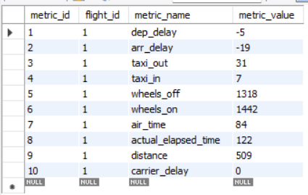
Observation: As seen in the output, each flight (referenced by flight_id) now has multiple entries for different operational metrics such as dep_delay, air_time, and distance. This structure allows for highly flexible analytical queries across the entire 23,877,490 record dataset.

