**Comsats University Islamabad**

**Terminal - LAB**

|  |  |  |  |
| --- | --- | --- | --- |
| **Program** | BCS 7A/7B | **Semester** | SP19 |
| **Subject** | Artificial Intelligence | **Subject Code** | CSC 462 |
| **Section** | A/B | **Instructor** | Dr. Sohaib Ali |

NOTE: ONLY upload .m file in portal designed in Matlab 2017 or earlier.

**Question: CLO-7**

The body mass index pf a person is given by weight / (Height * Height), where weight is in Kg and height is in meters. Generate 50 sample points randomly, where each sample corresponds to a person’s weight and his/her height. Using these two values, calculate the corresponding BMI value. Assume that the weight lies within the interval 30-110 kg and height lies within 1-4 meters. A sample distribution of 50 samples is shown below. Note that in your distribution weight and height MUST be generated randomly.

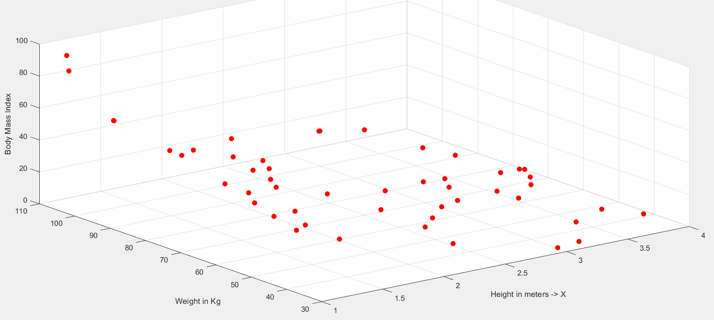

You are supposed to find the value of K in order to use K nearest neighbor for regression. Use 5 fold cross validation for this purpose. Also draw the corresponding graph that shows the validation error for different values of K. Instead of doing cross validation for K =1 to 40, only validate for values of K between 1 to 15. You are not allowed to use the built in functions for k nearest neighbors or cross validation.