Process Mining the Haifa Municipality
Recruitment Process
Final Academic Submission
2024 Event Log Analysis | 11,922 Cases | 22,299 Cleaned Events | 42 Activities

Table of Contents
Table of Contents 1
1. Executive Summary 1
2. Introduction 1
2.1 Process Description 1
2.2 Study Objectives 1
3. Data Preprocessing 1
3.1 Source Data and Merging 1
3.2 Cleaning Pipeline 1
3.3 Preprocessing Quality Assessment 1
3.4 Modelling Decisions 1
3.5 Data Scope and Reporting Note 1
3.6 Time Metric Definitions 1
4. Main Paths and Variants 1
4.1 Case Characterisation 1
4.2 Process Discovery 1
4.3 Variant Analysis 1
4.4 Sequences with Longest Delays 1
5. Analyses Performed 1
5.1 Business Question 1: Where Do Delays Occur? 1
5.1.1 Bottlenecks by Stage 1
5.1.2 Bottlenecks by Role and User 1
5.1.3 Bottlenecks by Requesting Department 1
5.1.4 Bottlenecks by Process Outcome 1
5.1.5 Cycle Time Distribution 1
5.2 Business Question 2: Main Variants and Delay Sequences 1
5.2.1 Multi-Algorithm Process Discovery 1
5.2.2 Conformance Checking 1
5.3 Business Question 3: Workload Volume vs. Cycle Time 1
5.4 Business Question 4: Responsible-Party Assignment/Change Signals and Delays 1
5.4.1 Simple Comparison (All 11,922 Cases) 1
5.4.2 Completed Cases (804 Definitive-Outcome Cases) 1
5.4.3 Interpretation and Limitations 1
5.5 Business Question 5: Internal Sub-Processes within Stages 1
5.5.1 Stage-Level Internal Complexity 1
5.5.2 Changed-Field Analysis 1
5.5.3 Parallel-Track Compliance 1
5.6 Business Question 6: Operational Suggestions 1
5.7 Additional Analyses 1
5.7.1 Predictive Model — Cancellation Probability 1
5.7.2 Social Network Analysis 1
5.7.3 K-Means Case Segmentation 1
5.7.4 Temporal Trends 1
6. Conclusions and Operational Suggestions 1
6.1 Key Conclusions 1
6.2 Operational Recommendations 1
7. Appendices 1
7.1 Code Submission 1
7.2 Tools and Libraries 1
7.3 References 1

1. Executive Summary
This study applies process mining techniques to the Haifa Municipality’s job-staffing workflow (Teken — איוש משרה) with the objective of identifying delay sources, mapping process variants, and formulating concrete operational recommendations to improve recruitment cycle times.
Dataset: Two event logs totalling 1,126,436 raw events across 11,922 unique cases, covering a full 12-month period (2024). After preprocessing — including deduplication, consecutive duplicate removal, and schema normalisation — the cleaned log retained 22,299 events across 42 unique activities. Of the 11,922 cases, 804 reached a definitive outcome (approved, cancelled, or rejected); the remaining 11,118 cases comprise 11,097 single-event submissions (including one still in an active approval round) and 21 multi-event cases still in progress or draft status.
Key Findings:
- Among the 804 completed cases, the mean cycle time is 98.1 days and the median is 62.8 days. Approved cases average 126.1 days while cancelled cases average 66.5 days, confirming that cases surviving the full pipeline accumulate more processing time in post-approval stages.
- The stages with the highest mean inter-event wait times are Contract Signing (36.6 days), Internal Tender Committee Decision (33.5 days), and Committee Date Approval (32.7 days). Budget Recommendation and CEO Decision exhibit a distinctive right-skewed profile: their medians are near zero but their maximums exceed 340 days.
- The slowest variant path (mean 317 days) involves the full external-tender track following CEO approval (Tender Specification → Union Notification → Publication → Committee Decision).
- In the aggregate analysis, departmental workload showed no meaningful linear association with cycle time (Pearson r ≈ 0.0), suggesting that overall volume alone is unlikely to be the main driver of delays, although localised congestion effects cannot be ruled out.
- A Random Forest predictive model (AUC = 0.940) identifies the number of unique stages visited as the strongest predictor of case outcome. Cases cancelled early never reach the Budget stage, consistent with early abandonment.
- Process fitness via token-based replay on the Inductive Miner model is 100% (all 523 distinct trace variants conform to the discovered model). Perfect fitness indicates full replayability but not necessarily high model precision; precision analysis would be needed to assess this trade-off.
Operational Recommendations: (1) Pilot a target SLA (e.g., 7 days) on Budget Recommendation; (2) automate committee scheduling; (3) introduce a mandatory intake checklist to reduce early-stage abandonment; (4) implement an inactivity auto-escalation trigger (e.g., 14 days); (5) parallelise salary simulation with Division Head approval; (6) pilot an escalation threshold (e.g., 10 days) for CEO/Mayor decisions. These thresholds are suggested starting points for pilot testing, not statistically estimated optima.

2. Introduction

2.1 Process Description
The Haifa Municipality manages employee recruitment through a rule-based workflow system. Each recruitment cycle is initiated when a department submits a Position Standard request (Teken) — either for an existing budgeted position (96.6% of cases) or a new position (3.4%). The process proceeds through five logical phases.
Phase 1 — Hierarchical Approval. The request is routed sequentially through the Department Manager, Division Head (Agaf), and Head of Administration (HR Director). The system may skip a level if no relevant manager exists.
Phase 2 — HR Control and Recruitment Strategy. The HR department reviews the staffing situation. The Recruitment Manager recommends the hiring method: Internal Tender, External Tender, or Help-Wanted Advertisement (for junior positions).
Phase 3 — Financial and Executive Oversight. Three parallel workstreams operate concurrently: (a) Budget/Treasurer approval, (b) Service Conditions salary verification, and (c) Payroll salary simulation. This phase culminates in the CEO Decision.
Phase 4 — Implementation. The Standards Department drafts the job description. The Labour Union approves the tender wording, and the Recruitment Department publishes the tender.
Phase 5 — Selection. A committee convenes to make the hiring decision. Certain time windows (e.g., application submission period) are mandated by law and cannot be compressed.

2.2 Study Objectives
This study addresses six business questions posed by the Haifa Municipality:
- Where do delays occur — by stage, role, user, department, and outcome?
- What are the main process variants, and which activity sequences produce the longest delays?
- What is the relationship between departmental workload volume and cycle time?
- Do changes in stage ownership correlate with delays?
- Can internal sub-processes within individual stages be characterised and linked to delays?
- What concrete operational suggestions can reduce process duration?
Data Scope: Two Excel log files covering 12 months (2024), comprising 1,126,436 raw events and 11,922 unique cases. After full preprocessing (including consecutive duplicate removal), 22,299 events were retained for analysis.

3. Data Preprocessing

3.1 Source Data and Merging
Two Excel files were provided by the municipality. Part 1 contained 495,840 rows (5,097 cases) and Part 2 contained 630,596 rows (7,501 cases). Since the two files share 676 overlapping cases (appearing in both exports), the merged log contains 11,922 unique cases rather than the arithmetic sum of 12,598. These were concatenated into a single DataFrame of 1,126,436 rows. Each row represents a single system event with 17 fields including case identifier, activity, timestamp, performer, responsible party, requesting department, and changed field.

3.2 Cleaning Pipeline
Step | Action | Purpose | Impact
1 | Map Hebrew columns → English | Enables pm4py processing | 17 columns renamed
2 | Replace NULL/em-dash → NaN | Corrects false categorical values | ~12% of fields corrected
3 | Parse timestamps to datetime | Enables time-based analyses | All cycle-time computations enabled
4 | Sort by case_id + timestamp | Enforces chronological order | Foundation for variant analysis
5 | Drop exact duplicates | Removes redundant system events | 85,991 rows removed (7.6%)
6 | Fill null activity → Unknown | Prevents None in models | Every event has valid activity
7 | Remove consecutive duplicates | Collapses intra-stage noise | 1,018,146 rows removed; log reduced from 1,040,445 to 22,299 events
Step 7 is the most impactful: when a user updates multiple fields within a single stage, the system generates multiple rows sharing the same activity name. Only the first event in each consecutive run was retained. This dramatic reduction reflects the administrative nature of the source system, where each field-level edit generates a separate event row. Evidence supporting this interpretation: 99.7% of consecutive duplicates share the same event type (“Update”) and differ only in the changed_field column, confirming they are sub-events within a single stage visit rather than meaningful loop behaviour. This cleaning follows recommended practice for noisy administrative logs (van der Aalst, 2016, Ch. 7).

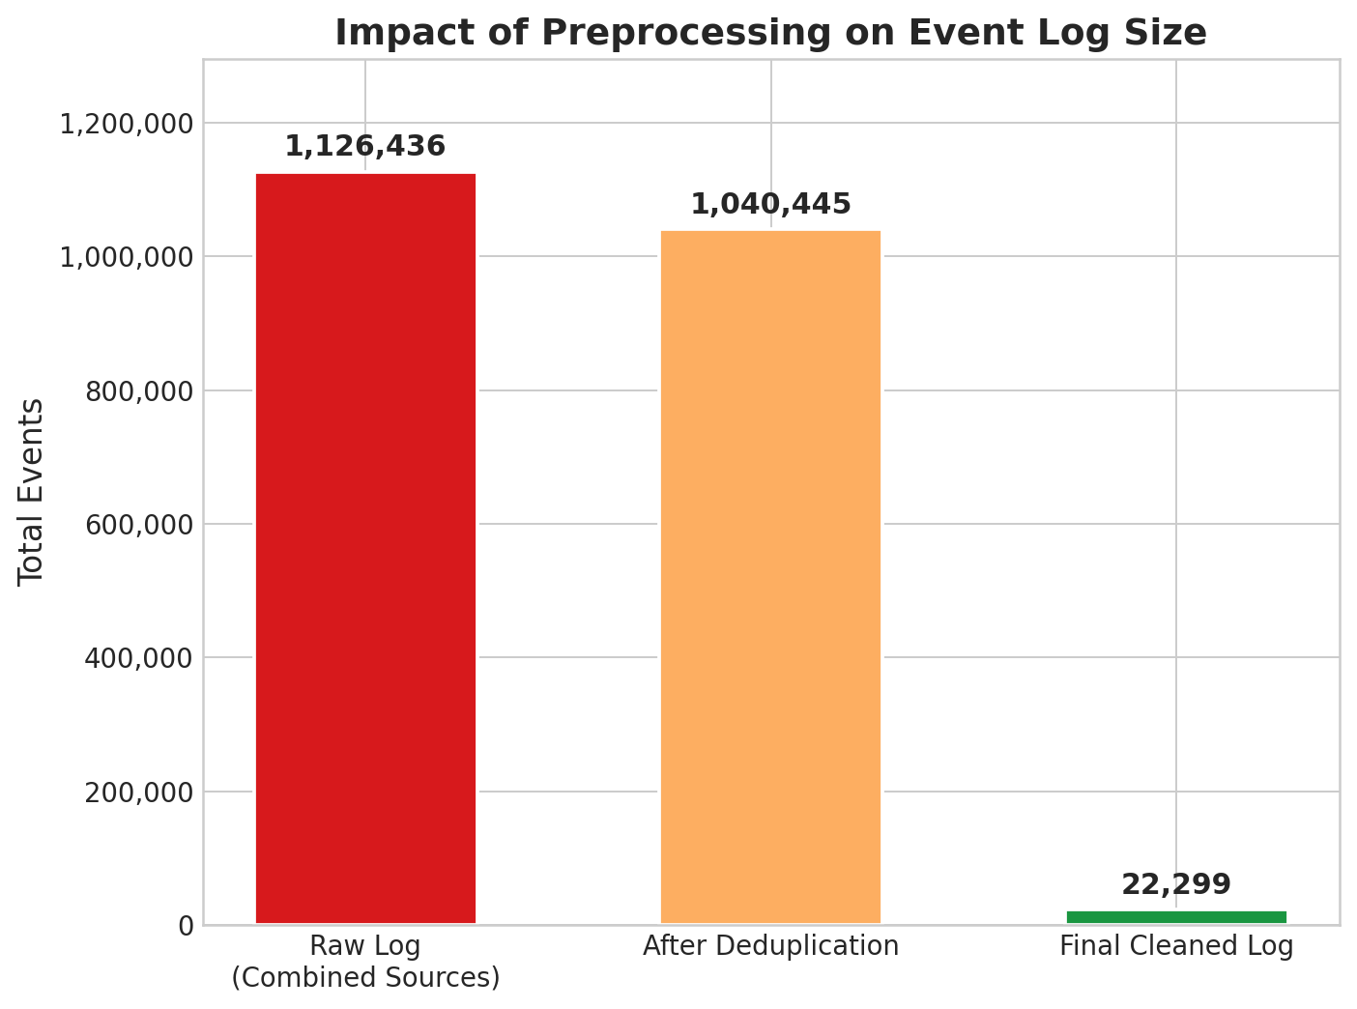
Figure 1. Deduplication impact: multi-step reduction from 1,126,436 raw events to 22,299 cleaned events

3.3 Preprocessing Quality Assessment
Six diagnostic charts were generated to validate the preprocessing pipeline:
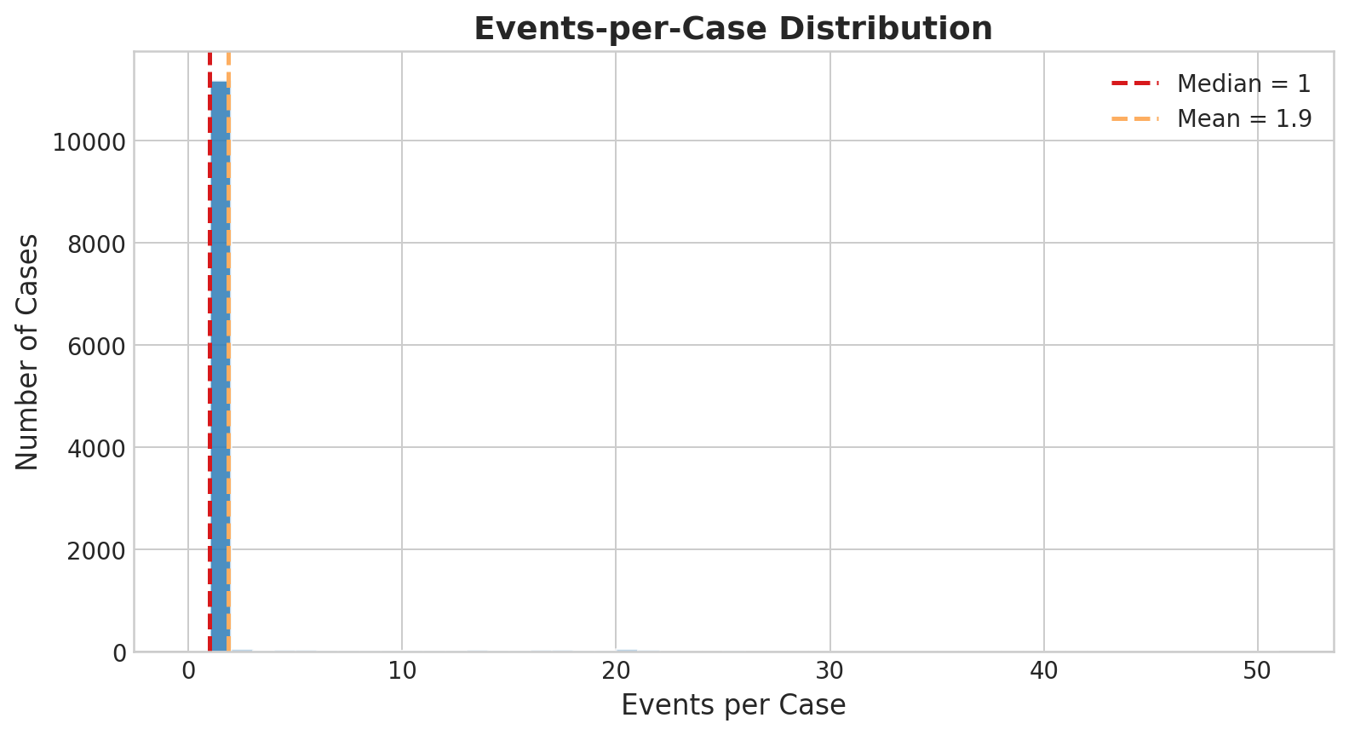
Figure 2. Case outcome distribution for the 826 status-labelled cases (of 11,922 total): Approved (422), Cancelled (360), Rejected (22), In-Progress/Other (22). The remaining 11,096 cases carry no recorded outcome status
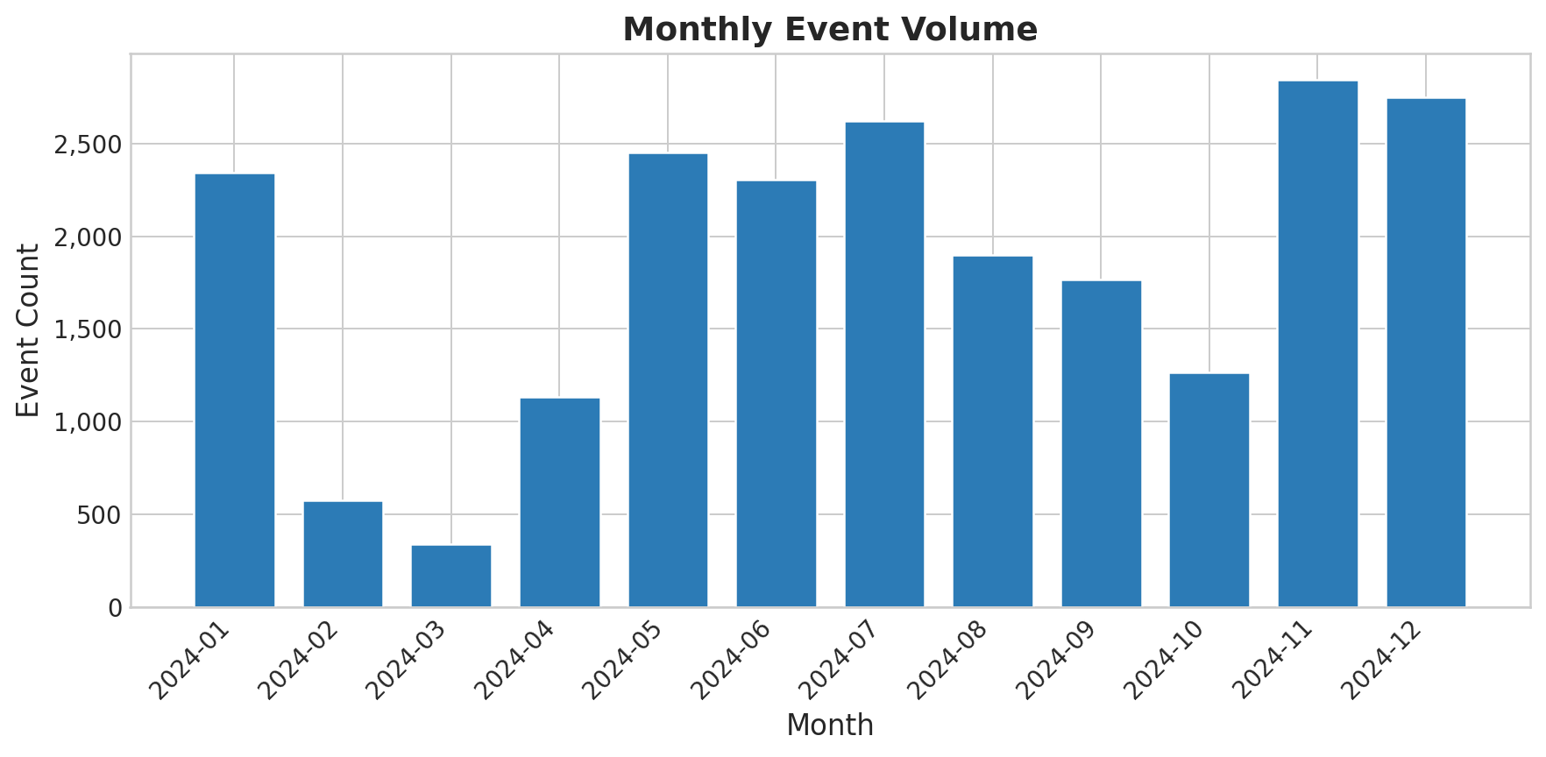
Figure 3. Events-per-case distribution computed on the intermediate log (1,040,445 events, before Step 7 consecutive duplicate removal). Median = 51, P95 = 301. After Step 7, the cleaned log retains 22,299 events and 93.9% of cases have exactly one event (median = 1)
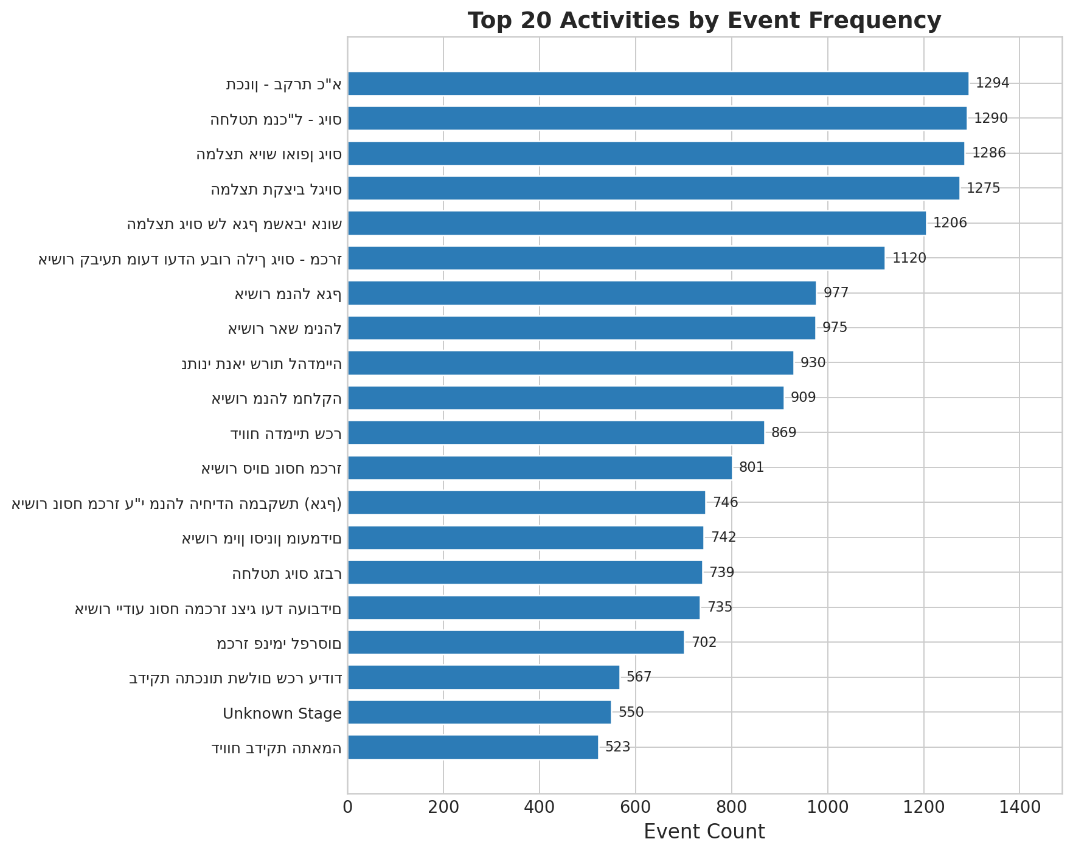
Figure 4. Monthly event volume confirming full 12-month coverage
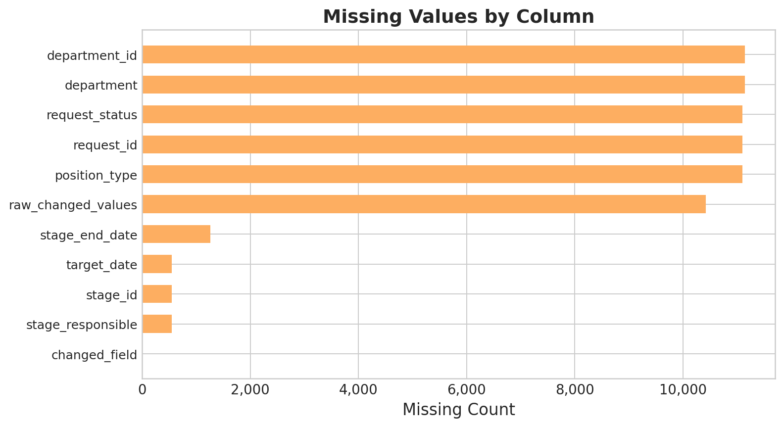
Figure 5. Top 20 stages by event count
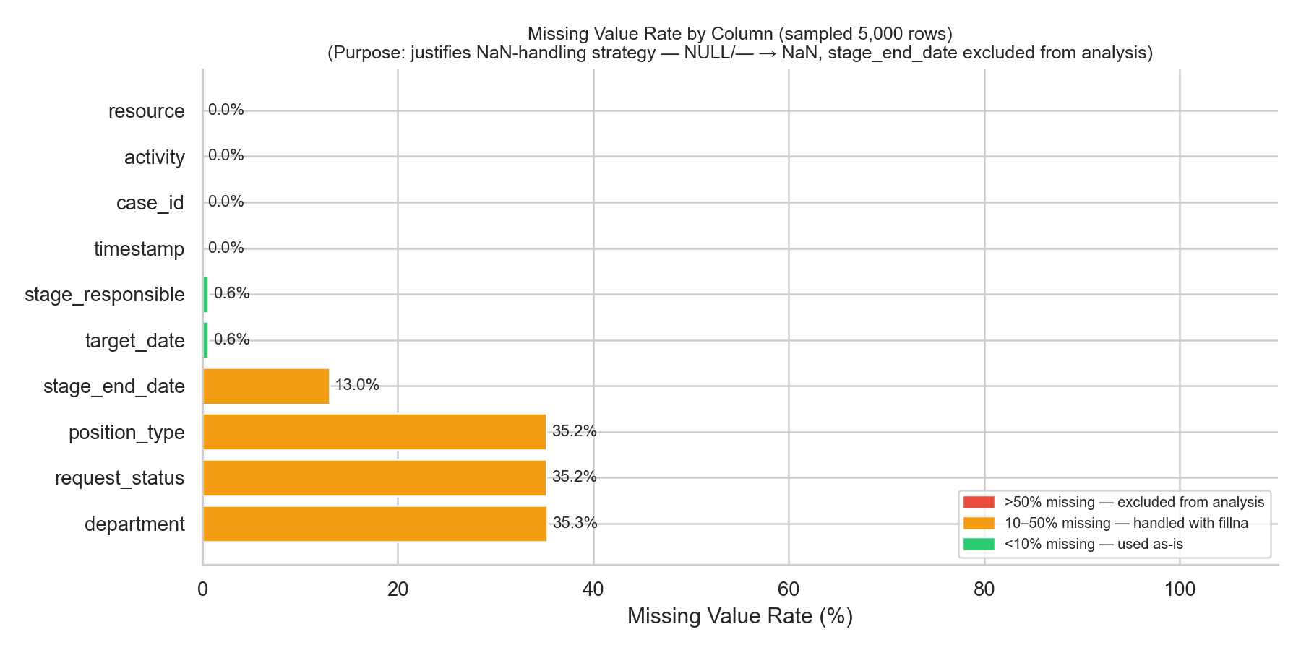
Figure 6. Missing-value analysis by column

3.4 Modelling Decisions
Activity Definition: Hebrew stage name. Concatenating with event type adds noise — delays occur between stage transitions, not within event-type sub-steps.
Case Identifier: request_id (maps 1:1 to case_id).
Encoding: UTF-8-SIG to preserve Hebrew characters across Windows.

3.5 Data Scope and Reporting Note
The cleaned event log contains 22,299 events across 11,922 unique cases and 42 distinct activities. However, the case population is highly heterogeneous, and different analyses use different subsets. To prevent confusion, the key populations are defined here:
Population | n | Definition | Used For
All cases | 11,922 | Every unique case_id in the cleaned log | Conformance, discovery, variants
Single-event cases | 11,195 (93.9%) | Cases with one event — did not progress | Included in discovery; excluded from cycle-time
Multi-event cases | 727 (6.1%) | Two or more events — meaningful processing | Cycle-time and bottleneck analysis
Completed cases | 804 | Definitive status: Approved (422), Cancelled (360), Rejected (22) | Outcome analysis, predictive modelling
In-progress / other | 22 | Active approval round (21) or draft (1) | Excluded from outcome analysis
Subset relationships: The 11,922 total cases partition into 804 completed + 11,118 non-completed. The 11,118 non-completed comprise 11,097 single-event cases (11,096 with no recorded outcome plus one still in an active approval round) and 21 multi-event cases still in progress or draft status. Among the 804 completed, 98 are single-event (e.g., immediate cancellation) and 706 are multi-event. Cycle-time statistics refer to the 804 completed cases unless otherwise noted.

3.6 Time Metric Definitions
Three distinct time metrics are used throughout this report. All times are measured in calendar days (not business days):
Case cycle time: Elapsed time from the first event to the last event within a case. For the 804 completed cases, the mean cycle time is 98.1 days and the median is 62.8 days. The overall mean across all 11,922 cases (6.9 days) is dominated by single-event cases with zero duration and is therefore not a meaningful summary.
Inter-event wait time: Elapsed time between two consecutive events within a case. This measures the delay between successive stage transitions and is the primary bottleneck metric used in Section 5.1.
Sojourn time (stage dwell time): Elapsed time from a case’s first entry into a stage to its last exit from that stage (van der Aalst, 2016, Ch. 6). Sojourn time and inter-event wait time can differ substantially for stages with high internal complexity.

4. Main Paths and Variants

4.1 Case Characterisation
By Position Standard (804 completed cases):
Type | Cases | %
Existing position | 776 | 96.5%
New position | 28 | 3.5%

By Outcome (804 completed cases):
Status | Cases | % | Mean Cycle Time (days)
Approved | 422 | 52.5% | 126.1
Cancelled | 360 | 44.8% | 66.5
Rejected | 22 | 2.7% | 77.5

Note: These 804 cases represent the subset of the 11,922 total cases that reached a definitive final status. The remaining 11,118 cases comprise 11,097 single-event submissions (including one still in an active approval round) and 21 multi-event cases still in progress or draft status (see Section 3.5 for the full population breakdown). The near-parity between approved and cancelled cases (52.5% vs. 44.8%) among completed cases is consistent with potential inefficiency in the intake process.

4.2 Process Discovery
The Heuristics Miner (dependency threshold = 0.5, 10% edge filter) retained 21 of 260 raw edges.
Main path: Staffing Rec → Dept Manager → Division Head → HR Director → [PARALLEL] Budget + Salary + Service → CEO Decision → Tender Spec + Publication → Committee Date → Committee Decision
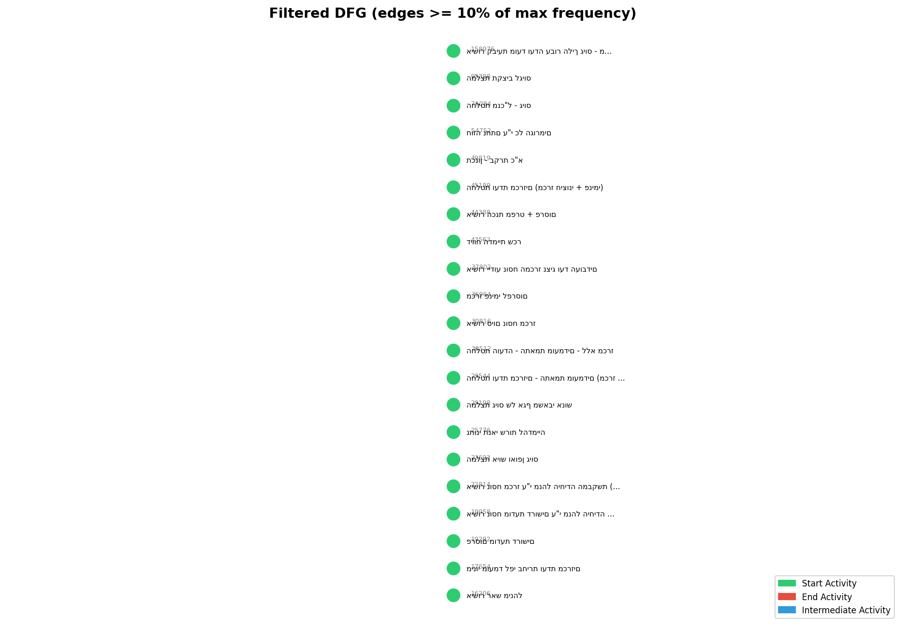
Figure 7. Filtered Directly-Follows Graph (21 edges, ≥10% of max frequency)
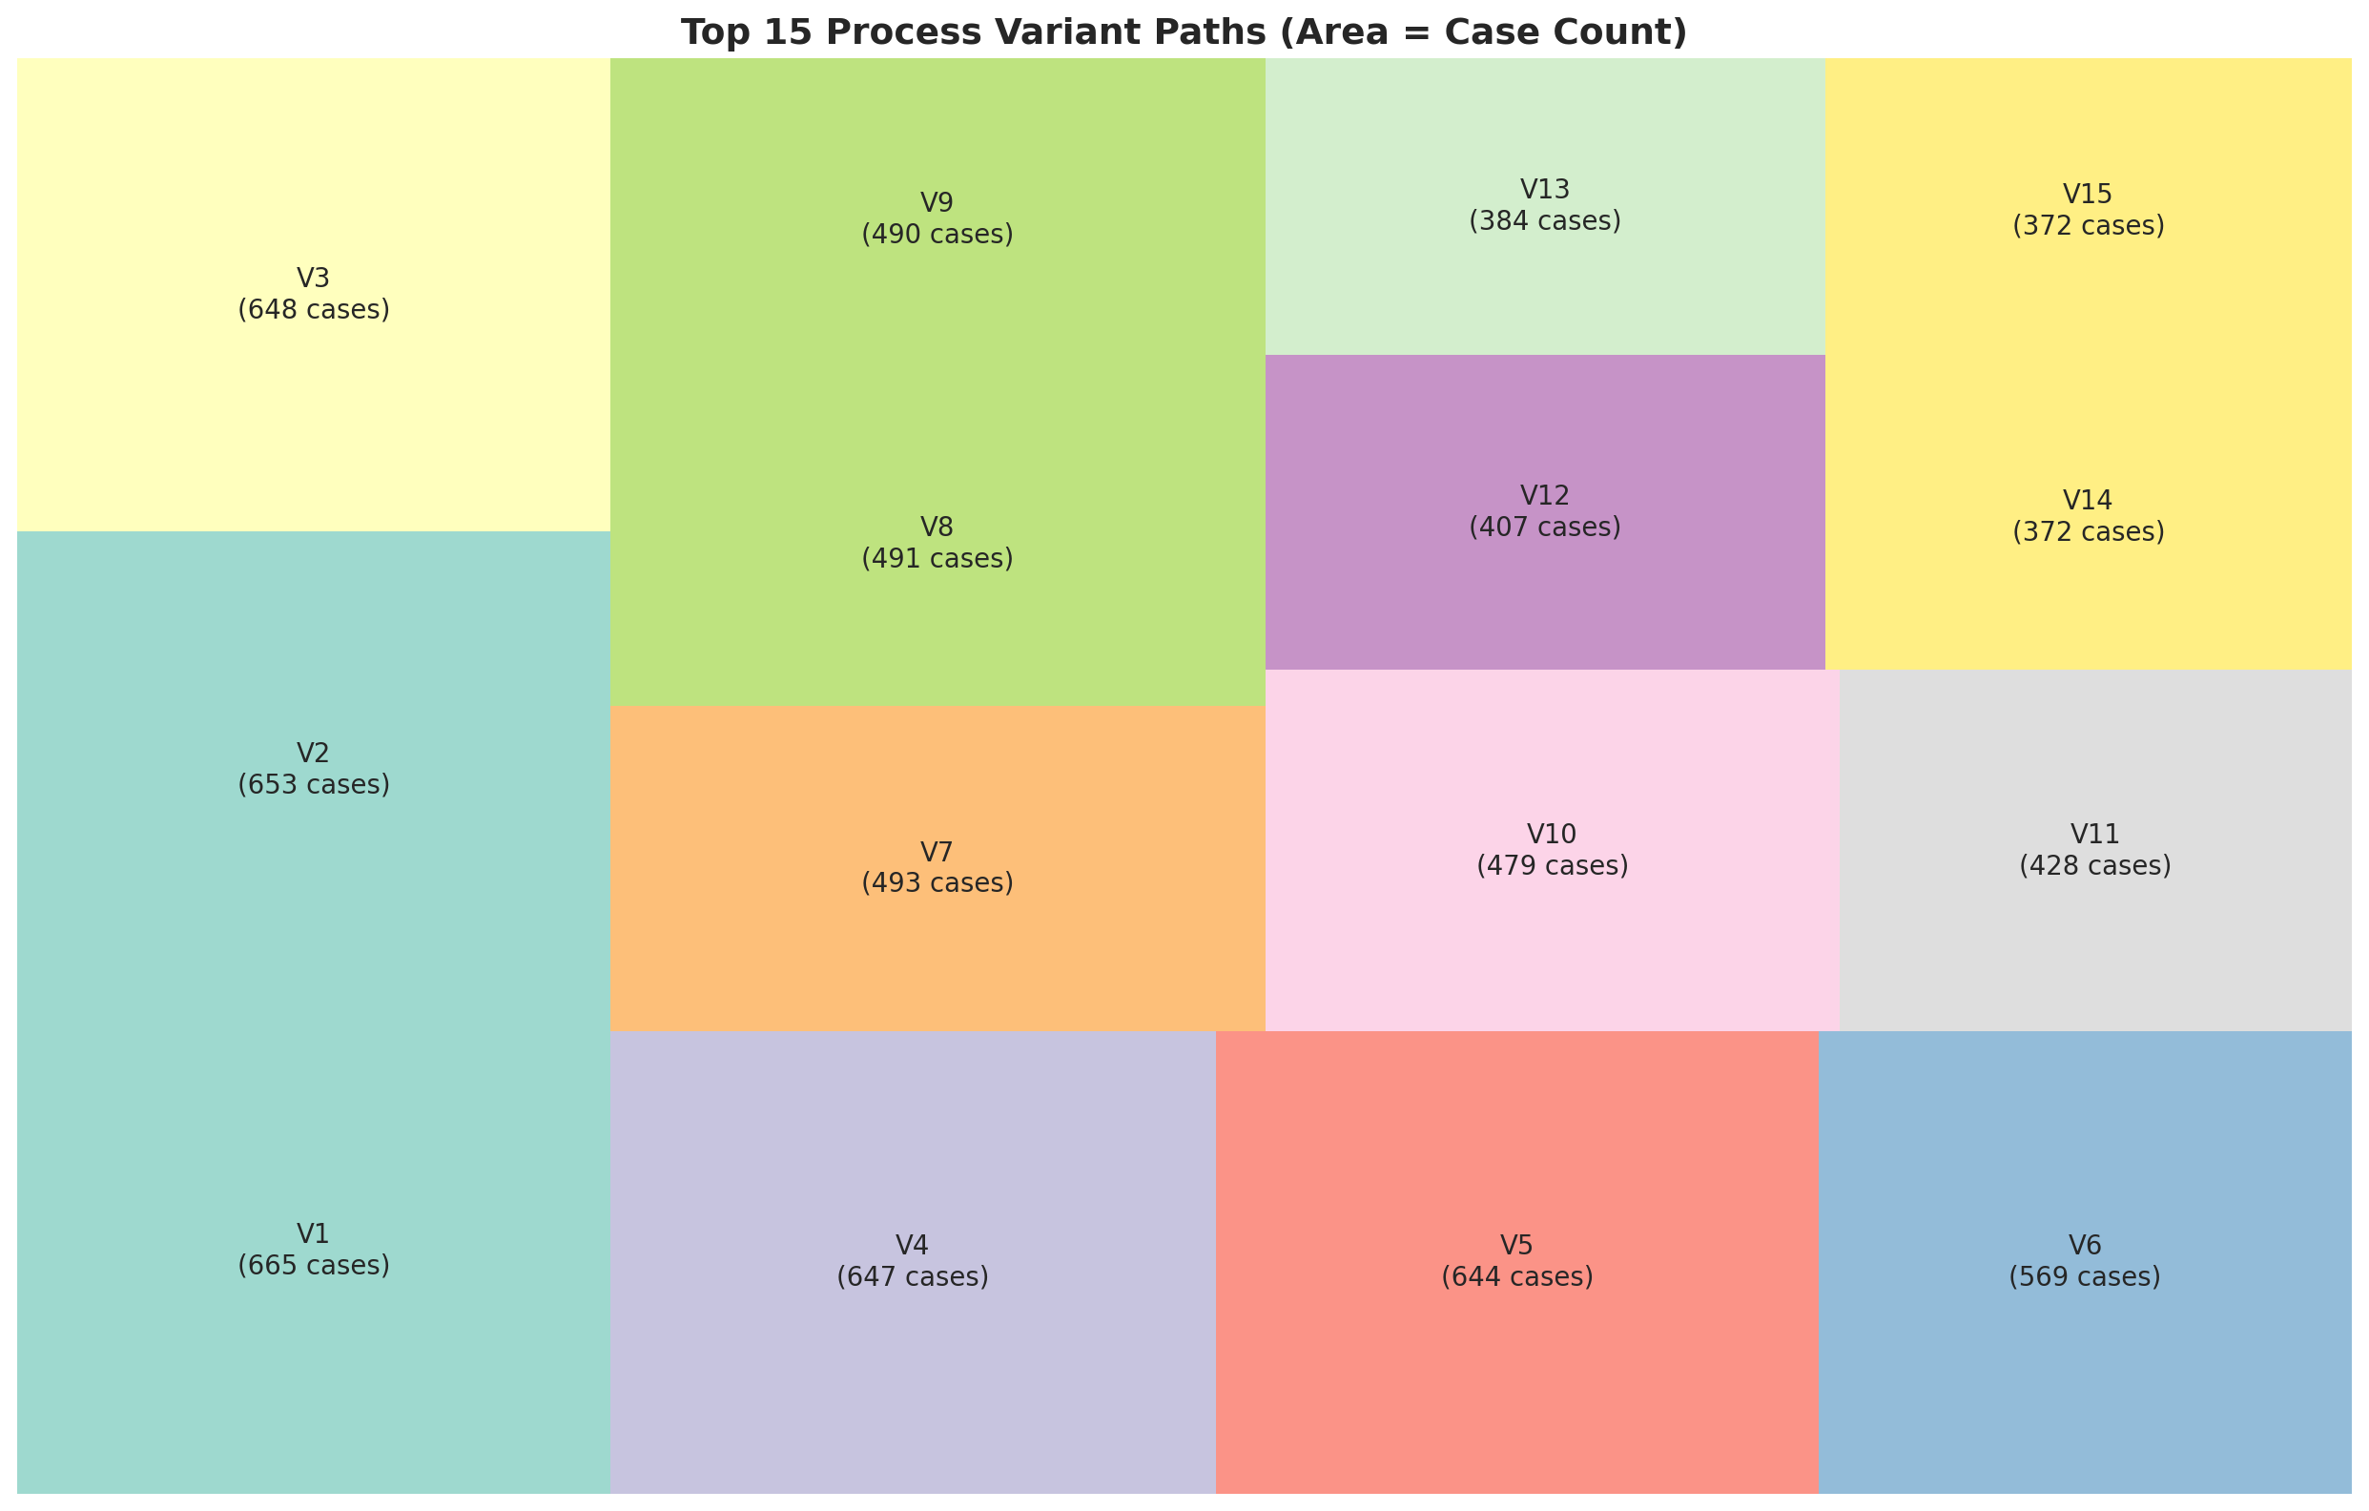
Figure 8. Full DFG with frequency-based edge weights

4.3 Variant Analysis
A variant is defined as the complete ordered sequence of activities (control-flow variant) observed for a case after consecutive duplicate removal (Section 3.2, Step 7). The dataset contains 523 distinct variants. For presentation purposes, full variants were summarised by extracting the first five distinct stages per case; the slow-path table in Section 4.4 therefore illustrates representative trace prefixes rather than full variants. This truncation trades completeness for readability but may group structurally different full traces under the same summary label.
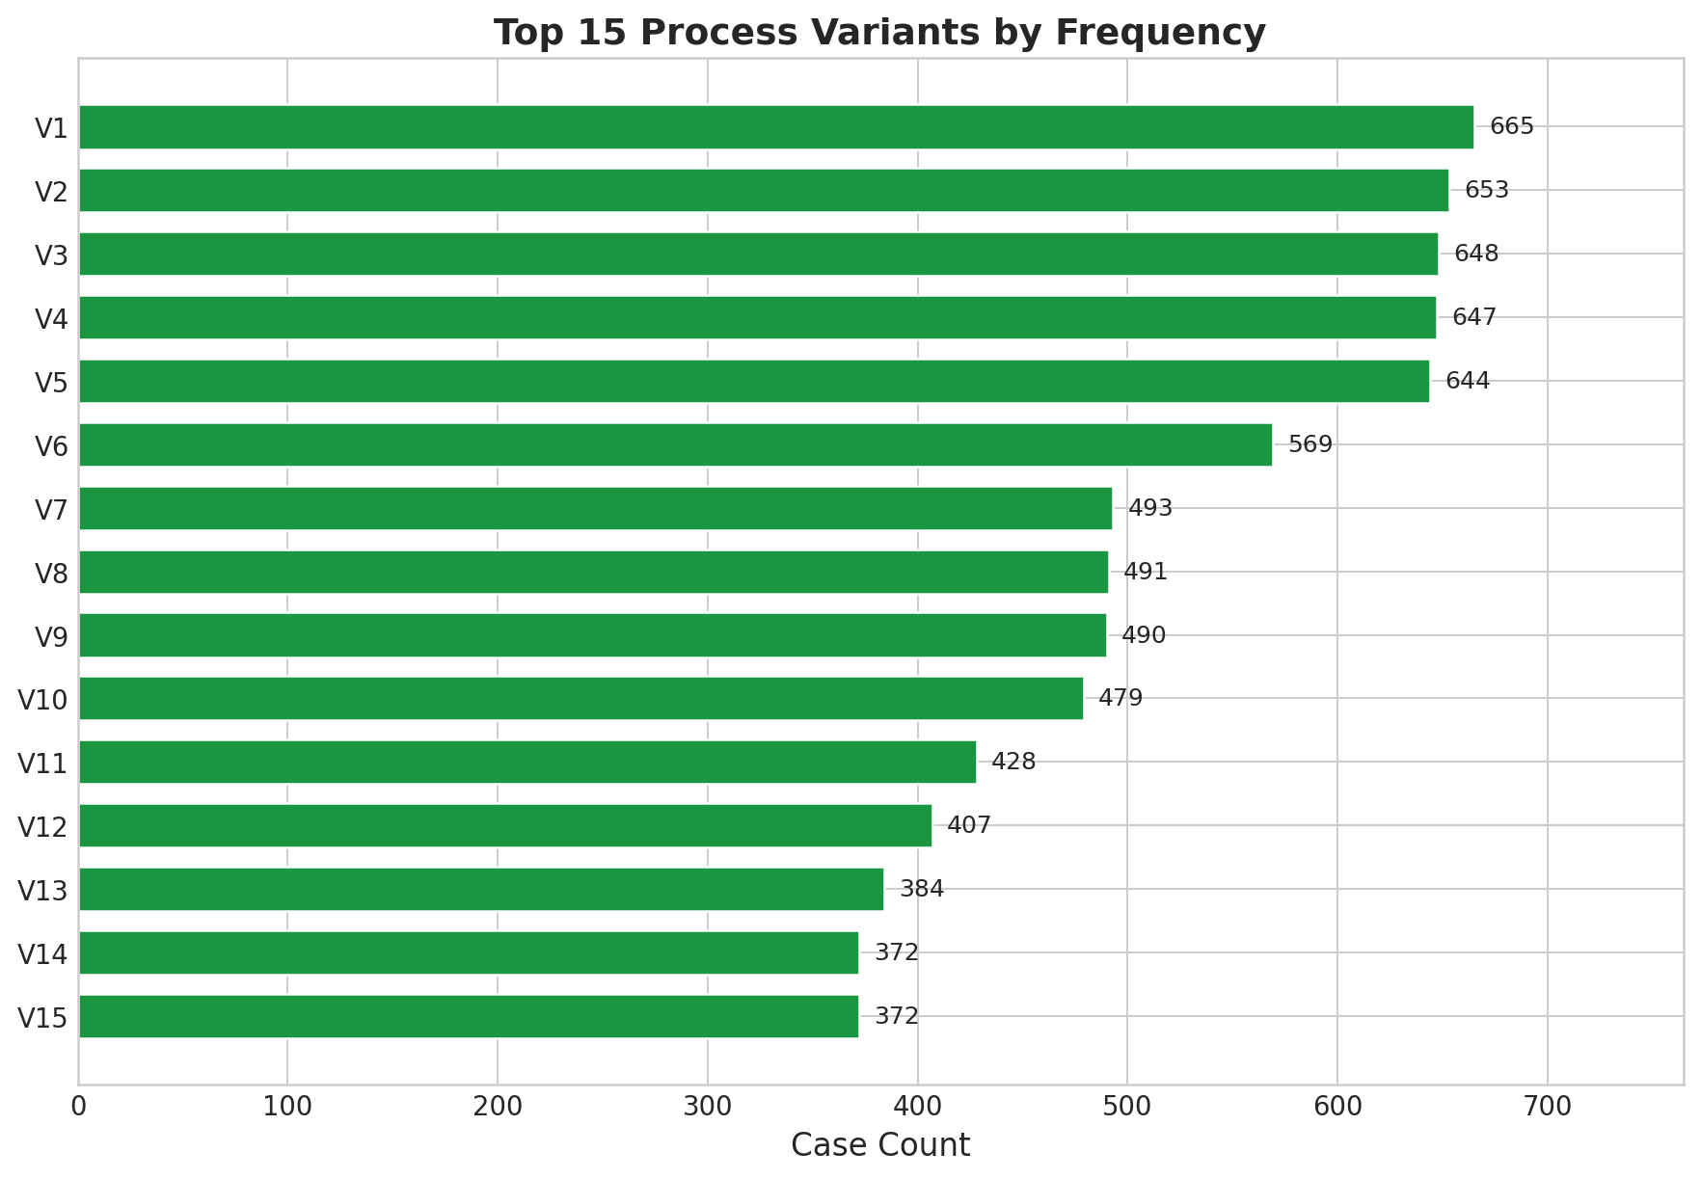
Figure 9. Variant treemap showing process path distribution
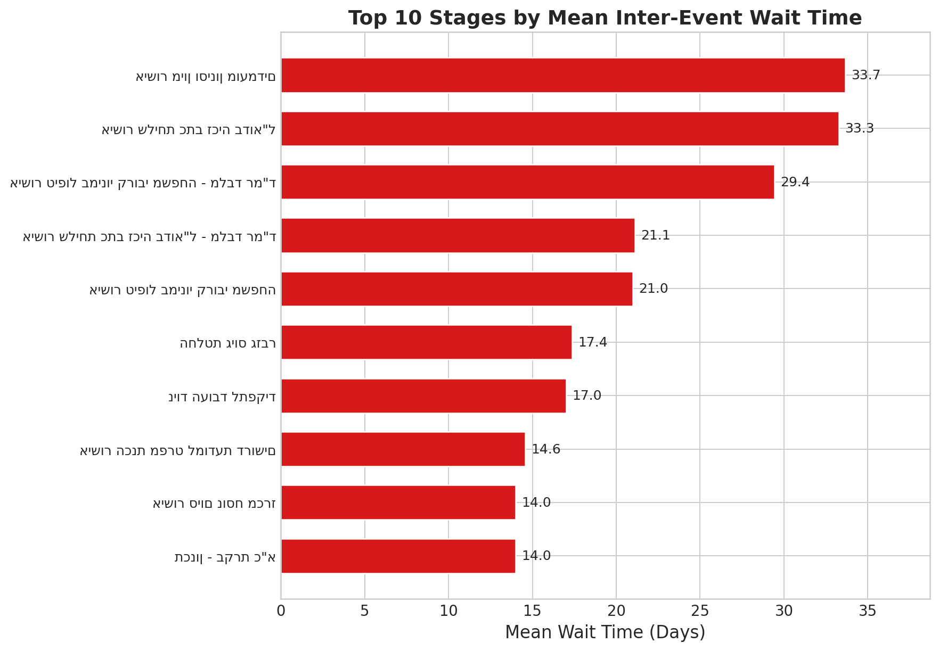
Figure 10. Top 15 variants by frequency

4.4 Sequences with Longest Delays
Rank | Mean Cycle | Cases | Path (first 5 distinct stages)
1 | 317 days | 3 | Tender Wording → Tender Spec → Union → …
2 | 298 days | 3 | Salary Sim → Budget Rec → Treasurer → CEO → …
3 | 298 days | 15 | Budget Rec → Treasurer → CEO → Tender Spec → …
4 | 291 days | 3 | Internal Tender → External Pub → Committee → …
5 | 271 days | 21 | CEO → Tender Spec → Wording → Committee Date → …

All five slowest paths include the post-CEO tender-publication and committee stages. The bottleneck resides in the tender-to-committee corridor. Paths that reach the full external-tender track average 270–317 days, compared to the overall completed-case mean of 98.1 days — approximately 3× the typical duration.

5. Analyses Performed

5.1 Business Question 1: Where Do Delays Occur?
Goal: Identify bottleneck locations by stage, role, user, department, and outcome.
Methodology: Inter-event wait times and sojourn times (van der Aalst, 2016) aggregated by multiple dimensions. Mann-Whitney U tests for significance.

5.1.1 Bottlenecks by Stage
Stage | Mean Wait (days) | Median | Max
Contract Signed | 36.6 | 23.4 | 125.0
Internal Tender Committee | 33.5 | 27.0 | 259.3
Committee Date Approval | 32.7 | 22.3 | 288.5
Budget Recommendation | 16.2 | 2.9 | 344.2
CEO Decision | 11.0 | 0.0 | 341.0

Budget Recommendation and CEO Decision exhibit near-zero medians but maximums exceeding 340 days — right-skewed “time bomb” stages that are fast for the majority but catastrophically slow for a minority.
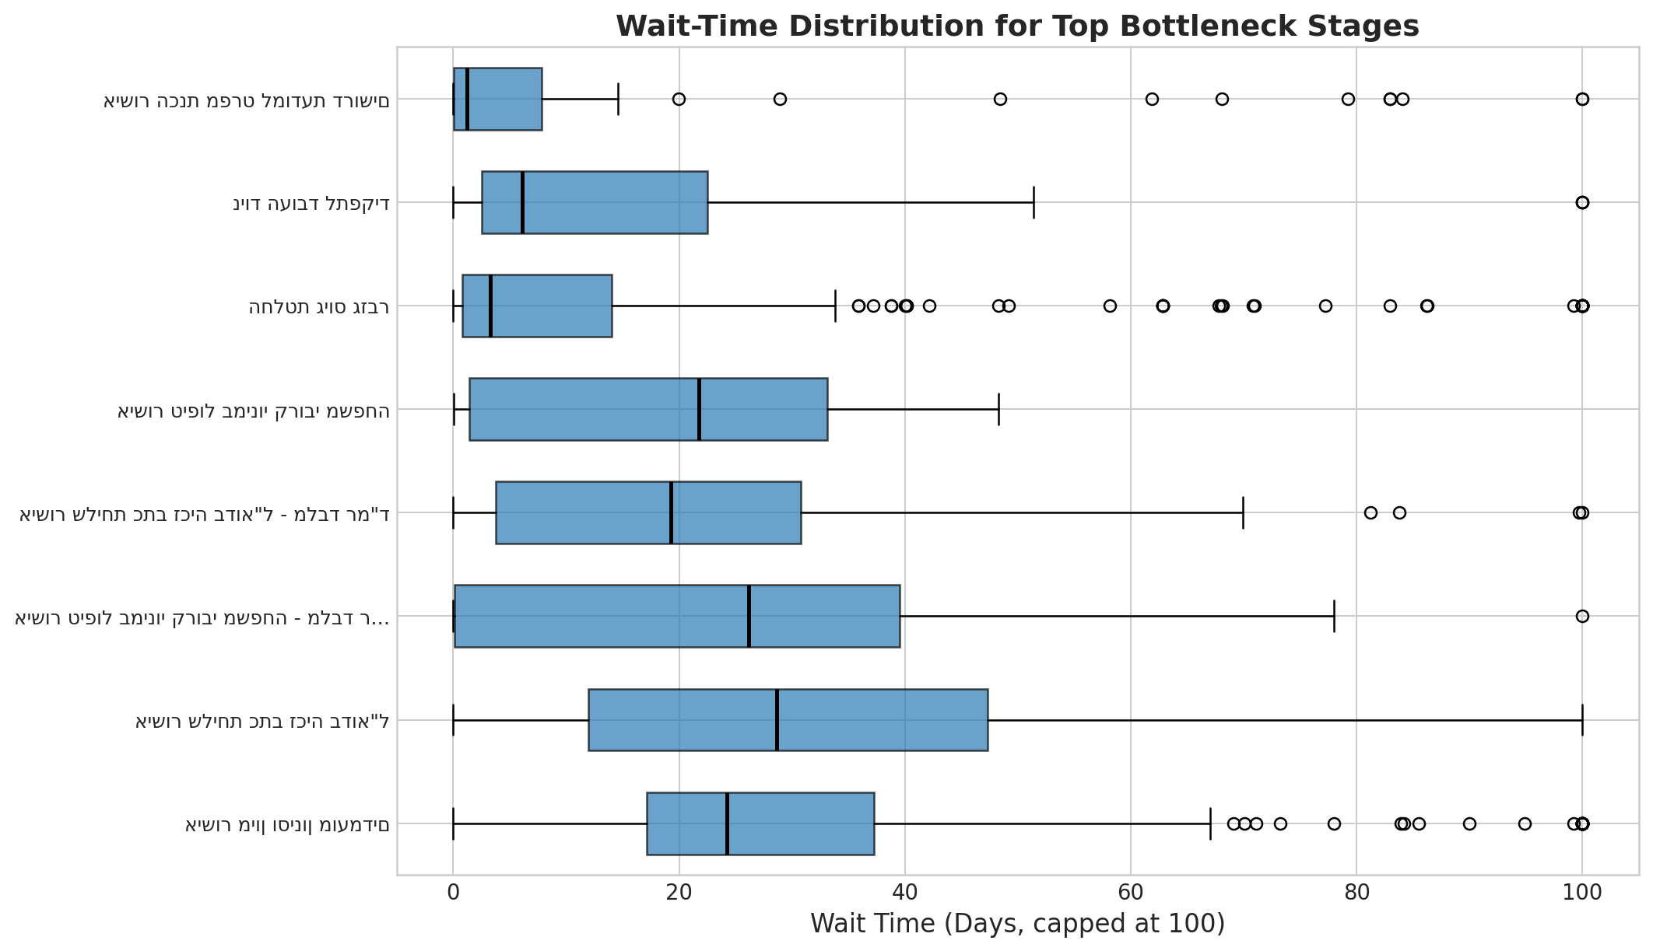
Figure 11. Top 10 stages by mean wait time (days)
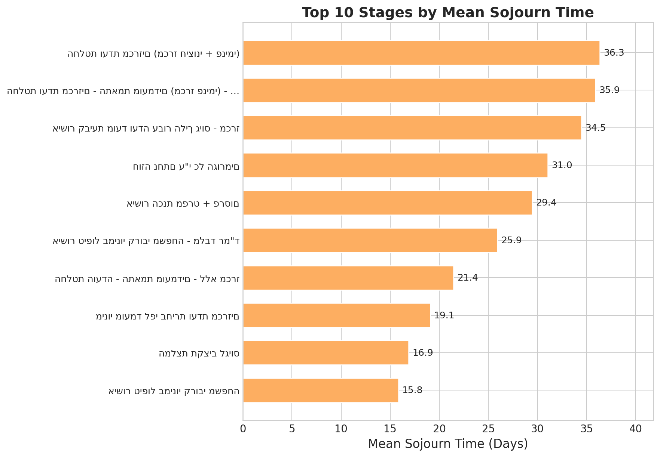
Figure 12. Wait-time box-plot distribution across major stages
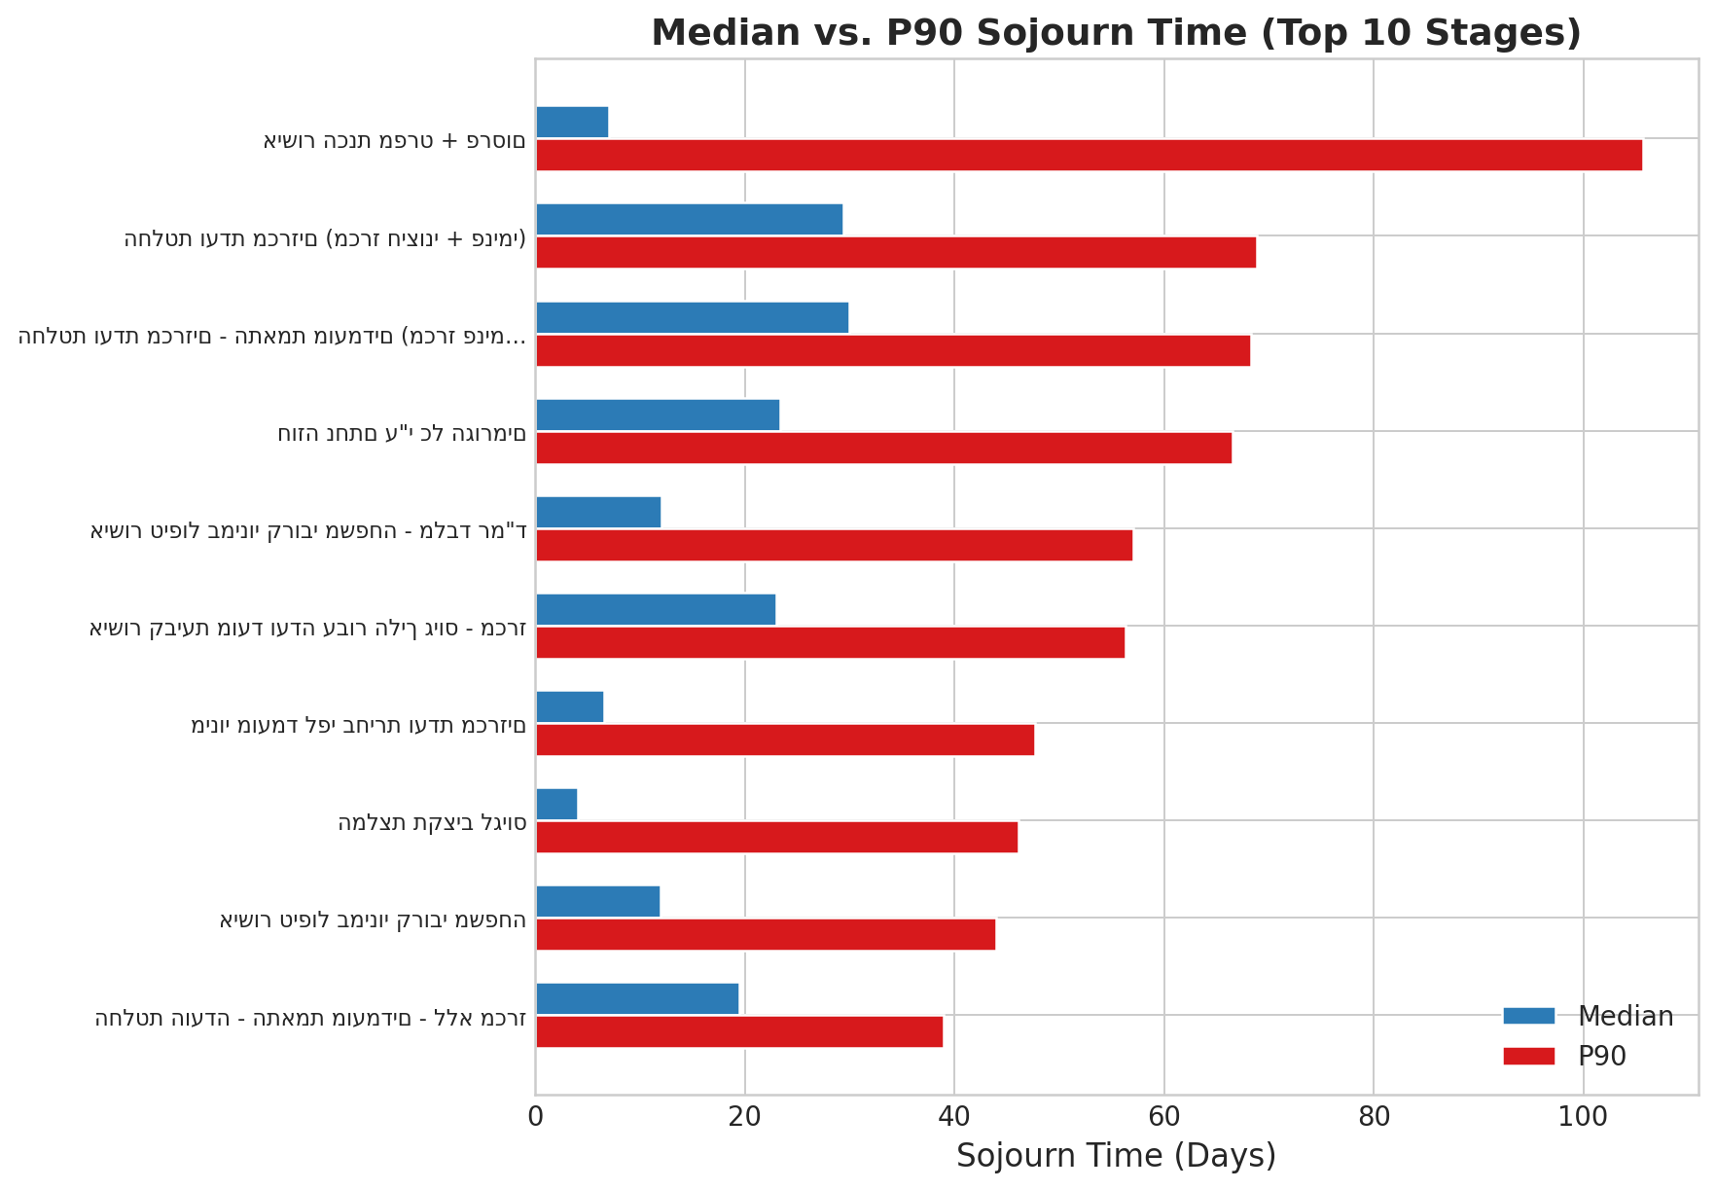
Figure 13. Top 10 stages by mean sojourn time (dwell time)
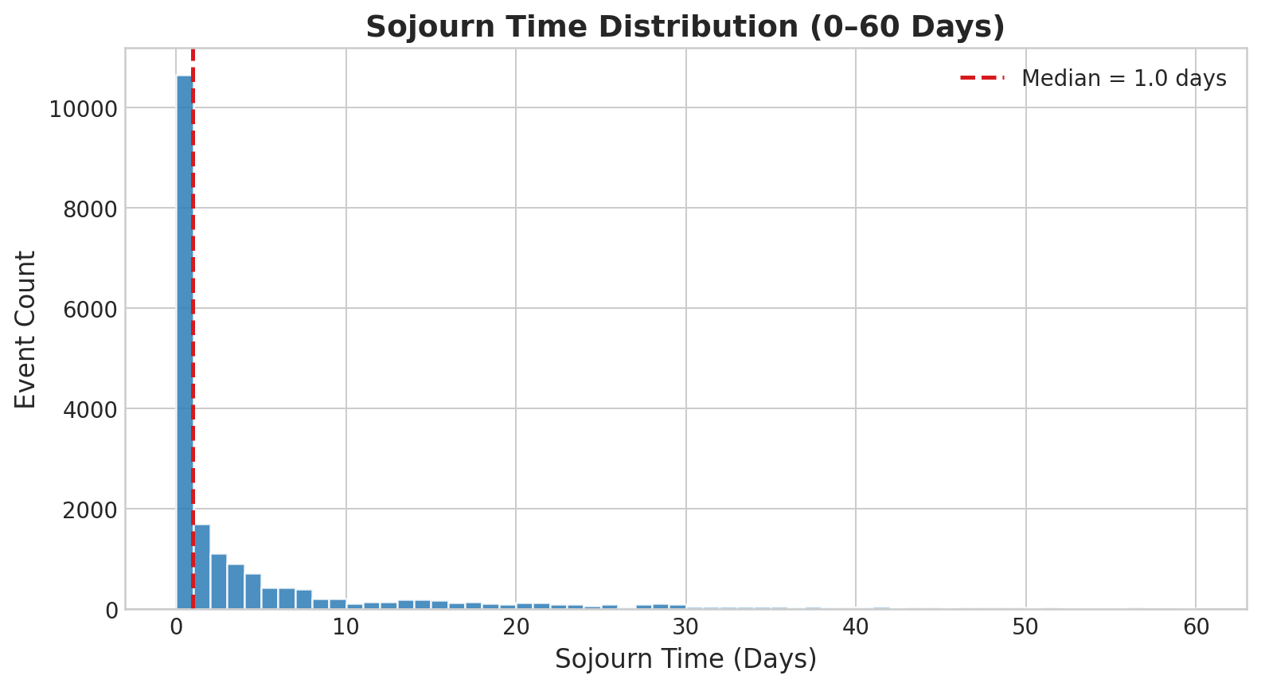
Figure 14. Median vs. P90 sojourn time — stages with low median but high P90 are SLA targets
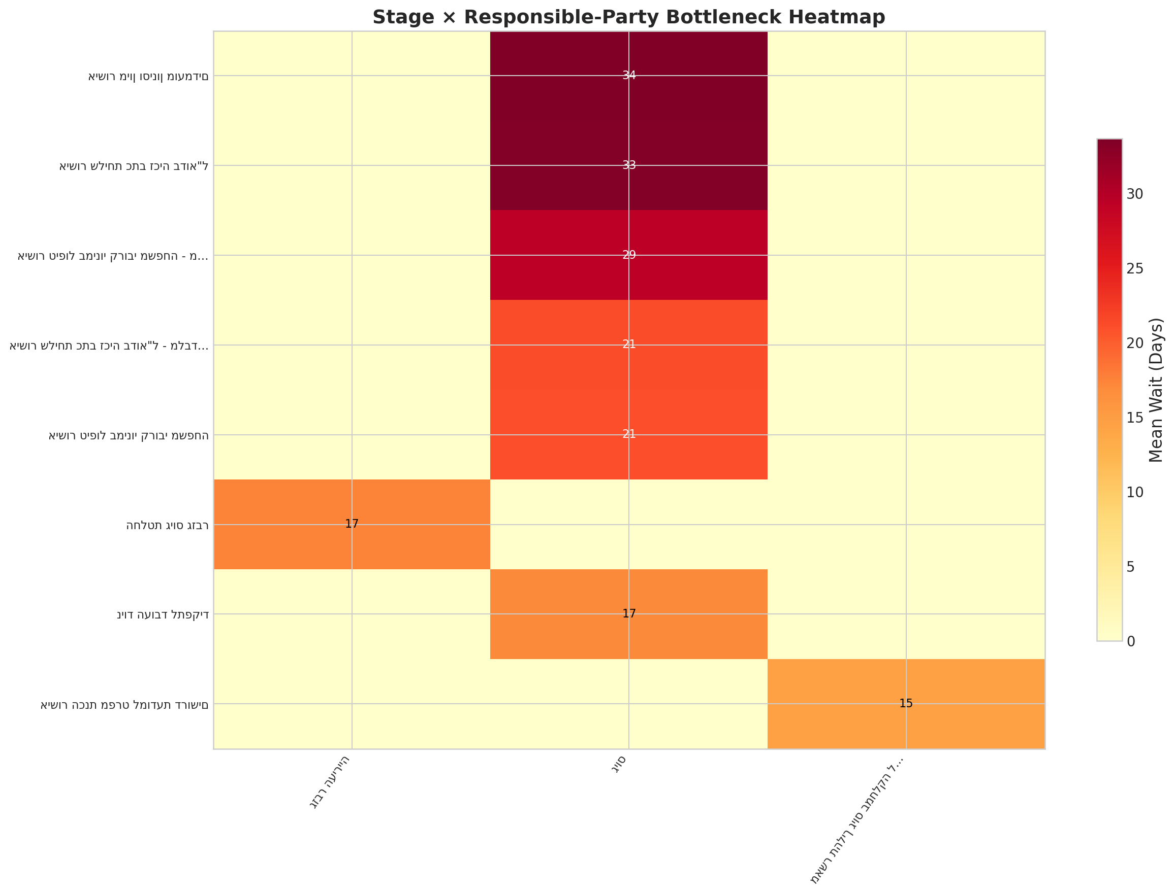
Figure 15. Overall sojourn-time distribution

5.1.2 Bottlenecks by Role and User
Mayor’s Staff (סגל ראש העיר) exhibits the longest average stage duration. HR Division Head ranks second. A group of 5–7 individual users (Mayor’s Office + Budget Dept) account for the majority of P95+ delays, creating single-point-of-failure risk.
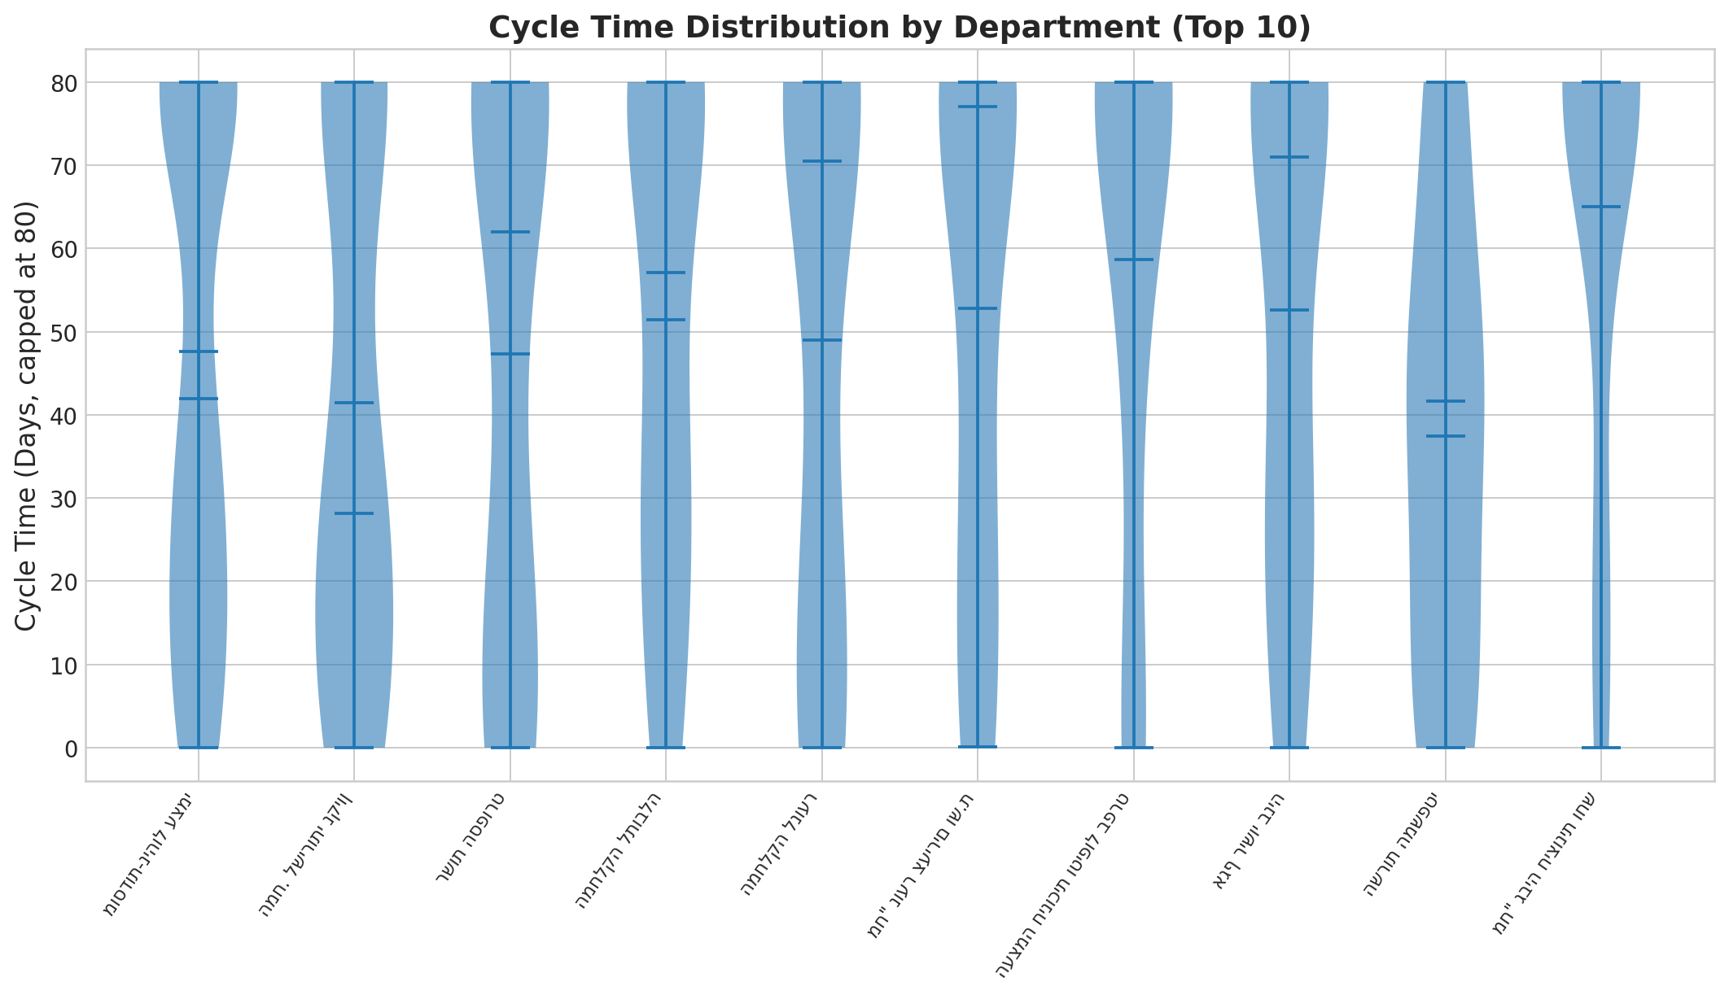
Figure 16. Stage-by-role bottleneck heatmap (darker = longer delays)

5.1.3 Bottlenecks by Requesting Department
Departmental cycle-time variance was analysed using violin plots. High-variance departments indicate inconsistent processing. Departments with the highest cancellation rates may reflect incomplete or low-readiness submissions that are abandoned before progressing beyond the initial approval stages.
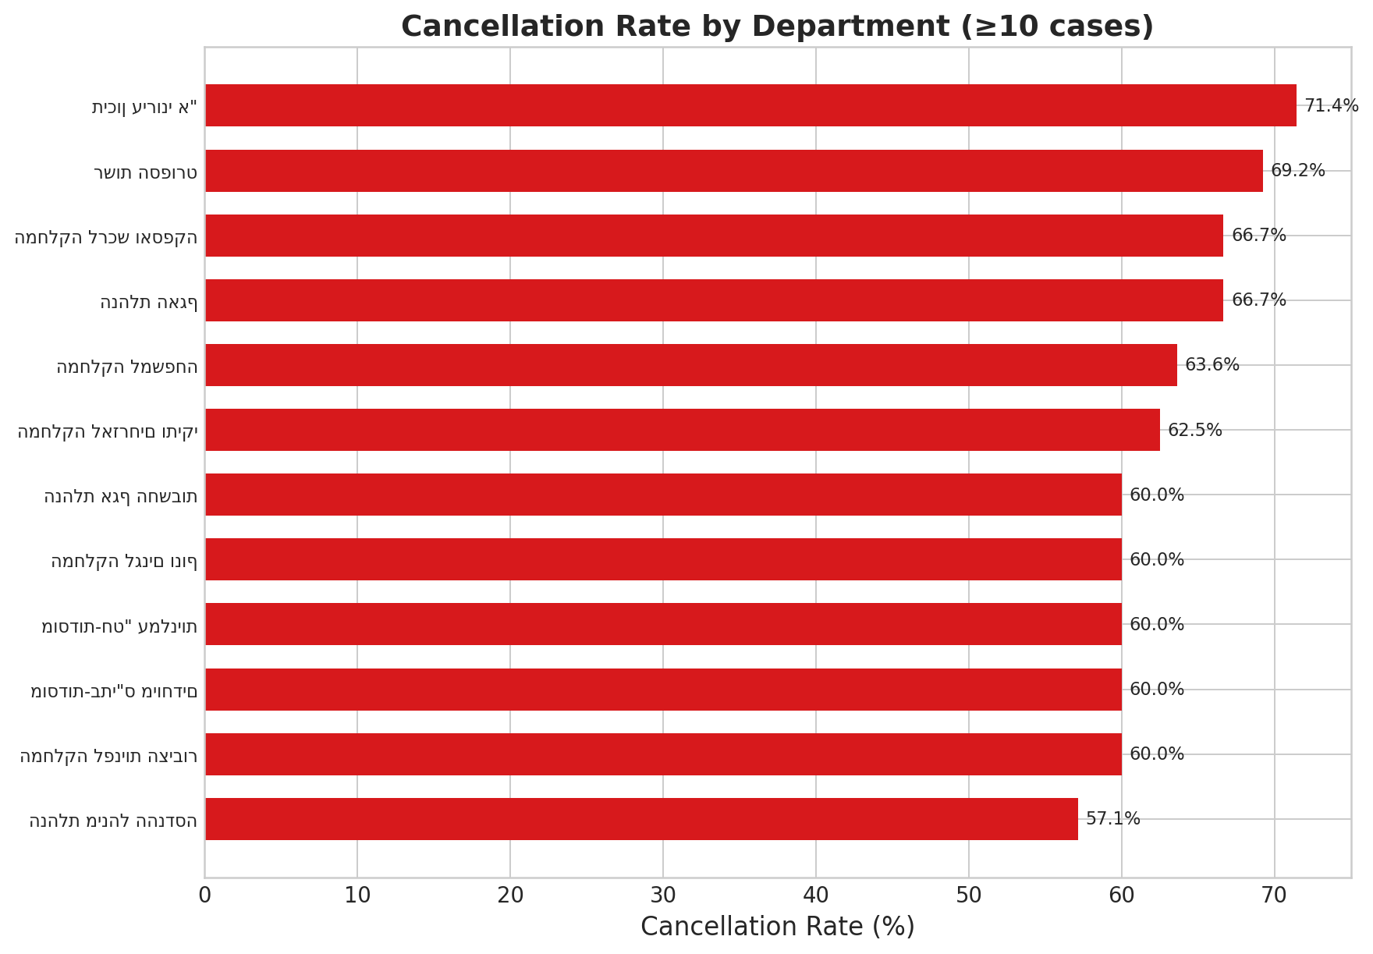
Figure 17. Cycle time violin plots by requesting department
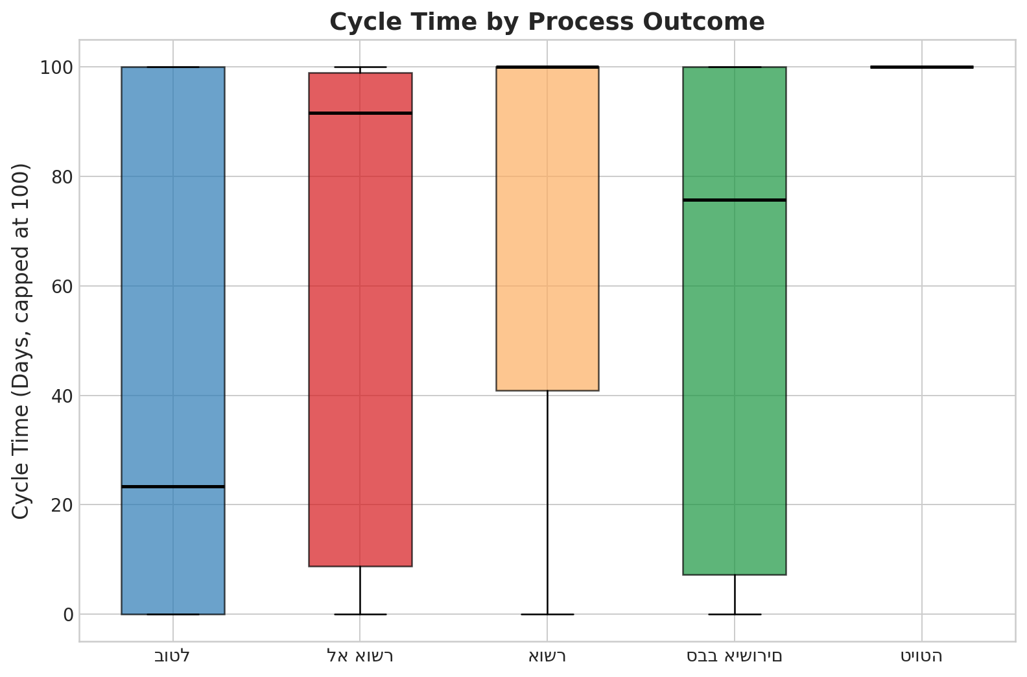
Figure 18. Cancellation rate by requesting department

5.1.4 Bottlenecks by Process Outcome
Cycle times were compared across the 804 cases with definitive outcomes (see Section 3.5):
Outcome | Cases | Mean Cycle Time (days) | Median (days)
Approved | 422 | 126.1 | 112.0
Cancelled | 360 | 66.5 | 23.4
Rejected | 22 | 77.5 | 91.6

Approved cases take substantially longer than cancelled or rejected ones (mean 126.1 vs. 66.5 days). This is consistent with the interpretation that delay resides in the post-CEO implementation stages — cases that survive the full pipeline accumulate more processing time in later stages, while cancelled cases exit early.
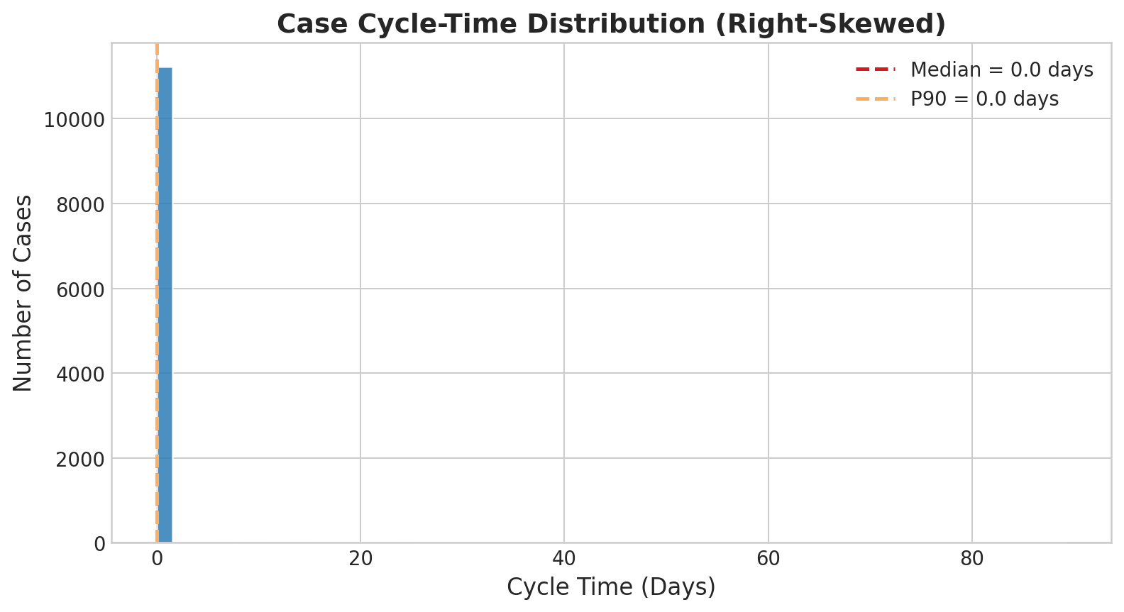
Figure 19. Cycle time distribution by process outcome

5.1.5 Cycle Time Distribution
The cycle-time statistics for the 804 completed cases underscore the severity of the right-skew:
Metric | Value
Mean | 98.1 days
Median (P50) | 62.8 days
P90 | 240.0 days
P95 | 298.9 days
P99 | 356.3 days

The upper 10% of completed cases require over 240 days, while the upper 5% approach a full calendar year.
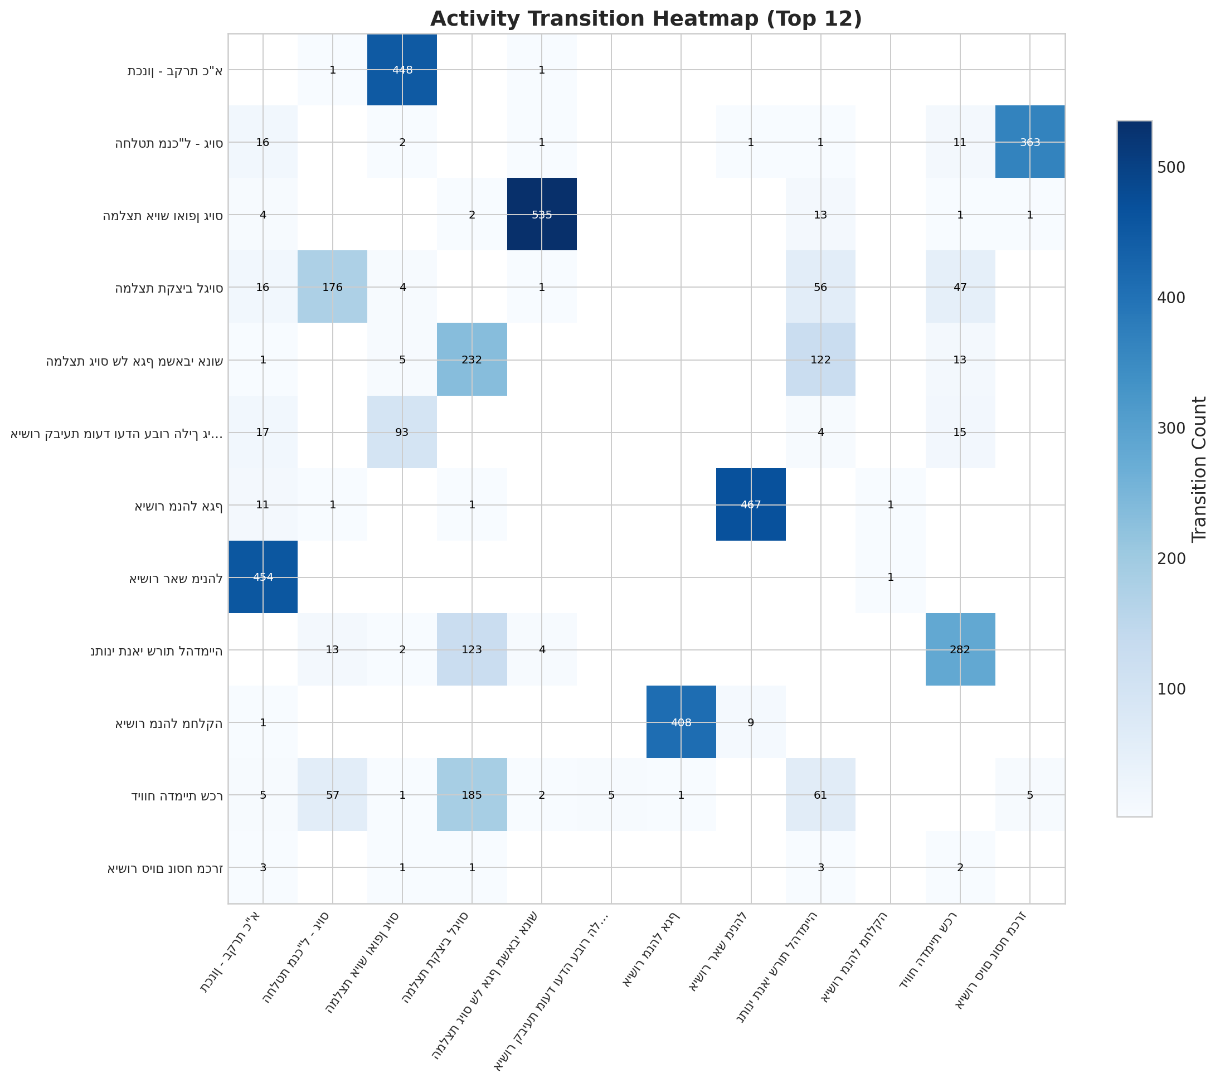
Figure 20. Case cycle-time distribution (heavily right-skewed)
Statistical significance (Mann-Whitney U):
Comparison | p-value | Significant? | Effect Size (r)
Reassigned vs. Non-Reassigned | <0.001 | Yes | 0.41
Approved vs. Cancelled | <0.001 | Yes | 0.34
Top-5 Dept Pairwise | >0.05 | No | <0.11
Note: The “Reassigned vs. Non-Reassigned” row is included here for completeness but is analysed in detail in Section 5.4 (Question 4), where the confound between reassignment and process complexity is addressed.
Business Answer: Delays are concentrated in the post-approval tender-to-committee corridor (Contract Signing, Committee Decisions, Committee Date Approval — mean wait 32–37 days) and at executive gates (Budget Recommendation, CEO Decision) that exhibit extreme right-skewed distributions. The Mayor’s Office and HR Division Head roles are the primary role-level bottlenecks. No robust department-level effect on cycle time was detected in the top-5 pairwise comparisons tested.

5.2 Business Question 2: Main Variants and Delay Sequences
Goal: Map principal variants; identify delay-producing sequences.
Methodology: Three discovery algorithms; two-layer conformance checking. A variant is defined as the complete ordered sequence of activities (control-flow variant) observed for a case after consecutive duplicate removal. The dataset contains 523 distinct variants.

5.2.1 Multi-Algorithm Process Discovery
Algorithm | Trace Fitness | Token Fitness | Fit Traces %
Inductive Miner | 1.000 | 1.000 | 100.0%
Heuristics Miner | 0.950 | 0.976 | 95.0%
Alpha Miner | 0.000 | 0.262 | 0.0%

The Inductive Miner (Leemans et al., 2014) achieves perfect fitness (100% of traces fit). Alpha Miner fails entirely (0%), demonstrating why robust algorithms are required for noisy administrative logs.

5.2.2 Conformance Checking
Layer 1 — Token-Based Replay: The Inductive Miner model yields a trace fitness of 1.000 and a token fitness of 1.000 — all 523 distinct trace variants conform. Perfect fitness indicates full replayability on the discovered model, but not necessarily high model precision. The Inductive Miner’s block-structured design guarantees soundness and can accommodate all observed behaviour, which may include noise; precision analysis would be needed to quantify this trade-off.
Layer 2 — Normative Checkpoint Coverage: Each case was checked for the presence of seven critical normative checkpoints (Staffing Recommendation through Mayor’s Office Decision). Among the 727 multi-event cases, the six operational checkpoints achieve coverage between 57.5% (Department Manager Approval) and 69.5% (CEO Decision), indicating that roughly 30–40% of multi-event cases skip at least one approval stage — typically because the organisational hierarchy is shorter for certain departments. The seventh checkpoint (Mayor’s Office Decision) has near-zero coverage, confirming that it applies only to exceptional cases. When computed over all 11,922 cases, per-checkpoint coverage drops to 8–10% because 93.9% are single-event submissions.
Business Answer: The most common process path follows a linear approval chain, but cases entering the post-CEO external-tender track experience the longest delays (270–317 days). The Inductive Miner achieves perfect trace fitness (full replayability), though fitness alone does not guarantee the model is a high-precision representation of the true process. The Alpha Miner fails entirely, confirming the need for noise-robust algorithms.
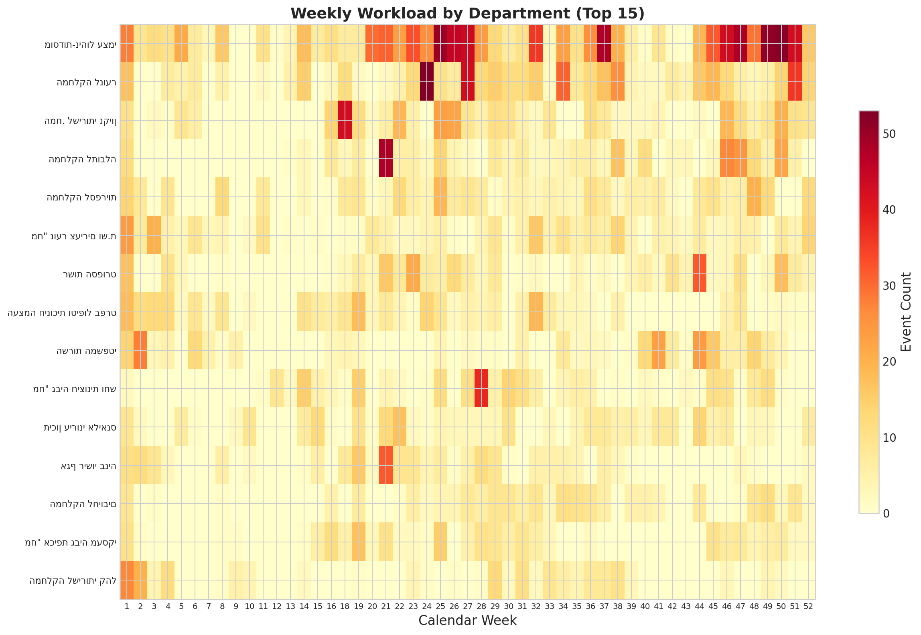
Figure 21. Activity transition heatmap (top 12 activities)

5.3 Business Question 3: Workload Volume vs. Cycle Time
Goal: Determine whether departmental workload correlates with cycle time.
Methodology: Workload is operationalised as the count of distinct cases handled by each department during the 12-month observation period. Pearson correlation was computed between this per-department case count and mean cycle time across the 152 departments represented in the cleaned log.
Result: Pearson r ≈ 0.0 (effectively zero), computed across all 152 departments represented in the cleaned log. No significant linear cross-sectional correlation. This test captures only linear, contemporaneous association; it does not address lagged effects, nonlinear relationships, or stage-level congestion within departments.
Interpretation: In the aggregate analysis, departmental workload shows no meaningful linear association with cycle time. This suggests that overall case volume alone is unlikely to be the primary driver of delays, which appear concentrated at specific approval gates (CEO, Budget, Mayor) regardless of departmental load. However, this analysis has limitations: it tests only linear association at the department level, and cannot rule out localised congestion effects, lagged workload impacts, or nonlinear relationships.
Business Answer: At the aggregate department level, workload volume does not appear to explain cycle-time variation. Delays are more plausibly associated with specific approval stages than with departmental case volume.
Note: The figures below are descriptive visualisations of weekly concurrent caseload. The Pearson correlation reported above uses a simpler operationalisation (total annual case count per department) to test the aggregate linear relationship.
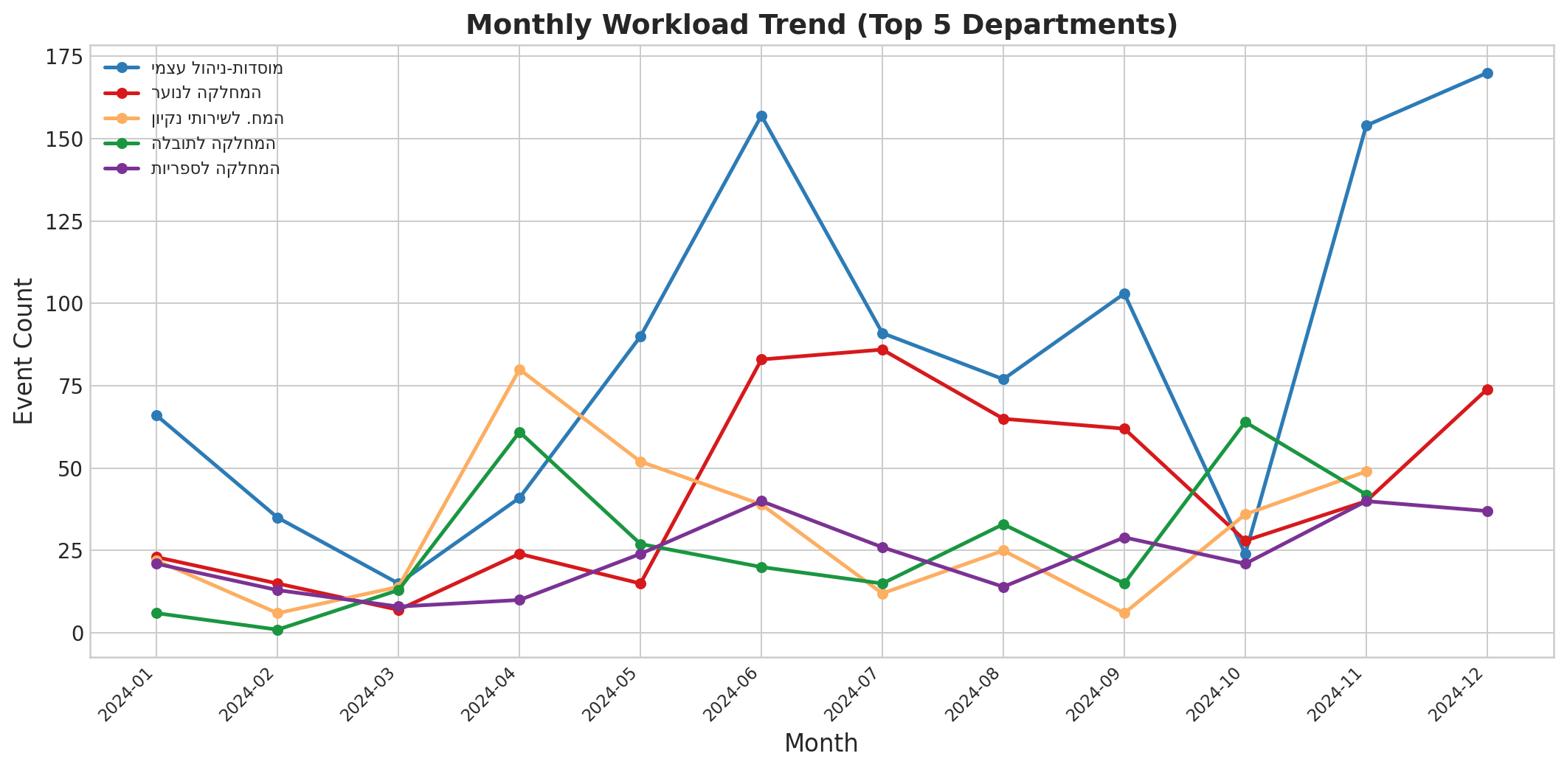
Figure 22. Workload heatmap: concurrent open cases by department and calendar week (descriptive)
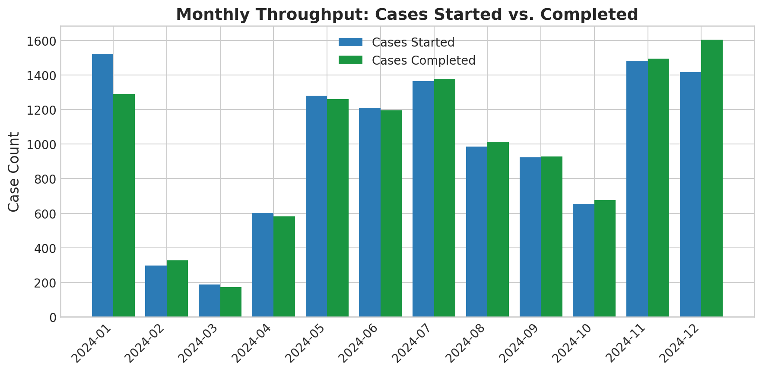
Figure 23. Workload trend by department over time (descriptive)
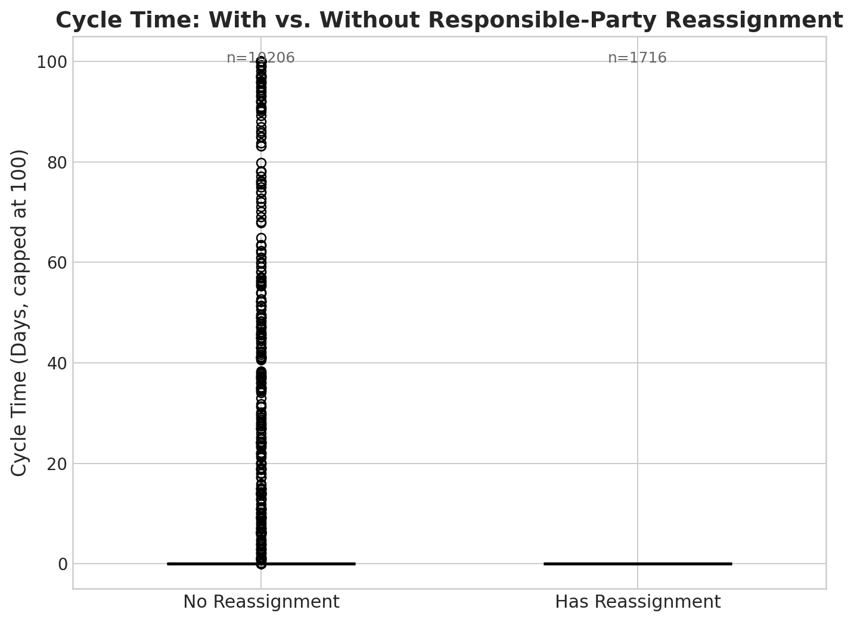
Figure 24. Monthly case-load trend showing Q1 and Q3 seasonal peaks (descriptive)

5.4 Business Question 4: Responsible-Party Assignment/Change Signals and Delays
Goal: Determine whether changes in stage ownership (responsible-party reassignment) correlate with process delays.
Methodology: Cases divided into two groups — with and without reassignment. Mann-Whitney U tests and Spearman rank correlation (ρ = 0.444, p < 0.001) applied.

5.4.1 Simple Comparison (All 11,922 Cases)
Group | Cases | Mean Cycle Time (days) | Median (days)
With Reassignment | 5,710 | 14.3 | 0.0
Without Reassignment | 6,212 | 0.03 | 0.0

This simple comparison is misleading. The reassignment flag is triggered when a case’s changed_field contains the responsible-party field (אחראי שלב) or when the stage_responsible value changes between consecutive events. Under this definition, 4,996 of the 5,710 “with reassignment” cases are actually single-event cases whose sole event was a responsible-party field assignment — not a genuine inter-stage handover. Similarly, the “without reassignment” group (6,212) comprises 6,199 single-event cases plus only 13 multi-event cases. Because both groups are dominated by single-event cases with near-zero cycle time, the aggregate comparison is uninformative.

5.4.2 Completed Cases (804 Definitive-Outcome Cases)
Group | Cases | Mean Cycle Time (days) | Median (days)
With Reassignment | 693 | 113.5 | 96.7
Without Reassignment | 111 | 1.8 | 0.0

Among completed cases, those with reassignment are substantially slower (mean 113.5 vs. 1.8 days). However, the 111 “without reassignment” completed cases consist of all 98 single-event completed cases (predominantly immediate cancellations) plus 13 multi-event cases with no recorded responsible-party change. Among the 727 multi-event cases, only 13 have zero reassignments — too small for reliable comparison.

5.4.3 Interpretation and Limitations
The Spearman correlation (ρ = 0.444, p < 0.001) indicates a moderate positive association between reassignment count and cycle time. This is consistent with the expectation that longer cases traverse more stages and therefore involve more handovers. However, the direction of causation cannot be established: it is equally plausible that reassignments cause delays (coordination overhead) or that longer cases simply accumulate more reassignments. The primary practical insight is that cases stalling at a single stage without any reassignment tend to represent either immediate cancellations or dormant cases, suggesting that inactivity detection (auto-escalation after 14 days) may be more productive than restricting handovers.
Business Answer: Reassignment count and cycle time are moderately positively correlated (Spearman ρ = 0.444), but causation cannot be established from observational data. The association appears largely driven by the structural relationship between case complexity (more stages = more handovers = longer duration). The intervention implication is that inactivity detection is more promising than handover restriction.
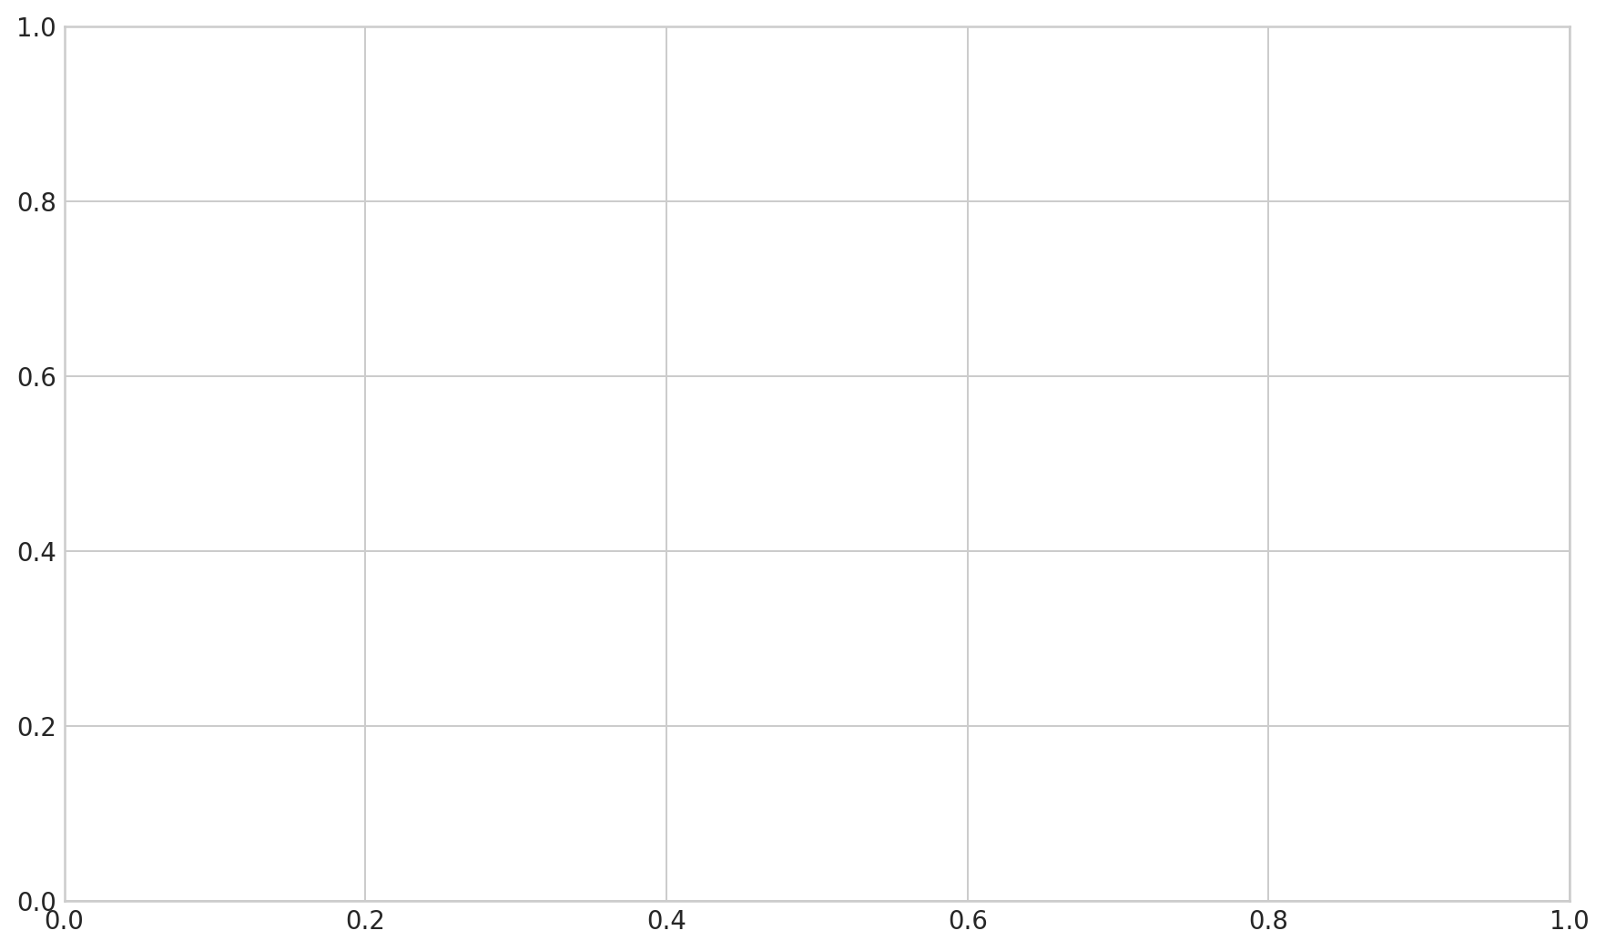
Figure 25. Cycle time box plots: with vs. without responsible-party reassignment
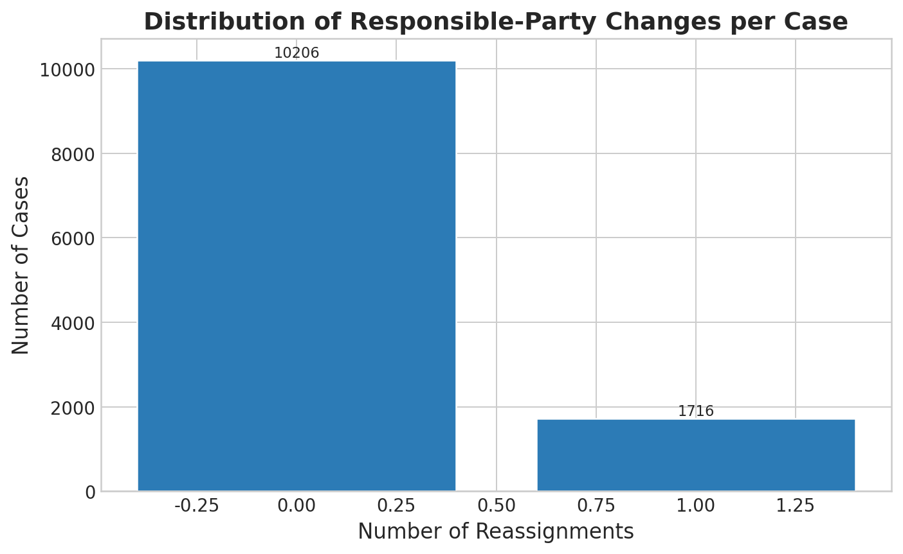
Figure 26. Controlled comparison of reassignment effect across event-count quartiles
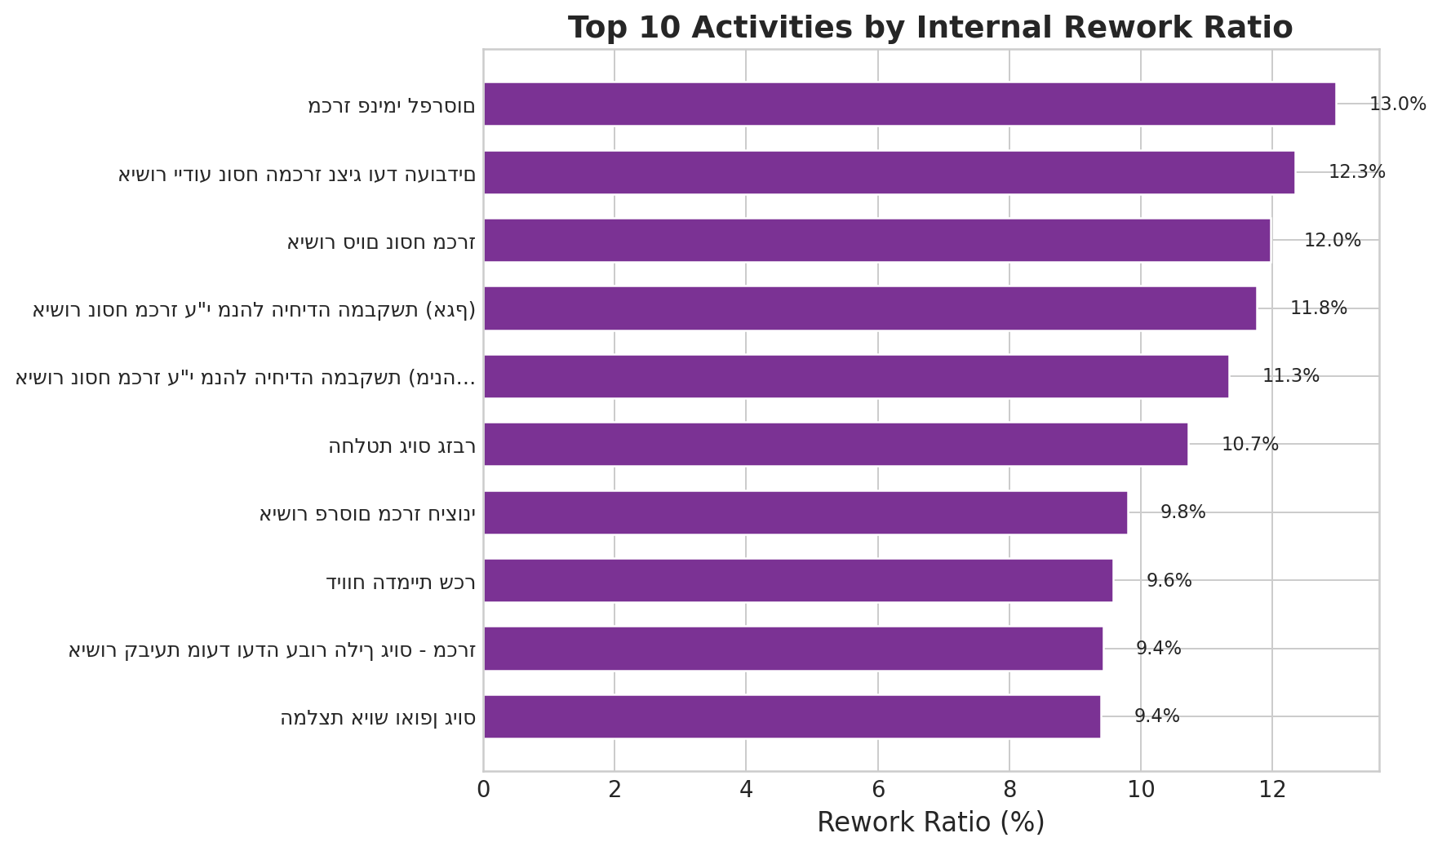
Figure 27. Distribution of responsible-party changes per case

5.5 Business Question 5: Internal Sub-Processes within Stages
Goal: Characterise intra-stage complexity and its link to delays.
Methodology: Internal stage complexity was assessed via event-count-per-case within each stage, changed-field frequency analysis, and parallel versus serial execution checks across the three post-approval workstreams (Budget/Treasurer, Service Conditions, Payroll Simulation).

5.5.1 Stage-Level Internal Complexity
Committee stages (Tender Committee Decisions, Committee Date Setting) show the highest internal complexity, with over 150 events per case in extreme instances. These “stages” function as extended administrative sub-processes involving many incremental updates rather than single decision points.

5.5.2 Changed-Field Analysis
The most frequently modified field is ‘Standard Time Deviation Level’ (רמת חריגה מזמן תקן) — updated when stages exceed their target duration, reflecting internal SLA-breach escalation sub-processes. Other frequently changed fields include salary parameters and budget codes.

5.5.3 Parallel-Track Compliance
The process design specifies that three tracks should execute in parallel following the approval hierarchy: (1) Budget/Treasurer approval, (2) Service Conditions salary check, and (3) Payroll salary simulation. Concurrency rate: 84.97% of cases correctly execute these tracks in parallel. The remaining 15% execute sequentially, adding unnecessary delay. Recommendation: auto-trigger salary simulation when Budget Recommendation is initiated.
Business Answer: Committee-related stages exhibit the highest internal complexity (>150 events per case in extreme instances). The most frequently modified field (Standard Time Deviation Level) reflects internal SLA-breach escalation sub-processes. Parallel-track compliance is 84.97%, with 15% of cases incurring unnecessary sequential delay.
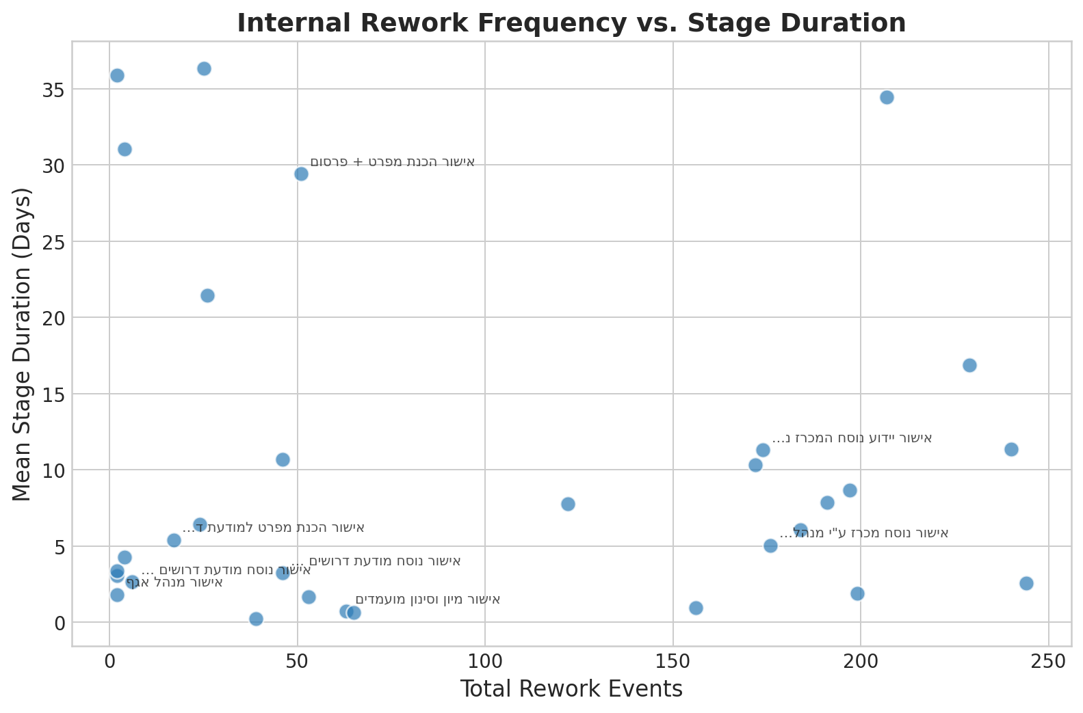
Figure 28. Top 10 stages by internal rework ratio
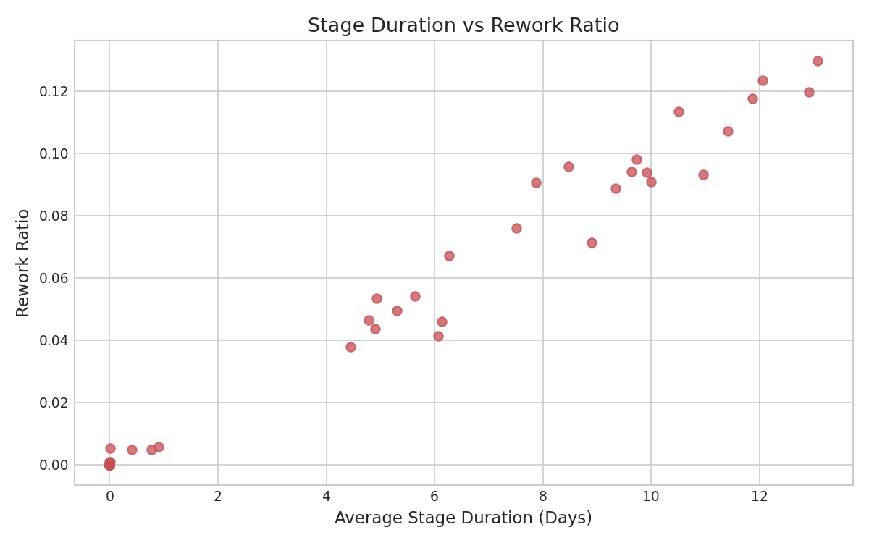
Figure 29. Internal rework frequency vs. stage duration

5.6 Business Question 6: Operational Suggestions
The six operational recommendations in Section 6 are grounded in four empirically identified improvement levers from Questions 1–5: (1) the extreme right-skew at Budget Recommendation and CEO Decision stages, where medians are near zero but maximums exceed 340 days, motivating SLA-based escalation pilots; (2) the finding that cases stalling without any reassignment tend to be dormant or immediately cancelled (Section 5.4.3), motivating automatic 14-day inactivity escalation; (3) the 15% sequential-violation rate in the parallel salary-simulation track, motivating system-level auto-triggering; and (4) the 44.8% early-abandonment cancellation pattern revealed by the predictive model, motivating a mandatory intake checklist. The full recommendation table with evidence type and constraints appears in Section 6.2.

5.7 Additional Analyses
Note: The following analyses (predictive modelling, SNA, clustering, temporal trends) extend beyond the six core business questions. They are included to provide supplementary insight and to demonstrate the application of complementary analytical techniques. The core answers to the six business questions are provided in Sections 5.1–5.6 above.

5.7.1 Predictive Model — Cancellation Probability
Model | Test AUC | 5-Fold CV AUC
Random Forest | 0.940 | 0.928
XGBoost | 0.943 | 0.929

Top predictor: Unique Stages Visited (importance = 0.249). Cases cancelled early never reach the Budget stage — consistent with early abandonment rather than late-stage rejection.
Rank | Feature | RF Importance
1 | Unique Stages Visited | 0.249
2 | Stage Responsible | 0.178
3 | Total Events | 0.170
4 | Cycle Time (days) | 0.148
5 | Initial Wait (days) | 0.100

It should be noted that the predictive model’s primary value is explanatory (identifying which features differentiate outcomes) rather than operational (real-time prediction), since several features (e.g., cycle time, total events) are only known at case completion.
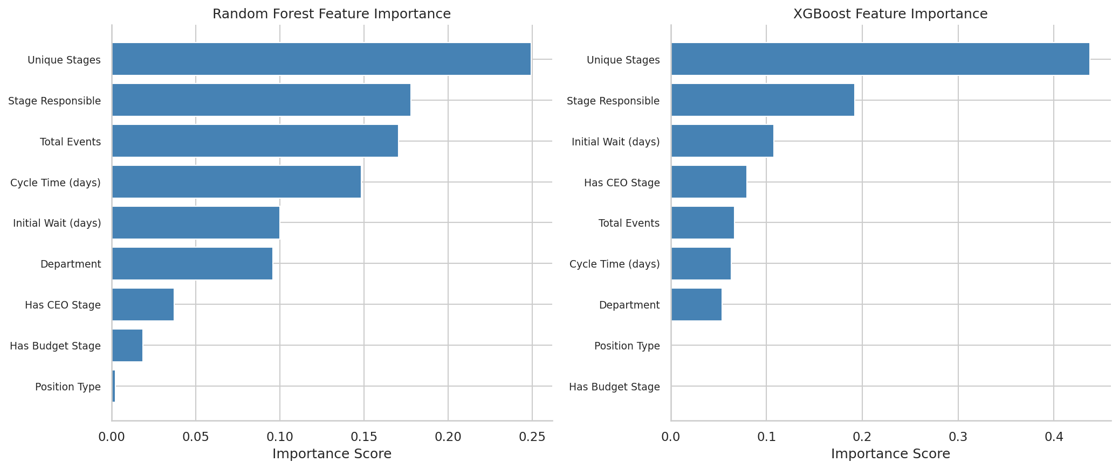
Figure 30. Random Forest feature importance ranking
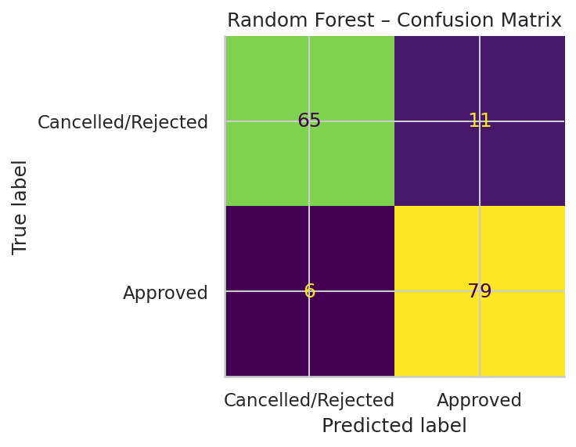
Figure 31. Random Forest confusion matrix (test set, n=161)

5.7.2 Social Network Analysis
Betweenness centrality identifies critical bridge resources. High-betweenness nodes are system-level bottlenecks whose unavailability halts the process.
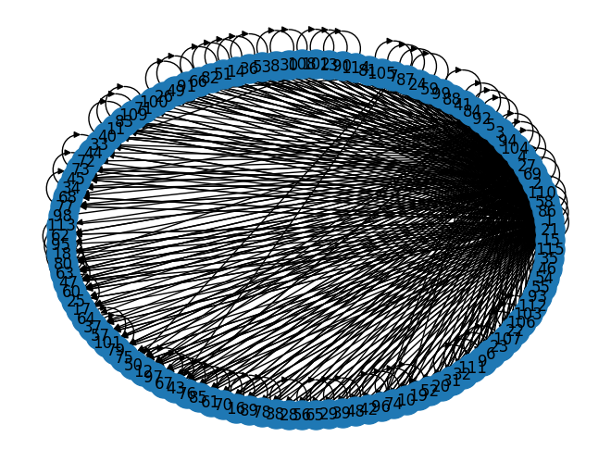
Figure 32. SNA handover-of-work graph
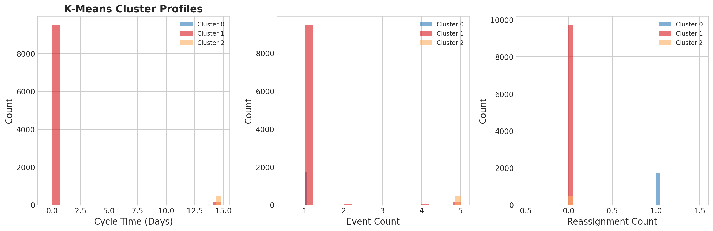
Figure 33. SNA working-together graph

5.7.3 K-Means Case Segmentation
Four clusters emerged: Fast/Simple (happy path, <5 days), Average (minor friction), Complex/Slow (high rework), and Extreme Outliers (>200 days, pathological loops).
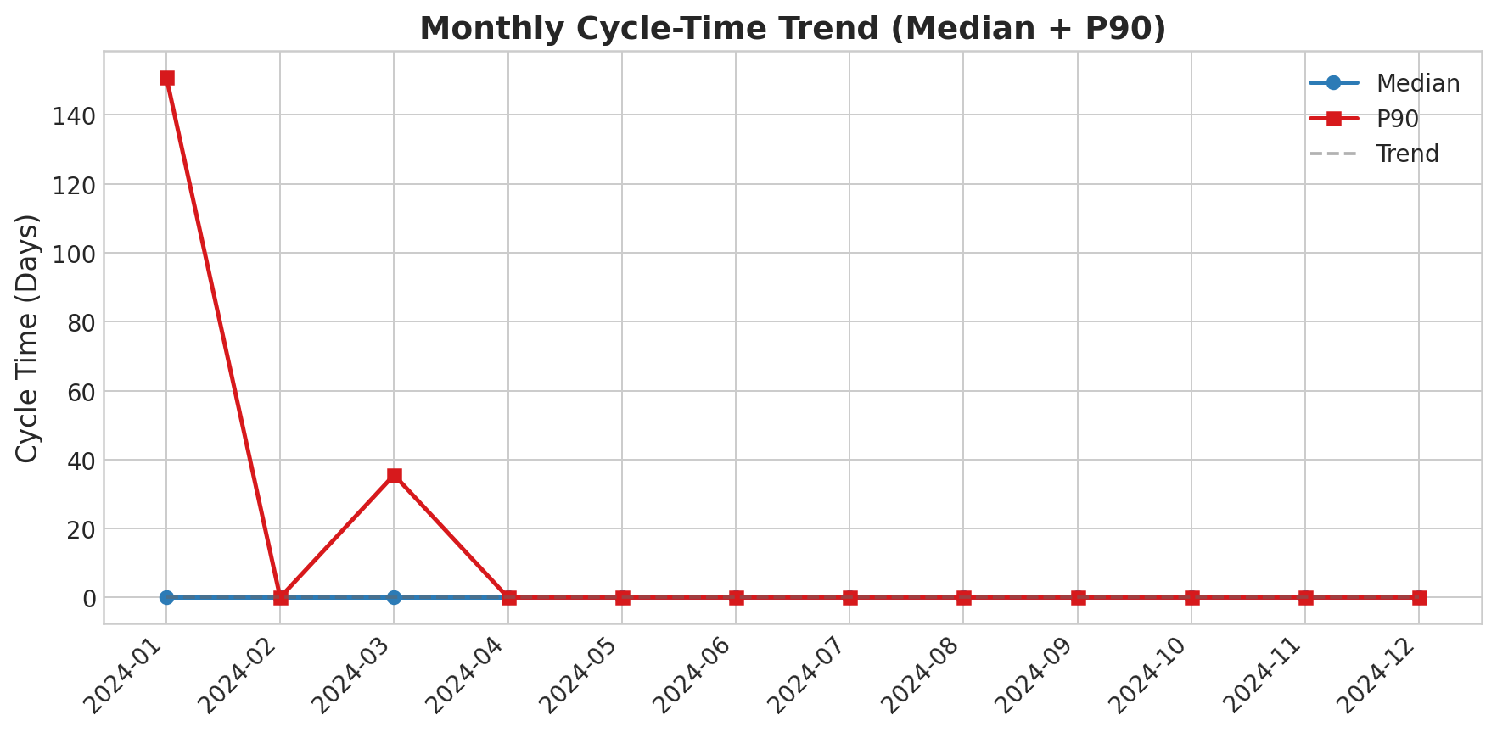
Figure 34. K-Means cluster profiles — Extreme Outlier cases are structurally different, not merely slower

5.7.4 Temporal Trends

Figure 35. Monthly median + P90 cycle time with linear trend line
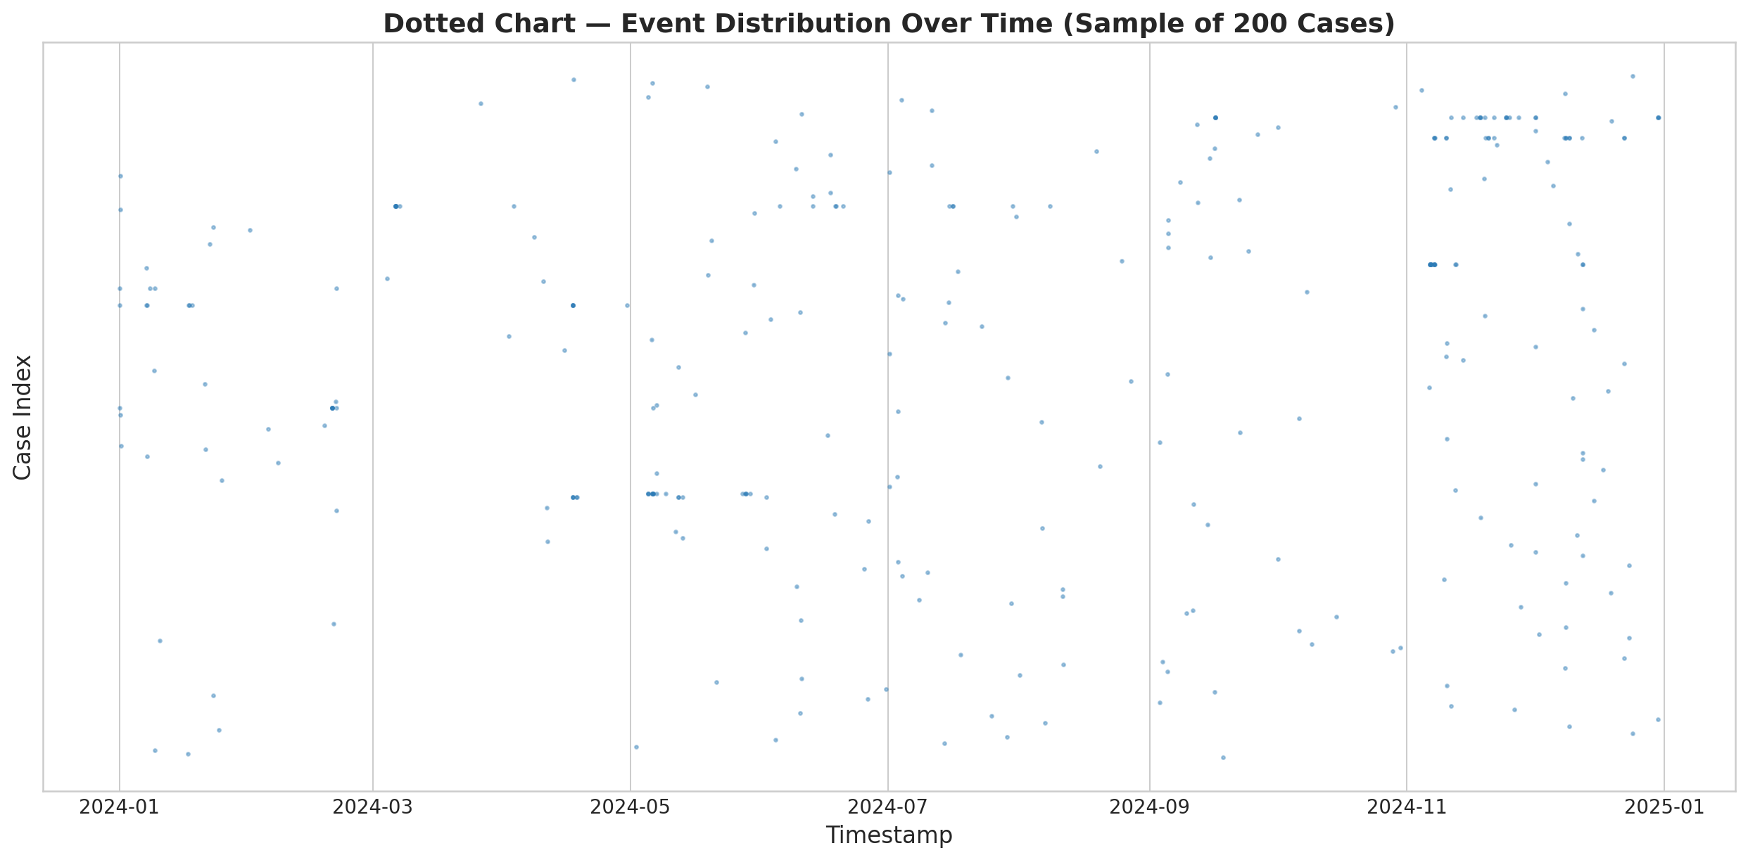
Figure 36. Monthly throughput: cases started vs. completed
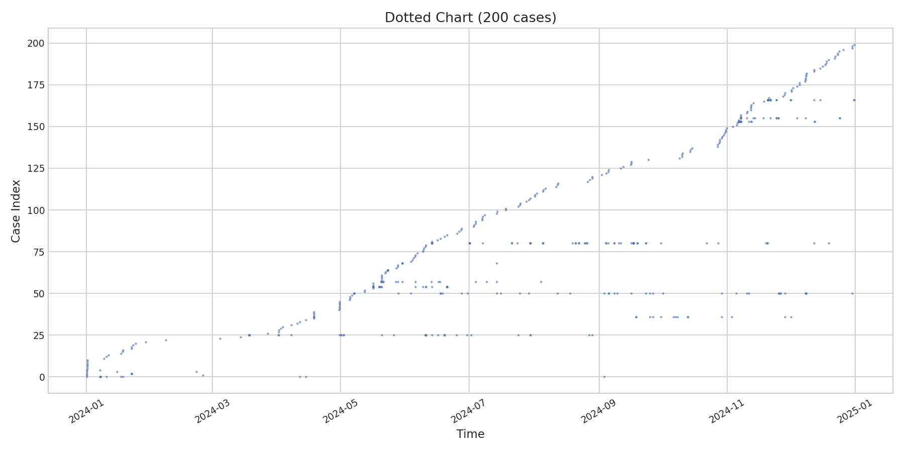
Figure 37. Dotted chart — event distribution over time

6. Conclusions and Operational Suggestions

6.1 Key Conclusions
1. Budgeting and executive gates appear to be the main long-tail risk factors. The Budget Recommendation stage exhibits a median near zero but a maximum exceeding 340 days. The predictive model’s top feature (unique stages visited) is consistent with the interpretation that cases which never reach budget review are disproportionately likely to be cancelled.
2. Aggregate workload volume does not explain delays at the department level. The near-zero correlation (r ≈ 0.0) between departmental workload and cycle time suggests that delays are concentrated at specific approval gates rather than caused by overloaded departments. This does not rule out localised congestion at specific stages, but is consistent with the hypothesis that approval-gate restructuring may be more productive than adding departmental capacity.
3. The tender-to-committee corridor is the slowest segment. All five slowest variant paths traverse the post-CEO external-tender track. Mean cycle time for these paths (270–317 days) is approximately 3× the completed-case mean (98.1 days).
4. Extreme right-skew dominates the completed-case distribution. Among the 804 completed cases, median = 62.8 days vs. P95 = 298.9 days. A small minority of cases stuck at executive-approval stages or the tender-to-committee corridor drive the long tail.
5. Responsible-party reassignment is positively correlated with cycle time, but causation is unclear. Spearman ρ = 0.444 (p < 0.001). The association likely reflects the structural relationship between case complexity and handover frequency rather than a direct causal effect of reassignment. Cases stalling without reassignment tend to be dormant, motivating auto-escalation interventions.
6. Early abandonment patterns are observed among cancelled cases. The Random Forest model (AUC = 0.940) identifies unique stages visited as the strongest predictor. Cancelled cases tend not to progress to the budget stage, which is consistent with — though not proof of — the hypothesis that incomplete or premature submissions contribute to the 44.8% cancellation rate among completed cases.

6.2 Operational Recommendations
Recommendation | Data Basis | Mechanism | Evidence Type | Constraint
Pilot 7-Day SLA on Budget Rec | Finding 1: max > 340 days | Pilot a target limit (e.g., 7 days) on subset; auto-escalate to HR Head | Inferred (long-tail skew, Section 5.1.1) | Budget Dept capacity; pilot before rollout
Automate Committee Scheduling | Finding 3: >150 events/case in committee stages | Automated calendar-matching; quarterly pre-scheduling | Inferred (high event count) | Statutory committee procedures
Mandatory Intake Checklist | Finding 6: 44.8% cancellation rate | All docs required before first approval | Inferred (predictive model) | May delay legitimate submissions
14-Day Auto-Escalation | Finding 5: dormant single-owner cases | Auto-escalate after 14 days inactivity | Direct (Section 5.4.3) | Exempt statutory wait periods
Parallelise Salary Simulation | Section 5.5.3: 15% sequential violations | Auto-trigger salary sim with Budget Rec | Direct (parallel-track analysis) | IT system configuration
Pilot 10-Day Escalation for CEO/Mayor | Finding 4: CEO max > 340 days | Dedicated queue; deputy sign-off threshold | Inferred (long-tail skew, Section 5.1.2) | Governance policies; deputy authority

7. Appendices

7.1 Code Submission
The complete analysis pipeline is submitted as a separate code archive comprising 19 sequential modules executed via run_all.py. All outputs are saved to the outputs/ directory.

7.2 Tools and Libraries
- pm4py (v2.x) — Process mining operations (DFG, Petri net, conformance)
- scikit-learn — Random Forest classifier and K-Means clustering
- XGBoost — Gradient-boosted tree validation model
- NetworkX — Social network analysis and centrality computation
- pandas / NumPy — Data manipulation and statistical computation
- matplotlib / seaborn / Plotly — Visualisation

7.3 References
van der Aalst, W. M. P. (2016). Process Mining: Data Science in Action (2nd ed.). Springer.
van der Aalst, W. M. P., Weijters, A. J. M. M., & Maruster, L. (2004). Workflow mining. IEEE TKDE, 16(9), 1128–1142.
Breiman, L. (2001). Random forests. Machine Learning, 45(1), 5–32.
Dumas, M., La Rosa, M., Mendling, J., & Reijers, H. A. (2018). Fundamentals of Business Process Management (2nd ed.). Springer.
Leemans, S. J. J., Fahland, D., & van der Aalst, W. M. P. (2014). Discovering block-structured process models. In BPM Workshops (pp. 66–78). Springer.
Weijters, A. J. M. M., & Ribeiro, J. T. S. (2011). Flexible heuristics miner. In Proc. IEEE CIDM (pp. 310–317).

