**Computer Graphics Project Report**

|  |  |
| --- | --- |
| **Name** | **ID** |
| Ali Mohamed Ali | 1190223 |
| Amr Yasser Salah El-Din | 1190380 |
| Omar Atef Ahmed | 4200338 |
| Yomna Osama Hussein | 1190203 |

**Contributions:**

|  |  |  |  |  |
| --- | --- | --- | --- | --- |
| Members | Ali | Amr | Omar | Yomna |
| Requirements in phase 1 | 1, 4, 7, 9, 10, 11 | 1, 2, 5, 6, 8, 9, 10, 11 | 3, 4, 7, 10, 11 | 1, 5, 6, 8, 10, 11 |
| Phase 2 | Game Logic | Lights | Game Logic | Lights |

In phase 2, all of us have contributed almost equally to all the parts of the project; we started by understanding what we needed to do to implement lighting in our game. Later on, we realized it was taking far too long for all the members to work on it. So, Amr and Yomna started working more on the lighting process, while Ali and Omar worked on the game design, logic, and working on finding the suitable objects, sky background, and post processing effects to make the game more appealing and coherent.

# Menu State

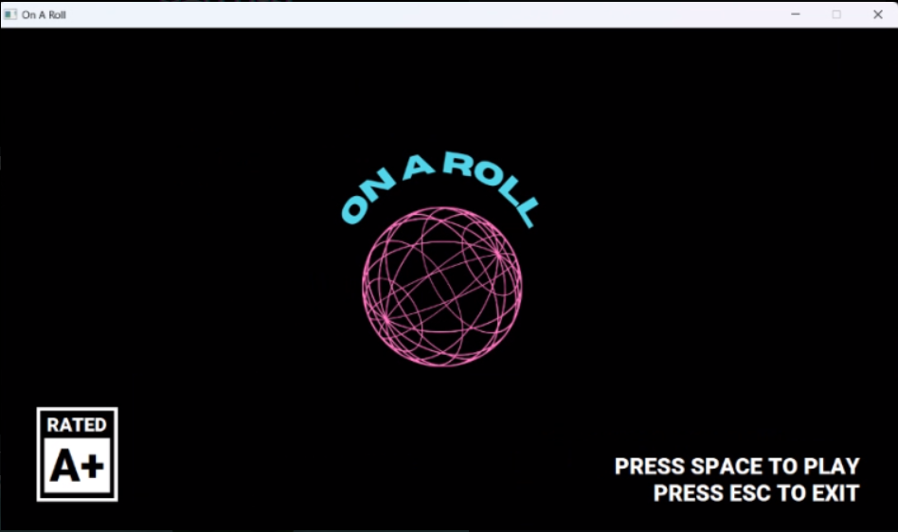

# https://cdn.discordapp.com/attachments/830550741709094982/1058938906885763184/image.pngStart of the game

# Start of the game with post-processing effect (plus tinting)

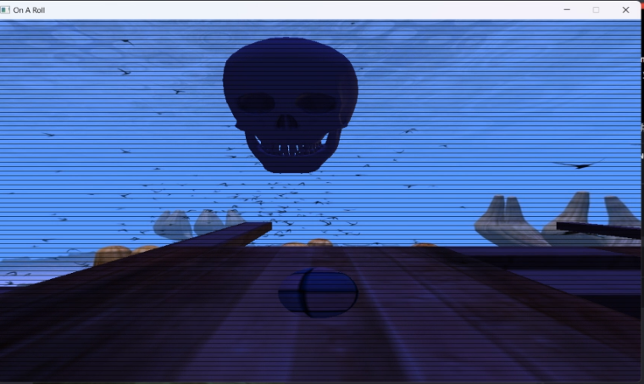

# Start of the game with post-processing effect (no tinting)

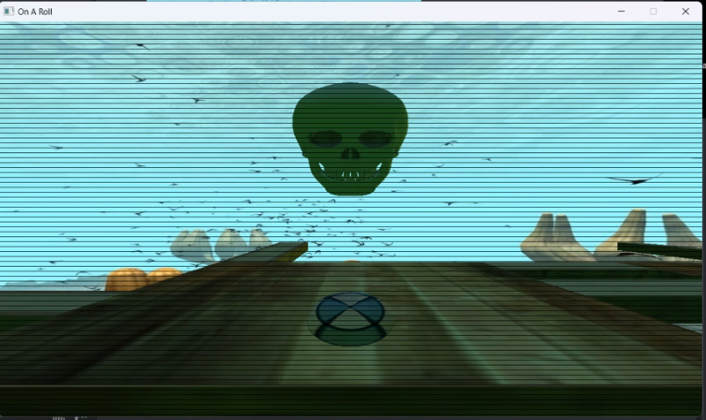

# An emissive object indicating the direction you took is incorrect

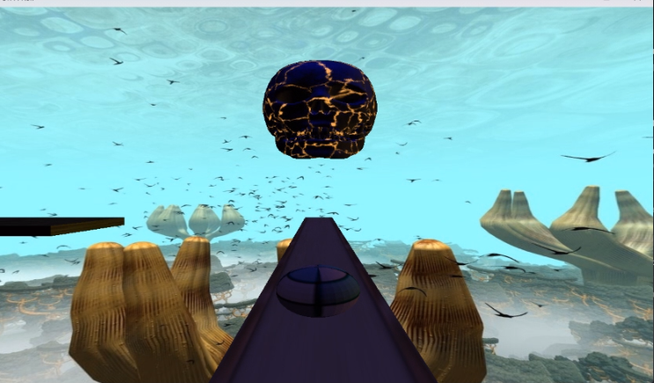

# Moving to the statue triggers the win state

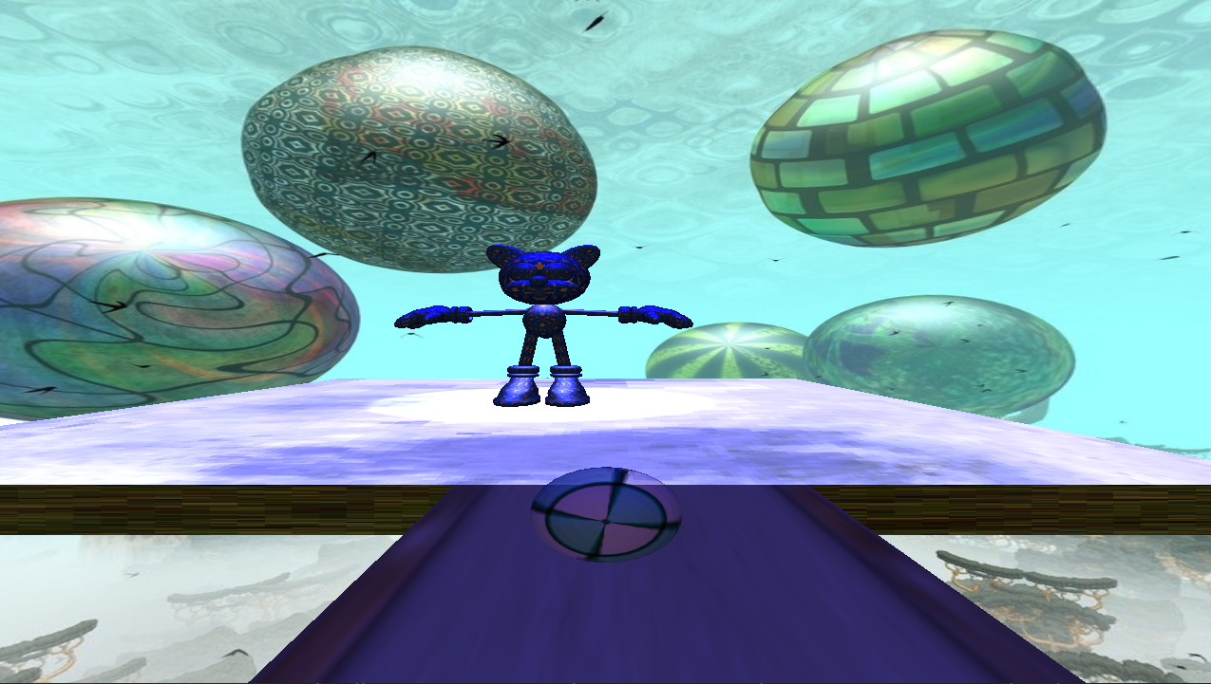

# Win State is triggered

