EDUMS
UNIVERSITY OF ENGINEERING AND TECHNOLOGY, LAHORE
Education Management System
CSC-104L Database Systems Lab

Group DBS25F014
2024-CS-186 Muhammad Farhan Ali
2024-CS-212 Ali Hassaan
2024-CS-217 Amaan Sabir

Submitted To : Sir Nazeef Ul Haq
Section : D
Overview

Description
This project is made to tackle problems of students and teachers in an educational institute to tackle their problems. It involves solving problems of students and teachers and effectively managing their courses and assessments and results. It focuses on effective educational system to provide ease to both teacher and student to manage a course. This project is selected as final project for DB course as it includes many functionalities that covers our course. It will help students and teachers to easily use the application. Based on the user each one is provided a different interface to solve their desired queries and to perform specific tasks. In this teacher are assigned course or can ask for a course and then the student enrolls in that course and is graded by the teacher and so on and at the end his result is taken out. This application helps to manage the education system more easily in a more effective way.

Business Case
This application can be used by educational institutes to manage their students and teachers and course management to enforce smooth workflow in the institute and easily help the institute and the users to manage their data.

Motivation
Our educational website eduko motivated us to create an application version of it to replace the paperwork and other system to digital application system just like eduko. This motivated us to create EDUMS to counter education management issues just like eduko.

Audience
It targets teachers and students of educational institutes for easy education and course management and effective education.

Features
- User Friendly UI
- Easy Account Handling
- Student Attendance
- Course Management
- Maintains Results of Students
- Manage Student Assessments
- Easy Lecture Management
- Generate PDF reports by Admin

Technology Stack
Following technologies are used in this application

Platform | Desktop
Language | C#
Database | MySQL Database
Additional Packages | Krypton Forms for UI and ODBC for connection with database for reports

Wireframes/Use Cases

- Login Page

Name | Login Page
Actor | User
Description | User Logins into the application according to his role and when he logs in the interface is shown to him according to his role and based on student, teacher or admin he can perform different functionalities and this is the page which decides which interface to show based on user and his role. Otherwise in case of incorrect user it doesn’t log in.
UI

- Assessment by Course

Name | Student Assessment by Course Page
Actor | User (Student)
Description | The student can submit Assessments/Assignments according to the course. He can submit the assignment assigned of a particular course using the easy interface of EDUMS application.
UI

- Mark Attendance

Name | Teacher Mark Attendance
Actor | User (Teacher)
Description | The teacher can easily mark attendance of a student in an enrolled course and mark him present or absent based on the status of student in the class.
UI

- User Management

Name | Admin User Management
Actor | User (Admin)
Description | The admin can add users and delete and update them and also view them by role in the grid view given in the side. Admin will have the control to add other admins and teachers as well as students.
UI

- Attendance Report
Name | Attendance Report
Actor | User (Admin)
Description | The admin can view the attendance of students and can generate a report of it for based on course and lecture. This helps the admin to view attendance of students in an easy way.
UI And
PDF Report

- Teacher Report
Name | Teacher Report
Actor | User (Admin)
Description | To see all the teachers in the system the admin can generate a report of all the teachers in the system and can see the teachers registered in the education system.
UI And
PDF Report

- Student Enrollment Report

Name | Student Report
Actor | User (Admin)
Description | The admin can view the students enrolled in a course and can generate a report of the students enrolled in the course.
UI And
PDF Report
Database Design

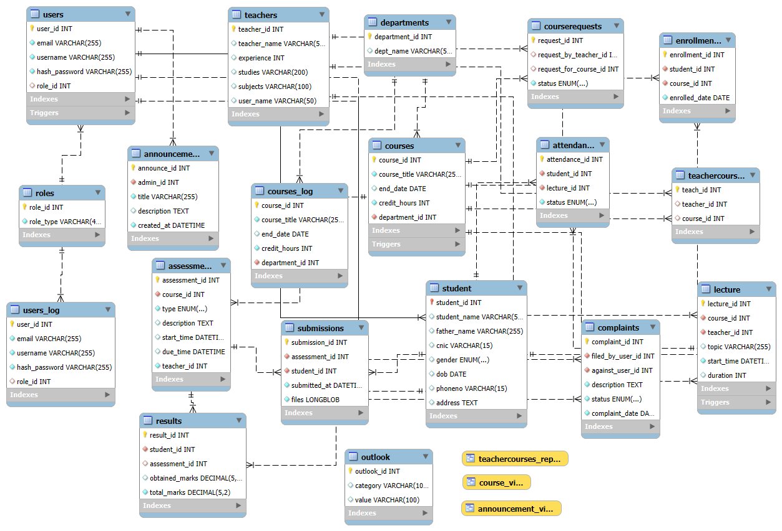

Tables in database

- announcements
- assessments
- attendance
- complaints
- courserequests
- courses
- departments
- enrollments
- lecture
- outlook
- results
- roles
- student
- submissions
- teachercourses
- teachers
- users

ERD

Users of Application

- Student: The student will be the main goal of this application as this mostly revolves around the user as he will be the one to enroll in courses and submit assignments and take lectures and son on.
- Teacher: The teacher will be the main supporting character as he will be the one who will create assignments and grade the student and teach a course.
- Admin: Admin will be the character managing the application as adding departments and new courses and managing both teacher and students. He will create reports and will have key role in the application.

Functional Requirements

 | As a | I want to perform | So that I can
1 | Student | Create an account  Log into his account  Register into a course  Take lectures  Submit assignments  See results  File complaints  See Announcements  View attendance | To use the app  To see student interface  To access that course  To learn  To get grades  To see the results of assignments  To complain against any issue  To see any notifications  To view his running attendance
2 | Teacher | Create an account  Log into his account  Request Course  Manage Assignments  Manage Lectures  See Announcements  Make Results | To use the app  To see teacher interface  To teach a course  To give assignments to student  To give lectures to student  To view notifications  To grade the student
3 | Admin | Create an account  Log into his account  Manage courses  Manage Departments  Manage Announcements  See Attendance, Teacher, student, Complaint, Result reports | To use the app  To see admin interface  To create courses  To manage departments  To create announcements  To view reports of different kinds

Data Structures

- Lists: Lists are used for storing objects as well as name of some attributes in some tables to extract ID from them.
- Data Sources: Data sources have been used for combo boxes and grid views.

Classes

