PROJECT 1 REPORT
Robotic Arm Kinematics & Path Planning
Simulated Inverse Kinematics, ROS2/MoveIt2 Motion Planning, and Collision-Aware Trajectory Execution
Prepared by | Ali Hassan
Internship | DecodeLabs — Robotics & Automation (Batch 2026)
Week | Week 1 of 4
Environment | Windows 10 + WSL2 (Ubuntu 22.04) + ROS2 Humble
Tools Used | ROS2 Humble, RViz2, MoveIt2, colcon

1. Introduction
This report documents the completion of Project 1 of the DecodeLabs Robotics & Automation internship: Robotic Arm Kinematics & Path Planning. The objective of this project was to program a simulated 6-axis robotic arm capable of moving accurately from a starting configuration to a target position without colliding with objects in its environment, using Inverse Kinematics (IK) to calculate joint angles and a motion-planning pipeline to generate a smooth, collision-free trajectory.
The project was carried out entirely in simulation using ROS2 Humble, RViz2, and MoveIt2 on a Windows machine via the WSL2 (Windows Subsystem for Linux) environment running Ubuntu 22.04.

2. Objectives
- Set up a complete ROS2 + MoveIt2 development environment from scratch.
- Demonstrate Forward Kinematics by loading and manipulating a 6-axis robotic arm model in RViz.
- Demonstrate Inverse Kinematics by specifying a target end-effector pose and having the system calculate the required joint angles.
- Generate and execute a collision-free trajectory using MoveIt2's motion-planning pipeline.
- Introduce an obstacle into the planning scene and verify that the planner avoids it (collision-aware planning).

3. Environment Setup
Since no Linux machine was available, the environment was set up using WSL2 on Windows 10. The setup process involved the following stages:
- Enabling WSL2 and installing Ubuntu 22.04 LTS as the Linux distribution.
- Installing ROS2 Humble Desktop (full desktop variant, including RViz2 and demo packages).
- Configuring the locale (en_US.UTF-8) as required by ROS2.
- Adding the official ROS2 apt repository and signing key.
- Installing Gazebo ROS packages, MoveIt2, and the colcon build toolchain.
- Verifying the installation using ROS2's built-in talker/listener demo nodes to confirm inter-node communication was working correctly.
Once the base installation was verified, a ROS2 workspace (~/ros2_ws) was created, and the Universal Robots UR5 description package was cloned into it to build and visualize a 6-axis arm URDF model as a Forward Kinematics reference.

4. Forward Kinematics Demonstration
The UR5 6-axis arm URDF (Unified Robot Description Format) model was loaded into RViz2 using the joint_state_publisher_gui, which provides manual sliders for each of the six joints. Moving these sliders changes each joint angle and the end-effector position updates accordingly in real time — this is a direct, practical demonstration of Forward Kinematics: given a set of joint angles, the end-effector pose is computed deterministically.
This confirmed that the robot model, its joint limits, and its link geometry were all correctly defined and ready for use in motion planning.

5. Inverse Kinematics and Path Planning
For the Inverse Kinematics and motion-planning stage, the MoveIt2 Motion Planning demo (using the standard Franka Panda 7-DOF arm model bundled with MoveIt2) was used, since it provides a complete, ready-to-use IK solver, collision checker, and trajectory planner without additional configuration.
An interactive marker attached to the arm's end-effector was used to specify a target pose. Dragging this marker to a new position and clicking "Plan" triggers the following pipeline:
- MoveIt2's IK solver computes a valid set of joint angles that place the end-effector at the requested target pose.
- The OMPL (Open Motion Planning Library) planning pipeline — using the RRTConnect algorithm — generates a smooth trajectory of intermediate joint configurations between the current state and the goal state.
- The Flexible Collision Library (FCL) checks every intermediate state of the trajectory against the environment and the robot's own geometry for collisions.
- "Execute" then sends the validated trajectory to the simulated joint controllers, which move the arm smoothly along the planned path.
Multiple target poses were tested successfully, with the planner consistently returning valid solutions in well under a second (typical planning time: 0.07–0.15 seconds).

6. Collision-Aware Path Planning
To validate collision avoidance specifically, a box object was added to the planning scene (via the Scene Objects panel) so that it intersected the direct path between the arm's current position and a new target. With "Collision-aware IK" enabled, the planner was required to find a path that kept the entire arm clear of the box at every point along the trajectory, rather than only checking the final goal pose.
Two categories of failures were encountered and resolved during this stage, both instructive for understanding how MoveIt2 validates trajectories:
- Invalid start state: when the obstacle was placed too close to the robot's resting pose, the planner reported the starting configuration itself as being in collision, so no tree could be initialized. This was resolved by repositioning the obstacle further from the robot's base.
- Invalid intermediate states: even with a valid start and goal, the planner rejected a full trajectory in one instance because several waypoints near the target end-effector (panda_hand) still intersected the box. This confirmed that MoveIt2 checks the entire path — not just the endpoints — for collisions.
After adjusting the obstacle's position, a valid collision-free plan was found and executed successfully, with the arm visibly routing around the box rather than passing through it.

7. Results
The screenshots below show the Panda arm in RViz2/MoveIt2 with the green obstacle box in the scene and the interactive IK marker used to define the target pose. Across the trials shown here and additional trials performed during testing, the planner consistently found valid, collision-free trajectories and executed them successfully.
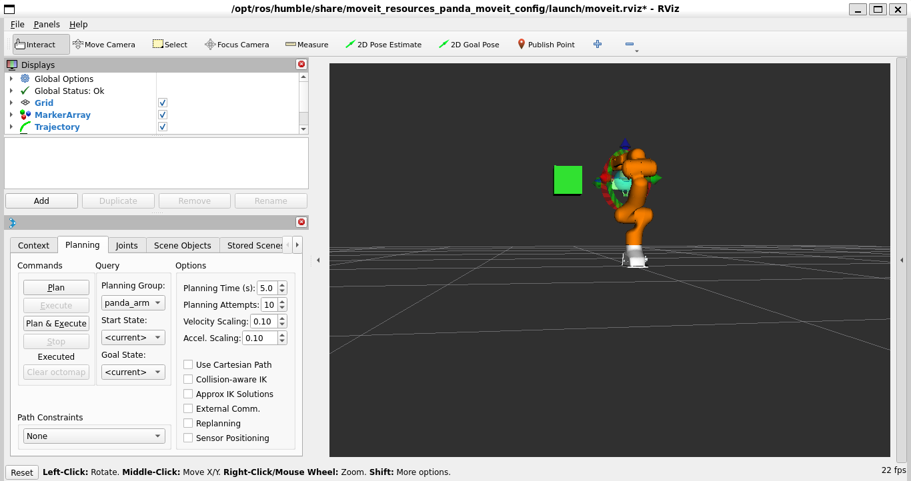
Figure 1 — Panda arm and IK marker positioned near the obstacle box, prior to planning.
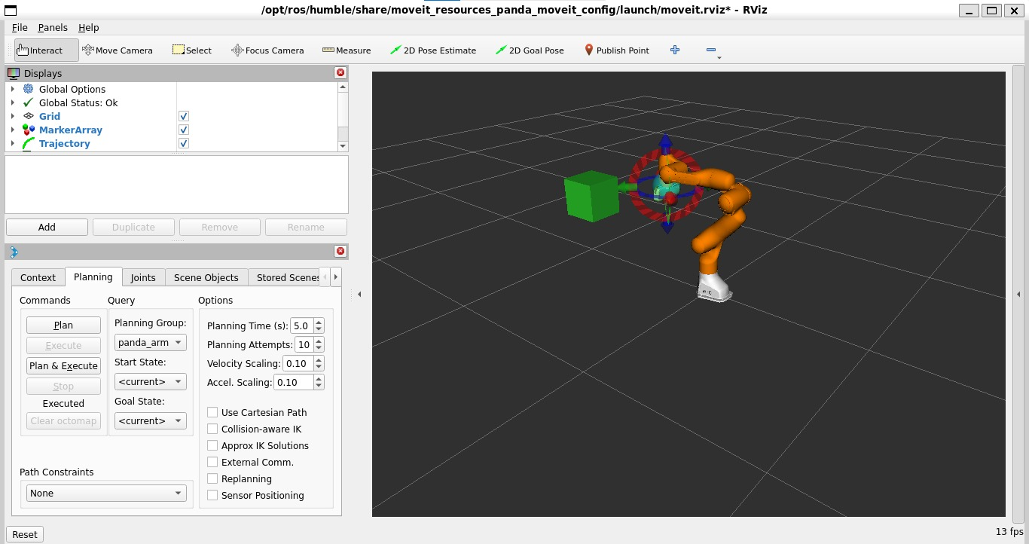
Figure 2 — Target pose set on the opposite side of the obstacle; interactive marker (rings/arrows) visible at the goal.
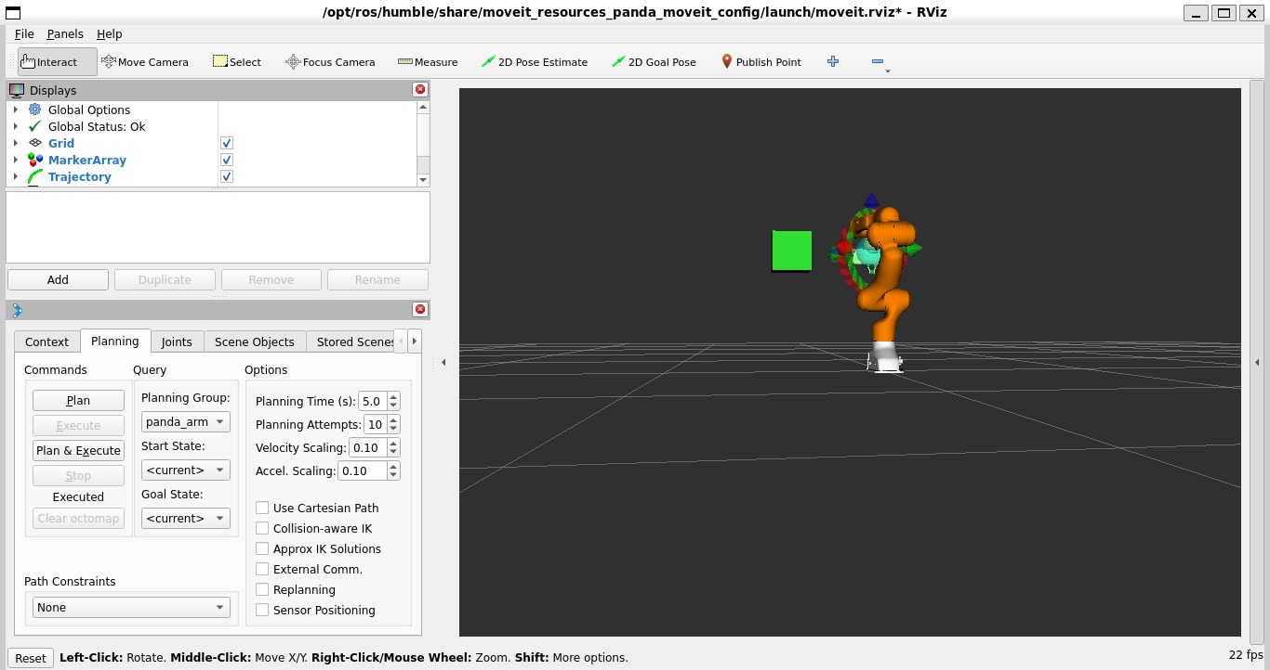
Figure 3 — Successful plan executed; the arm reaches the target while the obstacle remains un-collided.

8. Challenges and Solutions
Challenge | Resolution
No Linux machine available | Installed WSL2 with Ubuntu 22.04 on Windows 10 as the working environment.
Terminal copy-paste not working | Switched from the legacy console host to Windows Terminal, which supports Ctrl+V paste.
colcon command not found immediately after install | Package was installed correctly but not yet registered in the current shell session; resolved by opening a fresh terminal.
ur_controllers / ur_robot_driver build failures | These packages target real UR hardware and were unnecessary for simulation; excluded from the build using COLCON_IGNORE, and the ready-made MoveIt2 Panda demo was used instead for IK/planning.
"Invalid start state" during planning | Caused by the obstacle box overlapping the robot's resting pose; fixed by repositioning the obstacle further from the base.
Plan succeeded but Execute reported a timeout | WSLg's simulated clock made execution appear slower than the monitored threshold; resolved by launching with trajectory_execution.execution_duration_monitoring:=false.

9. Note on Scope: Gazebo Physics Simulation
The project brief lists Gazebo physics simulation (gravity, contact dynamics, PID-controlled joint execution) alongside RViz for validating the trajectory. Within the one-week timeframe for this milestone, the work completed focused on RViz2 and MoveIt2: IK solving, OMPL-based trajectory planning, and FCL-based collision checking, all of which were demonstrated and verified successfully. Full Gazebo integration (URDF transmission tags, ros2_control hardware interfaces, and PID gain tuning) is recognised as the next logical extension of this work and is proposed as future scope.

10. Conclusion
This project successfully demonstrated the core computational pipeline behind robotic motion planning: translating a 3D target pose into joint-space commands through Inverse Kinematics, validating those commands against the robot's own geometry and its environment through collision checking, and executing a smooth, collision-free trajectory. Along the way, a complete ROS2/MoveIt2 development environment was built from the ground up on Windows via WSL2, and several real-world build and runtime issues were diagnosed and resolved. This foundation — a working ROS2 workspace, a validated 6-axis arm model, and a functioning MoveIt2 planning pipeline — directly supports the remaining three weeks of the DecodeLabs Robotics & Automation internship.

