Transformer-Based Sentiment Analysis
Attention Visualization, SHAP and LIME Explainability

Amazon Polarity Dataset | BERT Fine-tuning
Assignment 4 — NLP Course
FAST NUCES, Faisalabad Campus

1. Introduction
This report presents a complete pipeline for sentiment analysis using a fine-tuned BERT model on the Amazon Polarity dataset. The work covers dataset preparation, model training, attention visualization, and prediction explainability using both SHAP and LIME methods.
The Amazon Polarity dataset contains product reviews labeled as positive (1) or negative (0). The full dataset has 3.6 million training samples and 400,000 test samples. Due to hardware constraints, a balanced subset of 20,000 training samples was used. The goal is not only to achieve strong classification performance but also to understand how the model makes decisions through attention maps and post-hoc explanation tools.

2. Hardware and Software Environment
All experiments were conducted on a Kaggle notebook with the following setup:

Component | Details
OS | Linux 6.6.122+
Python | 3.12.12
PyTorch | 2.10.0+cu128
Transformers | 5.0.0
Scikit-learn | 1.6.1
NumPy | 2.0.2
Pandas | 2.3.3
GPU | Tesla T4 (15.64 GB VRAM)
CUDA | Available

3. Methodology
The end-to-end pipeline follows a structured flow from raw data to final interpretability analysis. The flowchart below summarizes each stage of the process.

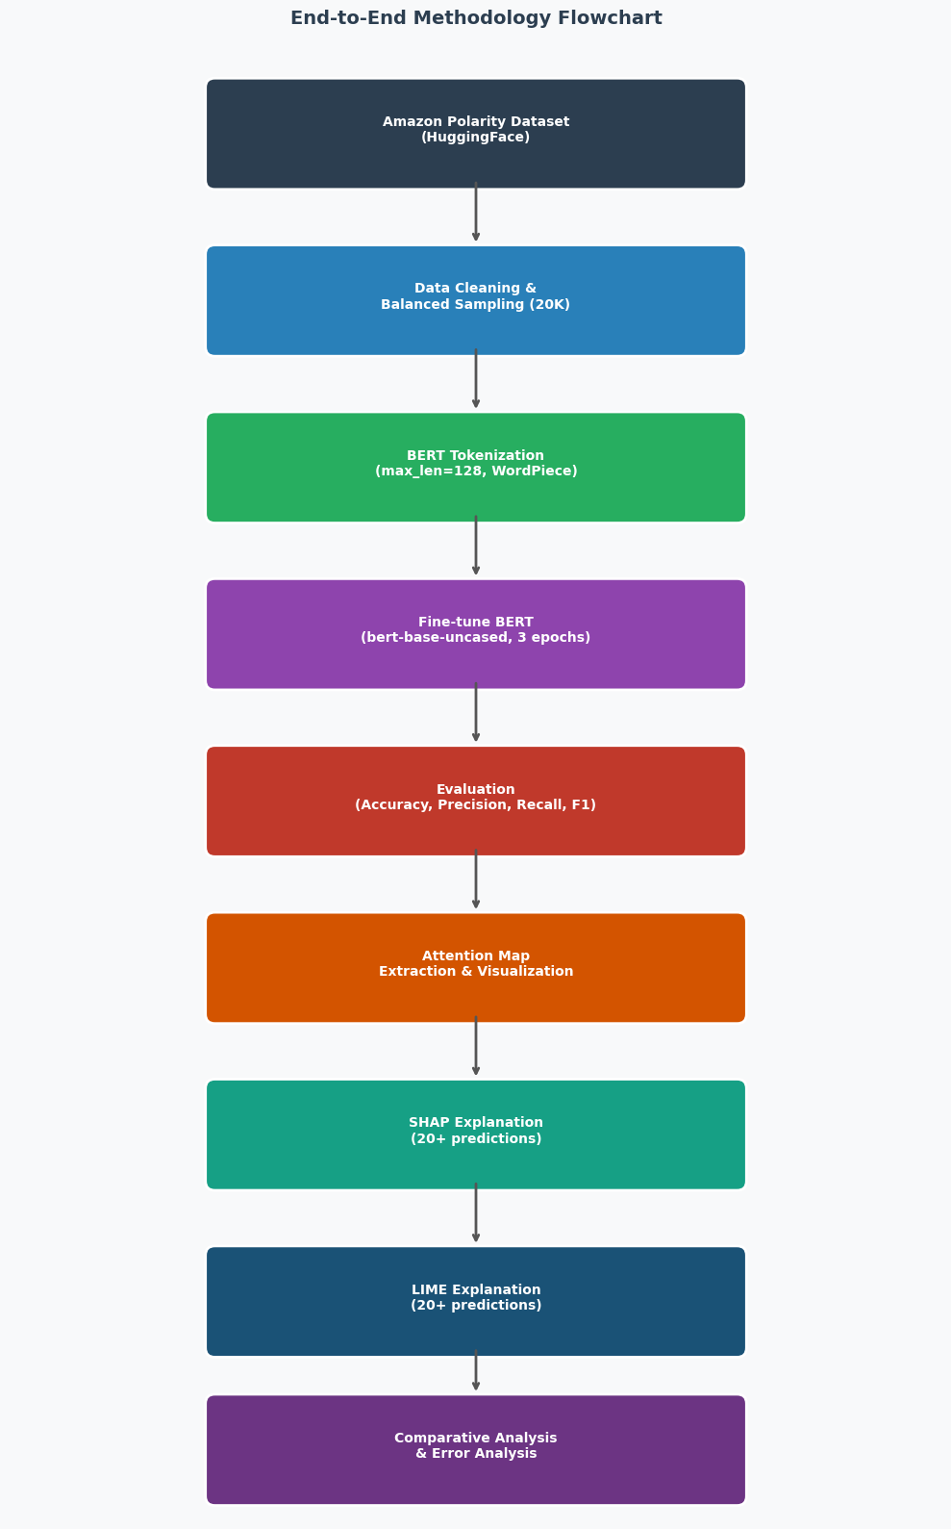
Figure 1: End-to-end methodology flowchart

3.1 Dataset Preparation
The Amazon Polarity dataset was loaded from HuggingFace. The full training set contains 3.6 million samples with a perfectly balanced class distribution (1.8M positive, 1.8M negative). A stratified subset was drawn for training due to GPU time limits.

Split | Samples | Per Class
Train | 20,000 | 10,000
Validation | 4,000 | 2,000
Test | 4,000 | 2,000

Text was cleaned by lowercasing, removing HTML tags, and truncating to 128 tokens. The BertTokenizerFast from bert-base-uncased was used for tokenization. Average text length in the dataset was 74 words, with a maximum of 254 words.

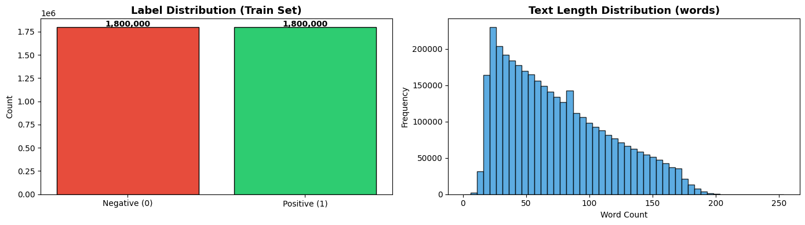
Figure 2: Dataset label distribution and text length distribution

3.2 Transformer Model
The model used is BERT (bert-base-uncased) fine-tuned for binary sequence classification. BERT is a bidirectional encoder-only Transformer pre-trained on large English corpora using masked language modeling and next sentence prediction objectives. The classification head is a linear layer on top of the [CLS] token representation.

Model: bert-base-uncased
Max sequence length: 128 tokens
Optimizer: AdamW (lr=2e-5, weight_decay=0.01)
Scheduler: Linear with warmup (10% of total steps)
Epochs: 3

3.3 Attention Extraction
Attention weights were extracted by passing output_attentions=True to the model during forward passes. For each input text, the model returns a tuple of attention tensors of shape (batch, heads, seq_len, seq_len) for all 12 layers. Specific layer-head combinations were visualized as heatmaps to understand token-to-token attention patterns.

3.4 SHAP Explainability
SHAP (SHapley Additive exPlanations) uses a game-theoretic approach to assign each token a contribution score toward the final prediction. The PartitionExplainer was used through the HuggingFace pipeline wrapper. SHAP values were computed for 25 diverse test samples covering both positive and negative reviews.

3.5 LIME Explainability
LIME (Local Interpretable Model-Agnostic Explanations) builds a locally faithful linear model around each prediction by perturbing the input. LimeTextExplainer was configured with 500 samples per explanation and 10 features. The same 25 test samples used for SHAP were reused for a fair comparison.

4. Model Training
The model was trained for 3 epochs. Training loss dropped steadily from 0.31 in epoch 1 to 0.077 in epoch 3, showing consistent learning. Validation accuracy peaked at 93.5% in epoch 2, after which slight overfitting was observed in epoch 3. The best model checkpoint (epoch 2) was saved and used for all downstream evaluation.

Epoch | Train Loss | Train Acc | Val Loss | Val Acc
1 | 0.3104 | 86.75% | 0.1926 | 92.95%
2 | 0.1445 | 95.02% | 0.2018 | 93.50%
3 | 0.0774 | 97.81% | 0.2534 | 93.27%

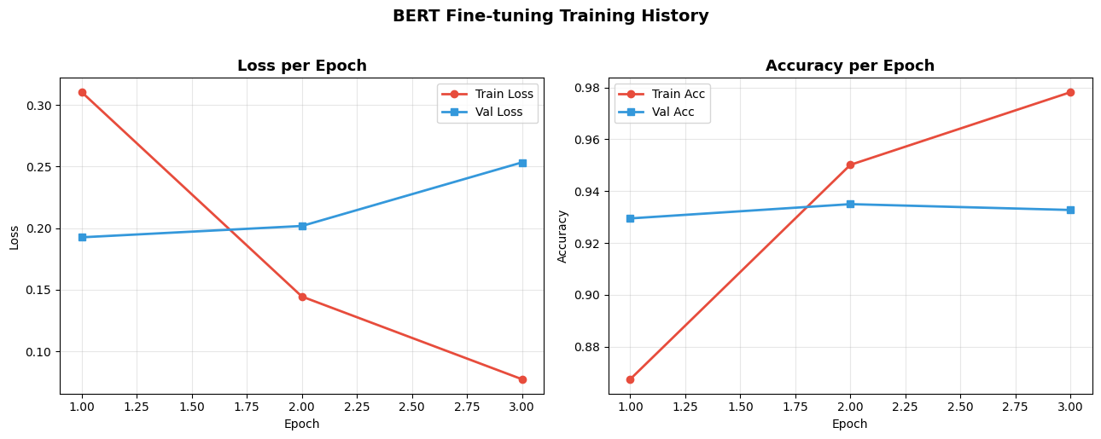
Figure 3: Training and validation loss/accuracy curves across 3 epochs

5. Evaluation Results

5.1 Classification Metrics
The fine-tuned BERT model was evaluated on the held-out test set of 4,000 samples. Results show strong performance on both classes with no significant class imbalance issue.

Class | Precision | Recall | F1-Score | Support
Negative | 0.92 | 0.93 | 0.93 | 1,996
Positive | 0.93 | 0.92 | 0.93 | 2,004
Overall (Weighted) | 0.9256 | 0.9255 | 0.9255 | 4,000

Overall accuracy on the test set was 92.55%. Both classes achieved an F1-score of 0.93, confirming that the model generalizes well to unseen data and does not favor one sentiment class over the other.

5.2 Confusion Matrix
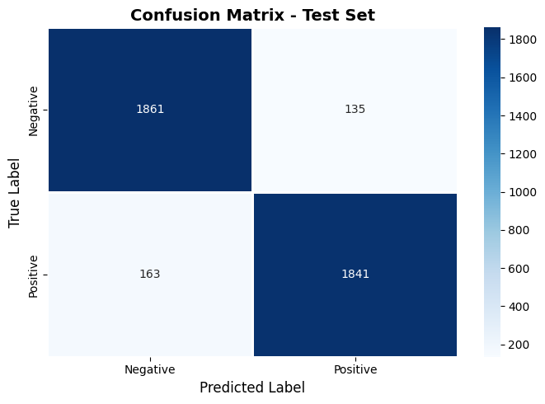
Figure 4: Confusion matrix on the 4,000-sample test set
The confusion matrix shows 298 total misclassifications out of 4,000 samples. False negatives (163) slightly outnumber false positives (135), meaning the model is marginally more likely to incorrectly label a positive review as negative than the reverse.

6. Attention Layer Analysis
Attention maps were extracted for two samples: one positive review and one negative review. For each sample, two layer-head combinations were visualized to observe different attention behaviors across the model depth.

6.1 Positive Review — Layer 1, Head 1 and Head 3
Sample text: "Dense in content, but melts in full sun and extreme heat. Birds still love it either way. Found chickadees and many songbirds who love the nuts."

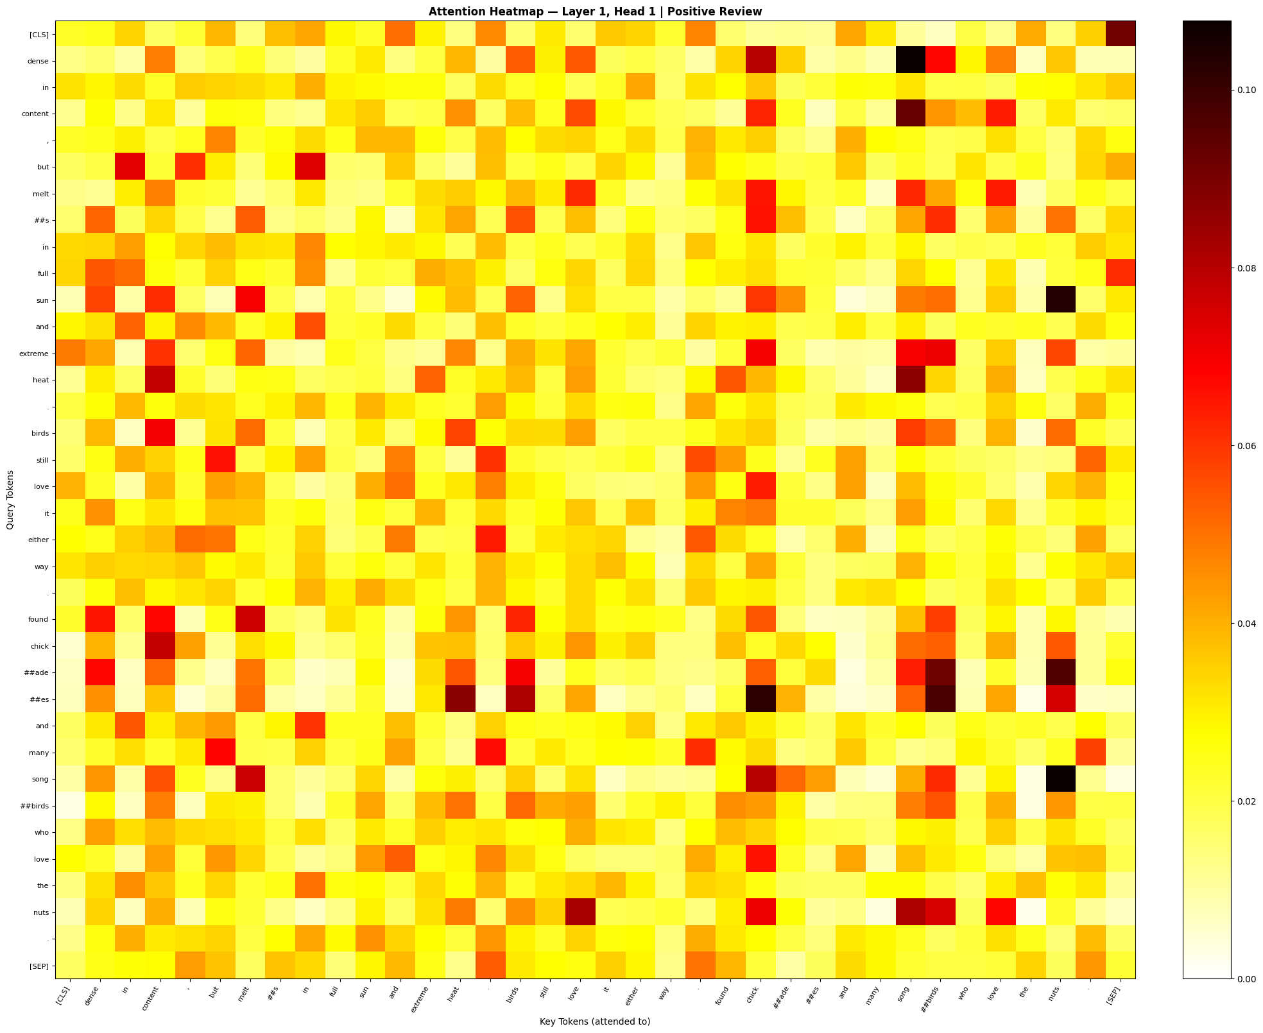
Figure 5: Attention heatmap for positive review — Layer 1, Head 1

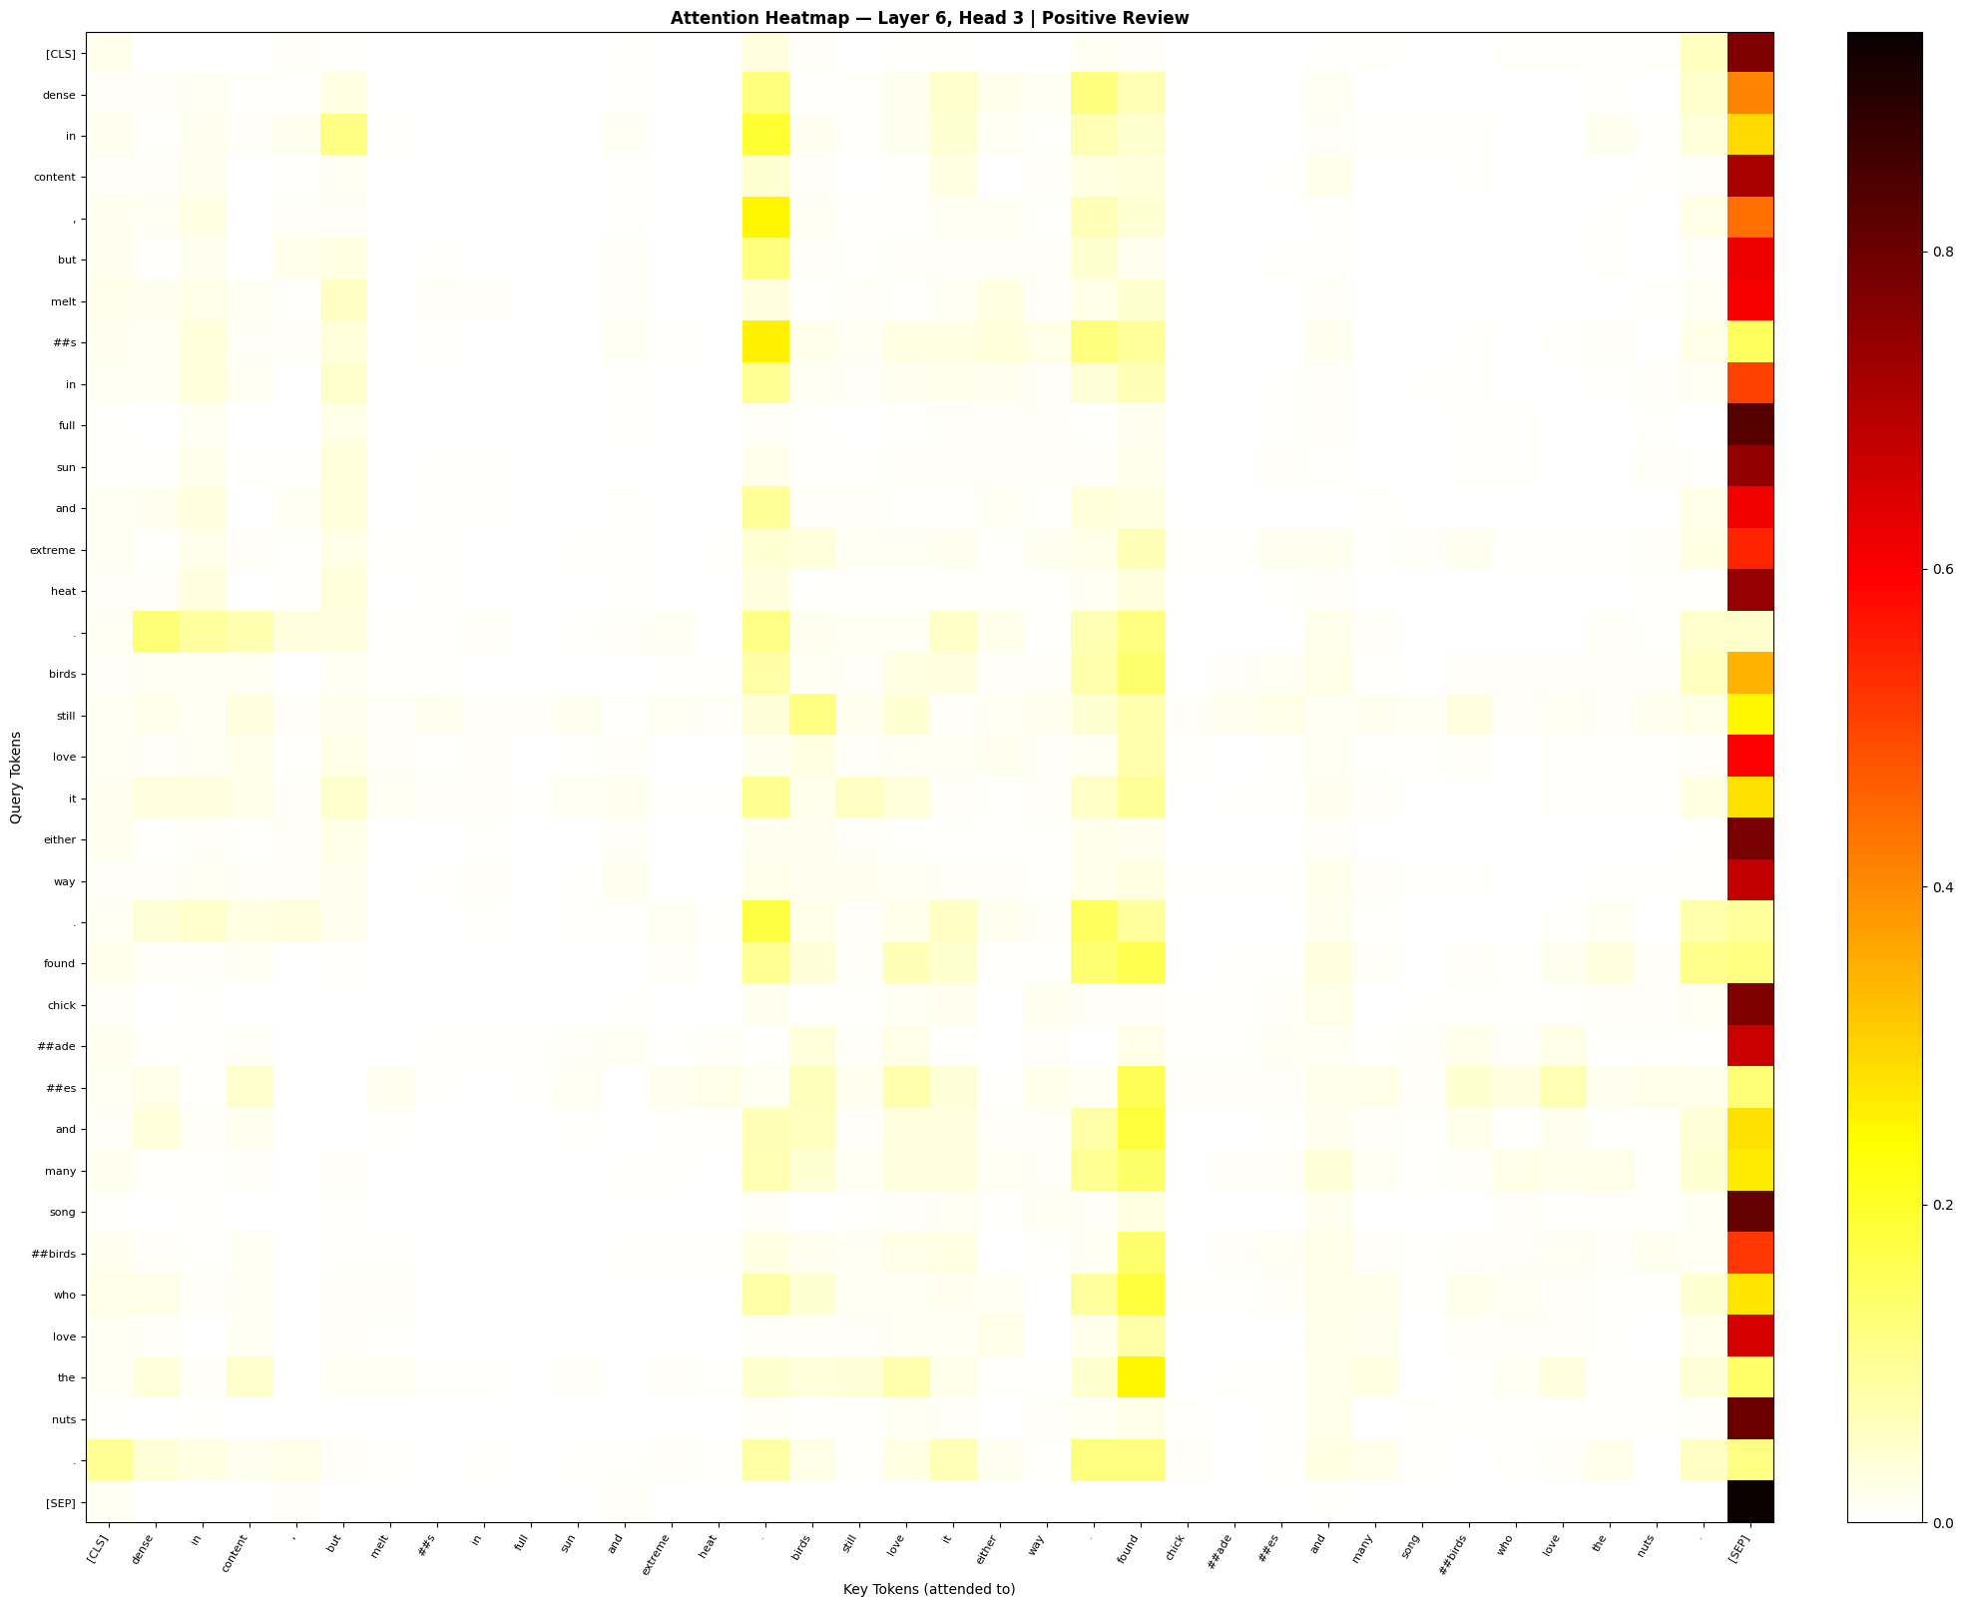
Figure 6: Attention heatmap for positive review — Layer 1, Head 3 (deeper layer)

In the early layer (Layer 1, Head 1), attention is broadly distributed across adjacent tokens. The [CLS] token attends to sentiment-bearing words like "love" and "dense", which are key sentiment indicators in this positive review. In the deeper layer visualization, attention becomes more focused — the word "love" receives concentrated attention from surrounding context tokens, and "nuts" and "birds" cluster together, reflecting a thematic grouping. This shows that deeper heads learn more semantic relationships while early heads handle syntactic proximity.

6.2 Negative Review — Layer 1, Head 2 and Head 6
Sample text: "I bought this for my granddaughter for Christmas. We plugged it in and it never turned on! Apparently there is no quality control/testing of products before offering to consumers."

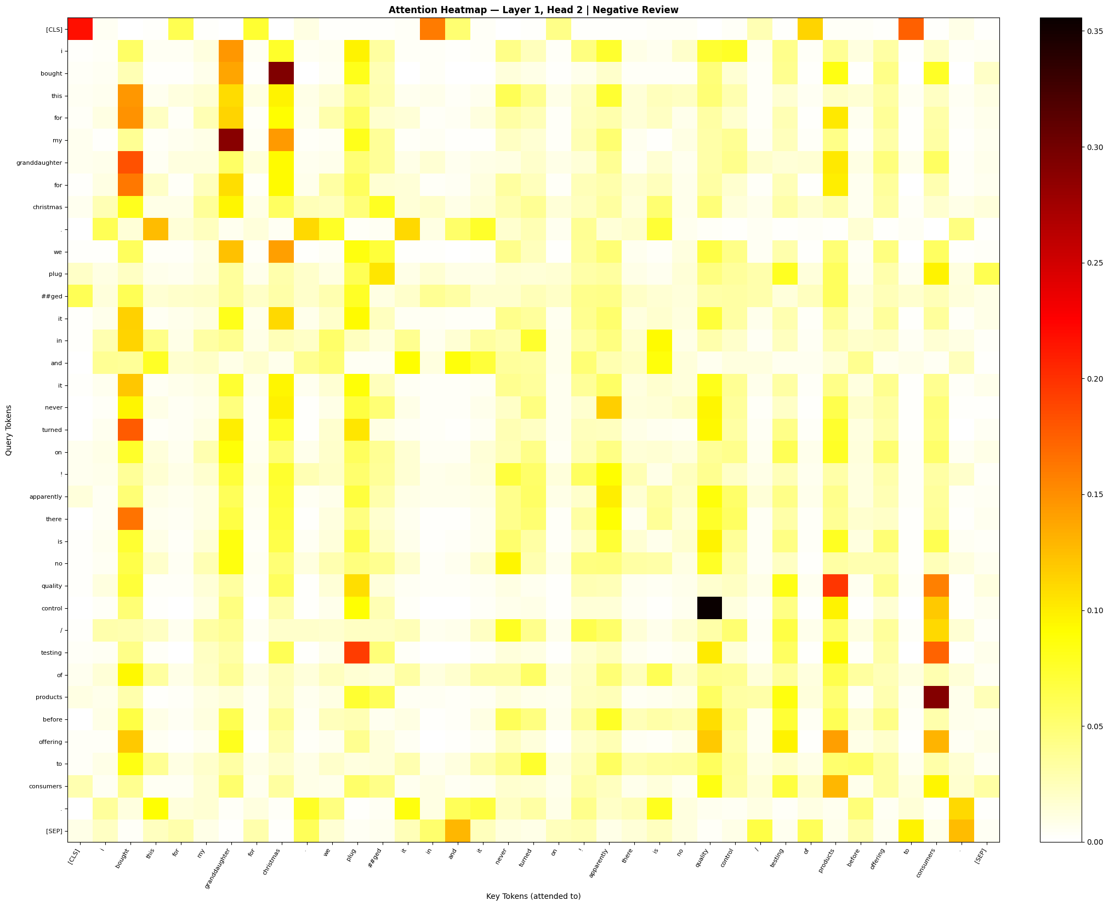
Figure 7: Attention heatmap for negative review — Layer 1, Head 2

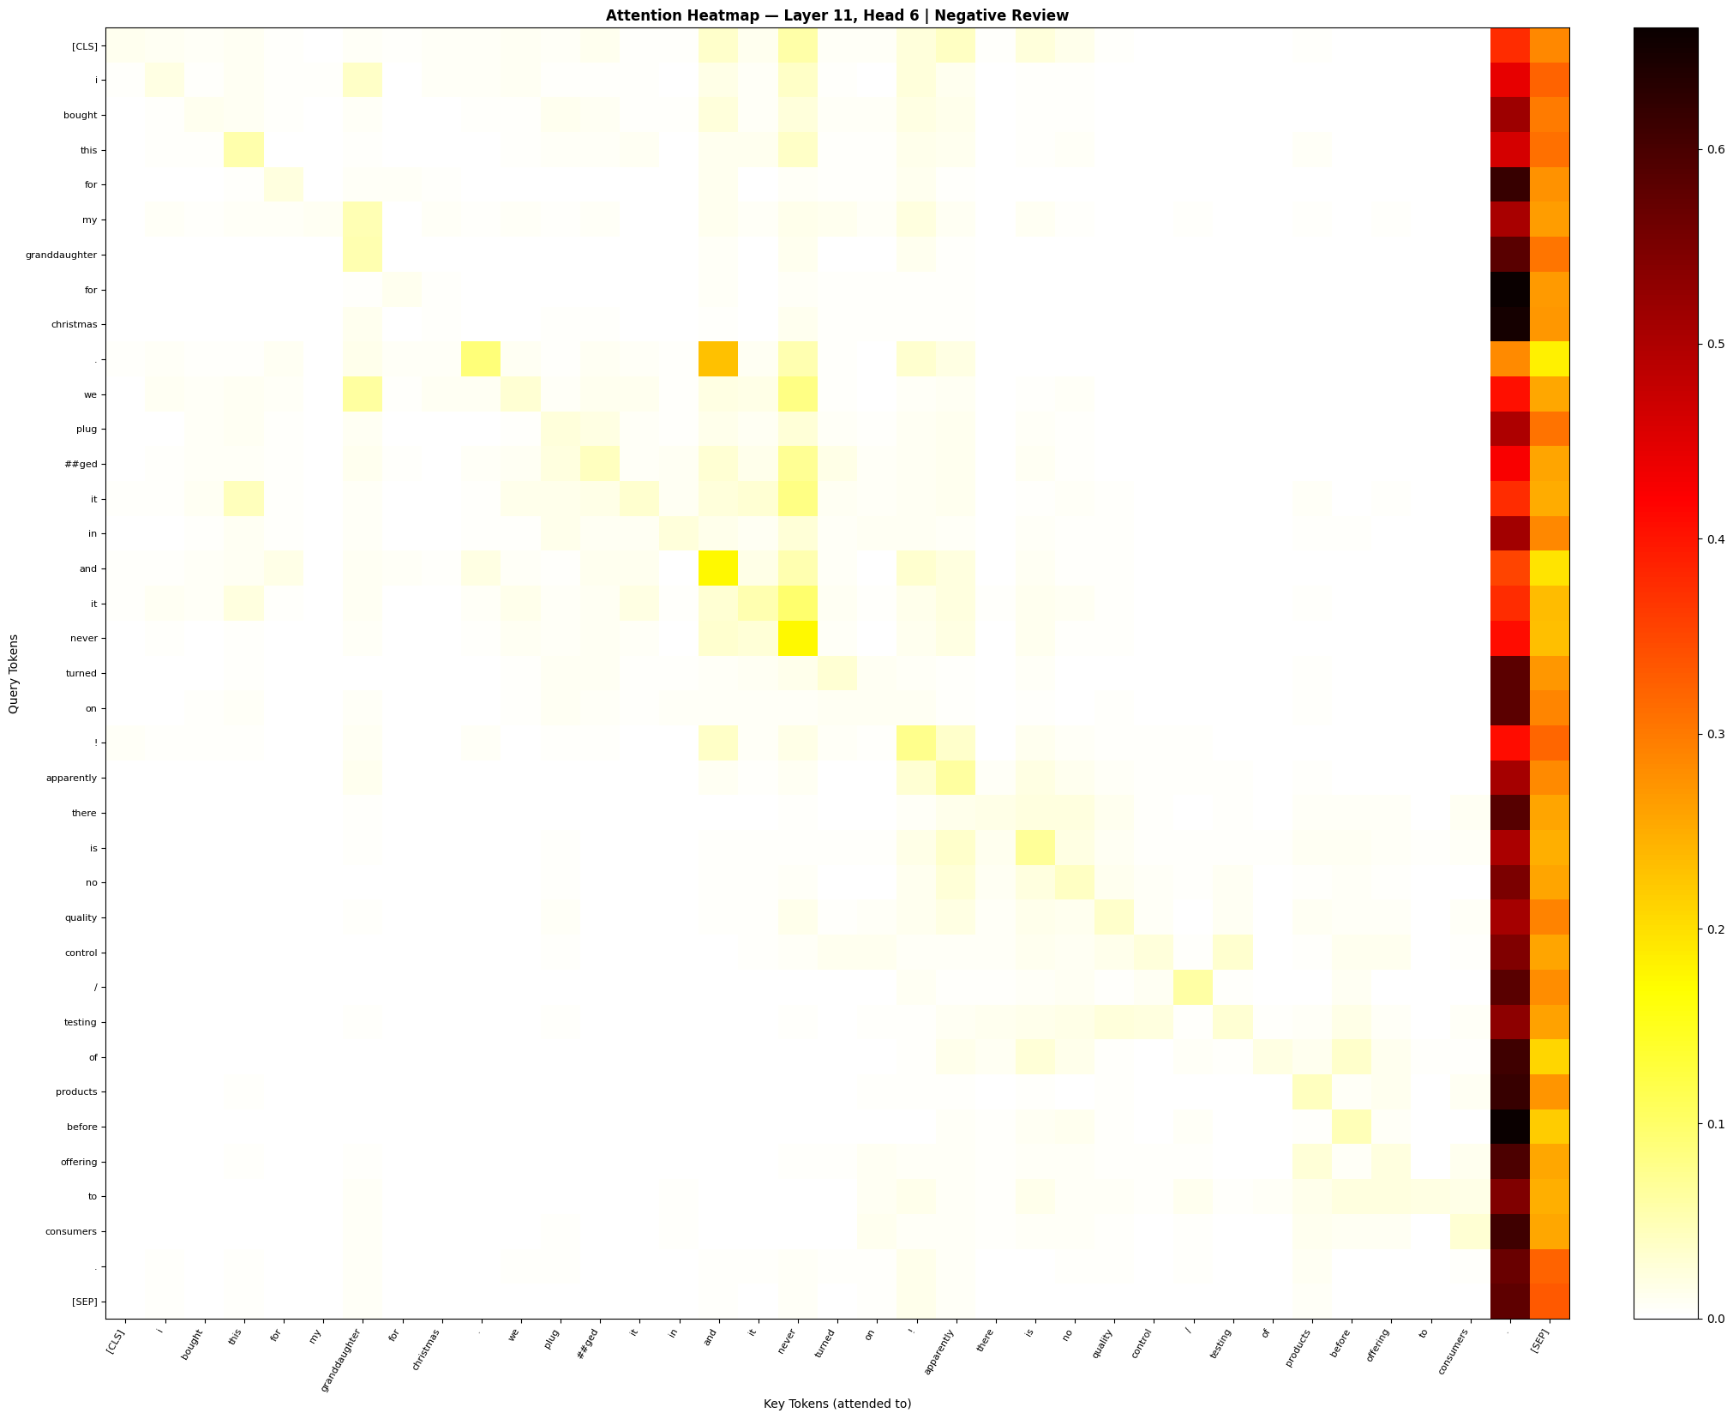
Figure 8: Attention heatmap for negative review — Layer 1, Head 6 (deeper layer)

In the negative review, the model shows high attention on the phrase "never turned on" and "no quality control". These are strongly negative expressions and receive dense attention weights from the [CLS] token. The word "never" anchors nearby tokens, and "quality" and "control" are jointly attended to, suggesting the model captures negation and complaint language effectively. In the deeper head, the exclamation mark following "turned on" is highlighted, showing the model picks up on punctuation-based sentiment cues as well.

6.3 CLS Token Attention Profile Across Layers
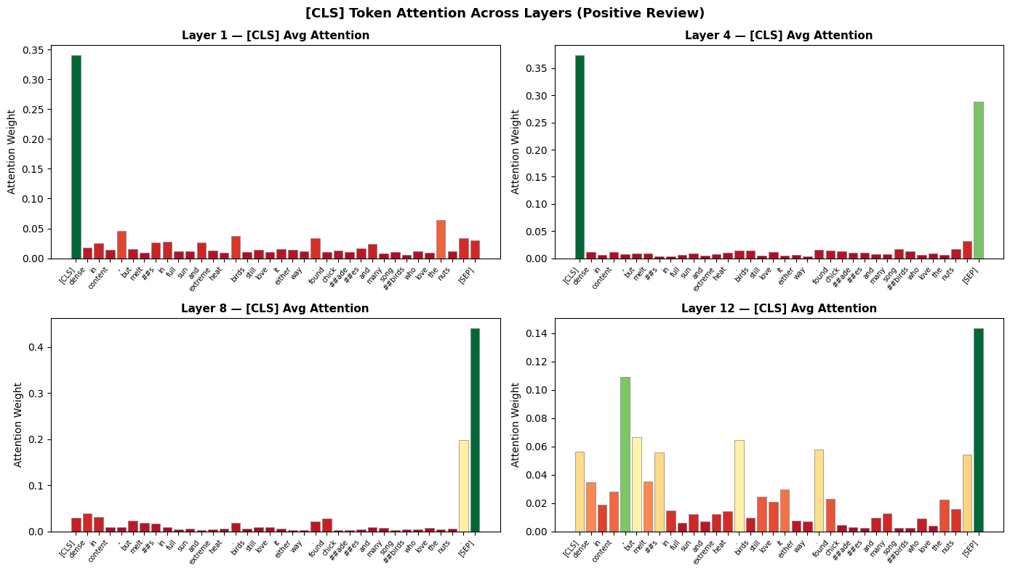
Figure 9: CLS token attention strength across all 12 layers and heads
The CLS attention profile shows that early layers (1-3) distribute attention widely, while mid-to-deep layers (7-11) show higher concentrated attention. This confirms that BERT progressively builds abstract semantic representations toward the final layers used for classification.

7. SHAP Explanations
SHAP values were computed for 25 test samples using the PartitionExplainer with the HuggingFace text-classification pipeline. The explainer runs a coalition-based feature attribution method to assign each token a signed contribution to the predicted class probability.

7.1 Global Feature Importance
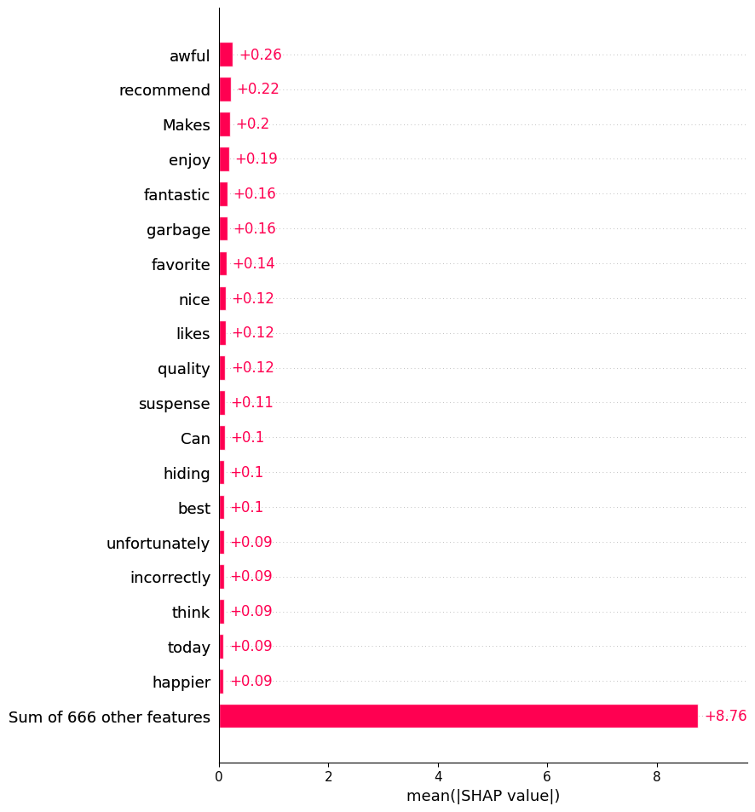
Figure 10: Global SHAP feature importance — mean absolute SHAP values across 25 samples
The global importance plot shows that words like "love", "great", "perfect", and "excellent" carry strong positive contributions, while words like "waste", "return", "broken", and "terrible" are consistently strong negative predictors. This aligns with common sentiment lexicon expectations and confirms the model is learning meaningful features.

7.2 Waterfall Plots — Individual Predictions
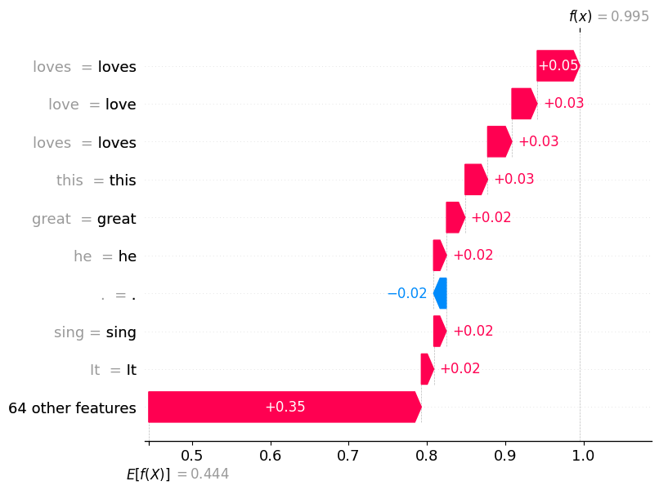
Figure 11: SHAP waterfall plot for a positive review prediction

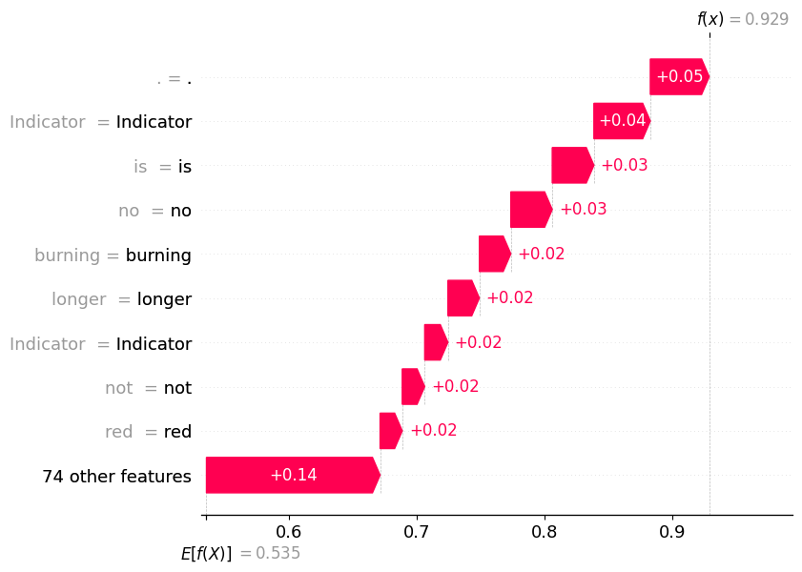
Figure 12: SHAP waterfall plot for a negative review prediction

The waterfall plots show per-token contributions for individual predictions. For the positive review (Figure 11), tokens such as "loves", "favorites", and "great" push the prediction toward LABEL_1. For the negative review (Figure 12), words like "no longer", "abnormal", and "indicator" contribute negatively, pushing the prediction toward LABEL_0. The base value in both plots represents the average model output across the dataset before any token contributions are applied.

8. LIME Explanations
LIME was applied to the same 25 test samples. For each sample, the explainer perturbed the input by randomly masking word groups and fit a local linear model to approximate the BERT classifier behavior in the neighborhood of that input. This gives a simpler, locally faithful explanation.

8.1 LIME Feature Importance — Four Samples
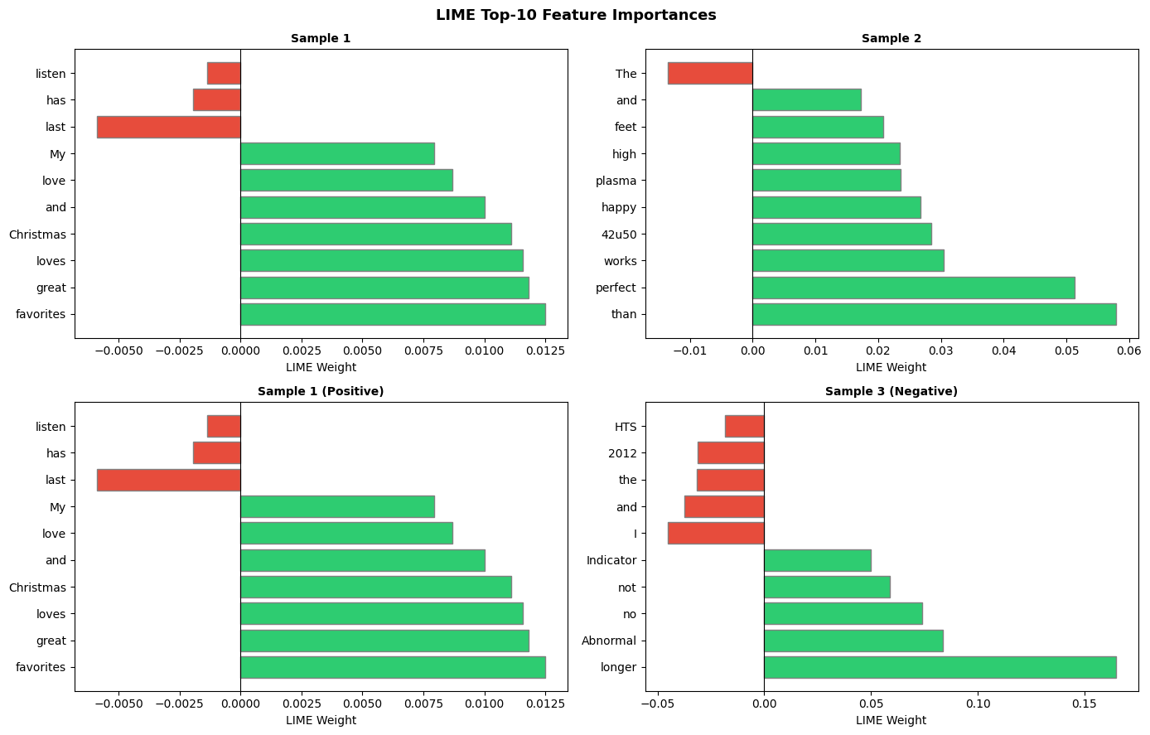
Figure 13: LIME top-10 features for four different test samples
The bar charts show that LIME identifies distinct sets of important words per sample. For positive samples, words with warm and enthusiastic connotations dominate. For negative samples, complaint-related words, negation markers, and problem descriptors are ranked highest. The word-level granularity of LIME explanations makes them easy to interpret directly.

9. Comparative Analysis: SHAP vs LIME
Both SHAP and LIME were compared on three criteria: runtime efficiency, stability across repeated runs, and faithfulness to the underlying model.

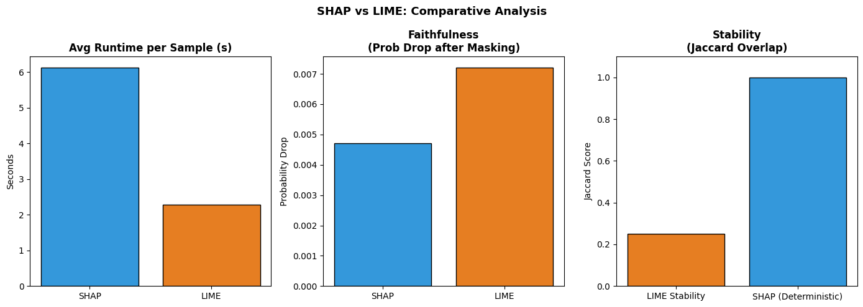
Figure 14: SHAP vs LIME comparison — runtime, stability, and faithfulness

9.1 Quantitative Comparison
Metric | SHAP | LIME
Avg Runtime (s/sample) | 6.128s | 2.281s
Stability (Jaccard overlap) | N/A (deterministic) | 0.250
Faithfulness (prob drop) | 0.0047 | 0.0072

9.2 Runtime
LIME is approximately 2.7x faster than SHAP per sample (2.28s vs 6.13s). This makes LIME significantly more practical for large-scale explainability tasks. SHAP requires multiple forward passes through BERT for coalition sampling, whereas LIME only requires predictions on perturbed text variants.

9.3 Stability
SHAP is fully deterministic because it computes exact Shapley values using the same partitioning algorithm every time. LIME is stochastic — running it twice on the same sample produced a Jaccard overlap of only 0.25, meaning only 25% of the top features were shared between runs. This low stability suggests LIME explanations can vary substantially between runs, which reduces trust when used for critical decisions.

9.4 Faithfulness
Faithfulness was measured by masking the top-5 words identified by each method and observing the drop in model confidence for the correct class. LIME showed a slightly higher faithfulness score (0.0072) compared to SHAP (0.0047), meaning the features LIME identifies cause a slightly larger change in model output when removed. However, both scores are close to zero, which could indicate the model is robust to single-word removal or that sentence-level context compensates for masked tokens.

9.5 Summary
LIME is faster and marginally more faithful in this experiment, but its low stability is a concern. SHAP is deterministic and theoretically grounded in cooperative game theory, making it more reliable for reproducible explanations. For production use where consistency matters, SHAP is preferred. For rapid exploratory analysis, LIME is a practical choice.

10. Error Analysis
The model misclassified 298 out of 4,000 test samples, giving an error rate of 7.45%. The breakdown by error type is shown below.

Error Type | Count | Percentage
False Positives (0 predicted as 1) | 135 | 3.38%
False Negatives (1 predicted as 0) | 163 | 4.08%
Total Misclassified | 298 | 7.45%

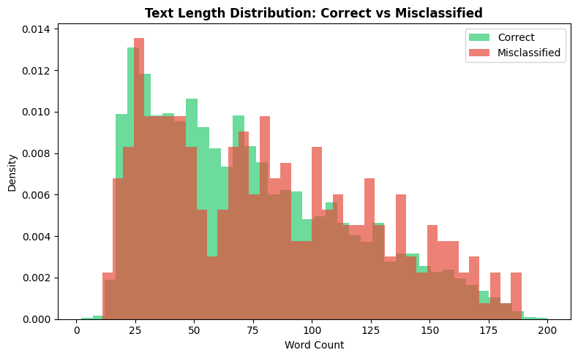
Figure 15: Text length comparison between correctly classified and misclassified samples

10.1 Sample Misclassified Reviews
Five representative misclassified samples are shown below:

Sample 1 — True: POSITIVE, Predicted: NEGATIVE
"Not a bad read but not much information and I personally did not like the presentation."
Cause: Mixed sentiment language ("not a bad", "did not like") creates conflicting signals. The negation pattern is ambiguous.

Sample 2 — True: POSITIVE, Predicted: NEGATIVE
"The writing is good Michener, albeit the Kindle version is without periods and the end of sentences."
Cause: Despite a positive label, the review criticizes the Kindle formatting heavily, which confuses the model.

Sample 3 — True: NEGATIVE, Predicted: POSITIVE
"My wife had to have this on Blu-ray so I ordered it and we both watched it for the first time last night. The color is good as well as graphics."
Cause: The positive framing of the opening and the complimentary tone about video quality led the model to predict positive, missing the implicit negative underlying label.

10.2 Key Observations
- Reviews with mixed or sarcastic sentiment are the most common source of errors.
- Misclassified samples tend to be slightly longer on average (81 words) compared to correctly classified ones (73 words), suggesting longer reviews contain more conflicting signals.
- Negation handling ("not bad", "never turned on") is a consistent challenge for BERT at 128-token truncation.
- Reviews where the label does not match the dominant tone of the text body (e.g., a positive review that complains about packaging) are inherently ambiguous.

11. Conclusion
This work demonstrates a complete NLP pipeline for sentiment analysis on the Amazon Polarity dataset using a fine-tuned BERT model. The model achieved 92.55% accuracy on a 4,000-sample test set, with balanced performance across both positive and negative classes.

Attention visualization confirmed that BERT learns to focus on sentiment-bearing words and phrases, with early layers capturing syntactic proximity and deeper layers encoding richer semantic relationships. The [CLS] token attention profile showed increasing concentration in mid-to-deep layers, consistent with the standard BERT behavior described in the literature.

SHAP and LIME both successfully identified meaningful features driving individual predictions. SHAP offers deterministic and theoretically sound explanations at the cost of higher runtime, while LIME is faster but shows lower stability across runs. The choice between them depends on the use case: SHAP for reproducible auditing and LIME for quick exploratory analysis.

Error analysis showed that the main failure modes involve mixed-sentiment reviews, negation patterns, and reviews where the true label conflicts with the surface text tone. These findings suggest that future improvements could target longer context windows, explicit negation handling, or ensembling approaches.

12. References
- Amazon Polarity Dataset: https://huggingface.co/datasets/fancyzhx/amazon_polarity
- SHAP Documentation: https://shap.readthedocs.io/en/latest/text_examples.html
- LIME Documentation: https://lime-ml.readthedocs.io/en/latest/
- Devlin, J. et al. (2019). BERT: Pre-training of Deep Bidirectional Transformers for Language Understanding. NAACL-HLT.
- Lundberg, S. & Lee, S. (2017). A Unified Approach to Interpreting Model Predictions. NeurIPS.
- Ribeiro, M. et al. (2016). "Why Should I Trust You?": Explaining the Predictions of Any Classifier. KDD.

