**LAB 01**

Name : **Ali Abdo Ali Qasem Humadi** Roll.No:**07**

Class:**IT**

**A. Write matlab code to display following binary images**

**Square, Triangle, Circle**

**1)**

**Circle code:**

**Theory :**

In this question we are using a function in **matlab** to print a binary image that shows circle shape

Initialize the size of Image using **zeros** (gives blank images with specific size as we mentioned ) function and store them in **A variable.**

Nested loop and mathematics operation to determine the radius and draw the image according the radius that passing by the **draw_circle( r )** function.

Using **imshow** function to represent the output image.

**Code :**

%Name:Ali Humadi

%Roll.No:07

function []=draw_circle(r)% declare function with one parameters

A=zeros(512,512);% initialize binary image with size 512*512 using zeros function

%using nested loop to represent the binary image

for i=1:512

for j=1:512

if(((i-256)^2+(j-256)^2)^0.5<=r)% conditions and mathematics operation to determine the radius

A(i,j)=0;%drawing the circle shape with black color

else

A(i,j)=1;%drawing the remaining space of binary image with white color

end

end %end of if statement

end %end of nested loop

imshow(A),title("circle image") % represent the output image using imshow() function

end % end of function

**output:**



**2)**

**Tringle:**

**Theory:**

Firstly weInitialize the size of Image using **zeros**() function and store it in **M variable.**

Using nested loop.to represent binary image shape

Determine a specific size of binary image to draw the **triangle** shape

Using **imshow()** function to represent the output image.

**Code:**

%Name :Ali Humadi

%Roll.No:07

clc;

clear all;

% initialize binary image with size 512*512 using zeros function store it in M

M=zeros(512,512);

%using nested loop to represent the binary image

% declare specific size of that image to draw triangle shape

for i=100:360

for j=100:i

M(i,j)=1;% draw rectangle shape with white color

end

end % end of nested loop

% represent the output image using imshow() function, and add title for it

imshow(M),title("triangle")

**output**



**3)**

**Square:**

**Theory:**

Firstly weInitialize the size of binary Image using **zeros**() function and store it in **A variable.**

Using nested loop.to represent binary image shape

Determine a specific size of binary image to draw the **Square** shape

Using **imshow()** function to represent the output image.

**Code:**

%Name :Ali Humadi

%Roll.No:07

clc;

clear all;

% initialize binary image with size 512*512 using zeros function sote it in A

A=zeros(512,512);

%show the original binary image that we created

figure,imshow(A),title("binary image");

%using nested loop to represent the binary image

% determine specific size (row and columns) to draw the rectangle shape

for i=100:350

for j=100:350

A(i,j)=1;% draw the shape white color

end

end% end of nested loop

% show the output image

figure,imshow(A),title("Square image");



**B. Write matlab code to perform following operations on images**

**Flip Image along horizontal and vertical direction, Enhance quality of a given image by changing brightness of image, Image negation operation, Change contrast of a given Image.**

**1)**

**Flip Image along horizontal and vertical direction**

**Theory:**

In this question we need to **filp** image along with **horizontal** and **vertical** direction

Firstly we read the image from file and store it and **B** variable

We use **subplot function** to get 2*2 matrix to print 4 images in one figure

Print the original image in first part of figure using subplot function

Using nested loop to represent the image

In first part using this logic **a(i,y-j+1)=B(i,j)** to swap between pixels

In first part using this logic **z(x-i+1,j)=B(i,j)**to swap between pixels

Print the output image using **subplot(2,2,2)** and **subplot(2,2,4)using imshow()function.**

**Code:**

%Name :Ali Humadi

%Roll.No:07

clc;

clear all;

% read the image and store it in B

B=imread("cameraman.tif");

% show the orignal image

subplot(2,2,1);

imshow(B),title("orignal image")

% store the image size in 2-D matrix [x,y]

[x,y]=size(B);

%using nested loop to represent the image

for i=1:x

for j=1:y

a(i,y-j+1)=B(i,j);%swap each pixel from most right to most lift

end

end% end of nested loop 1

% print the output of horizontal image

subplot(2,2,2)

imshow(a),title("Horiznal")

% using another nested loop to represent the original image

for i=1:x

for j=1:y

z(x-i+1,j)=B(i,j);% swap each pixel from most bottom to most top

end

end % the of second nested loop

%draw the original image again

subplot(2,2,3)

imshow(B),title("Orignal image")

% draw the vertical image

subplot(2,2,4)

imshow(z),title("Vertical")

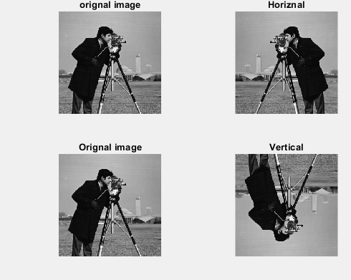

**2)**

**Enhance quality of a given image by changing brightness of image**

**Theory:**

Firstly read the image from file and store it in B variable

Add specific value to that image to increase the brightness here we increase the value by **+50 for each pixel**  store them in a variable

Show the output image using **imshow()** function

**Code:**

%Name :Ali Humadi

%Roll.No:07

clc;

clear all;

close all;

% read the image from file

B=imread("image.jpg");

% show the original image

figure,imshow(B),title("orig_image")

% increas each pixel by +50

a=B+50;

% show the enhancement brightness image

figure,imshow(a),title("enhance brightness image")

**Output:**

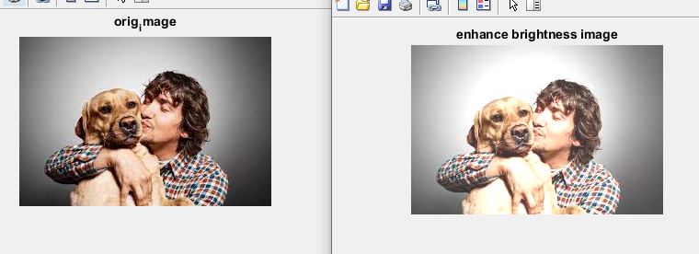

**3)**

**Image negation operation.**

**Theory:**

Read the image from the file and store it in one variable a

The negative of an image is achieved by subtract each pixel from 255, **255 - a**, i.e. **the darkest pixels will become the brightest and the brightest pixels will become the darkest**

Show the original image and the negation image using build function in matlab figure and imshow().

**Code:**

%Name :Ali Humadi

%Roll.No:07

clc;

close all;

clear all;

% read the image from file and store it in a varaible

a = imread('first.jpg');

%show the original image

figure,imshow(a),title("original image")

% subtratct each pixel by 255

b=255-a;

% show the negation image

figure,imshow(b),title("negation image")

**OutPut:**

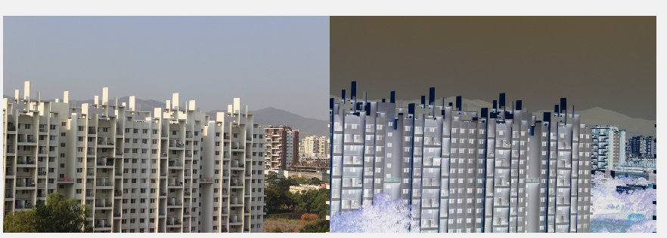

**4)**

**Change contrast of a given Image.**

**Theory:**

First read an image and store it in **a variable**

If we want to enhance the contrast of image we **multi each pixel by specific value above 1**

In this code I enhance the contrast by different values and observed the changes from output images

Using **subplot and imshow()** built function inn matlab to see the output

**Code:**

%Name :Ali Humadi

%Roll.No:0

clc;

close all;

clear all;

%read the image from file and store it in a variable

a=imread("first.jpg");

% using subplot funcition to show the images

subplot(2,2,1)

% show the original image in first part of figure

imshow(a),title("orignal")

% enhace the contrast by *3

b=a*3;

% show the image in second part of the figure

subplot(2,2,2)

imshow(b),title("contrast image1")

% enhace the contrast by *2

c=a*2;

% show the image in third part of the figure

subplot(2,2,3)

imshow(c),title("contrast image2")

% enhace the contrast by *1.2

d=a*1.2;

subplot(2,2,4)

% show the image in last part of the figure

imshow(d),title("contrast image3")

**Output:**

