End-to-End Predictive Analytics

Customer Churn Prediction for a Telecom Business

Name: Ali Hunain Sajid
Week: 3
Date: 02-08-2026

Executive Summary
This report documents a complete predictive analytics pipeline built to predict customer churn for a telecom business, using IBM's public Telco Customer Churn dataset (7,043 customers). The pipeline covers data collection, cleaning, feature engineering, model training, hyperparameter tuning, and evaluation, followed by business recommendations.
The tuned Gradient Boosting model achieved 80.4% test accuracy and 0.846 ROC-AUC on held-out data, with a train/test accuracy gap of only 1.5 points — evidence of a well-generalizing model. As a deliberate contrast, an unconstrained decision tree was also trained on the same data and reproduced the classic overfitting symptom (99.8% train accuracy vs. 72.8% test accuracy), which grounds the answer to Question 1 in real, reproducible numbers rather than theory alone.
- Key business finding: contract type and customer tenure are, by a wide margin, the strongest predictors of churn — more predictive than price. This points to contract-upgrade incentives and early-lifecycle engagement as the highest-leverage retention actions.

1. Data Collection
The dataset used is IBM's publicly released Telco Customer Churn sample — a standard, widely cited benchmark for churn modeling in the telecom industry. It contains 7,043 customer records with 21 attributes spanning demographics (gender, senior citizen status, partner/dependents), account information (tenure, contract type, payment method, billing), subscribed services (phone, internet, streaming, security add-ons), and the churn label itself.

2. Data Cleaning
Three real data-quality issues were identified and resolved:
- TotalCharges was stored as text and contained 11 blank values — not true NaNs, so they silently passed a naive missing-value check. Investigation showed all 11 belonged to customers with tenure = 0 (brand-new customers not yet billed); these were filled with 0 rather than dropped or mean-imputed, since the true value structurally is zero.
- customerID was dropped — a unique identifier carries no predictive signal and only adds noise.
- Churn (Yes/No) and SeniorCitizen were encoded to numeric 0/1 for modeling.
Class balance was also checked: 73.5% of customers stayed and 26.5% churned. This imbalance is why the evaluation in Section 5 relies on precision, recall, F1, and ROC-AUC, not accuracy alone.

3. Feature Engineering
Six engineered features were added on top of the raw attributes, chosen from domain knowledge of what drives telecom churn:
- AvgMonthlySpend — TotalCharges divided by tenure, smoothing out billing-cycle noise.
- tenure_group — bucketed tenure (0–12, 13–24, 25–48, 49–60, 61–72 months), since risk is highly non-linear in tenure.
- num_services — count of subscribed add-on services (phone, security, backup, protection, support, streaming); more services correlates with stickier customers.
- has_internet — binary flag for any internet subscription.
- is_month_to_month — binary flag for the contract type most associated with churn.
- auto_payment — binary flag for automatic payment methods, associated with lower churn.

4. Model Training & Hyperparameter Tuning
Data was split 80/20 (5,634 train / 1,409 test rows) with stratification on the churn label to preserve class balance in both sets. Numerical features were standardized and categorical features one-hot encoded inside a single scikit-learn Pipeline, avoiding leakage between train and test.
Three algorithms were trained and tuned with 5-fold stratified GridSearchCV, optimizing ROC-AUC: Logistic Regression, Random Forest, and Gradient Boosting.
Model | Train Acc | Test Acc | Precision | Recall | F1 | ROC-AUC
Logistic Regression | 81.0% | 79.9% | 0.653 | 0.519 | 0.578 | 0.842
Random Forest (tuned) | 82.6% | 80.6% | 0.676 | 0.513 | 0.584 | 0.843
Gradient Boosting (tuned) — SELECTED | 81.9% | 80.4% | 0.667 | 0.524 | 0.587 | 0.846
Table 1. Tuned model performance on the held-out test set (1,409 customers).
Gradient Boosting was selected as the final model based on the highest test ROC-AUC (0.846), with the best combination of precision and recall for the churn class among the three.
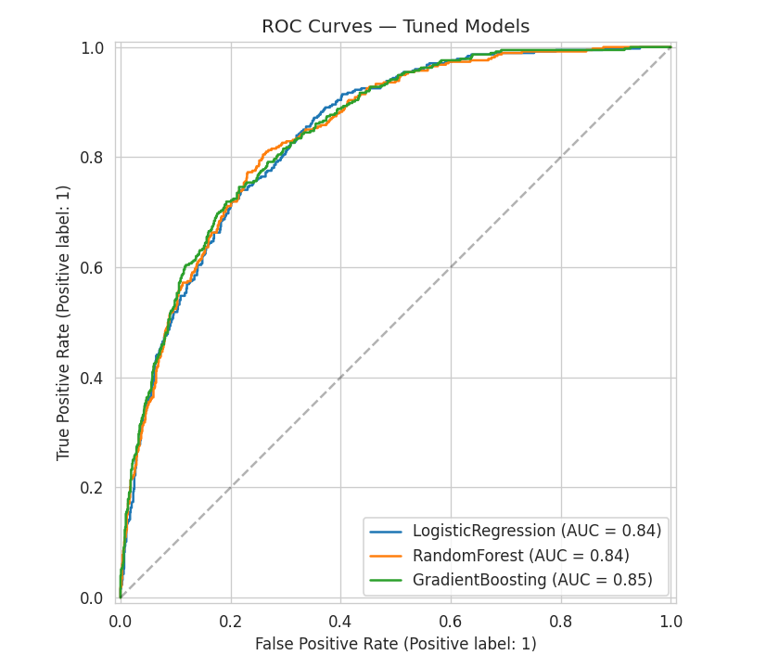
Figure 1. ROC curves for all three tuned models on the test set.
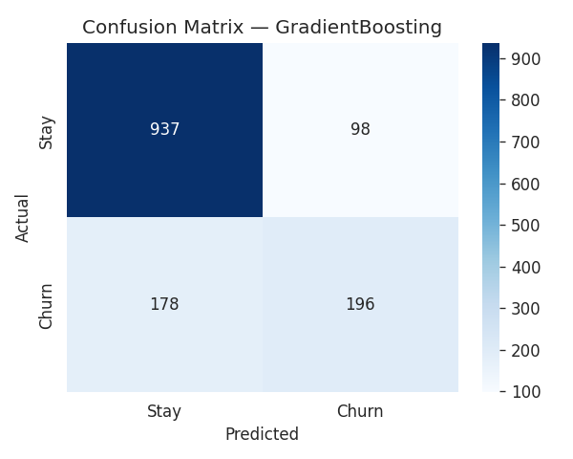
Figure 2. Confusion matrix for the selected Gradient Boosting model.
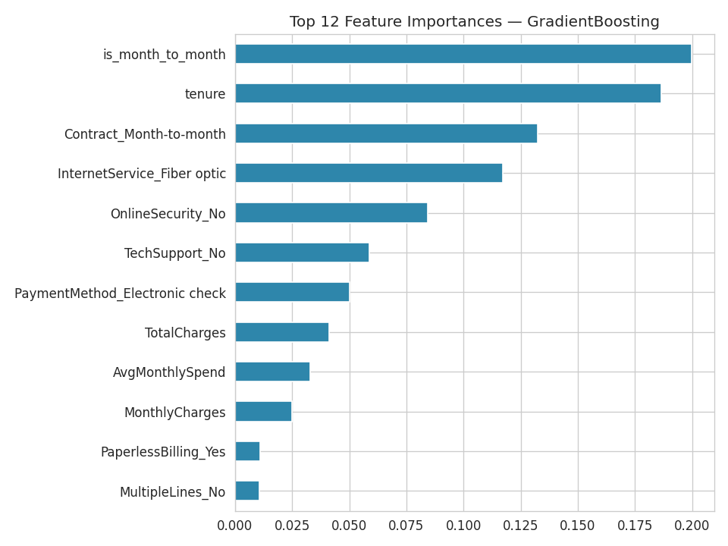
Figure 3. Top drivers of churn according to the tuned Gradient Boosting model.

5. Business Insights
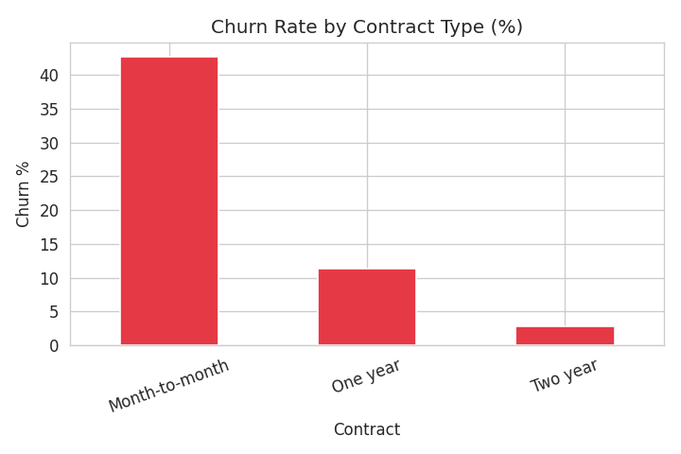
Figure 4. Churn rate by contract type — the single clearest business lever in the data.
- Contract type dominates churn risk. Month-to-month customers churn at a far higher rate than one- or two-year contract holders. Because this is something the business can directly act on, contract-upgrade incentives are the highest-leverage retention lever available.
- Tenure matters most in the first year. New customers are the highest-risk segment; risk drops steadily the longer someone stays. Early-lifecycle engagement (onboarding calls, first-90-days offers) should have outsized ROI relative to blanket retention spend.
- Fiber-optic customers churn more than DSL customers despite paying more, which is worth investigating from a service-quality or price-perception angle rather than a pricing angle alone.
- Missing add-on services correlate with churn. Customers without OnlineSecurity or TechSupport churn more; bundling these in at signup, even at a discount, may be more cost-effective than an across-the-board price cut.
- Payment method is a low-cost lever. Electronic-check payers churn more than automatic-payment customers — a small incentive to switch to autopay is cheap to test.
- Recommended action: score the live customer base monthly with this model and route the top-decile predicted-churn customers to a retention team with a targeted contract-upgrade or service-bundle offer.

- Question 1 — 99% Training Accuracy vs. 74% Testing Accuracy
This exact symptom was deliberately reproduced on this dataset (not simulated) by training an unconstrained decision tree and an unconstrained random forest — the results are shown below.
Model Configuration | Train Acc | Test Acc | Gap
Unconstrained Decision Tree (no depth limit) | 99.8% | 72.8% | 27.0 pts
Unconstrained Random Forest (300 trees, no depth limit) | 99.8% | 78.0% | 21.8 pts
Tuned Gradient Boosting (max_depth=2, 200 trees) | 81.9% | 80.4% | 1.5 pts
Table 2. Overfitting reproduced on real data, and resolved via regularization + tuning.

Why this happens
- Excessive model complexity: an unconstrained tree/forest keeps splitting until leaves are pure, memorizing individual training rows rather than learning the underlying churn pattern.
- No regularization: no depth limit, no minimum samples per leaf/split, no complexity penalty.
- High dimensionality after one-hot encoding relative to sample size increases the model's capacity to fit noise.
- Model selection on a single train/test split (rather than cross-validation) can hide this instability until it's too late.
- Insufficient data for the chosen model complexity — 5,634 training rows supports a regularized model but not an unconstrained one.

Techniques to improve generalization (all applied above)
- Limit complexity: cap max_depth, raise min_samples_leaf/min_samples_split, cap max_features.
- Regularization: L2 penalty (tuned C) for Logistic Regression; shrinkage (learning_rate) and subsample < 1 for Gradient Boosting.
- Cross-validation during tuning: 5-fold Stratified GridSearchCV instead of a single split, so chosen hyperparameters generalize.
- Ensembling: Random Forest averages many decorrelated trees, cancelling individual trees' overfit noise.
- Early stopping / bounded boosting rounds: tune n_estimators rather than letting boosting run indefinitely.
- More/better data, or class-balancing techniques (e.g., SMOTE) for the minority churn class.
- Feature selection to drop low-importance or redundant encoded columns and shrink the hypothesis space.
- Always benchmark against a simple baseline (Logistic Regression) — added complexity has to earn its keep on held-out data.
Result: applying these techniques took the train/test gap from ~27 points (99.8% → 72.8%) on the unconstrained tree down to 1.5 points (81.9% → 80.4%) on the tuned Gradient Boosting model.
- Question 2 — Redesigning the Workflow for 50 Million Records
At 7K rows, the entire pipeline above runs in-memory on a single machine in seconds. At 50 million records, nearly every stage needs a different architecture, not just a bigger machine.

1. Data Collection & Storage
- Move from flat CSV to a columnar, partitioned format (Parquet/Delta/Iceberg) on object storage (S3/GCS/ADLS) or HDFS, partitioned by a natural key such as signup month or region.
- Ingest via streaming or scheduled batch pipelines (e.g., Kafka feeding a lakehouse) rather than a single read_csv call.

2. Data Cleaning & Feature Engineering
- Replace pandas with a distributed engine — Apache Spark (PySpark) or Dask — so cleaning, joins, and aggregations run across a cluster instead of one machine's RAM.
- Push transformations into the engine's lazy execution graph to minimize intermediate materialization; use Spark MLlib's StringIndexer/OneHotEncoder for categorical encoding at scale.
- Compute and persist a feature table once (a feature store) and reuse it across experiments instead of recomputing per run.
- Sample intelligently for exploratory analysis (a stratified 1–5% sample) instead of full-data plotting.

3. Model Training
- Use algorithms with distributed or mini-batch implementations: Spark MLlib, or XGBoost/LightGBM with their Dask/Spark integrations, instead of single-node scikit-learn.
- For very large data, consider incremental learning (SGDClassifier with partial_fit, or epoch-wise neural network training) so the full dataset never needs to fit in memory at once.
- Downsample the majority class for training (churn is imbalanced) to cut compute cost, validating on the full, untouched distribution.

4. Hyperparameter Tuning
- Full grid search becomes infeasible — switch to randomized search or Bayesian optimization (Optuna/Hyperopt) with a fixed compute budget.
- Tune on a representative subsample first, then confirm on more data with fewer, targeted runs.
- Use early stopping for boosting models and parallelize trials across a cluster (Ray Tune/Spark) instead of running them sequentially.

5. Model Evaluation
- Evaluate on a distributed, held-out test set using the same engine's evaluators (e.g., Spark MLlib) so scoring doesn't require pulling tens of millions of rows onto one machine.
- Aggregate metrics across partitions rather than materializing every prediction locally.

6. Cost & Execution-Time Controls
- Right-size the cluster and use spot/preemptible instances for training jobs.
- Cache and checkpoint intermediate Parquet outputs so re-runs skip expensive joins/cleaning.
- Apply column pruning and predicate pushdown so jobs only read the columns/partitions they need.
- Use autoscaling clusters (EMR/Databricks/Dataproc) that scale down between jobs.
- Move from ad-hoc notebooks to an orchestrated pipeline (Airflow/Dagster/Databricks Jobs) with caching, retries, and monitoring.

7. Serving
- Batch-score the full 50M customers on a schedule (a nightly Spark job writing predictions back to the warehouse) rather than a live single-machine call per row.
- Expose a lightweight or distilled model for any real-time scoring needs.
In short: the statistical techniques from Question 1 don't change — regularization, cross-validation, and ensembling still apply — but the engine underneath every stage changes from single-machine pandas/scikit-learn to a distributed, partition-aware, cost-controlled pipeline.

