**RESTful API for a Simple To-Do List Application**

**1-Retrieving all tasks** (Retrieving all tasks with pagination):

**Method: GET**

**EndPoint:** <http://localhost:8080/api/v1/tasks>

**Query-Params:** page->for page number (Default value = 0).

size->for size of element to be retrieved

per page (Default value = 5).

sortBy->for sorting retrieved data

(Default value = id).

**-Request/Response Sample using postman: status (200) indicate a (success)**

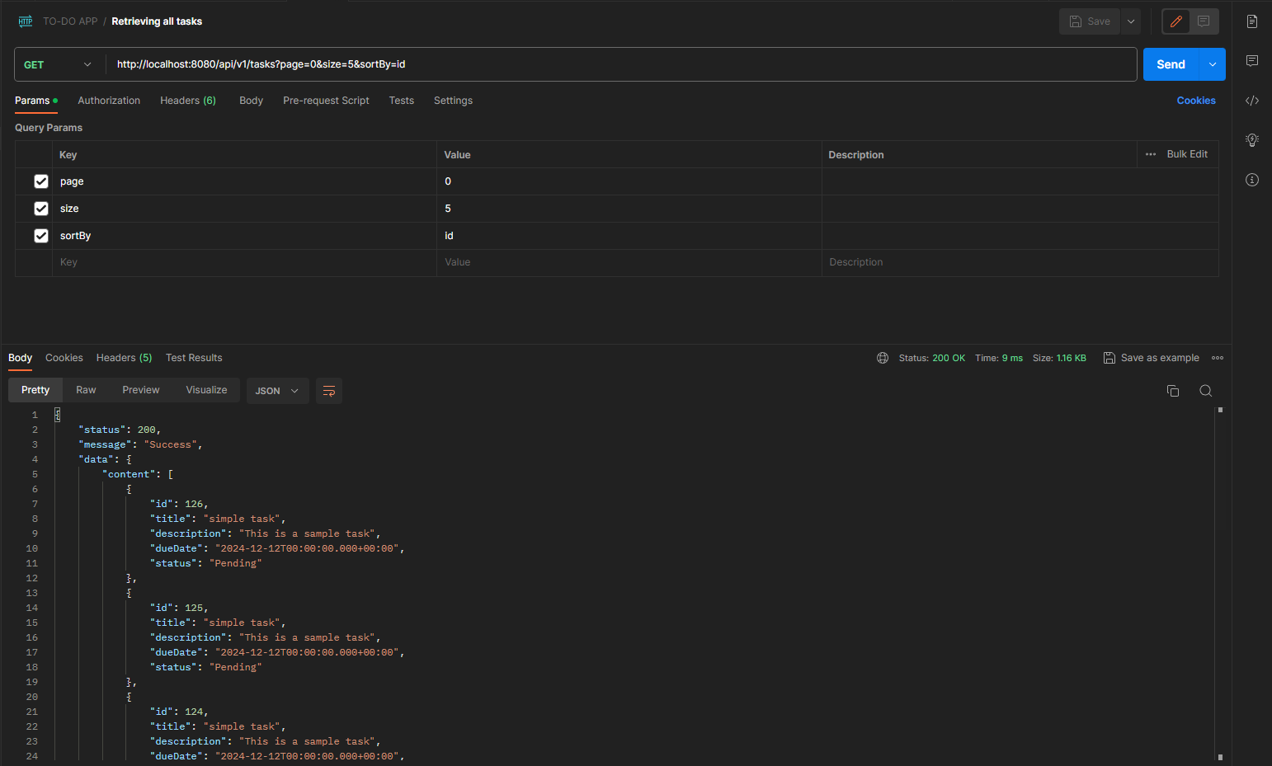

**-Data Pagination sample:**

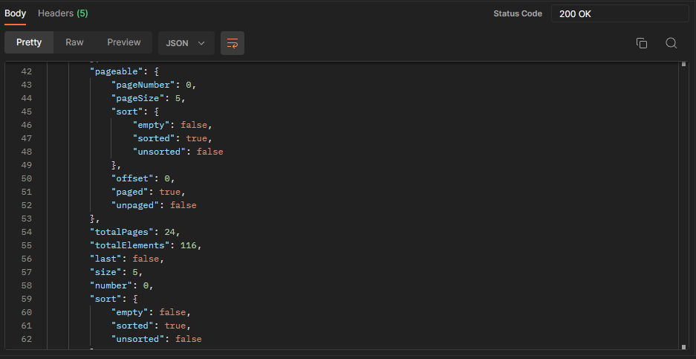

**2-Creating a new task:**

**Method: POST**

**EndPoint:** <http://localhost:8080/api/v1/new-task>

**Body:**

{

  "title": "simple task",

  "description": "This is a sample task",

  "status": "Pending",

  "dueDate": "12/12/2024"

}

**-if request is successful it will return status (201) with message “created successful”  
 -if mandatory request data is missing the request return status (400) bad request with**

**message contains the missing parameter name**

**-Request/Response Sample using postman:**

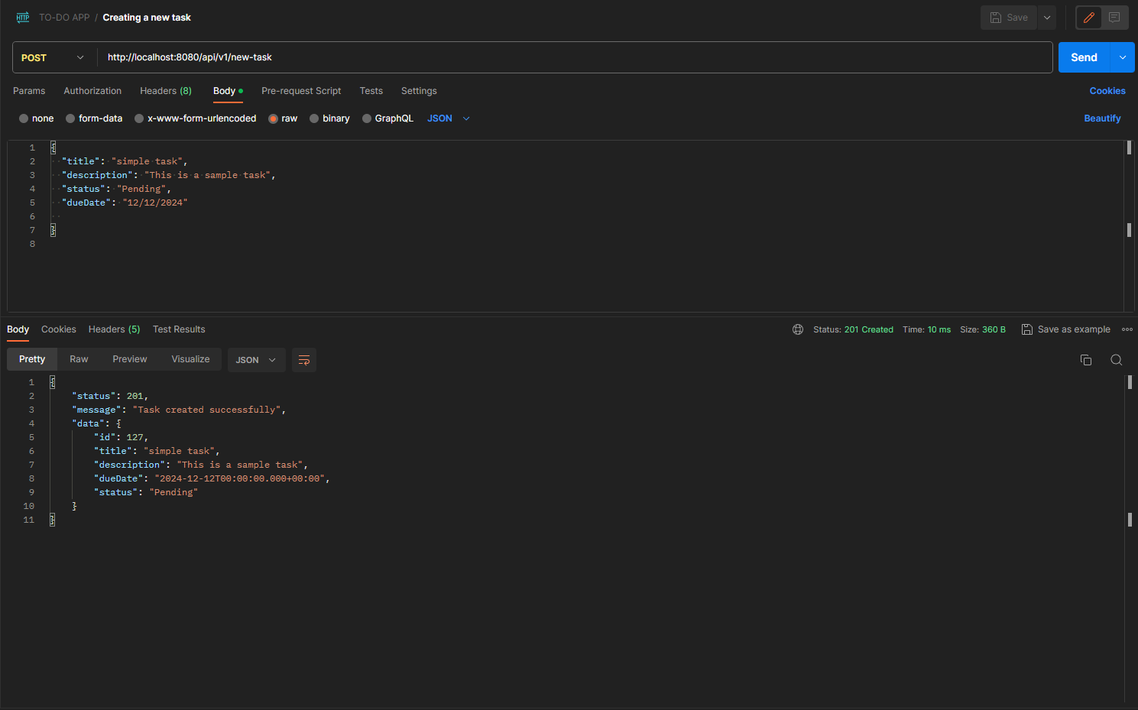

**3- Retrieving a specific task by ID:**

**Method: POST**

**Endpoint:** <http://localhost:8080/api/v1/task>

**Body: (form-data):**

**-(id)-> task id**

**-Request/Response Sample using postman:**

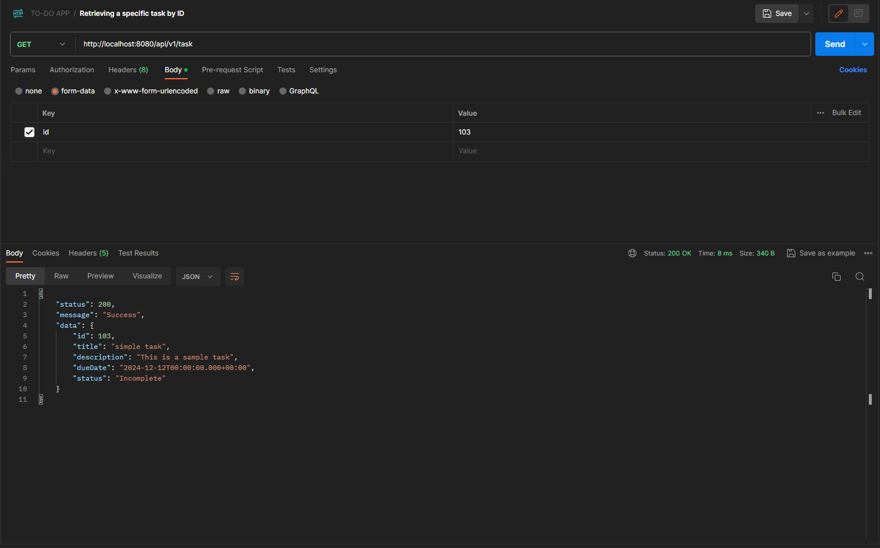

**-4 Update a specific task status by ID:**

**Method: PUT**

**Endpoint:** <http://localhost:8080/api/v1/task-status>

**Body: (form-data)**

**-(Id)->for task id**

**-(newStatus)->to update the task current status**

**-Request/Response Sample using postman:**

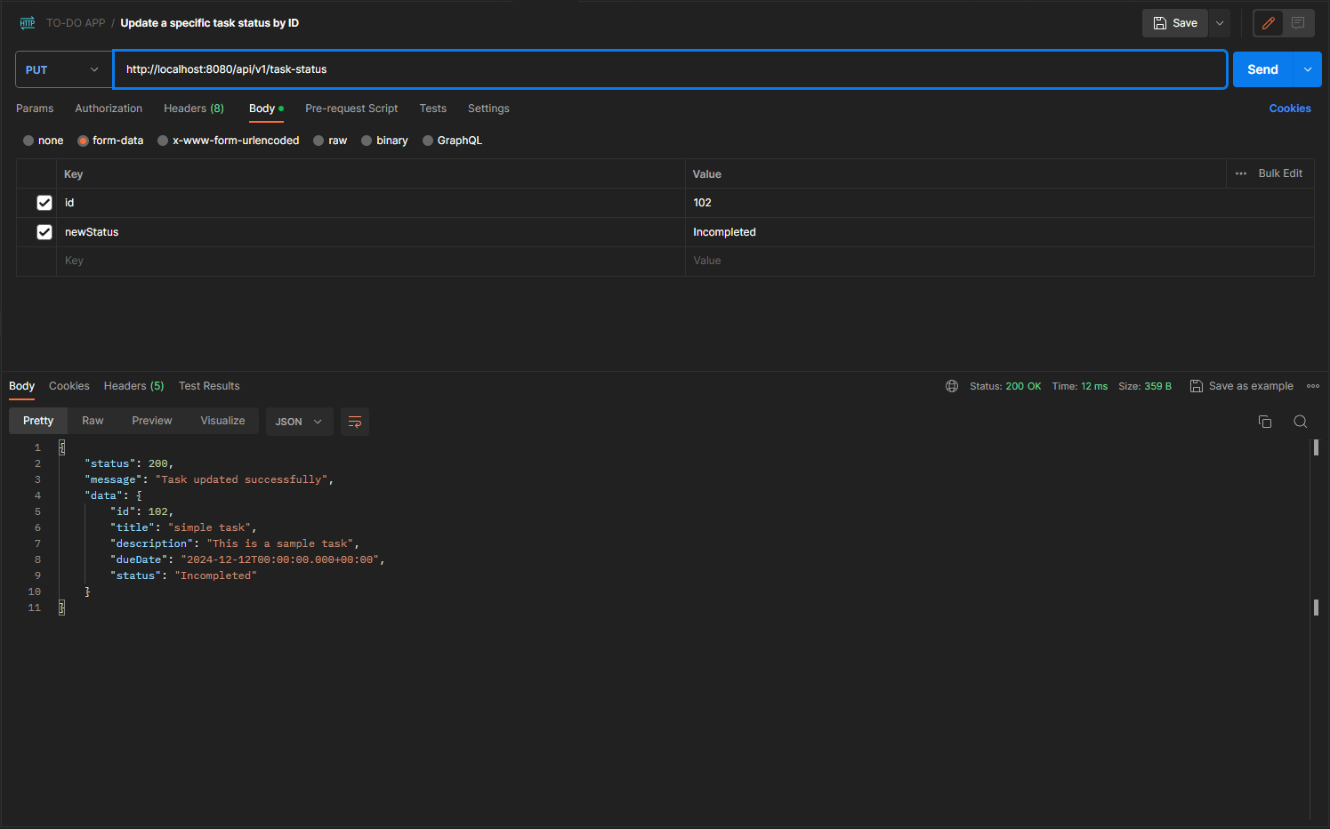

**5- Delete a specific task by ID:**

**Method: DELETE**

**Endpoint:** <http://localhost:8080/api/v1/end-task>

**Body (form-data)**

**-(Id)-> Task Id**

**-Request/Response Sample using postman:**

