Essay 1

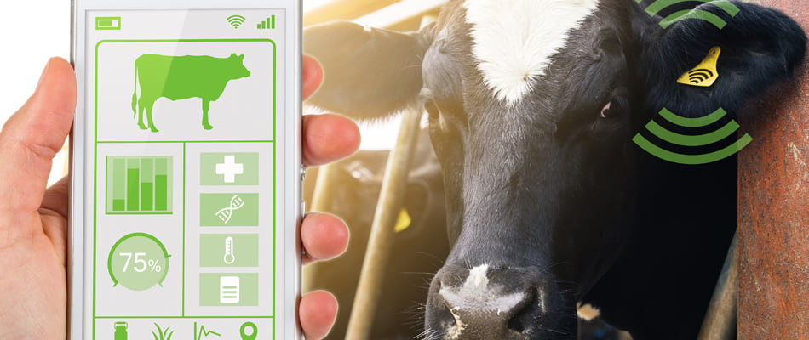

Maintaining detailed and accurate records of your animals is essential to successfully managing a farm. The ideal solution for this is to maintain digital records for each animal. Many farmers prefer to use livestock management software instead of attempting to figure out how to keep detailed spreadsheets and documents organized.

In fact, understanding feed usage is essential to your ranch's operational effectiveness. These agricultural technology devices may measure each animal's food consumption as well as assist you in creating feeding schedules for your animals. With the help of this information, you can quickly and accurately estimate costs and do basic feed calculations. The ideal nutritional balance for each animal may be found using those systems, and if your animals graze, you can utilize the pasture management function to schedule herd movements and forecast field yields. The food management instruments can show you how these changes influence your herds over time whether the cattle receive supplements or vary their diets. Also, ranchers with a large number of animals can profit from using these animal control systems' sophisticated recordkeeping capabilities, but any size business can gain from using such technologies and devices. Moreover, images of the animal during its life as well as information about its weight, gender, breed, health, date of birth, and general performance may be found in individual information.

Most farmers and ranchers undoubtedly find accounting to be the least enjoyable aspect of their jobs, but livestock software tools may help a lot to make managing your financial affairs less painful. Accounting is made easier with these platforms since you can quickly access any financial data you might need, which may significantly decrease the amount of paperwork and difficulty you must deal with when it comes to keeping your accounting records in order.

For customers, manufacturers, and regulators, farm welfare for animals is a crucial problem. Today's livestock producers have to successfully tackle consumer worries about security of goods and the well-being of animals while maintaining a profit. The standards for the care, wellness, and overall quality of farm animals have increased as a result of technological advancements.

Citations

(*The Importance of AG Tech in Farm Management | Chetu*, n.d.)