DAD 220 Module Five Major Activity Template

Overview

Review the scenario for this activity in the guidelines and rubric. Then complete the steps below as you work through the directions for this activity. Replace the bracketed text with your screenshots and responses to the prompts. Size each screenshot and its explanation to fit approximately one-quarter of the page with the description written below the screenshot. Review the Template Screenshot Example linked in the guidelines and rubric for this assignment to see an example of how screenshots for your assignment should look.

Create a Database

- Write SQL commands that capture specific, usable data that can be used in your analysis.

- Analyze the results of queries to identify specific information that can be presented in your summary.
  - Sales by region:
    - Analyze sales data by state to determine where the company has the largest customer base.

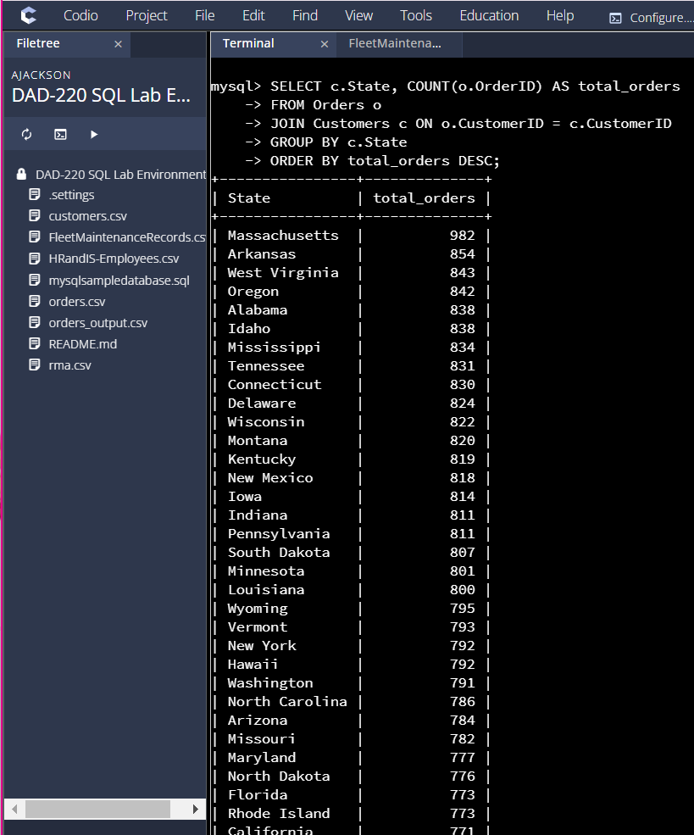
Massachusetts comes in first followed by Arkansas, and then west virginia at number 3

    - Analyze the data to determine the top three products sold in the United States.

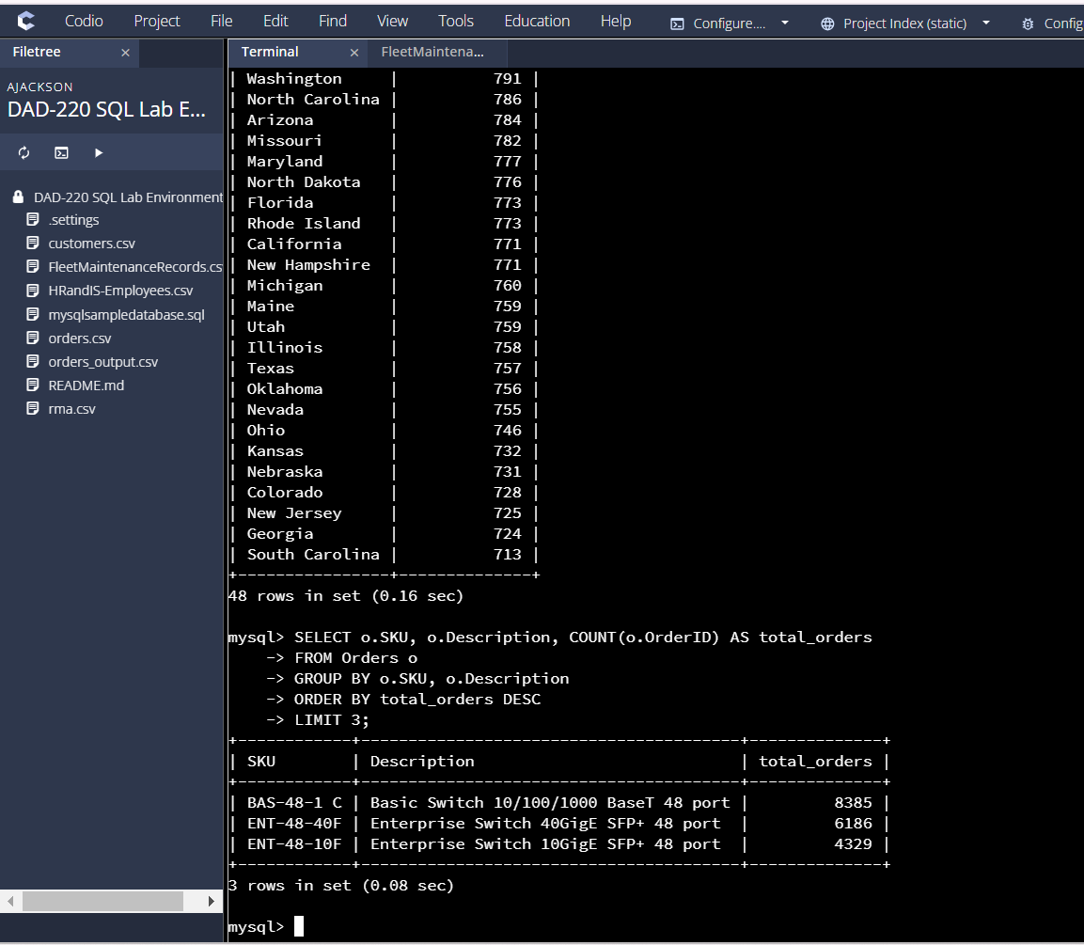
The top three products sold in the United States are the BAS-48-1 C, ENT-48-40F, and ENT-48-10F switches. These products have the highest order counts, with the BAS-48-1 C switch leading by a significant margin, followed by the ENT-48-40F and ENT-48-10F models.

    - Analyze the data to determine the top three products sold in the southeastern region of the United States.
- Southeastern states to include in your analysis: Virginia, North Carolina, South Carolina, and Georgia

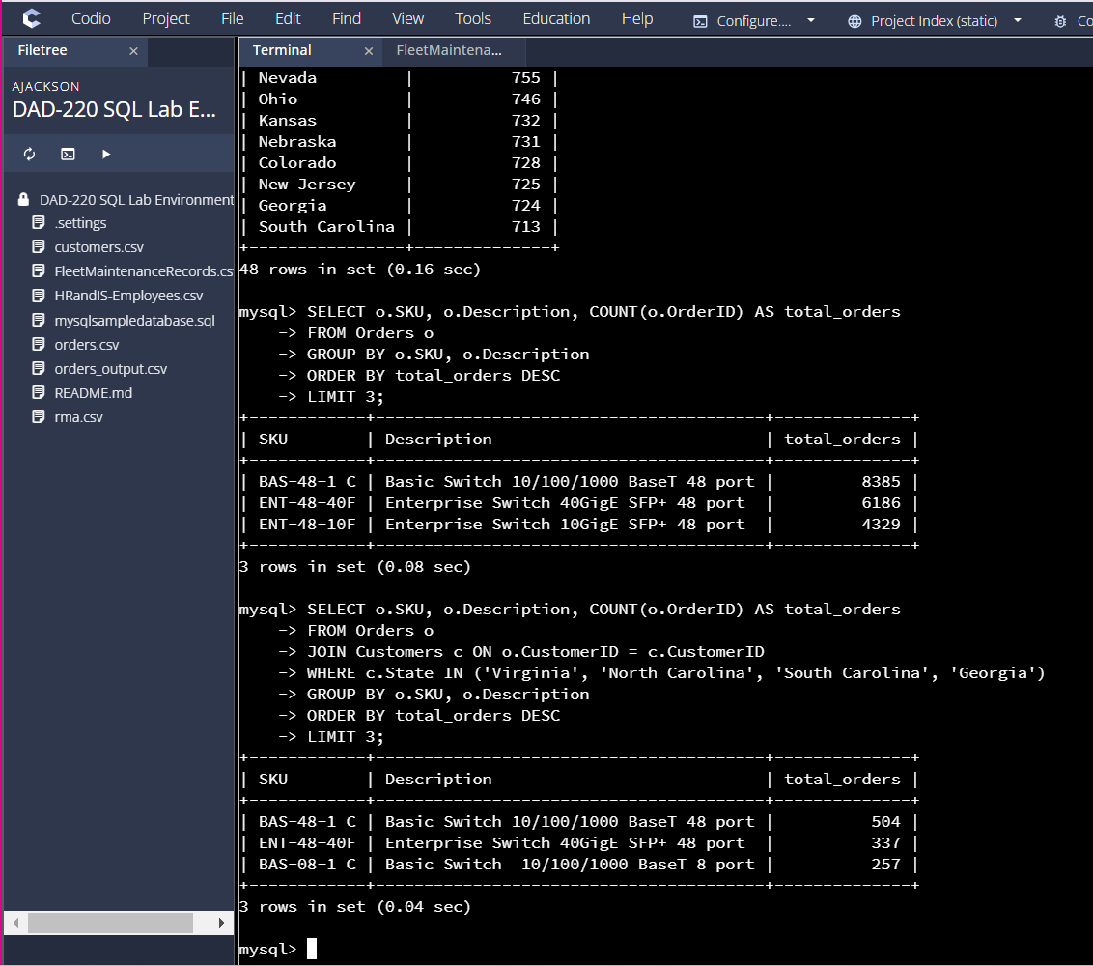
The most sold product in the southeastern states is the BAS-48-1 C, followed by the ENT-48-40F and BAS-08-1 C. This shows the popularity of the Basic Switch model in the region, with the Enterprise Switch being the second most sold.

  - Returns by region:
    - Analyze the data to determine the top three products returned in the United States.

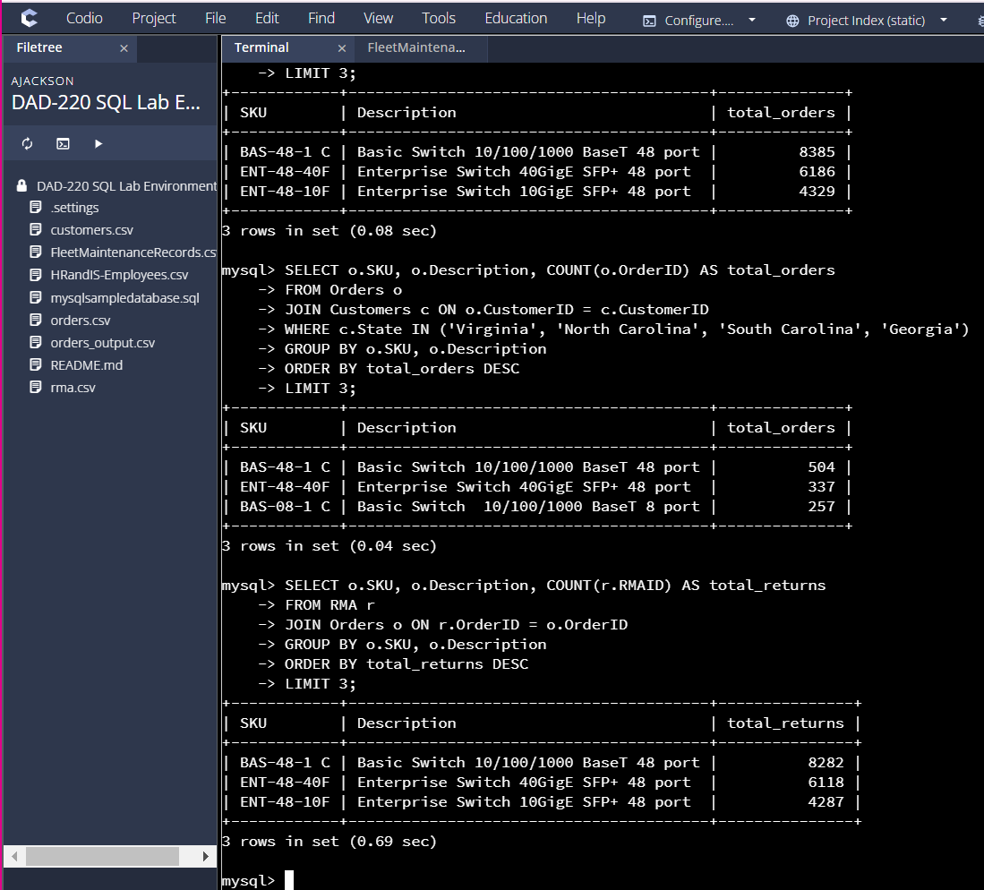
The BAS-48-1 C switch has the highest return count, followed by the ENT-48-40F and ENT-48-10F switches. This may indicate a higher return rate for these products, possibly due to defects, shipping issues, or customer dissatisfaction

    - Analyze the data to determine the top three products returned in the northwestern region of the United States.
- Northwestern states to include in your analysis: Washington, Oregon, Idaho, and Montana

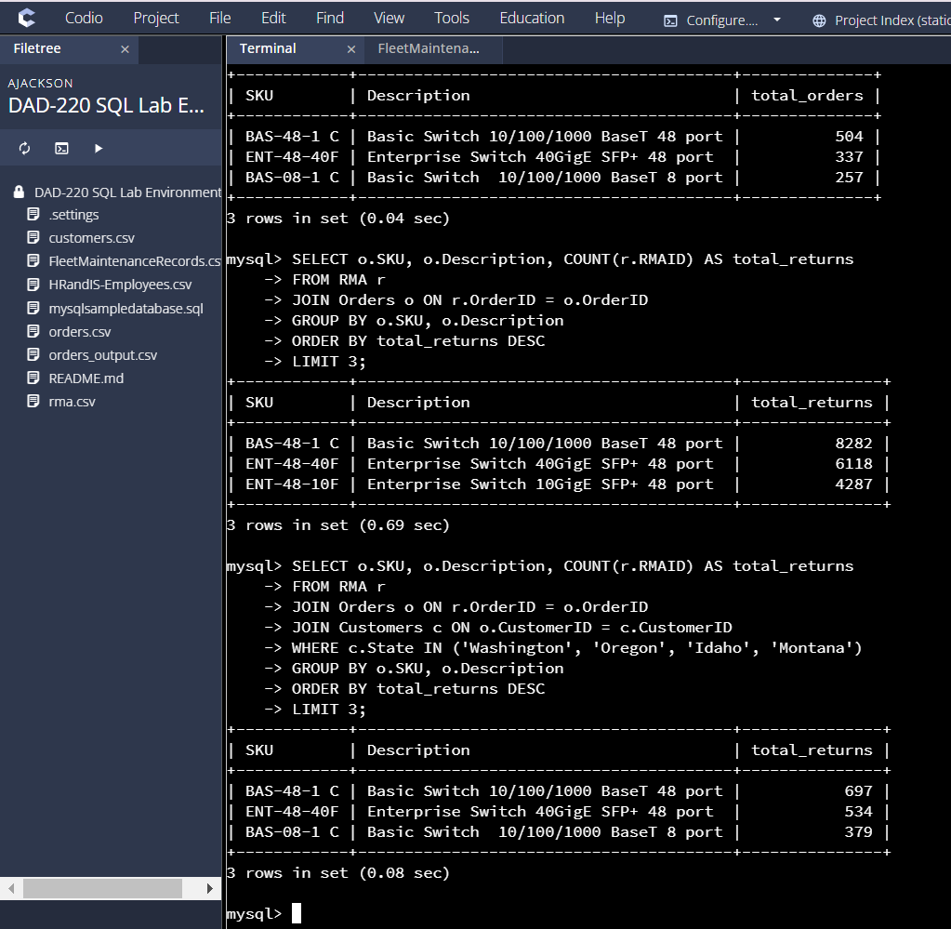
In the northwestern region, the BAS-48-1 C switch also has the highest return rate, with the ENT-48-40F and BAS-08-1 C switches following. These results indicate that returns are concentrated in the same products, likely due to similar reasons as in the nationwide analysis.

- Write a report to the Quantigration product manager that explains your findings in a way nontechnical stakeholders can understand and use.
  - Provide an effective summary of your findings from the analysis of the sales and returns data you captured. Write at least one paragraph for each of your responses to the prompts below.

    - Sales data by region: Provide a well-written summary of findings from your analysis in Step Two, Part A.

From the sales data analysis, we can see clear patterns in the purchasing behavior of customers across different regions. The top three products sold in the southeastern region of the United States, which includes Virginia, North Carolina, South Carolina, and Georgia, were the Basic Switch 10/100/1000 BaseT 48 port (BAS-48-1 C), the Enterprise Switch 40GigE SFP+ 48 port (ENT-48-40F), and the Basic Switch 10/100/1000 BaseT 8 port (BAS-08-1 C). These products were ordered the most in the region, reflecting a strong demand for networking equipment in these states. The Basic Switch 48 port model, in particular, was the top seller, with a total of 504 units ordered, indicating its popularity and reliability for larger-scale installations. This pattern suggests that businesses and institutions in the southeastern U.S. likely require robust and scalable networking solutions for their operations.

    - Returns data by region: Provide a well-written summary of findings from your analysis in Step Two, Part B.

In terms of returns, the analysis of the northwestern region, which includes Washington, Oregon, Idaho, and Montana, highlighted a similar trend in product returns. The Basic Switch 10/100/1000 BaseT 48 port (BAS-48-1 C) again topped the list, with 697 returns, followed by the Enterprise Switch 40GigE SFP+ 48 port (ENT-48-40F) and the Basic Switch 10/100/1000 BaseT 8 port (BAS-08-1 C). The high return rates for these products suggest that there may be potential issues with quality or customer satisfaction in this region, particularly for the Basic Switch 48 port, which saw both high sales and returns. The product's returns could be indicative of specific regional concerns, such as compatibility, performance, or installation challenges. This insight could inform future product improvements or targeted support efforts to address any potential issues in this region.

